Semi-annual Environmental Monitoring Report

Semi-annual report
Reporting period: January-June 2023
Project Number: 48025-004
Date: July 2023

UZB: Central Asia Regional Economic Cooperation Corridor 2 (Pap-Namangan-Andijan) Railway Electrification Project – Additional Financing

Loan No.4000-UZB
(Financed by the Asian Development Bank)

Prepared by: ITALFERR Consulting Company and PIU-ET JSC "O’zbekiston Temir Yo’llari" (UTY) for JSC "O’zbekiston Temir Yo’llari" and Asian Development Bank

This Annual Environmental Monitoring Report is a document of the borrower. The views expressed herein do not necessarily represent those of ADB’s Board of Directors, Management, or staff and may be preliminary in nature.
In preparing any country program or strategy, financing any project, or by making any designation of or reference to a particular territory or geographic area in this document, the Asian Development Bank does not intend to make any judgements as to the legal or other status of any territory or area.

CURRENCY EQUIVALENTS
(As of 15 July 2023)
Currency unit | – | Sum (SUM)
SUM1.00 | = | $0.000092
$1.00 | = | SUM 11582.14

ABBREVIATIONS
ADB | - | Asian Development Bank
CAP | - | Corrective action plan
CM | - | Cabinet of Ministers
EHS | - | Environmental, Health and Safety Guidelines
EMP | - | Environmental Management Plan
EMR | - | Environmental monitoring report
GRM | - | Grievance redress mechanism
HH | - | Household
IEE | - | Initial Environmental Examination
IFC | - | International Finance Corporation
PIU-ET |  | Project Implementation Unit for Electrification and Renewal of Rolling Stock
PMC |  | Project Management Consultant
ТA | - | Technical assistance
UTY | - | O’zbekiston Temir Yo’llari

NOTE{S}
In this report, "$" refers to United States dollars unless otherwise stated.
TABLE OF CONTENTS

1 INTRODUCTION 4
1.1 Preamble 4
1.2 Headline Information 4
2 PROJECT DESCRIPTION AND CURRENT ACTIVITIES 4
2.1 Project description 4
2.2 Project Contracts and Management 10
2.3 Project activities during the current reporting period 11
2.4 Description of Any Changes to Project Design 11
2.5 Description of Any Changes to Agreed Construction Methods 11
3 Environmental Safeguard activities 13
3.1 General Description of Environmental Safeguard Activities 13
3.2 Site Audits 13
3.3 Issues Tracking (Based on Non-Conformance Notices) 15
3.4 Trends 16
3.5 Unanticipated Environmental Impacts or Risks 16
4 STATUS OF COMPLIANCE WITH COVENANTS 17
5 ReSULTS OF Environmental monitoring 21
5.1 Overview of Monitoring Conducted during Current Period 21
5.2 Air Quality Monitoring 21
5.3 Noise 21
5.4 Vibration 21
5.5 Water quality Monitoring 21
5.6 Topsoil Management and Soil Contamination 21
5.7 Waste Management 21
5.7.1 Non-hazardous Waste 21
5.7.2 Hazardous Waste 21
5.8 Construction Camp Conditions and Facilities for Workers 21
5.8.1 Storage of construction materials on site 21
5.8.2 Refueling station N/A 21
5.9 Health and Safety 21
5.9.1 Community Health and Safety 21
5.10 Material Resources Utilization 21
5.11 Covid-19 activities 22
5.12 Track Record System and Complaints 22
5.13 Trainings 22
5.14 Environmental Management Plan Implementation 22
6 Functioning of THE SSEMP 26
6.1 SSEMP Review 26
7 Good practice and opportunity for improvement 27
7.1 Good Practice 27
7.2 Opportunity for Improvement 27
8 Summary and recommendations 28
8.1 Summary 28
8.2 Recommendations 28
Annex 1. COnclusion of Environmental Expertise (OVOS) 29

1 INTRODUCTION

1.1 Preamble
- This report is the 1st Semi - Annual Environmental Monitoring Report (SAEMR) for L4000-UZB Central Asia Regional Economic Cooperation Corridor 2 (Pap-Namangan-Andijan) Railway Electrification Project - Additional Financing (CARECC 2 REPAF). This report was prepared and covers the period of January-June 2023. There were not any physical activities, as the design was carried out.

Headline Information
- In accordance with Safety Policy Statement (SPS 2009), the project is category B, as a project with site-specific impacts, few of which are irreversible, and where is most cases mitigation measures can be designed. The project’s Initial Environmental Examination was approved in August 2020.
- Anticipated environmental impacts may be reviewed at three stages: pre-construction, construction and operation. During the preconstruction stage, it is important to receive necessary permits and approvals are received. During the construction phase, primary impacts relate to waste generation, air pollution, increase of noise level, vibration, construction camp allocation area, soil quality and community health and safety and etc. To evaluate noise impacts during the operation phase, noise levels generated by the railway on buildings and premises located adjacent to the project. But all these impacts can be mitigated through implementation of Environmental Management Plan requirements.

2 PROJECT DESCRIPTION AND CURRENT ACTIVITIES

2.1 Project description
- The railway network in eastern Uzbekistan consists of a loop linking Pap, Namangan, Andijan, Asaka, Margilan, and Kokand, and a line from Pap through the Kamchik tunnel to Angren and further on to Tashkent. A number of branch lines also extend into the Kyrgyz Republic and Tajikistan. These lines provide a vital connection for both passenger and freight transport, between major cities in the Fergana Valley, as well as to Tashkent and beyond. The lines are also part of regional transport corridors linking East Asia with Europe through Central Asia.
- In the previous project, to electrify the missing 145.1 kilometres (km) of a single-track non-electrified track between the Pop, Namangan and Andijan. The electrification of this network has been completed. However, there are no permanent signalling and communication systems between Angren, the Pop, Kokand and Andijan, which seriously affect the efficiency and safety of rail transport. There are also restrictions on the number of trains that can be operated due to the lack of traction substations. Additional funding is therefore required for works on the Angren-Pap-Kokand-Andijan site.
- The additional financing will complete the modernization of the railway network in the Fergana Valley, by installing signaling and telecommunications in the missing sections. The additional financing will complete works originally envisaged to be completed under the project referred to as “Construction of electrified railway line Angren-Pap with electrification of the railway section Pap-Kokand-Andijan,” which covers the installation of additional signaling, telecommunication and video surveillance systems, construction of traction substations at Kokand and Asaka, as provided for in the government’s feasibility study for the project approved by the instructions of the Cabinet of Ministers of the Republic of Uzbekistan No РКМ-642 dated 20 August 2016. This scope of work was planned to receive financial support from the World Bank. However, procurement delays led to the cancellation of the amount associated with this component, and the loan was closed in March 2020. This decision took place amidst a challenging procurement landscape facing Uzbekistan in 2017 and 2018, where all international financial institutions (IFIs) faced delays across all sectors. ADB and UTY exercised patience and steadily worked with the government to formulate new procedures that are fully compatible with the rules and regulations of IFIs. Since then, implementation of ADB financed projects has accelerated.
- With this additional financing, UTY will be able to complete the modernization of this part of the network, and trains will be able to travel safely and at more frequent intervals between the towns and cities within the Fergana Valley, as well as to and from Tashkent. This will reduce journey times and monetary cost of travel for the population in the Fergana Valley, improve access for women and children to safer transport, with gender-inclusive facilities in trains and at modernized stations which are already in place, and enhance access of the population to essential facilities, most of which are located in the cities of Andijan and Kokand. Prior to seeking the additional financing, UTY and the government has already constructed the external power supply lines between the two new traction substations at Asaka and Kokand and the power grid: this will be considered an associated/existing facility.
- Impact and Outcome. The project is aligned with the following impact(s): (i) stimulated economic growth in the Fergana Valley, and (ii) improved connectivity and increased regional trade along CARECC Corridor 2. The project will have the following outcome: level of rail passenger and freight service in, to and from the Fergana Valley improved.
- Outputs. The current project has the following outputs:
- Output 1. Railway infrastructure along the Pap-Namangan-Andijan railway line upgraded. This includes electrification of 145.1 km of the main railway line to 27.5 kilovolts alternating current, construction of 2 traction substations and dispatcher points, purchase of maintenance equipment and machinery, modernization of signaling and communications facilities, and construction of external power supply facilities which will transmit electricity from the main grid to the traction substations.
- Output 2. Safety of railway operations improved. UTY’s institutional capacity will be strengthened, especially with regards to operational safety for general public along the railway. With the project, it is expected that train frequencies and speeds will increase. Also, the presence of the power lines may pose additional risks of electrocution. To offset any potential negative impacts which may arise, the project will support UTY in (i) conducting an assessment of the existing and anticipated safety situation to the general public including women and children, (ii) supporting the development of practical countermeasures, and (iii) training of staff (including female staff) to plan future railway developments in the safest manner.
- The proposed additional financing will expand the existing outputs and include two new outputs to complete the modernization of the railway network as described below:
- Output 3. Railway infrastructure along the Angren-Pap-Kokand-Andijan line upgraded. This output will focus primarily on the supply and installation of the missing signaling and telecommunications system on 441km of existing track, including four branch lines adjacent to the main line, which will allow UTY to operate trains safely and at increased frequency, thus maximizing the utility of existing infrastructure. To allow a larger number of trains to be run, 2 traction substations will be constructed and a further two upgraded and connected to a supervisory control and data acquisition (SCADA) and external power supply. Two sectioning posts will also be constructed. Machinery and equipment for maintenance of electrified lines, as well as for upgrading of Kokand depot will also be acquired and commissioned.
- Output 4. Train control and management system upgraded. The completion of the installation of signaling and telecommunications system will allow UTY to control and manage all train movements in the Fergana Valley from the central train control center in Tashkent. ADB will add value to the project through this output, through which (i) the central train control center in Tashkent will be upgraded, (ii) an automated train scheduling system will be made functional, and (iii) staff members, including all relevant female technical staff will be trained on the modernized train control and management system.
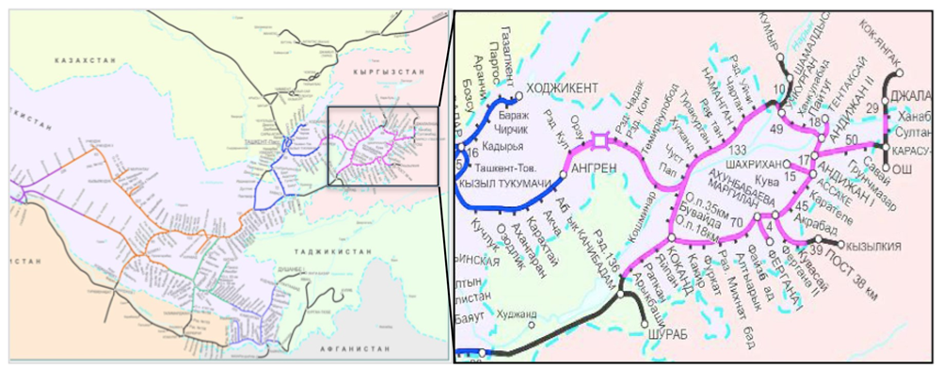
- The alignment of the project region is shown in the figures below:
Figure 1. Railway map

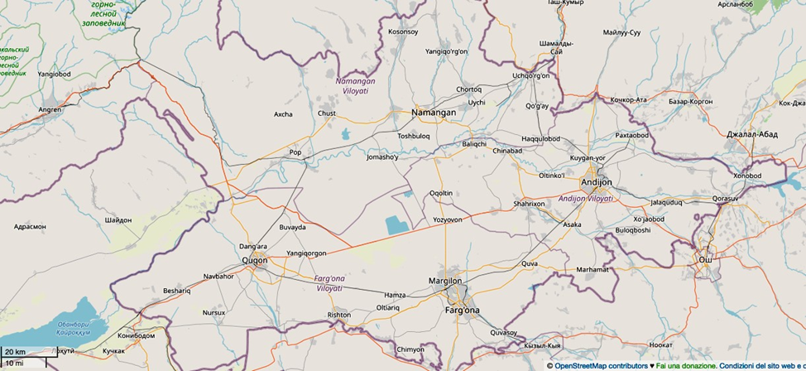

Borders of Namangan, Fergana and Andijan regions
Rivers and reservoirs
Roads
Roads
Railways
Figure 2. Open Street Map
- Institutional chart. UTY, the executing agency (EA), is adequately staffed and uses acceptable financial management, has good management practices and a sound track record with project implementation. Implementation arrangements build on ADB’s successful railway project experiences in the country. UTY established a project implementation unit for electrification (PIUE) on 1 May 2011, which became fully operational following UTY’s internal order 163 issued on 16 March 2012. On 6 December 2018, based on the order of the First Deputy Chairman of the Board of UTY No. 2188-N, PIU-E merged with another PIU which hitherto implemented projects for the procurement of rolling stock. PIU-E was renamed as the Project Implementation Unit for Electrification and Renewal of Rolling Stock (PIU-ET).
- The PIU-ET comprises 23 staff including the head, two deputy heads, senior legal counsel, administrator, head of technical department, three signalling and telecommunications specialists, three power supply specialists, one locomotive specialist, one environmental protection specialist, head of financial department, one accountant, one economist, one head of monitoring and procurement department, and two procurement specialists. PIU-ET staff have experience of undertaking projects financed by international financial institutions, including those financed by ADB. 8. International and national experts are engaged as engineering and construction supervision consultants. Contract modalities include design and build work, hence the engineering and construction supervision consultants’ role is to manage contracts with PIU-ET and give hands-on training in procurement, project management and oversight, operation and maintenance, and reporting
- International and national experts are engaged as engineering and construction supervision consultants. Contract modalities include design and build work; hence the engineering and construction supervision consultants’ role is to manage contracts with PIU-ET and give hands-on training in procurement, project management and oversight, operation and maintenance, and reporting.
- Institutional Chart of EA and PIU-ET are shown in the Figure 3 and 4 below:

ADB
Ministry of Finance
UTY
(
Executing Agency)
Project Implementation Unit for Electrification and
Renewal of Rolling Stock
Engineering and
Construction Supervision
Consultants for Current
Project
G
oods contractors for
external power supply,
OCS, and maintenance
machinery.
Plant contractors for
signaling and
telecommunications,
traction substations and
SCADA

Project
Agreements
Memorandum of
Understanding
Uzbekenergo,
subsequently JSC
“National Electric
Networks of Uzbekistan”

PIU
-
ET

Team

•
Head (1)
•
Deputy heads (2)
•
Senior legal counsel (1)
•
Administrator (1)
•
Head of Technical Department (1)
•
Signaling and telecommunications
specialists (3)
•
Power supply specialists (2)
•
Head of locomotive procurement (1)
•
Locomotive lead specialists (2)
•
Locomotive specialist (1)
•
Environmental protection specialist (1)
•
Head of financial department (1)
•
Accountant (1)
•
Economist (1)
•
Head of monitoring and procurement
department (1)
•
Procurement specialists (3)

Loan Agreements
Relending Agreements
Engineering and
Construction Supervision
Consultants for Additional
Financing

Goods contractors for
maintenance machinery.
Plant contractors for
signaling and
telecommunications,
traction substations,
video surveillance
system, and CTC
upgrade

Figure 3. Institutional chart

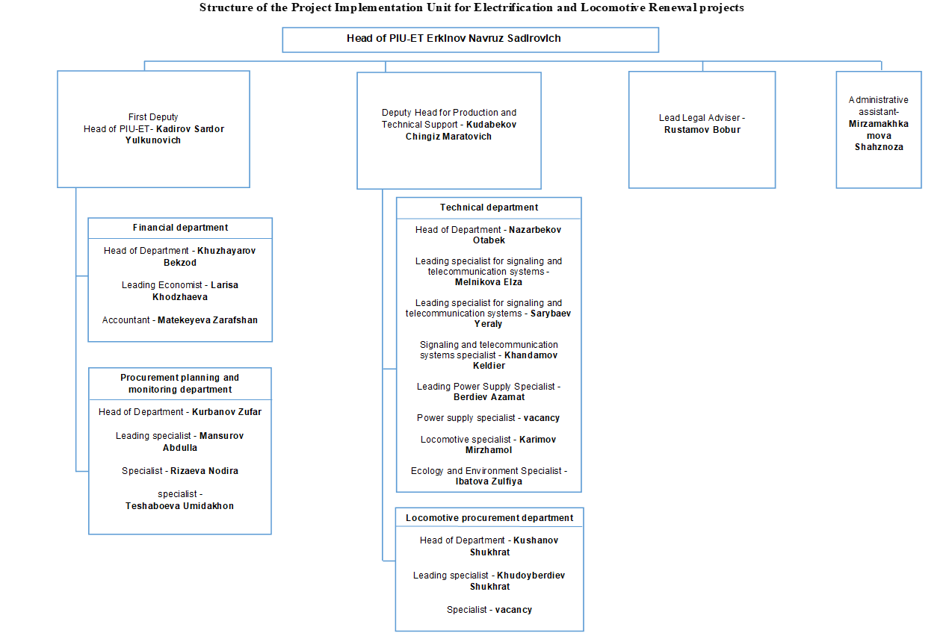
Khojanyarova Guzal

Figure 4: PIU-ET Project organization structure

2.2 Project Contracts and Management
- The ITALFERR Consulting Company is hired for project supervision consulting services (PSC) of the project.
- The task of the services is to provide support to the UTY at several stages of the project: development of tender documentation; support in the bidding process; viewing drawings developed by the UTY and/or contractors; supervision and monitoring of construction work, technical, commercial and in-time project realization; interface management; construction supervision; claims management.
- In addition, the Consultant provides training to the UTY staff after the implementation of the upgraded train control and management system.
- At the procurement stage, the Consultant will provide support in the preparation of technical specifications and tender documentation in accordance with the procedures of Open Competitive Bidding (OCB), in accordance with the ADB Procurement Policy and Procurement Standards and taking into account the package of contracts based on the Procurement Plan approved by ADB. During the implementation of this task, the Consultant provides constant assistance to PIU in the overall procurement process, attending all meetings with contractors and contract negotiations.
- During the supervision of construction works, the Consultant will monitor the execution of the work, checking the work of the Contractor, in order to ensure compliance with the project implementation schedule, budget, quality and safety in accordance with ADB safeguard requirements and with national legislation Depending on what is stricter. ADB's Safeguard Policy Framework consists of three distinct operational policies: (i) for environmental protection, (ii) for indigenous peoples, (iii) for forced relocation. In addition, risk management is regulated by the requirements of IFC performance standards for environmental and social sustainability:
Name of the standard | Description of the standard
Performance Standard 1 | Assessment and management of environmental and social risks and impacts
Performance Standard 2 | Labor and working conditions
Performance Standard 3 | Resource efficiency and pollution prevention
Performance Standard 4 | Community health, safety, and security
Performance Standard 5 | Land acquisition and involuntary resettlement
Performance Standard 6 | Biodiversity conservation and sustainable management of living natural resources
Performance Standard 7 | Indigenous peoples
Performance Standard 8 | Cultural heritage

- A National expert on environment will carry out the tasks assigned by the team leader and provide assistance to PIU, especially its safeguard specialist, on environmental issues. The environment specialist shall (i) supervise the adherence of Contractors to mitigation measures in accordance with the EMP for Contractors for both ADB- and UTY-funded activities for the duration of activities and report back the findings to the Consultant team leader, PIU-ET staff and to ADB in written form; (ii) advise and endorse Contractors' site-specific EMPs (SEMPs) before submission to PIU for approval prior to commencement of physical works; (iii) prepare a section on Environment, Health and Safety (EHS) in the monthly and quarterly project progress reports; (iv) assist PIU-ET in updating IEE/EMP as necessary; (v) assist PIU-ET in preparing semi-annual environmental monitoring reports in accordance with ADB requirements; and (vi) provide a short training program on EHS to the PIU-ET safeguard staff and Contractors' environment officers.
- The main organizations involved in the project and key specialists in these organizations, who are instructed to monitor the implementation of environment safeguards are shown in Table 1 below.

Table 1. Personnel relevant to Environmental Safeguards
Type of project participant | Name of Agency / Company | Job Title | Name | E-mail
Executing Agency | JSC «UTY» | Project Manager | Navruz Erkinov | utypiu@gmail.com
 |  | Environmental Specialist | Khojamyarova Guzal | +998 99 877 22 10  guzal7123@gmail.com
Project supervision Consultant | ITALFERR | International Environmental Specialist | Lasha Nodiya | +998 94 060 01 05  lashagiorge@yahoo.com
 |  | Environmental expert | Sharipova Elnora | +998 90 961 89 52  sharip.eln@yandex.ru
Contractor | JSC “Uzelektroapparat- Electroshield” (objects: TSS Asaka,  TSS Kokand) | Manager | Khashimov Kudrat | +998 93 380 99 60  Kudrat.KHoshimov@uzea.uz
Contractor | LLPC  "Temirzhol Zhondeu” | Manager | Shitikov Timur | +998 90 983 65 85  timur.shitikov@gmail.com
Note: Managers are temporarily employed as an environmental specialist.

2.3 Project activities during the current reporting period
- As the design work was carried out during the reporting period, no monitoring was carried out.

2.4 Description of Any Changes to Project Design
- No changes have been occurred for CARECC 2 REPAF during the period. Design preparation stage is undergoing.

2.5 Description of Any Changes to Agreed Construction Methods
- Since construction works were not started yet, changes have not been occurred to agreed construction method.

Table 2. Summary of Civil Works Contracts and Works’ Progress
Package | Scope | Contractor | Signed | Approval Date |  |  | Name of personnel |  | Civil Work |  |  | Progress as of (%)
 |  |  |  | SSEMP | HSMP | ERP | Environmental officer | Health and Safety officer | Start | End | DLP | 30 June 2023 | 31 June 2023
ААХ 01-1 | Construction of objects: TSS Asaka,  TSS Kokand | JSC “Uzelektroapparat- Electroshield” | December 2022 | At the design stage | At the design stage | At the design stage | Khashimov Kudrat | Khashimov Kudrat | - | - | - | 0 | 0
ААХ-01-2 | Design supply, installation: signaling, telecommunication systems and installation of SCADA system | LLPC  "Temirzhol Zhondeu” | February  2023 | 25.05.2023 | 25.05.2023 | 25.05.2023 | Shitikov Timur | Shitikov Timur | - | - | - | 0 | 0
Note: 1. The Month/Years in brackets are planned schedule.
SSEMP = site-specific environmental management plan, HSMP = Health and Safety Management Plan, ERP = Emergency Response Plan, DLP = defects liability period.
2. Currently the manager of JSC “Uzelektroapparat- Electroshield” performs the duties of the ecologist. The company is in the process of finding a specialist.

3 Environmental Safeguard activities

3.1 General Description of Environmental Safeguard Activities
- The CARECC 2 REPAF is under design stage.
- Under this project there was assigned one environmental specialist (national) for PIU and one international environmental specialist for supervision consultant. And activities carried out by International Environmental Specialist of supervision consultant during the monitoring period are provided in Table 3.
Table 3. Environmental Safeguards Activities Carried out During Reporting Period (January - June 2023)
Environmental Safeguard Activities
- The international environmental expert of Supervision Consultant ITALFERR for this project is Mr. Lasha Nodiya.
- January - June 2023 period general environmental monitoring.
- The national environmental specialist of Supervision Consultant ITALFERR for this project is Mrs. Elnora Sharipova
- January - June 2023 period environmental monitoring.

3.2 Site Audits
- Because of no civil work activity for this project, general site inspection for environmental monitoring was conducted during this reporting period (Figure 5 and 6).
Table 4. Site Audits Conducted during the Monitoring Period
Date of Visit | Auditor | Purpose of Audit | Summary of any Significant Findings | Letters issued after the Audit
29 March-30 March 2023 | Sharipova E. | Inspection of facilities | N/A | N/A
13 June-16 June 2023 | Sharipova E.  Nodiya L. | Inspection of facilities | N/A | N/A

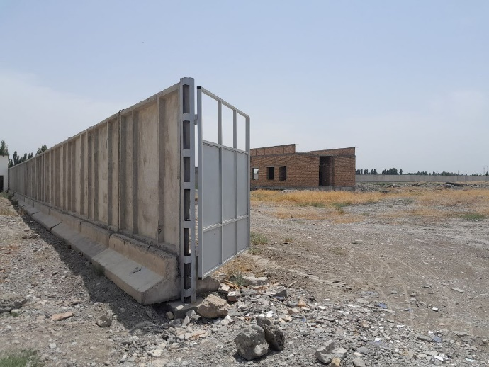 | 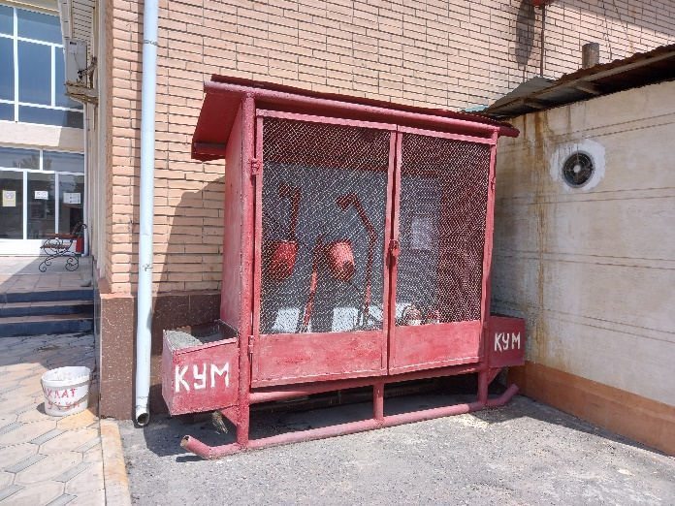
Traction substation «Kokand». Future construction | Duty substation «Furkat». Fire shield
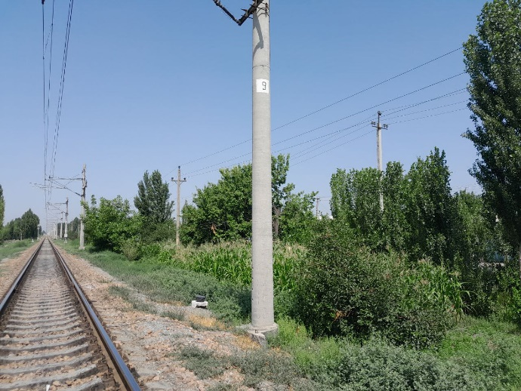 | 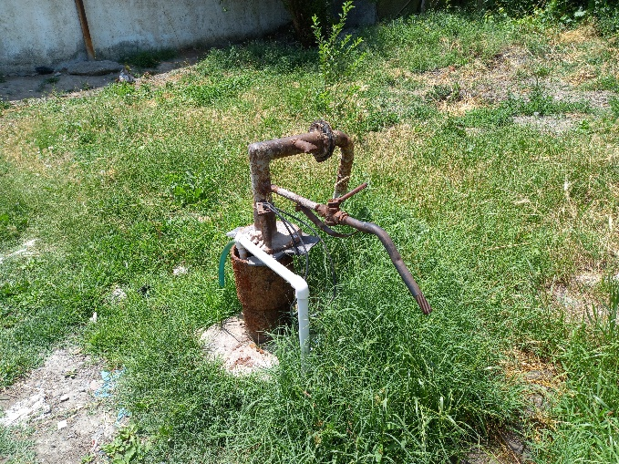
Future Sectioning post «Furkat» | Station «Oltiarik». Water well
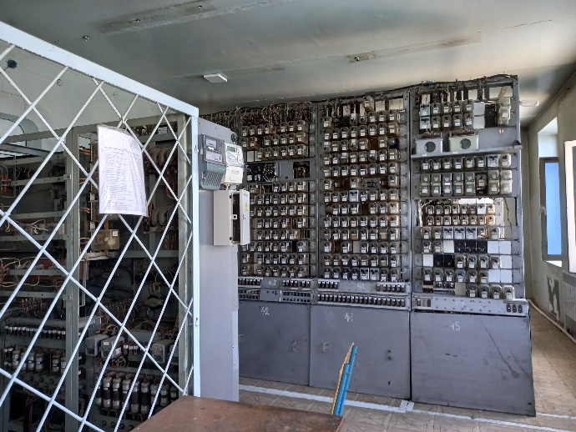 | 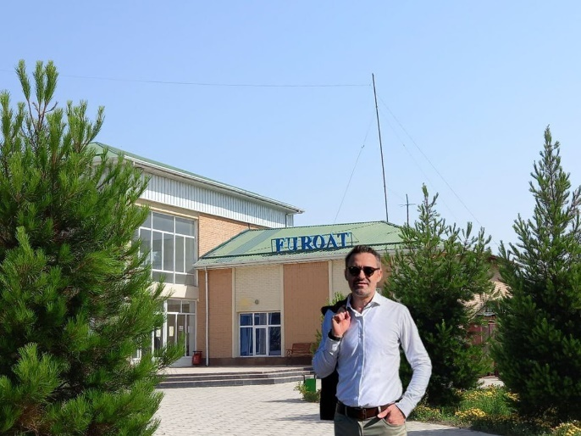
Station «Akhunbabayev». Relay room | Duty substation «Furkat». The international environmental expert Mr. Lasha Nodiya
Figure 5. Objects of visitation
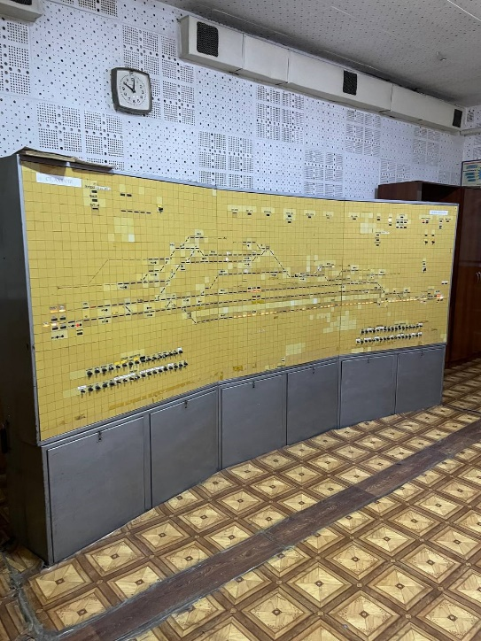 | 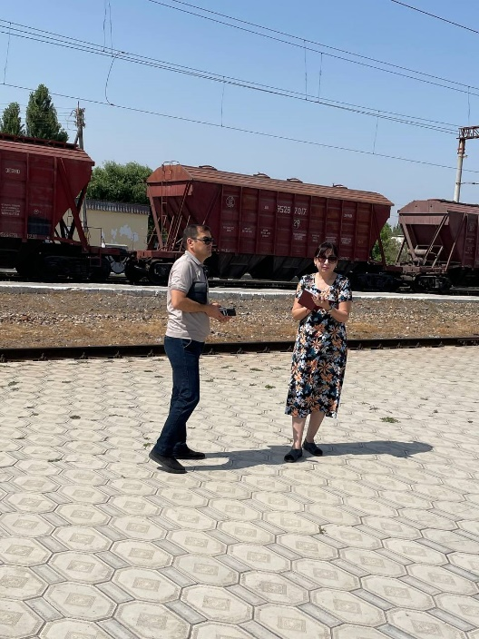
Duty substation «Andijan-1». Control panel | Duty substation «Furkat». The national environmental specialist Mrs. Elnora Sharipova
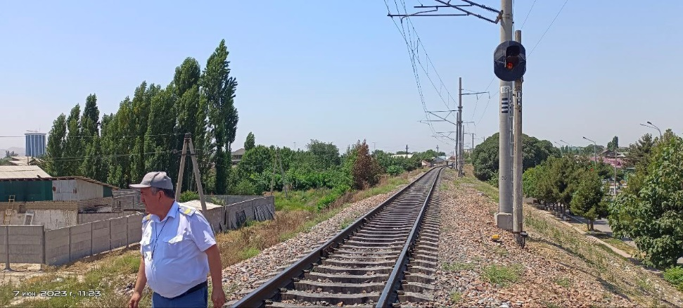
Future sectioning post «Andijan»
Figure 6. Objects of visitation

3.3 Issues Tracking (Based on Non-Conformance Notices)
- No issues were identified yet.
Table 5. Summary of Issues Tracking Activity for Current Period
Summary Table | Number
Total Number of Issues for Project | 0
Number of Open Issues | 0
Number of Closed Issues | 0
Percentage Closed | 0%
Issues Opened This Reporting Period | 0
Issues Closed This Reporting Period | 0

3.4 Trends
- This is the first SAEMR and no trends were monitored for this project.

3.5 Unanticipated Environmental Impacts or Risks
- Unanticipated environmental impacts are not defined yet.

4 STATUS OF COMPLIANCE WITH COVENANTS
- Status of compliance with environmental safeguards related covenants in the Project’s Loan Agreement signed between Republic of Uzbekistan and ADB on 6 August 2021 is summarized in Table 6.
Table 6. Loan Agreement Compliance Status
Schedule | Paragraph | Covenant | Compliance Status
4 | 3 | Terms of Contract award.  The Borrower shall ensure, or cause UTY to ensure that no Works Contracts is awarded which involves environmental impact until:  - the relevant environment authority of the Borrower has granted the final approval of the IEE; and  - UTY has incorporated the relevant provisions from the EMP into the Works contract. | Complied.
4 | 4 | Environment  The Borrower shall ensure, or cause UTY to ensure, that the preparation, design, construction, implementation, operation and decommissioning of the Project and all Project facilities comply with (a) all applicable laws and regulations of the Borrower relating to environment, health and safety; (b) the Environmental Safeguards; and (c) all measures and requirements set forth in the IEE (including, without limitation, the corrective action plans for the Associated Facilities and Existing Facilities) and the EMP, and any corrective or preventative actions set forth in a Safeguards Monitoring Report. | Complied.  In accordance with national regulations, a project cannot start if the feasibility study is not approved by all government bodies associated with the project, including the Ministry of Justice, the Ministry of Construction, the Ministry of Health, the Ministry of Employment and Labor Relations, and the State Committee for the Environment Protection, etc. All these bodies check the compliance of the project with all relevant regulations and approve the feasibility study or issue their comments / notes prior to the issuance of the Presidential Decree on the implementation of the project. All measures and requirements outlined in the IEE and EMP, as well as all corrective or preventive.
4 | 8 | Human and Financial Resources to Implement Safeguards Requirements.  The Borrower shall make available, or cause UTY to make available, the necessary monetary and human resources to fully implement the EMP; the Social Due Diligence Report, including the corrective actions set out in such report. | Complied.  PIU has recruited one environmental and social specialist from UTY (“Uzbekistan Temir yullari”). The environmental specialist is responsible for part of the EMP of all UTY implementing ADB-financed projects. The Supervision Consultant that was hired by PIU includes a one national and one international environmental specialists responsible for environment health and safety compliance, and one national social affairs specialist.
4 | 9 | Safeguards - Related Provisions in Bidding. Documents and Works Contracts.  The Borrower shall ensure, or cause UTY to ensure, that all bidding documents and contracts for Works contain provisions that require contractors to:  - comply with the measures relevant to the contractor set forth in the IEE, the EMP and the Social Due Diligence Report (to the extent they concern impacts on affected people during construction), and any corrective or preventative actions set forth in a Safeguards Monitoring Report;  - make available a budget for all such environmental and social measures;  - provide the Borrower with a written notice of any unanticipated environmental, resettlement or indigenous peoples risks or impacts that arise during construction, implementation or operation of the Project or the Associated Facilities or Existing Facilities that were not considered in the IEE, the EMP, and the Social Due Diligence Report;  - adequately record the condition of roads, agricultural land and other infrastructure prior to starting to transport materials and construction; and  - upon the completion of construction, reinstate pathways and other local infrastructure to at least their pre-project condition, and recultivate agricultural land. | Complied.  - The IEE and EMP are integral parts of all bidding documents and work contracts and are included as annexes to the contracts. Accordingly, contractors must comply with the IEE and EMP requirements unconditionally. All corrective or preventive actions are presented in semi-annual environmental monitoring reports.  - Contractors' budgets partially include necessary IEE and preventive actions. Regardless, contractors must comply with the requirements in accordance with national regulations.  - The borrower will be informed in the event of any unforeseen impacts. Since the continuation of the project is impossible without the Borrower's decision  - Before starting work, the Contractor obtains permits from the State Committee for Highways under the Ministry of Transport with a preliminary selection of road inspectors. Regarding agricultural land and other infrastructure, the district / city governors issue a decision with the permission of land users or landowners  - All permits are issued only on condition of restoration after completion of work.
4 | 10 | Safeguards Monitoring and Reporting.  The Borrower shall do the following, or cause UTY to do the following:  - submit semiannual Safeguards Monitoring Reports to ADB and disclose relevant information from such reports to affected persons promptly upon submission;  - if any unanticipated environmental and/or social risks and impacts arise during construction, implementation or operation of the Project, the Associated Facilities or the Existing Facilities that were not considered in the IEE, the EMP and the Social Due Diligence Report, promptly inform ADB of the occurrence of such risks or impacts, with detailed description of the event and proposed corrective action plan; and  - report any actual or potential breach of compliance with the measures and requirements set forth in the IEE; EMP; the Social Due Diligence Report, including the corrective actions set out in such report, promptly after becoming aware of the breach. | Complied.  The Loan Agreement requires to submit  Safeguards Monitoring Reports, as per IEE, the PIU submits the semiannual reports, as it was also agreed upon during the Missions of ADB on Safeguard Issues.  а) After publication of EMR at ADB web-site reports are translated into Russian and then published on web-site of the Executing Agency. The annual report for 2022 was provided.  Complied.  b) No environmental and/or social risks and impacts occurred between January and June 2023 due to lack of construction.  с) Complied - all actual or potential breach of compliance with the measures and requirements set forth in the IEE; EMP will be immediately reported; the Social and Environmental Due Diligence Report, including the corrective actions set out in such report, promptly after becoming aware of the breach.
4 | 11 | Prohibited List of Investments.  The Borrower shall ensure, and cause UTY to ensure, that no proceeds of the Loan are used to finance any activity included in the list of prohibited investment activities provided in Appendix 5 of the SPS. | Complied - The Loan Proceeds are not used to finance any activities included in the list of the prohibited investment activities, as per the Attachment 5, SPS.
4 | 12 | Labor Standards, Health and Safety.  The Borrower shall ensure, and cause UTY to ensure, that the core labor standards and the Borrower’s applicable laws and regulations are complied with during Project implementation. The Borrower shall cause UTY to include specific provisions in the bidding documents and contracts financed by ADB under the Project requiring that the contractors, among other things: (a) comply with the Borrower’s applicable labor law and regulations and incorporate applicable workplace occupational safety norms; (b) do not use child labor; (c) do not discriminate workers in respect of employment and occupation; (d) do not use forced labor; (e) allow freedom of association and effectively recognize the right to collective bargaining; and (f) disseminate, or engage appropriate service providers to disseminate, information on the risks of sexually transmitted diseases, including HIV/AIDS, to the employees of contractors engaged under the Project and to members of the local communities surrounding the Project area, particularly women. | Complied.  The Project is being implemented in accordance with the main labor standards and the applicable laws and normative acts. The respective provisions are included in the bidding documents and the works contracts.
4 | 13 | The Borrower shall strictly monitor compliance with the requirements set forth in paragraph 12 above and provide ADB with regular reports. | Complied.

5 ReSULTS OF Environmental monitoring

5.1 Overview of Monitoring Conducted during Current Period
- Only design stage in under preparation stage. Thus, monitoring of Environmental indicators were not started yet.

5.2 Air Quality Monitoring
- N/A

5.3 Noise
- N/A

5.4 Vibration
- N/A

5.5 Water quality Monitoring
- N/A

5.6 Topsoil Management and Soil Contamination
- N/A

5.7 Waste Management
- N/A

5.7.1 Non-hazardous Waste
- N/A

5.7.2 Hazardous Waste
- N/A

5.8 Construction Camp Conditions and Facilities for Workers
- N/A

5.8.1 Storage of construction materials on site
- N/A

5.8.2 Refueling station N/A
- N/A

5.9 Health and Safety
- N/A

5.9.1 Community Health and Safety
- N/A

5.10 Material Resources Utilization
- N/A

5.11 Covid-19 activities
- N/A

5.12 Track Record System and Complaints
- GRM was developed during the drafting phase. UTY has established a grievance mechanism under the current project, and this will be expanded to cover components with additional funding. There is a two-tiered complaints mechanism, namely: (i) Level 1: any railway station, and (ii) Level 2: UTY secretariat in Tashkent. As a third mechanism, affected persons can apply to any court of due jurisdiction at any stage of the complaint. PIU-ET guarantees that grievances and complaints at any stage of the project will be dealt with in a timely manner and resolved satisfactorily through GRM. UTY ensures that the needs of vulnerable and disadvantaged groups are given special attention throughout the project. There will be no obstacles to judicial or administrative permits in the country. UTY and its PIU-ET will keep a record of complaints received during the project, which will be taken over and presented during regular ADB observation missions during public consultations. All information on GRM will be disseminated by means of an information leaflet/brochure. Leaflets/brochures will be produced in the local language.

5.13 Trainings
- The ADB provided specialized training on social protection and environmental protection to the railway sector from 12 to 13 June 2023. The purpose of this training was to increase the capacity of UTY employees to prepare and implement social and environmental protection measures within the framework of the project funded by ADB. Environmental specialist with PIU-ET UTY assisted in the collection of 10 participants from regional and local units of UTY. After the training, participants were presented with prizes and handouts for further use in the process. List of Participants: PIU-ET - Khujayarov B., Khojamyarova G., Melnikova E., Abdugafarova D. From Safety Management - Gayfullina E. From Directorate of Capital Construction – Boltaboyev A., Isroilov Z., Khakimjanov S. From Tashkent regional railway hub - Vakhobov A. From Kokand regional railway hub - Meliboyev R.

5.14 Environmental Management Plan Implementation
- Status of compliance with environmental management plan (EMP) which was approved under the project IEE on June 2023 is presented in the Table 7 below.

Table 7. Implementation Status of EMP
Subject | EMP Requirement | Compliance Attained (yes/no) |  | Comment on Reasons for Partial or Non-Compliance | Required Action and Target Dates to Achieve Compliance
 |  | JSC “Uzelektroapparat- Electroshield” | LLPC  "Temirzhol Zhondeu”
Pre-construction period
Generation of different potential environmental impacts due to changes in design, layout | - Update or new IEE to be prepared with full compliance of ADB SPS (2009). | yes | yes | Design is under process, not any difference between design and IEE yet. Thus, update or new IEE is not required.
Lack of proper environmental requirements | - Ensure that environmental provision along with EMP are included in the bidding documents and in contracts for Contractors;  - Bids evaluation needs to be done with consideration of: capacity of bidders to meet EMPs requirements, proposing adequate budget efficient for Implementation EMP, existence of good practice in environmental performance within other similar projects;  - Within 30 days after contract award and prior to commencing any physical works, Site-specific Environmental Management plans (SSEMPs) will be developed by the Contractors under the guidance of the PMC, and be endorsed by PMC before submission to PIU-ET for approval. | yes | yes | -
Using of unauthorized borrow pits | - Selected contractor needs to identify location of closest authorized borrow pits and conclude agreements on inert material supply with relevant agencies (State Committee on geology and mineral resources, Sanitarian Epidemiological Station). | yes | yes | -
Non-compliance of purchased machinery with national requirements for equipment and machinery | - Ensure that procured machinery complies with Euro-3 standards for emissions. | yes | yes | -
Non-compliance of goads procurement procedure with ADB SPS (2009) | - Ensure that procurements of goods within the project will be done In compliance with ADB Prohibited Investment Activities List set forth at Appendix 5 of the Safeguard Policy Statement (2009). | yes | yes | -
Improper SEMP and SSEMP development | - Within 30 days after contract award and prior to commencing any physical works, Siie-specifio Environmental Management plans (SSEMPs) will be developed by the Contractors under the guidance of the PMC, and be endorsed by PMC before submission to PCU for approval; In addition to SSEPMs, Topic Specific SEMPs need to be prepared by Contractors, endorsed by PMC and approved by PCU for the following activities: Traffic Management Plan for construction of distribution network within settlements. Waste management Plan for sites with demolishing works. Hazardous Wastes Management Plans ss described in the next sub-sections, Construction Camps Management Plan and Occupational Health and Safety Plan (OHS Plan); | at the development stage | yes | - | The contractor prepared the SSEMP plan, the Project Management Consultant reviewed, commented and edited them. Documents have now been approved and a final version has been prepared. The document covers the following:  - Topsoil conservation. Monitoring: inspections: observations after the site is prepared. after the materials have been stored and after the project works have been completed.  - Construction site and towns of workers. Monitoring: quarterly in the construction phase.  - Maintenance and refuelling of equipment. Monitoring: Surprise inspections during construction.  - Workers' health and safety. Monitoring: inspections during construction in case of complaints.  - Surface water protection. Monitoring: surprise inspections during work near water bodies.  - Tree protection. Monitoring: After the start of construction work on the respective site.
Construction period
Implementation is at the design stage.

6 Functioning of THE SSEMP

6.1 SSEMP Review
- The SSEMP is under development JSC "Uzelektroapparat- Electroshield", namely: the primary version was presented and the revision was carried out. Adjustments are being introduced. The SSEMP of LLPC "Temirzhol Zhondeu" was developed and approved. The main objective of the SSEMP is to ensure appropriate mitigation of various adverse impacts associated with the project. The objectives of the EMP at different stages of project planning and execution are as follows:
Phase of construction and installation works:
-Prevent and reduce negative environmental impacts of the project by implementing mitigation measures;
-Ensure that the SSEMP instructions are strictly adhered to and implemented;
-Establish the roles and responsibilities of all parties involved in the environmental management project;
-Ensure implementation of recommended actions aimed at enhanced environmental management.
Operation stage:
-Provide protection of environmental components – air, water, soil, noise, etc.

7 Good practice and opportunity for improvement

7.1 Good Practice
- At the design stage.

7.2 Opportunity for Improvement
- The project does not need improvement at this stage.

8 Summary and recommendations

8.1 Summary
- At the design stage. Environmental control is not required.
- At this stage, the following should be noted: (i) PIU has one environmental and social specialist, (ii) Consultant recruits national experts, one on environmental protection and one on social issues, and one international environmental expert, (iii) the SSEMP is under development JSC "Uzelektroapparat- Electroshield", namely: the primary version was presented and the revision was carried out. Adjustments are being introduced. The SSEMP of LLPC "Temirzhol Zhondeu" was developed and approved, (iv) Compliance with SSEMP requirements will be monitored as the field commences, (v) Environmental and plant protection training will be provided to construction and installation staff as the field commences.

8.2 Recommendations
- At the design stage.
- It is recommended monitoring of compliance with the requirements for the protection of the surrounding environment of ADB and the legislation of Republic of Uzbekistan according to the Law on Environmental Control of Republic of Uzbekistan during the further implementation of the project.

Annex 1. COnclusion of Environmental Expertise (OVOS)

Currency exchange of the Central Bank of Uzbekistan. https://cbu.uz/uz/arkhiv-kursov-valyut
The plot involved in the project is highlighted in red.
PAM of the project: https://www.adb.org/projects/documents/uzb-48025-004-pam
Loan Agreement: https://www.adb.org/projects/documents/uzb-48025-004-lna
Initial Environmental Examination: https://www.adb.org/projects/documents/uzb-48025-004-iee

