Semi-annual Environmental Monitoring Report



3 Semi-Annual Report
Reporting Period: January - June 2024
Project Number: 53271
Date: July 2024
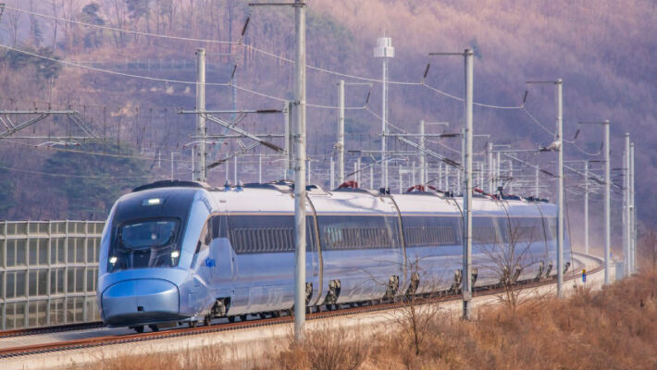
Uzbekistan: Project of the electrification of the railway line (Bukhara-Urgench-Khiva) running along the corridor within the framework of the 2nd Central Asian Regional Economic Cooperation

Loan No. 4170-UZB
(Financed by the Asian Development Bank, Asian Infrastructure Investment Bank)

Tashkent 2024
Prepared by: National Environmental Consultant of the Consulting Company DB Engineering & Consulting GmbH (hereinafter referred to as DB E&C) for JSC ‘O’zbekiston Temir Yo’llari’ and the Asian Development Bank.

This semi-annual environmental monitoring report is a document of the borrower. The views expressed herein do not necessarily reflect the views of ADB's Board of Directors, management, or staff and may be preliminary.
In preparing any country program or strategy, financing any project, or in the designation or reference to a particular territory or geographic area in this document, the Asian Development Bank does not intend to make any judgments regarding the legal or other status of any territory or locality.
CURRENCY EQUIVALENTS
(As of June 31, 2024)
 | Currency Unit – ($)
UZS | 1.00 “=“ 0,000080 | US dollars
$1.00 | "=" | UZS 12 575.00

ABBREVIATIONS
ADB  AIIB  BMUK | -  - | Asian Development Bank  Asian Infrastructure Investment Bank  Bukhara-Miskin-Urgench-Khiva
CAP | - | Corrective Action Plan
СМ | - | Cabinet of Ministers
PMC | - | Project Management Consultant
EHS | - | Environmental, Health and Safety Guidelines
EMP  SSEMP | -  - | Environmental Management Plan  Site-specific environmental management plan
EMR | - | Environmental Monitoring Report
GRM | - | Grievance Redress Mechanism
HH  PEA | -  - | Household  Preliminary Environment Assessment
IEE | - | Initial Environmental Expertise
IFC | - | International Finance Corporation
PIU | - | Project Implementation Unit
ТS | - | Technical support
UTY  PPE  Мinecology  EIA  EIS  SES  SPZ  PMT of "Centre of State Ecological Expertise"  PBD | -  -  -  -  -  -  -  -  - | O’zbekiston Temir Yo’llari  Personal protective equipment  Ministry of Ecology, Environmental Protection and Climate Change of the Republic of Uzbekistan  National abbreviation for Environmental Impact Assessment Process  National abbreviation for Environmental Impact Statement  Sanitary and Epidemiological Service  Sanitary protection zone  A government agency under the Ministry of Ecology responsible for conducting state environmental assessments  Path Blocking Device (PBD)
ТSS | - | Тraction Substation
SCADA | - | supervisory control and data acquisition system
MSW  MPC  RRJ | -  -  - | Municipal solid waste  Maximum permissible concentrations  Regional Railway Junction
NOTE
In this report, “$” refers to U.S. dollars unless otherwise noted
Table of contents
1 INTRODUCTION 6
1.1 Preamble 6
1.2 General Information 6
2 DESCRIPTIONS OF THE PROJECT AND EXISTING SITUATION 7
2.1 Description of the project 7
2.2 Project contracts and management 15
2.3 Project activities for the current reporting period 18
2.4 Description of any changes in the design of the project 24
2.5 Description of any changes to agreed construction practices 30
3 ENVIRONMENTAL PROTECTIVE MEASURES 31
3.1 General description of environmental protection measures 31
3.2 Аudit of objects 31
3.3 Summary of the results of the inspection of construction sites: Ошибка! Закладка не определена.
3.4 Issue tracking (based on non-compliance notifications) 44
3.5 Тrends 52
3.6 Unintended environmental impacts or risks 52
4 COMPLIANCE STATUS 53
5 ENVIRONMENTAL MONITORING RESULTS 57
5.1 Overview of monitoring carried out during the current period. 57
5.2 Air quality monitoring 57
5.3 Noise.................................................................................................58
5.4 Vibration 58
5.5 Water quality monitoring 58
5.6 Topsoil management and soil pollution 58
5.7 Waste generation 58
5.8 Non-hazardous waste 58
5.9 Hazardous waste 59
5.10 The conditions of the construction camp for workers 59
5.11 Storage of building materials on site 59
5.12 Refuelling station N/A 60
5.13 Health and safety 60
5.14 Health and safety of population 60
5.15 Covid-19 activites 60
5.16 Grievance Redress Mechanism 60
5.17 Trainings 60
5.18 Implementation of the environmental management plan 61
6 FUNCTIONING OF SSEMP 77
6.1 Review of SSEMP 77
7 GOOD PRACTICE AND OPPORTUNITY FOR IMPROVEMENT 78
7.1 Good practice 78
7.2 Opportunity for improvement 78
8 SUMMARY AND RECOMMENDATIONS 79
8.1 Summary 79
8.2 Recommendations 78
Appendix 1. Environmental Assessment Report
Appendix 2 Environmental Expertise Report and EIA Draft
Appendix 3. ACT of JSC Boshtransloyiha
Appendix 4 ADB Mission
Appendix 5 Agreement For Waste Disposal
Appendix 6 Тraining
Appendix 7 - Letter - Appeal To the PIU on Hiring an Ornithologist Specialist
Appendix 8 - Inspection Questionnaire
Appendix 9 - Report on the Status of the Implementation of the SSEMP
Appendix 10 - Health and Safety, Occupational Safety

INTRODUCTION

Preamble
- This report is the third Semi-Annual Environmental Monitoring Report (SAEMR) for L4170-UZB - Central Asia Regional Economic Cooperation Corridor 2 - Bukhara-Urgench-Khiva Railway Electrification Project (CAREC Corridor 2). This report has been prepared and covers the period from January to June 2024 and provides information on the implementation status of the CAREC Corridor 2. Construction works have commenced since April 2024.

General Information
- According to ADB's Safeguard Policy (2009), the project is classified as Category B, as a project with site-specific impacts, some of which are irreversible, and where mitigation measures can be developed in most cases. The project's preliminary environmental assessment was approved in October 2021.

- In accordance with national requirements for environmental categorization, the project is classified as Category II- a project with a moderate impact on the environment. The National Design Institute "Boshtransloyiha" carried out an environmental impact assessment (EIA) - prepared a Draft Environmental Impact Statement (EIS) for the facility: "Construction of external power supply facilities for the project "Electrification of the Bukhara-Urgench-Khiva railway line 110 and 220 kV overhead lines" and submitted it for state environmental expertise to the State Committee for Ecology and Environmental Protection of Uzbekistan² in July 2021. Following the review of the above-mentioned EIS Project, a positive conclusion was received from the State Ecological Expertise No. 04-01/10-08-1478 dated August 30, 2021 (Appendix 1).
Due to the fact that design changes occurred in March 2024, a repeated EIA was carried out for the project "Electrification of the Bukhara-Urgench-Khiva and Misken-Nukus railway line" and a positive conclusion was received from the state environmental expertise of the Ministry of Ecology of the Republic of Uzbekistan No. 01-02 / 01-389 dated 20.03.2024. (see Appendix 2).

- The expected environmental impact is considered at three stages: preparation for construction, construction and operation. At the construction stage, it is important to obtain the necessary permits and approvals from authorized government agencies. At the construction stage, the main impacts are related to the formation of construction, solid and liquid waste, air pollution, increased noise levels, vibration, the area of ​​the construction camp, disturbance of the soil cover, health, and safety of the population, etc. At the operation stage, the noise levels generated by the railway and affecting buildings and premises are determined. But all these impacts can be mitigated by fulfilling the requirements of the Environmental Management Plan (EMP), a contractual document between the Customer and the Contractor.

- All construction materials for the construction of the contact network and the TSS will be delivered by the existing railway. For the modernization of the depot "Bukhara" - "Urgench", the railway and existing roads will be used as access roads, the construction of new roads is not required.

DESCRIPTIONS OF THE PROJECT AND EXISTING SITUATION

Description of the project
- The project will electrify and modernize the 465 km long Bukhara-Urgench-Khiva railway line, which was put into operation in December 2017 and is currently used for low-speed diesel trains. (see Fig.1).
- The line has an estimated speed of 250 km/h and connects to the existing electrified high-speed railway line Tashkent-Samarkand-Bukhara. Basically, the route passes through the desert regions of Bukhara and Khorezm regions and the Republic of Karakalpakstan, and about 30% passes through agricultural land and settlements. Between the cities of Bukhara and Khiva there are ten railway stations, most of which have already been built or reconstructed. The route also has five junctions. Signalling, communications, and SCADA systems will also be installed at all stations and junctions.
- The project will radically change the economic geography of the Khorezm region, reduce the time distance to other urbanized regions of Uzbekistan. High-speed trains will reduce the travel time between Bukhara and Khiva to 3.0 hours compared to the current 8.0 hours. The total travel time from Tashkent to Khiva will be approximately 7.0 hours. The annual passenger traffic on the Bukhara-Khiva line is expected to increase from the current 149,500 passengers per year in 2021 to 1,410,000 passengers in 2026.
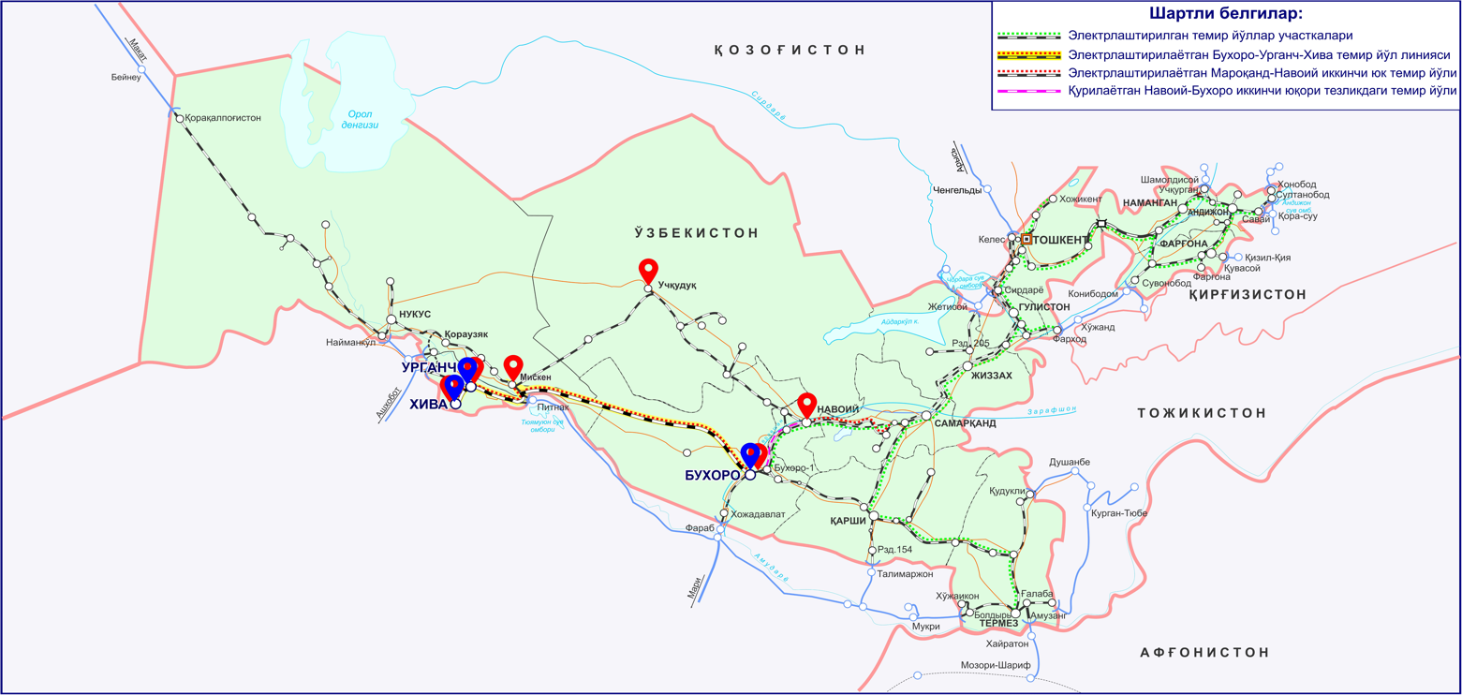

Figure 1. Project location and route
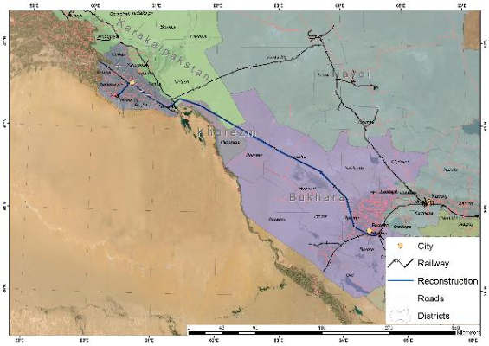
Figure 2. Scheme of the Project railway section.

- Result 1: modernization of the railway infrastructure along and adjacent to the Bukhara-Urgench-Khiva line. This includes (i) construction of 8 TSS, (ii) construction of 8 sectioning posts, (iii) supply and installation of contact network systems, (iv) supply and installation of signalling, communication, and supervisory control and data acquisition (SCADA) systems, (v) construction of external power supply, (vi) purchase of equipment and machinery for maintenance, and (vii) purchase of specialized wires for contact network, (viii) 44 level crossings with road blocking devices (RBD) (see Fig. 2). In addition, minor upgrades will be made to the electrification infrastructure on the adjacent lines from Bukhara to Tashkent and from Samarkand to the border with Afghanistan. These upgrades, while minor in scope and cost, will allow UTY's electrified network to continue to operate reliably and prepare the network for the expected growth in traffic. The infrastructure incorporates the latest technological advances to ensure efficiency and reliability.
Result 2: Development of the tourist corridor Bukhara-Urgench-Khiva. The railway line will connect the main tourist destinations of Uzbekistan through the services of a high-speed train (up to 250 km/h), which will allow traveling between Bukhara and Khiva in 2-2.5 hours, compared to a car trip, which will take about 6 hours). The project will provide travellers with the opportunity to visit the main tourist attractions of Uzbekistan comfortably in a short time, avoiding the need to make short flights. Passenger traffic will open the country, expanding the corridor of economic development in western Uzbekistan. To support the development of such an economic corridor, the project provides support for the following activities:
- Railway marketing coupled with Uzbekistan's broader tourist attraction efforts.
- Support for municipalities along the railway corridor with the development of transit-oriented developments around stations.
- Support to municipalities along the railway corridor with a sustainable tourism development plan; special attention will be paid to promoting the sustainability of new tourist sites and ecotourism,
- Implementation of an (online) ticketing system to make it easier for tourists and internal passengers to book tickets. A unified "Uzbekistan Rail Pass" could be introduced that would allow visitors to take advantage of unlimited train travel for a fixed fee to visit Tashkent, Samarkand, Bukhara and Khiva.
- Support for increased participation of women in new tourism-related economic activities.
- The TSS will be connected to existing and newly constructed electrical substations (SS) via constructed high-voltage lines (HVL) of 110 and 220 kV. The total length of the HVL under construction is about 482.9 km.
- It is planned to build the following TSS (see Fig.3):

1. ТSS 110/27,5/10kV at station Bukhara. Coordinates - 39°42'24.385"N.SH. 64°31'36.17"EВ
(coordinates have been changed due to design decisions being changed, see Chapter 2.4 “Description of any changes in the project design”)
2. ТSS 110 / 27,5 / kV at loop Navbakhor (Маshak) Coordinates - 40°05'26.50"С 64°05'33.80"В.
3. ТSS 110 / 27,5 / 10kV at loop Parvoz Coordinates - 40°30'32.00"С 63°37'20.71"В
4. ТSS 110 / 27,5 / 10kV at loop Kiyikli (Аlabuga) Coordinates - 40 ° 47.748'NС 62 ° 53.260'EВ
5. ТSS 220 / 27,5 / 10kV at loop Jayhun (loop Jakasay) Coordinates - 41 ° 4.631'NС 62 ° 13.940'EВ
6. ТSS 220 / 27,5 / 10kV at loop Тuron (Аkchuka) Coordinates - 41 ° 20.317'NС 61 ° 31.756'EВ
7. ТSS 110 / 27,5 / 10kV at station Khazarasp Coordinates - N41 ° 33035267 °E61.03372867 (coordinates have been changed due to design decisions being changed, see Chapter 2.4 “Description of any changes in the project design”)

8. ТSS110 / 27,5 / 10kV at station Urgench Coordinates - 41°31'49.35"С 60°39'53.06"В (coordinates have been changed due to design decisions being changed, see Chapter 2.4 “Description of any changes in the project design”)

- Five of the eight TSSs will be located in desert and semi-desert areas: Turon, Jakasay, Kiyikli, Parvoz and Navbakhor. Two TSSs will be located near populated areas: Khazarasp and Urgench.

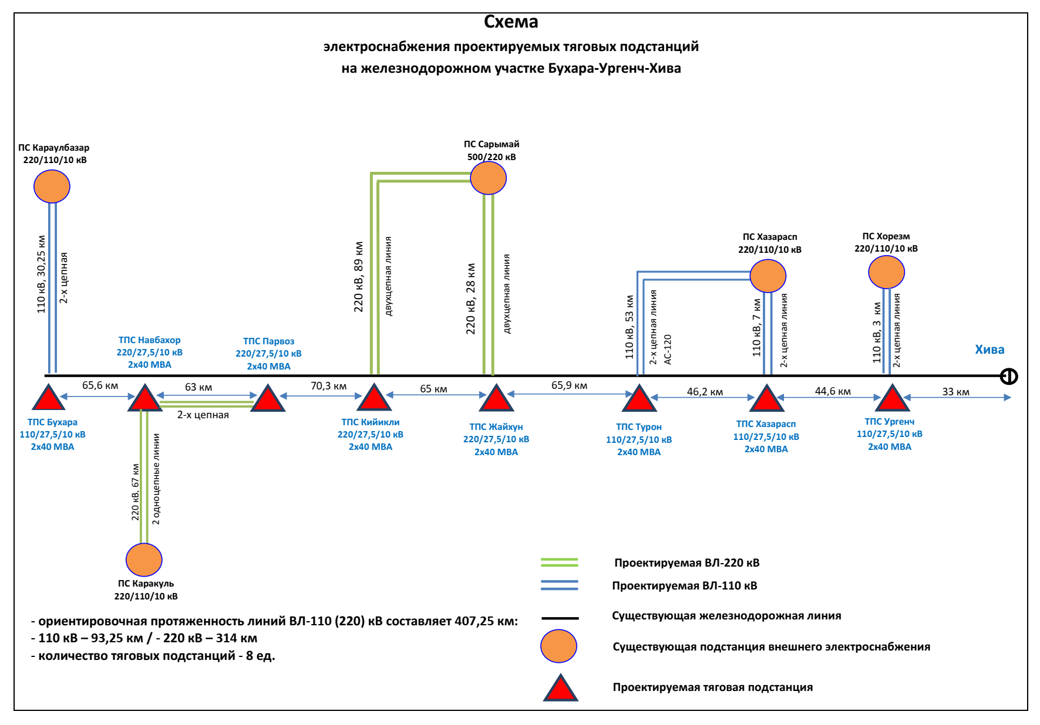
Fig 3. SCHEME of the location of the main objects (8 TSS) of the Bukhara-Urgench-Khiva railway line electrification project
- Improving the links between these major tourist destinations (Bukhara, Urgench, Khiva) will significantly enhance the attractiveness of Uzbekistan as a unique tourist destination. The project will stimulate the growth of this important economic corridor by supporting sustainable tourism and transit-oriented development, thereby supporting the recovery of the tourism industry from the impacts of the coronavirus (COVID-19) pandemic and empowering women to actively participate in rail transport and tourism. The project thus supports both the government's overall strategy for economic diversification and, in particular, the development of the tourism sector of Bukhara, Khorezm and the Republic of Karakalpakstan, as well as the strategy for achieving gender equality in the Republic of Uzbekistan until 2030. (see Fig. 4 and 5).

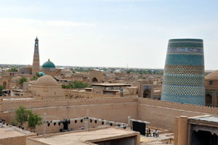 | 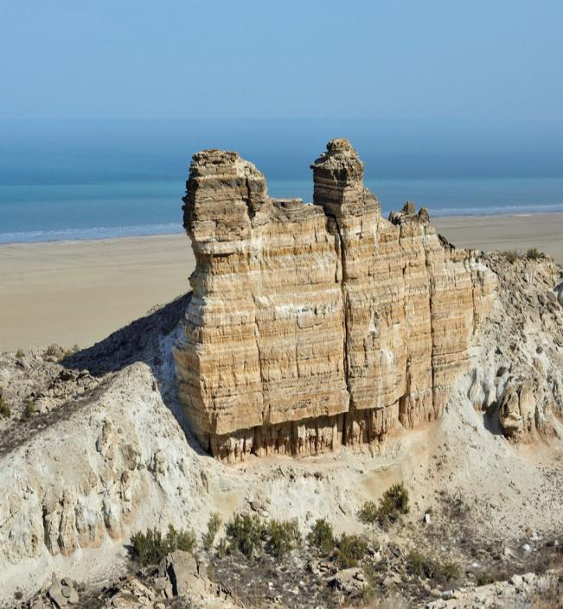
Fig. 4 Increasing the tourism potential of Khorezm and the Republic of Karakalpakstan


Fig. 5 Role of women in railway transport

- The project is being implemented based on the following resolutions:

  - Decree of the President of the Republic of Uzbekistan dated March 6, 2015, No. PP-2313 “On the Program for the Development and Modernization of Engineering, Communications and Road Transport Infrastructure for 2015-2019”;
  - Decree of the President of the Republic of Uzbekistan No. PP-72 of December 30, 2021. "On approval of the Investment Program of the Republic of Uzbekistan for 2022-2026 and the introduction of new approaches and mechanisms for managing investment projects";
  - Decree of the President of the Republic of Uzbekistan No. PP-2827 dated March 13, 2017 “On measures for the construction of the Bukhara-Miskin railway line”;
  - Decree of the President of the Republic of Uzbekistan No. 5 dated 16.01.2023. "On measures to implement the Bukhara-Urgench-Khiva and Miskin-Nukus Railway Electrification Project together with ADB and AIIB banks.
- Institutional scheme. UTY, the executing agency (EA), has adequate staff, a track record of successful implementation of similar projects, and operation and maintenance of both electrified and non-electrified lines. The implementation mechanisms are based on the successful experience of implementing ADB railway projects in the country. On May 1, 2011, the Department for the Implementation of Electrification Projects (PIU) was established at UTY, which began to function in full in accordance with UTY's internal order No. 163 dated March 16, 2012. On December 6, 2018, based on the order of the First Deputy Chairman of the Board of UTY No. 2188-N, PIU merged with another PIU that had previously implemented projects for the purchase of rolling stock. PIU was renamed into Project Implementation Unit for Electrification and Renewal of Rolling Stock (PIU).
- Project Implementation Unit for Electrification and Renewal of Rolling Stock (ERP-ET), established by UTY, has experience with ADB procedures and policies and will be responsible for project implementation. UTY's technical departments will also assist the PIU during project implementation. UTY will work in collaboration with National Electric Networks of Uzbekistan JSC (NENUz) and Regional Electric Networks (REN), which are energy companies responsible for supplying electricity from generating sources to consumers.
- The PIU consists of 22 employees, including the head, two deputy heads, senior legal adviser, administrator, head of the technical department, three signalling and telecommunications specialists, three electrical supply specialists, one locomotive specialist, one environmental protection specialist, head of the finance department, one accountant, one economist, one head of the monitoring and procurement department and two procurement specialists. PIU employees have experience in implementing projects financed by international financial institutions, including those financed by ADB. International and national experts are involved as consultants on engineering and construction supervision. The terms of the contract include design and construction work, so the role of engineering and construction supervision consultants is to manage contracts with PIU and provide hands-on training in procurement, project management and supervision, operation and maintenance, and reporting.
- International and national experts are involved as consultants on engineering and construction supervision. The terms of the contract include design and construction work; therefore, the role of engineering and construction supervision consultants is to manage contracts with PIU and provide hands-on training in procurement, project management and supervision, operation and maintenance, and reporting.
- The institutional schedule of the PIU and IA is shown in Figures 6 and 7 below:


ADB
Ministry of Finance
UTY
(
Executing Agency)
Project Implementation Unit for Electrification and
Renewal of Rolling Stock
Project
Agreements
Memorandum of
Understanding
Uzbekenergo,
subsequently JSC
“National Electric
Networks of Uzbekistan”

PIU
-

Team

•
Head (1)
•
Deputy heads (3)
•
Clerk (1)
•
Head of Technical Department (1)
•
Signaling and telecommunications
specialists (2)
•
Power supply specialists (2)
•
Head of locomotive procurement (1)
•
Locomotive specialists (2)
•
Locomotive specialist (2)
•
Environmental protection specialist (1)
•
Head of financial department (1)
•
Accountant (1)
•
Economist (1)
•
Head of monitoring and procurement
department (1)
•
Procurement specialists (3)

Loan Agreements
Relending Agreements
Engineering and
Construction Supervision
Consultants for Additional
Financing
Goods contractors for
maintenance machinery.
plant contractors for
signaling and
telecommunications,
traction substations,
video surveillance
system, and CTC
upgrade

Fig. 6 Institutional scheme
Fig. 7 Organizational structure of PIU
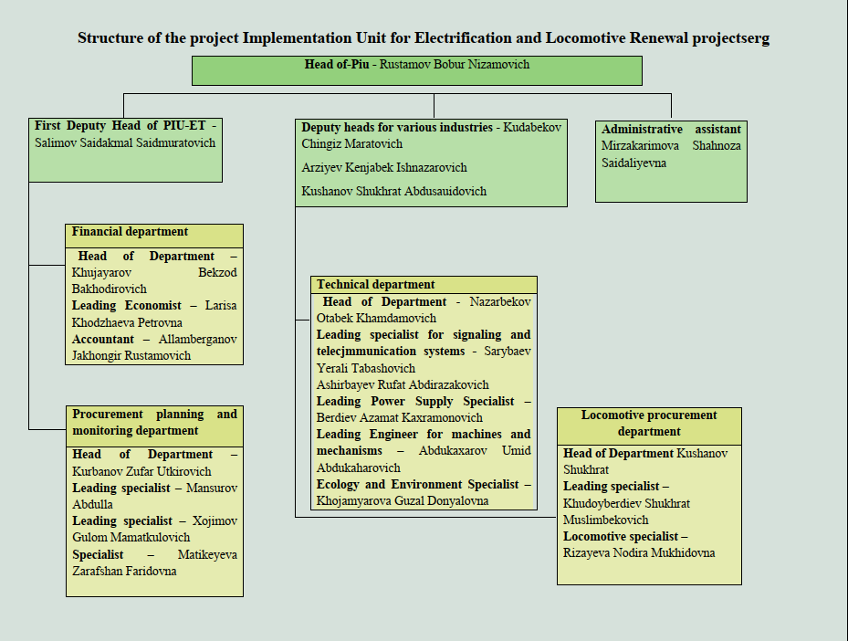

Project contracts and management
- The project is jointly financed by a loan from ADB and AIIB. The executing agency is PIU and the executor is UTY. The consulting company DB Engineering & Consulting GmbH (hereinafter referred to as PE DB E&C) has been hired to provide project supervision consulting (PSC).
- The task of the services is to provide support to UTY at several stages of project implementation: development of tender documentation; support during the bidding process; viewing drawings developed by UTY and/or contractors; supervision and control of construction works, technical, commercial, and timely implementation of projects; interface management; supervision of construction; claims management.
- In addition, the Consulting Company conducts training for UTY personnel after the implementation of the upgraded train control and management system.
- During the procurement stage, the Consulting Company will support the preparation of technical specifications and bidding documents in accordance with the Open Competitive Bidding (OCB) procedures, in accordance with the ADB Procurement Policy and Procurement Standards and taking into account the package of contracts based on the Procurement Plan approved by ADB. In the course of this task, the Consulting Company provides continuous assistance to the PIU in the overall procurement process by attending all meetings with contractors and contract negotiations.
- During supervision of construction works, the Consulting Company will monitor the execution of works, checking the work of Contractors to ensure that the project is implemented on schedule, on budget, and on quality and safety requirements, including environmental requirements, in accordance with ADB safeguards requirements and national laws, whichever is more stringent. ADB's safeguards policy framework consists of three separate operational strategies: (i) environmental protection, (ii) indigenous peoples, and (iii) involuntary resettlement.
- The International and National Environmental Consultants will carry out the tasks assigned by the Team Leader and assist the PIU, particularly its Environmental Specialist. The International Consultant will endorse the Contractors’ Site-Specific EMP before submitting them to the PIU for approval prior to the commencement of physical works. The National Environmental Consultant will (i) monitor the Contractors’ compliance with the mitigation measures in accordance with the Contractors’ EMPs for both ADB and UTY financed activities throughout the activities and report the results to the Team Leader, PIU, staff and ADB in writing; (ii) prepare the Environment, Health and Safety (EHS) section of the monthly and quarterly project progress reports; (iii) assist PIU in updating the IEE/ESMPs as necessary; (iv) assist PIU in preparing semi-annual environmental monitoring reports in accordance with ADB requirements; and (v) conduct a short training programme on EHS section for the PIU staff and the Contractors' environmental specialists.
The Contractors' contracts have entered into force, namely:
- JSC ‘O’zelectroapparat-Electroshield’ (Uzbekistan) contract BX-01-1 – Installation, design, supply, installation for the infrastructure of new traction substations and sectioning posts.
- Consortium JSC ‘Tojikhydroelectromontaj’ - JSC ‘O’zqishloqelektrqurilish’ (Tajikistan) contract BX-01-2 – Installation, design, supply, installation of external power supply
- In these organizations, senior managers or designated professionals are responsible for ensuring that the project is completed on time and within budget.
- The key organisations involved in the project, and the managers and key personnel within these organisations who are responsible for monitoring the implementation and enforcement of safeguards, are presented in Table 1 below.

Таble 1. Personnel involved in the implementation of environmental protection measures

Type of project participant | Agency/company name | Position | Name | Contact phone/Email
Executive agency | JSC «UTY» | Head | Rustamov Bobur Nizamovich | utypiu@gmail.com
 |  | Environmental Protection Specialist | Khodjamjarova Guzal | +998 99 877 22 10  guzal7123@gmail.com
Project Supervision Consultant | PE DB E&C | International Environmental Consultant | Syed Muhammad Latif | +8801715004452  latifsyed_ny@yahoo.com
 |  | National Environmental Consultant | Bekmirzaeva Karina Melisovna | +998 90 1689997  bekmirzaeva_k@mail.ru
Contractor | JSC "O’zelectroapparat-Electroshield" | Deputy CEO | Shukurov Sherzod Bakhodirovich | +998 93 380 99 60  Kudrat.KHoshimov@uzea.uz  bahramov.57@mail.ru
 |  | Мanager | Khashimov Kudrat
 |  | Social and Environmental Specialist | Bakhramov Rakhimjon
Contractor | JSC «Tojikhydroelectromontaj»- JSC «O’zqish loqelectrqurilish» | Deputy CEO | Muhammadiev Tulkin Rakhmatjonovich | +998944116114  ikmoliddini.inomuddin@tgem.tj,
 |  | Manager | Ikmoliddini Inomiddin
 |  | Social and Environmental Specialist | Yusupov Behzod

- A summary of the civil works contracts and progress is presented in Table 2. The awarded contract included the ADB-approved ESMPs and any applicable national EIA/IEE approval conditions.
Таble 2. Summary of upcoming civil works contracts and progress work
Package | Contractor | Scope | Contract signing | Date of approval |  |  | Name of personnel |  | Construction works |  |  | Progress as of (%)
 |  |  |  | SSEMP | HSMP | ERP | Environmental Specialist | Health and Safety Officer | Start | End | DLP | 1st January, 2024 | 31st July, 2024
ВХ-01-1 | JSC "O’zelectroapparat-Electroshield" | Design, supply, installation and commissioning of TSS and SP | 07.11.2023г | July 2024 | July 2024 | July 2024 | Bakhramov Rakhimjon | Bakhramov Rakhimjon | Аpril 2024 | 2026 | - | 10 | 40-
ВХ-01-2 | JSC «Tojikhydroelectromontaj»- JSC «O’zqishloqelektrqurilish» | It is planned to design, supply, install: overhead power lines, signalling systems, communications and installation of SCADA systems | 04.01.2024 | June 2024 | June 2024 | June 2024 | Yusupov Behzod | Yusupov Behzod | April 2024 | 2026 | - | 10 | 40

Note:
SSEMP = site-specific environmental management plan,
HSMP = health and safety management plan,
ERP = emergency response plan,
DLP = defect liability period.

Project activities for the current reporting period
- During the reporting period from January to March of this year, construction work was not carried out in the project areas, and environmental monitoring of construction indicators was not carried out.
- Since April 2024, the development of detailed design solutions for the main equipment and phased construction of 6 priority facilities has begun: TSS Bukhara, TSS Parvoz, TSS Turon, TSS Jayhun, TSS Urgench, TSS Navbakhor, as well as Overhead Lines.
- For the purpose of constructing traction substations (TSS), the territory allocated for TSS is used as construction camps and storage areas. No additional areas are required. The sites where the construction camps are located are covered with gravel for the convenience of the working personnel. Workers and construction materials for the construction of the contact network are placed on the territory of existing facilities (railway stations) of UTY. The option of resettling workers in populated areas located near the TSS and the external power supply line is also being considered.
- Construction work was carried out related to the removal of the fertile layer and the excavation and backfilling of soil, the planning of territories, the preparation of the bases of the oil collector and the laying of foundations for the TSS equipment. Excavation work is carried out using excavators and bulldozers. When excavating, the soil is stored near the trenches and pits. When carrying out excavation work, the soil is used as much as possible as backfill and embankment. Excess soil is waste and will be used in the planning of the territory.
- The foundation of the support is made of precast concrete structures. Precast concrete is preferred to minimize work on the construction site. Precast concrete foundations can reduce environmental impacts such as noise, dust, and workers on the construction site.
- In order to prevent unauthorized access to the substation areas, the territory is fenced with a fence at least 2 meters high. Fire extinguishing measures and equipment are also provided.
- Below is information on the implementation of construction and installation works on the electrification of the Bukhara-Urgench-Khiva railway at the following sites (see Table 3):

Таble 3: Information on construction and installation works performed by contractors.

№ | Name of the object | Types of work performed/completed | Construction companies
1 | TSS Bukhara 110/27.5/10 kV Kogan district, Bukhara region (fig. 1,2,3) | Completed:  Excavation work, clearing, planning and fencing of the site, construction camp;  In progress:  Laying the foundation, installing the TSS portals,  Laying the foundations for the traction transformers and oil collector and installing the structure for the TSS building, as well as the outdoor switchgear equipment;  Digging trenches for laying cables | JSC ‘O’zelectroapparat Electroshield’  Contractor - JSC ‘Turonelectromontaj’
2 | TSS Parvoz 220/27.5/10 kV Peshkun district Bukhara region (Fig.4) | Completed:  Excavation work, clearing, planning and fencing of the site, construction camp;  In progress:  Laying foundations for traction transformers and installing a structure for the TSS building, as well as outdoor switchgear equipment. | JSC ‘O’zelectroapparat Electroshield’  Contractor - JSC ‘Turonelectromontaj’
3 | TSS Turon 110/27.5/10kV  Tuproqqala district of Khorezm region (Fig.5) | Completed:  Excavation work, clearing, planning and fencing of the construction camp site;  In progress:  Laying foundations for traction transformers and installing a structure for the TSS building, as well as outdoor switchgear equipment. | Contractor – LLC Navoi Montaj-Avtomatika
4 | TSS Jayhun 220/27.5/10kV  Turtkul district of the Republic of Karakalpakstan (Fig.6) | Completed:  Excavation work, clearing, planning and fencing of the construction camp site;  In progress:  Laying the foundation, installing the TSS portals,  Laying the foundations for the traction transformers and  oil collector and installing the structure for the TSS building, as well as the outdoor switchgear equipment;  Digging trenches for laying cables. | Contractor – LLC Navoi Montaj-Avtomatika
5 | TSS Urgench 110/27.5/10kV st. Khonka in Urgench, Khorezm region (Fig.7) | Completed:  Excavation work, clearing, planning and fencing of the construction camp site;  In progress:  Laying the foundation, installing the TSS portals,  Laying the foundations for the traction transformers and  oil collector and installing the structure for the TSS building, as well as the outdoor switchgear equipment;  Digging trenches for laying cables. | Contractor - Power installation train No. 1
6 | TSS Navbakhor, 110/27.5/ kV Romitan district, Bukhara region (Fig.8) | In progress:  Excavation work, clearing, planning and fencing of the site, arrangement of the construction camp;  Installation of water tanks for storing water reserves, for external fire extinguishing | NOKS
7 | TSS Kiyikli Peshku district and TSS Khazarasp Khazarasp district of Khorezm region. | No work was carried out | JSC ‘O’zelectroapparat Electroshield’
8 | External power supply of SP Karaulbazar (expansion of 110 kV switchgear with installation of two 110 kV cells) | No work was carried out | JSC «Tojikhydroelectromontaj»- JSC «O’zqish loqelektrqurilish»
9 | Construction of a double-circuit 110 kV power transmission line SP Karaulbazar-TSS Bukhara, length - 30 km | Digging foundation pits for supports (3.5 m x 2.5 m), filling certain parts of the foundations with inert materials, installing concrete foundations and supports, and unwinding and installing contact wires. A railway crane will be used to install the support foundations from precast concrete. A trolley on a road and railway track will be used to unwind and install the contact wires;  According to the project, a total of 186 supports should be installed, of which 140 units (89%) of reinforced concrete supports SK22 and SK26 and 28 units of metal supports have been installed;  According to the project, a total of 112 foundations should be installed, of which 48 units (48%) have been installed. | JSC «Tojikhydroelectromontaj»- JSC «O’zqish loqelektrqurilish»
10 | SP Karakul (expansion of 220 kV switchgear with installation of two 220 kV cells) | No work was carried out | JSC «Tojikhydroelectromontaj»- JSC «O’zqish loqelektrqurilish»
11 | Construction of a single-circuit 220 kV power transmission line SP Karakul-TSS Navbakhor (1st circuit) length - 67 km | Digging pits for support foundations (3.5 m x 2.5 m), filling certain parts of the foundations with inert materials, installing concrete foundations and supports, and unwinding and installing contact wires. A railway crane will be used to install support foundations from precast concrete. A trolley on a road and railway track will be used to unwind and install contact wires. According to the project, a total of 333 SK26 reinforced concrete supports should be installed, of which 24 units have been installed. (7%) | JSC «Tojikhydroelectromontaj»- JSC «O’zqish loqelektrqurilish»
12 | SP Sarimay (expansion of 220 kV switchgear with installation of four 220 kV cells) | No work was carried out | JSC «Tojikhydroelectromontaj»- JSC «O’zqish loqelektrqurilish»
13 | Construction of a double-circuit 110 kV power transmission line SP Khazarasp-TSS Turon, length - 53 km (Fig.9, 10) | Digging pits for support foundations (3.5 m x 2.5 m), filling certain parts of the foundations with inert materials, installing concrete foundations and supports, and unwinding and installing contact wires. A railway crane will be used to install support foundations from precast concrete. A trolley on a road and railway track will be used to unwind and install contact wires. According to the project, a total of 301 reinforced concrete supports SK22 and SK26 should be installed, of which 12 units have been installed (4%). | JSC «Tojikhydroelectromontaj»- JSC «O’zqish loqelektrqurilish»
14 | Construction of a double-circuit 220 kV power line SP Sarimay-TSS Jayhun, length – 28 km (Fig.11) | Digging pits for support foundations (3.5 m x 2.5 m), filling certain parts of the foundations with inert materials, installing concrete foundations and supports, and unwinding and installing contact wires. A railway crane will be used to install precast concrete support foundations. A trolley on a road and railway track will be used to unwind and install contact wires. According to the project, a total of 380 foundations should be installed, of which 128 units (34%) have been installed;  According to the project, a total of 372 R1-A crossbars should be installed, including 128 units (34%). | JSC «Tojikhydroelectromontaj»- JSC «O’zqish loqelektrqurilish»
15 | SP Khazarasp (expansion of 110 kV switchgear with installation of four 110 kV cells) (Fig.12, 13) | Digging trenches to install the fence | JSC «Tojikhydroelectromontaj»- JSC «O’zqish loqelektrqurilish»
 | Construction of a double-circuit 220 kV power transmission line TSS Navbakhor-TSS Parvoz, length - 63 km (Fig. 14, 15) | Digging pits for support foundations (3.5 m x 2.5 m), filling certain parts of the foundations with inert materials, installing concrete foundations and supports, and unwinding and installing contact wires. A railway crane will be used to install support foundations made of precast concrete. A trolley on a road and railway track will be used to unwind and install contact wires. According to the project, a total of 764 foundations should be installed, of which 160 units (21%) have been installed. | JSC «Tojikhydroelectromontaj»- JSC «O’zqish loqelektrqurilish»
16 | SP Khorezm (expansion of 110 kV switchgear with installation of two 110 kV cells) | Digging trenches to install the fence | JSC «Tojikhydroelectromontaj-montaj»- JSC «O’zqish loqelektrqurilish»
17 | Construction of a double-circuit 110 kV power transmission line SP Khorezm-TSS Urgench, length - 0.5 km | No work was carried out | JSC «Tojikhydroelectromontaj»- JSC «O’zqish loqelektrqurilish»

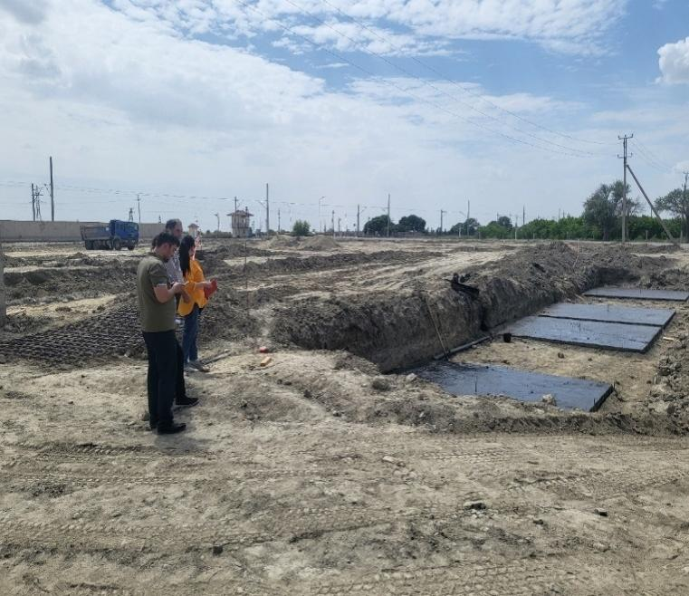 | 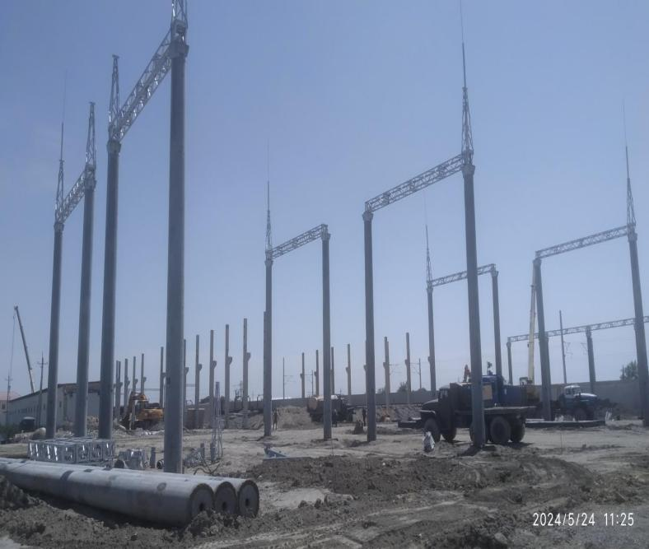
Fig. 1, 2 ТSS Bukhara 110/27.5/10 kV
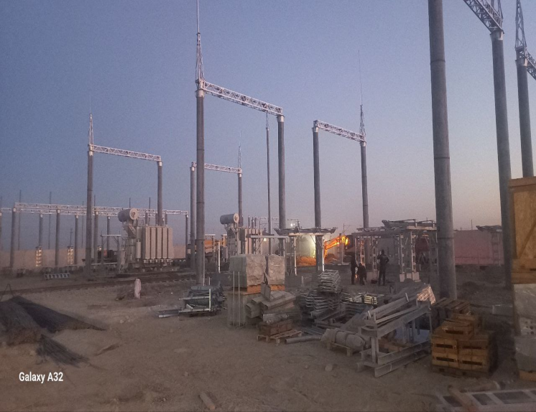  Fig.3 ТSS Bukhara 110/27.5/10 kV | 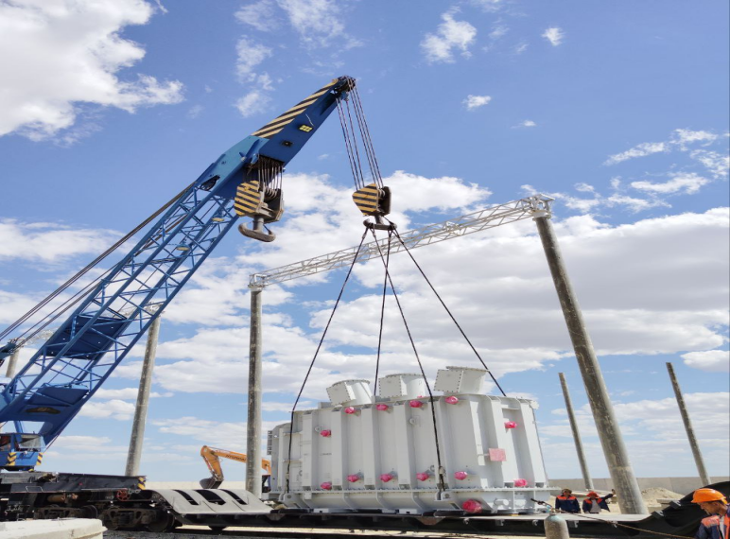  Fig.4 ТSS Parvoz 220/27.5/10 kV
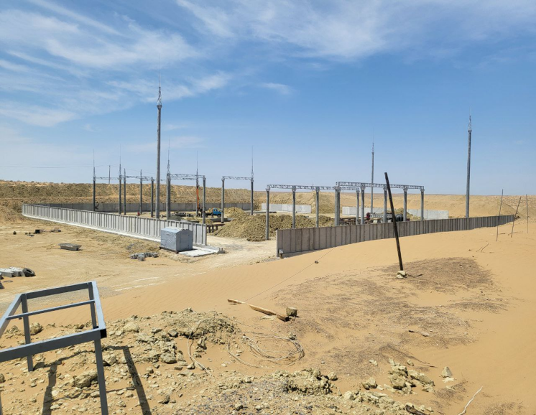  Fig.5 ТSS Тuron 110/27.5/10 kV | 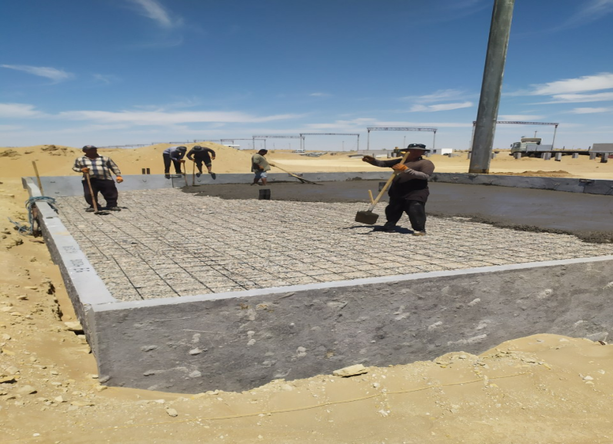  Fig.6 ТSS Jayhun 220/27.5/10 kV
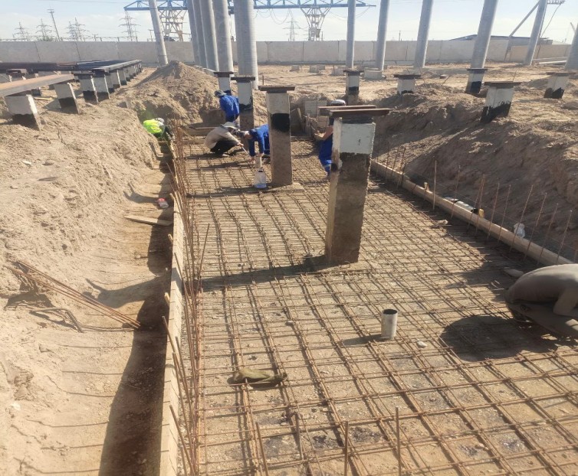  Fig.7 ТSS Urgench 110/27.5/10 kV | 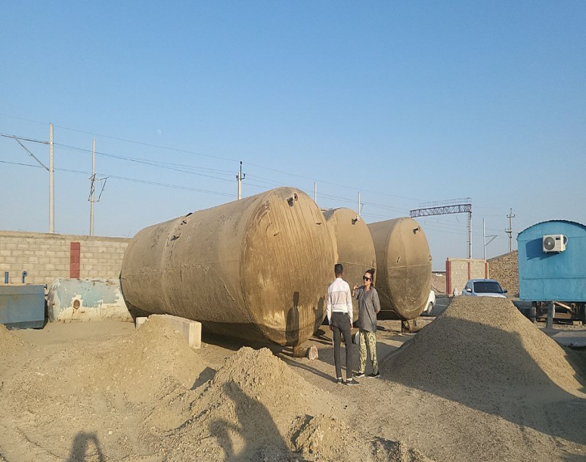  Fig.8 TSS Navbakhor 110/27,5/ kV

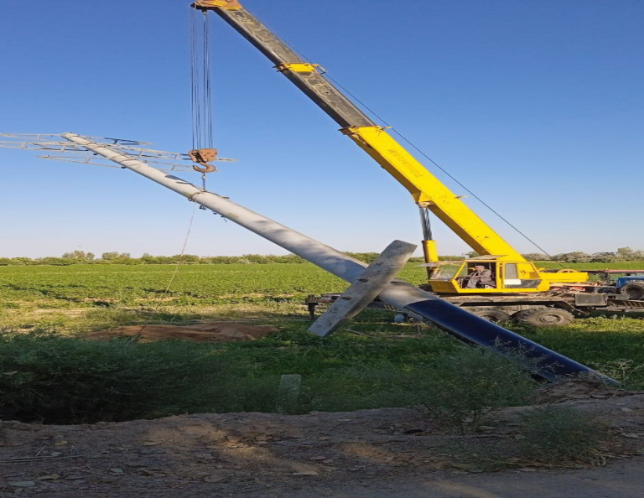 | 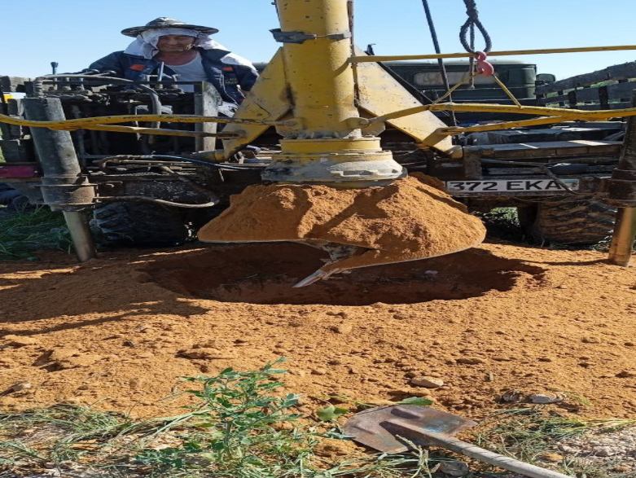
Fig. 9 Construction of Khazarasp-TSS Turon supports
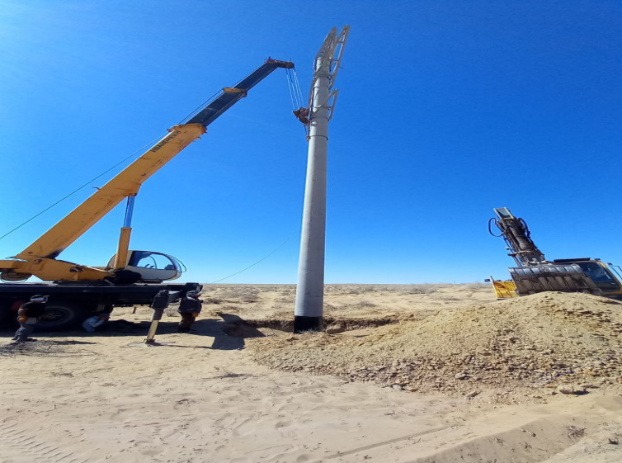  Fig. 10 Construction of Khazarasp supports - Тuron | 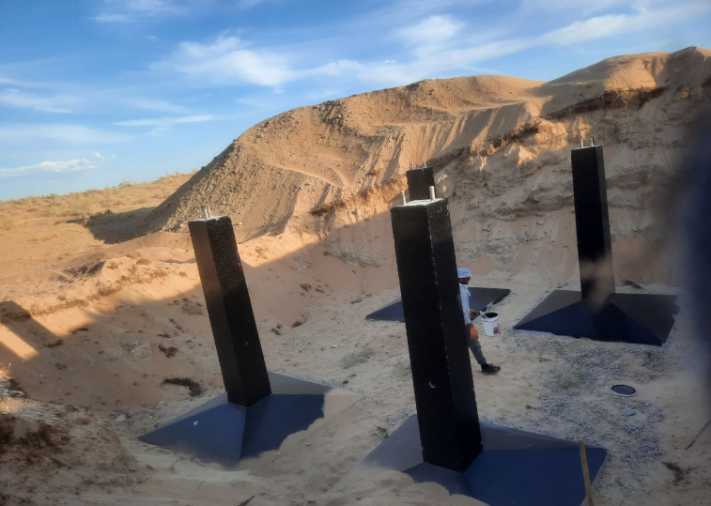  Fig.11. Construction of supports of SP Sarimay-TSS Jayhun
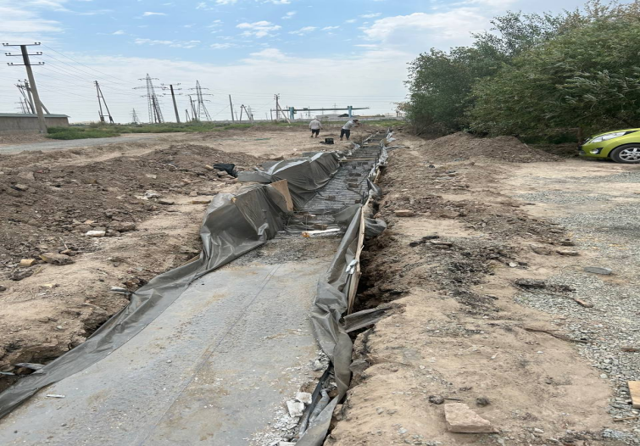  Fig.12 SP Khorezm (expansion of 110 kV switchgear with installation of two 110 kV cells) - trenches for installation of fencing | 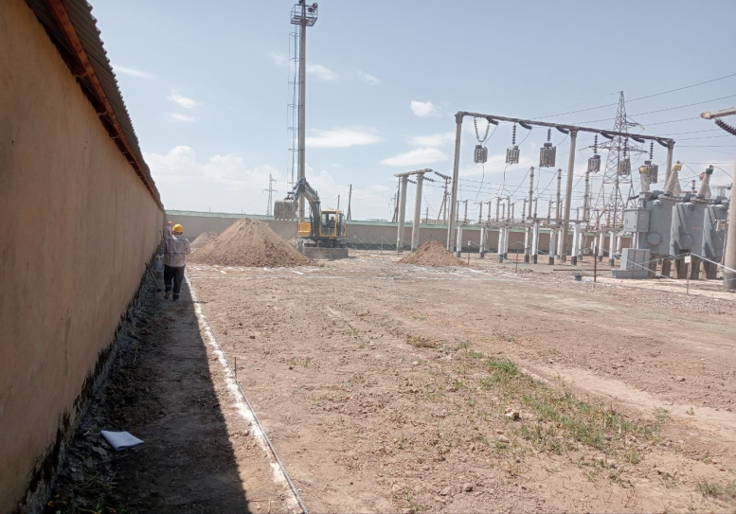  Fig.13 Existing SP Khorezm
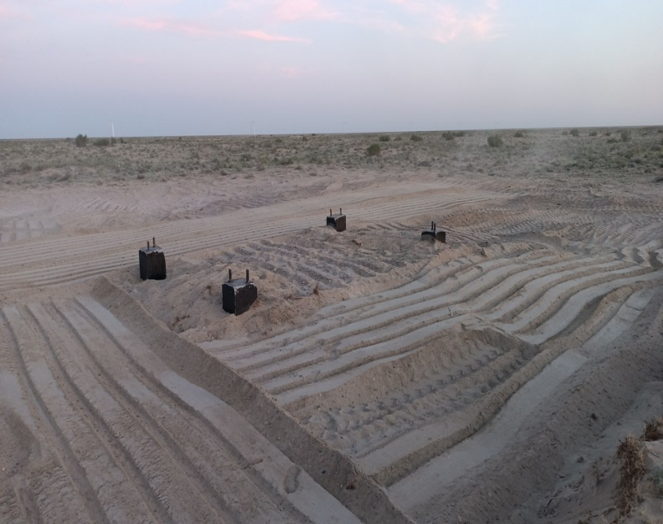 | 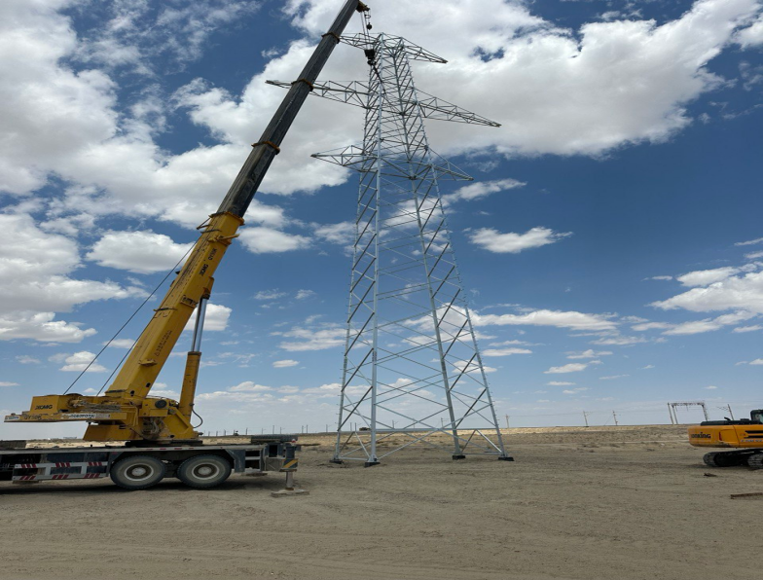
Fig. 14, 15 Construction of supports of TSS Navbakhor-TSS Parvoz

Description of any changes in the design of the project
- For the electrification facilities of the Bukhara-Urgench-Khiva railway line, the Customer, JSC ‘O’zbekiston Temir Yo’llari’, has decided to adjust the design solutions related to changing the location of the construction sites for the 110/27.5/10 kV TSS Khazarasp, TSS Bukhara 110/27.5/10 kV and TSS Urgench 110/27.5/10 kV.
- TSS 110/27.5/10 kV "Khazarasp". According to the Act of JSC "Boshtransloyiha" dated 11.01.2024 No. 93 (Appendix 3), it was established that the selected site for the construction of a traction substation on the section between the Khazarasp-Bagat stations in the Khazarasp district is located on the territory of about 30 household plots intended for agriculture. At the same time, taking into account the fact that when returning these household plots to the district reserve, problematic issues related to the owners of these plots may arise, and also taking into account that 1.04 hectares of irrigated land will be cut off from their intended use and the passage of agricultural machinery for carrying out agricultural activities will be limited, the members of the commission decided to select a land plot in the contour of 606 Dustlik massif on the section 356 km + 850 m between the stations Khazarasp-Bagat of the Khazarasp district (Fig. 1 Google map) for the construction of contact network maintenance division (CNMD) - 102 by 65 meters, the dimensions of the traction substation (TSS) - 127 by 86 meters.
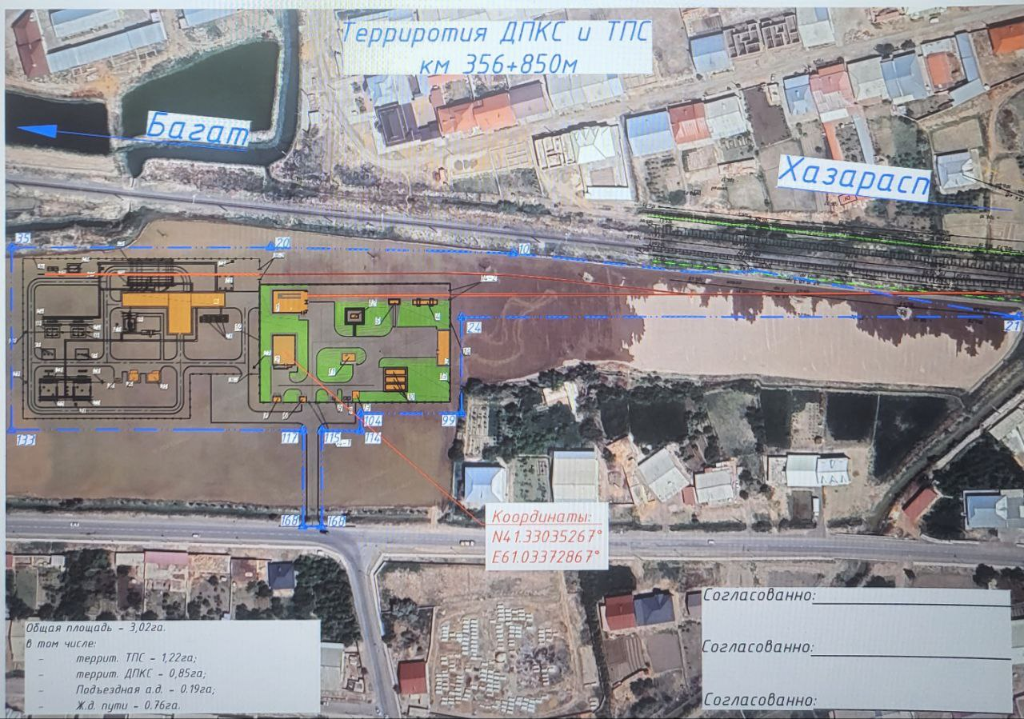
Fig.1 Google map. Land plot in contour 606 of the Dustlik massif on the section 356 km + 850 m between the stations Khazarasp-Bagat of the Khazarasp district
- In accordance with the above acts, it was decided to amend the design of the project for the location of the 110 / 27.5 / 10 kV TSS "Khazarasp" (geographical coordinates 41 ° 19'47.00"N 61 ° 02'00.90"E). In this regard, in order to assess the risks and harmful impacts on the health and safety of the population, a survey of the project site was conducted for the presence of nearby residential premises and other infrastructure. During the survey of the site, it was found that at a distance of 60 m, on the south side and 70 m on the north side, residential premises are located in accordance with the requirements of SES No. 0350-17 "Sanitary Standards and Protection of Atmospheric Air in Populated Areas of the Republic of Uzbekistan" (clause 2.23.4. sanitary protection zone for high-voltage lines with a voltage of 220 kV - is set at least 20 m). The construction of the TSS is not associated with the demolition of residential buildings, and therefore no changes in living conditions are expected.
Further, at a distance of 50 m on the northern side, there is an existing railway line, which will help ensure the delivery of building materials for the construction of the contact network and TSS.
There is an existing drainage channel located 50 meters away from the site, which is part of the irrigation infrastructure of these agricultural lands. Therefore, the proposed location of the TSS Khazarasp and the possible relocation of the drainage channel to a more remote location will be discussed with the Khazarasp District Water Resources Authority to ensure that changes to the drainage network do not lead to an increase in groundwater levels or adversely affect crop yields.
Some vegetation in the form of shrubs was identified outside the outline of the proposed site. No vegetation clearance will be carried out outside the areas allocated for construction work. According to the Environmental Management Plan developed by the contractor, mitigating protective measures will be applied to preserve vegetation, namely, existing vegetation will be preserved within the boundaries of the construction site where possible. The survey also showed that there are no protected areas, reserves, physical cultural resources (PCR), archaeological sites, cemeteries, or buffer zones near the project site. Therefore, no additional impacts on nearby buildings, social structure or farms are planned. Currently, land allocation materials are being processed, therefore, work has not started.
- Below are the diagrams of the initial planned location of the 110/27.5/10 kV TSS Khazarasp (see Fig. 2) and the adopted design solution for the location of the 110/27.5/10 kV TSS Khazarasp. (Fig. 3).

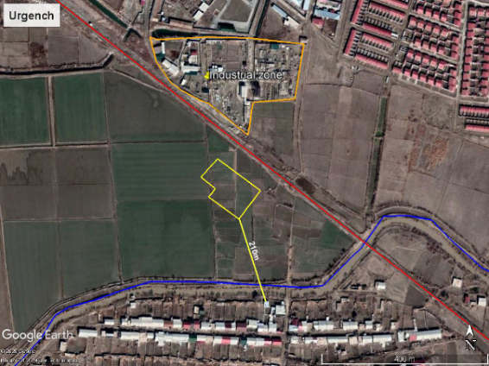
Fig. 2 Initial planned location of the TSS Khazarasp and the nearest sensitive receptors (65, 210 and 215 meters)

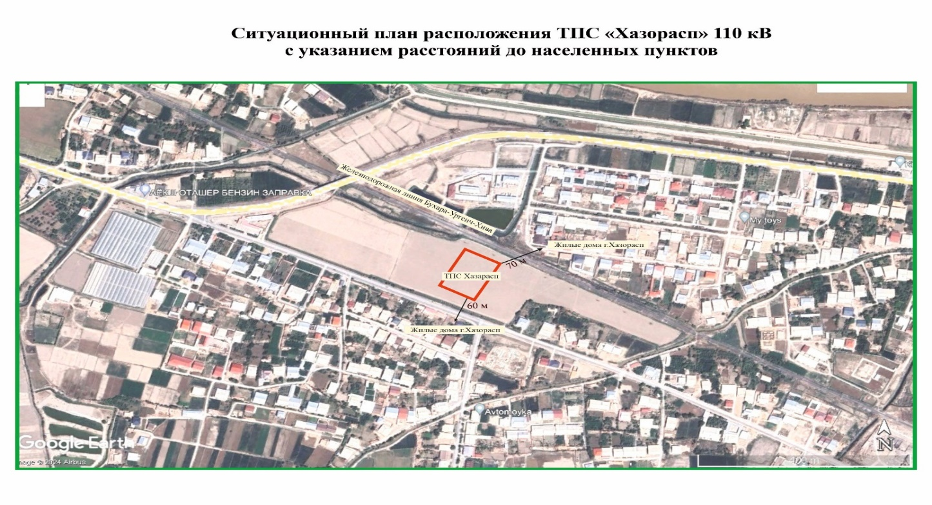
Fig.3 The adopted design location of the TSS Khazarasp and the nearest sensitive receptors (60 - 70 meters)
- ТSS Bukhara 110/27.5/10 kV. It was decided to locate the TSS Bukhara on the existing territory of the JSC ‘O’zbekiston temir yo’llari’. No land allocation is required. A survey of the construction site was conducted to assess the risks and harmful impacts on public health and safety. The site survey showed that at a distance of 150 m to the east of the construction site, residential premises are located in accordance with the requirements of SES No. 0350-17 "Sanitary Standards and Protection of Atmospheric Air in Populated Areas of the Republic of Uzbekistan" (clause 2.23.4. sanitary protection zone for high-voltage lines with a voltage of 220 kV - is set at least 20 m). There are no protected natural areas, surface watercourses, wildlife sanctuaries, physical cultural resources (PCR), archaeological sites, cemeteries, or buffer zones near the project site. There is no vegetation. In this regard, there will be no additional impact on nearby buildings, social structure, and land plots. Compared to the previous placement option, this site and the work carried out on it will not have a significant impact on farms.
Also, during the survey of the updated route from the territory of the TSS Bukhara to the territory of the TSS Kalaulbazar, the route passes through greenhouses, to which an asphalt access road adjoins. This updated route is the most optimal, since it bypasses and does not affect the greenhouses and is a shorter route, as well as with the least impact on farms, etc. In this regard, it was found that the revised design solutions will avoid the impact and its consequences and will not require the inclusion of protective social measures in the design solutions, including the need for appropriate compensation for the seizure of land.
- Below are the diagrams of the initial version of the location of the TSS Bukhara (see Fig.4) and the adopted design solution for the location of the TSS Bukhara (see Fig.5).

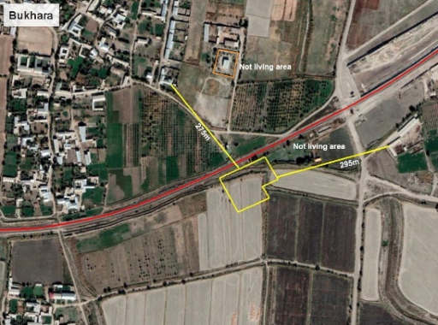
Fig.4 Initial design solution for the location of the TSS Bukhara and the nearest sensitive receptors - residential buildings (150 m and 230 m)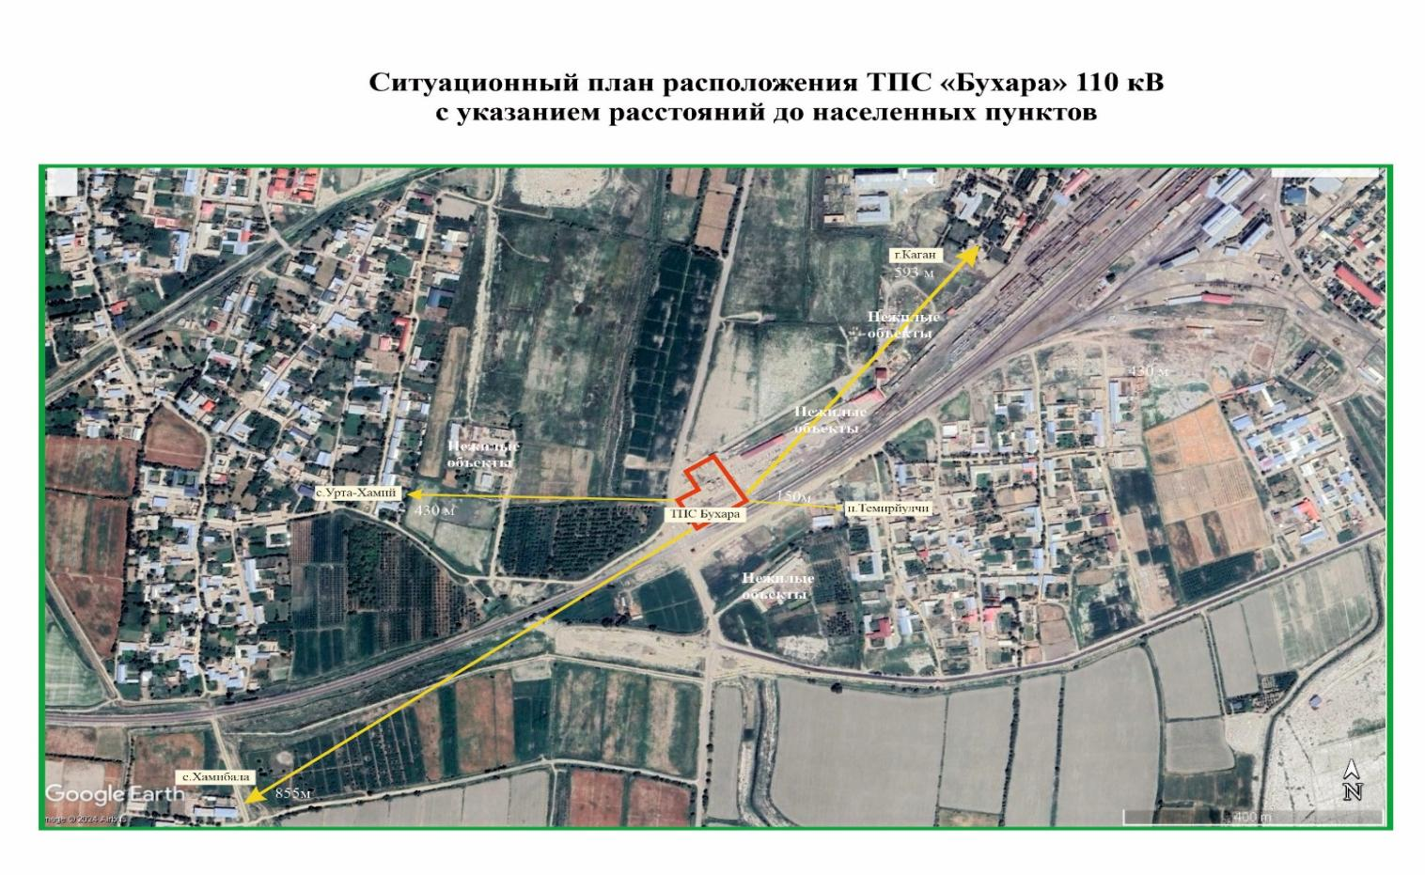
Fig.5 The adopted design solution for the location of the TSS Bukhara and the nearest sensitive receptors - residential buildings (150 m and 593 m)

- ТSS Urgench 110/27.5/10 kV. It was decided to locate TSS Urgench on the existing territory of the RRJ JSC "O’zbekiston Temir Yo’llari". Land allocation is not required. To assess the risks and harmful effects on public health and safety, a survey of the construction site was conducted. The site survey showed that at a distance of 283 m from the north side of the construction site, residential premises are located in accordance with the requirements of SES No. 0350-17 "Sanitary Standards and Protection of Atmospheric Air in Populated Areas of the Republic of Uzbekistan" (clause 2.23.4. sanitary protection zone for high-voltage lines with a voltage of 220 kV - is set at least 20 m).
- There are no protected natural areas, surface watercourses, wildlife refuges, physical cultural resources (PCR), archaeological sites, cemeteries, or buffer zones in the vicinity of the project site. There is no vegetation. Therefore, there will be no additional impact on nearby buildings, social structure, and land. Compared to the previous location option, this site and the work carried out on it will not have a significant impact on farms.
- Below are the diagrams of the initial version of the location of the TSS Urgench (see Fig. 6) and the adopted design solution for the location of the TSS Urgench (see Fig.7)

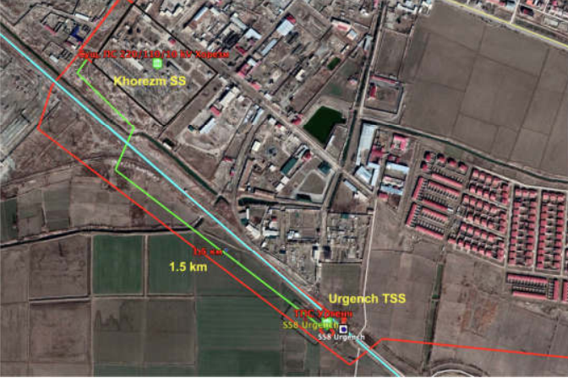
Fig. 6 TSS Urgench – SP Khorezm - green-red line (length - 1.5 km. Initial design solutions for the location of TSS Urgench and the nearest sensitive receptors (210 meters)
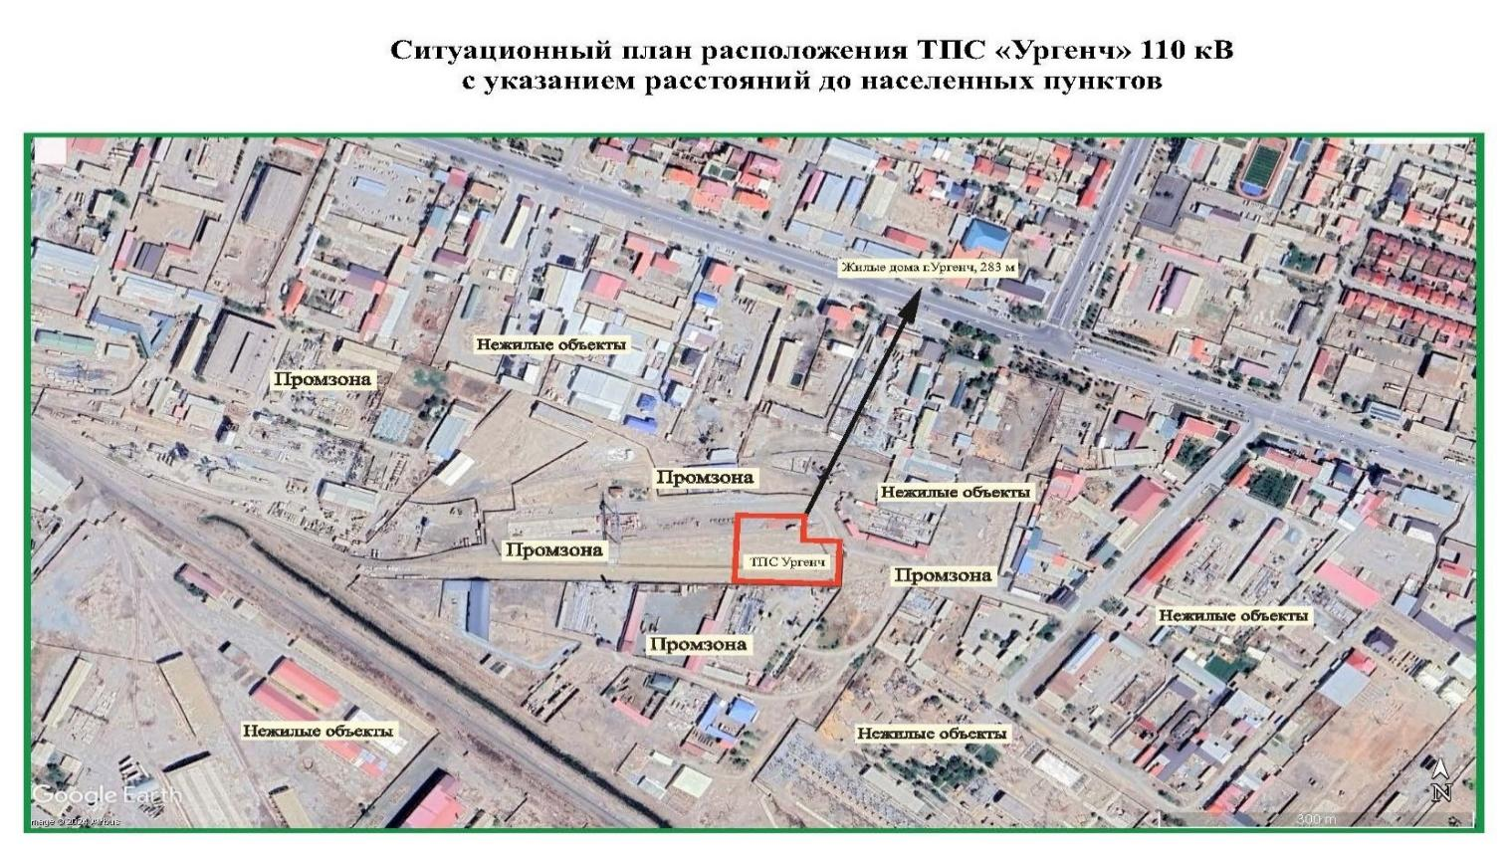
Fig.7 Adopted design solutions for the location of the TSS Urgench and the nearest sensitive receptors (283 meters)

Description of any changes to agreed construction practices
- Based on the act of JSC “Boshtransloyiha” dated 11.01.2024 No. 93, the members of the commission decided to select a land plot in the contour 606 of the Dustlik massif on the section 356 km + 850 m between the stations of Khazarasp-Bagat of the Khazarasp district for the construction of the contact network maintenance division (CNMD) and the traction substation (TSS).
- Based on the results of the decisions taken, changes were made to the approved methods for the construction of railway line electrification facilities by the design institute "Boshtransloyiha" (see Chapter 2.4).
- Based on the results of the above monitoring of the project areas, it is possible to accept the IEE as an adequate basis for subsequent implementation, but with modifications to the design or implementation proposals to avoid or reduce adverse impacts and risks. The design modifications are subject to an environmental safety assessment to understand the possible environmental risks and impacts and the necessary mitigation measures. It may be necessary to revise the EMP for these sites.
- In May 2024, the national consultant on environmental supervision of PE DB E&C officially notified the PIU-ET of JSC ‘O'zbekiston temir yo'llari’ about the need to develop the next stage of the EIA - the Statement of Environmental Impacts (SEI), taking into account the adjustment of design solutions related to the change in the location of Traction Substations (TSS) and Overhead Lines (OL) in accordance with paragraph 23 a), Chapter 3 of the Resolution of the Cabinet of Ministers No. 541 dated 07.09.2020 "On further improvement of the environmental impact assessment mechanism" of JSC ‘O'zbekiston temir yo'llari’ and then submitting them for environmental expertise to the "Center for State Ecological Expertise" under the Ministry of Ecology, Environmental Protection and Climate Change of the Republic of Uzbekistan in accordance with the established procedure.
Following the development of the EIS materials, if unforeseen environmental impacts associated with changes in design decisions become apparent, the Initial environmental examination (IEE) report shall be updated and submitted to ADB for approval, and the information shall be published on the ADB website.

ENVIRONMENTAL PROTECTIVE MEASURES

General description of environmental protection measures
- CAREC Corridor 2 is under construction. One national environmental consultant has been selected for the PIU under this project. A general description of the environmental protection activities carried out during the reporting period by the national environmental supervision consultant of PE DB E&C are summarized in the following in Table 4.
Таble 4. Environmental protection measures taken during the reporting period (January – June, 2024)
Environmental protection measures
National Environmental Consultant:
- Environmental survey of project areas and monitoring of the state of the environment and preparation of relevant reports.
- Preparation of the Semi-Annual Environmental Monitoring Report using information provided by local experts and the supervision team, and approval of the report before submission to ADB.
- Review of SEMPs submitted by Contractors.
- Review and analysis of the implementation of corrective actions submitted by contractors.
- Provision of advisory and methodological assistance on compliance with environmental legislation and ADB documents to the PIU ecologist and contractor ecologists.

- During the reporting period, the environmental protection situation at the project sites was satisfactory. Cases of environmental pollution occurred mainly due to the formation of construction and household waste, unintentional spills of fuel and lubricants, failure to comply with safety regulations, etc.
- At the project sites, various types of solid waste were generated during construction work, including wood, plastic, and cardboard boxes from packaging equipment. Measures based on the EMP include the provision of waste collection containers and removal to an authorized landfill for solid waste and construction waste by a specialized waste disposal and recycling organization.

Аudit of objects
- For the Bukhara-Khiva-Urgench railway line electrification project, several official monitoring of work sites for compliance with environmental protection requirements was carried out during the reporting period from January to July 2024. (Table 5)

Таble 5. Monitoring of objects for the reporting period
Date of site visit | Environmental Protection Supervision Consultant | Objective | Letters issued after monitoring
03.02. - 04.02.2024  TSS Bukhara, TSS Navbakhor, TSS Karakul, TSS Parvoz TSS Kiyikli. | National consultant on environmental protection of PE DB E&C  K. Bekmirzaeva | General overview and survey of project sites | At this stage it was not required, since construction and installation works were not carried out
11.03.-  14.03.2024  TSS Bukhara,  TSS Navbakhor,  TSS Karakul | International Environmental Protection Consultant - Syed Muhammad Latif, National consultant on environmental protection of PE DB E&C  K. Bekmirzaeva | Inspection of project sites for compliance with environmental protection and public safety requirements | At this stage it was not required, since construction and installation works were not carried out
19.04.-  26.04.2024  TSS Bukhara,  TSS Navbakhor,  TSS Karakul,  TSS Parvoz  TSS Kiyikli. | National consultant on environmental protection of PE DB E&C  K. Bekmirzaeva | Inspection of project sites for compliance with environmental protection and public safety requirements | №20240425-0089-DBEE from 25.04.2024
07.05.-  11.05.2024  Urgench, str. Khonka - existing substation (SS) Khorezm and projected Support No. 1 for the TSS Urgench; TSS Urgench; TSS Khazarasp; TSS Jayhun (Loop Jakasay) | National consultant on environmental protection of PE DB E&C  K. Bekmirzaeva | Inspection of project sites for compliance with environmental protection and public safety requirements | №20240607-0089-DBEE from 07.06.2024
ADB mission 15.05.2024 TSS Bukhara | Team Leader/CEF – Armine Edigaryan, RETA International Consultant on Environmental Safeguards – Keti Dgebuadze, National Environmental Consultant TA 10110 – REG – Erkindjon Matjanov, as well as Management and Environmental Protection Specialist of PIU  G. Khodjamyarova,  National consultant on environmental protection of PE DB E&C  K. Bekmirzaeva | Inspection of project sites for compliance with environmental protection and public safety requirements | №20240607-0089-DBEE from 07.06.2024
ADB mission  23.05.2024 - 24.05.2024  TSS Urgench | Team Leader/CEF – Armine Edigaryan, RETA International Consultant on Environmental Safeguards – Keti Dgebuadze, National Environmental Consultant TA 10110 – REG – Erkindjon Matjanov, as well as Management and Environmental Protection Specialist of PIU  G. Khodjamyarova,  National consultant on environmental protection of PE DB E&C  K. Bekmirzaeva | Inspection of project sites for compliance with environmental protection and public safety requirements | №20240607-0089-DBEE from 07.06.2024
11.06.-  15.06.2024  Urgench, str. Honka - design Support No. 1 for TSS Urgench near the existing Substation (SS) Khorezm;  design Support, the construction of which is planned near the existing SP Khazarasp TSS Turon. | National consultant on environmental protection of PE DB E&C  K. Bekmirzaeva | Inspection of project sites for compliance with environmental protection and public safety requirements | The report has been sent to contractors and PIU

- Information on the findings of inspections and on-site monitoring of work sites includes data on any identified circumstances and identified problematic issues. Below is a summary of the findings on identified problematic issues for the electrification facilities of the Bukhara-Urgench-Khiva railway line.

Summary of the results of monitoring construction sites:
- During the monitoring of the construction sites of TSS - Urgench and TSS - Bukhara by the ADB Mission, the following was revealed:
On 15 and 24 May 2024, an ADB mission consisting of Team Leader/CEF Armine Yedigaryan, RETA International Safeguards Consultant Keti Dgebuadze, TA 10110 – REG National Environmental Consultant Erkinjon Matjanov conducted a site visit to the L4170 - UZB Central Asia Regional Economic Cooperation (CAREC) Corridor 2 (Bukhara-Miskin-Urgench-Khiva) Railway Electrification Project located in the Khorezm and Bukhara regions of the Republic of Uzbekistan.
During the monitoring, the Mission established that construction work had begun at 5 traction substations (TSS). The survey was carried out on the territory of TSS - Urgench and TSS - Bukhara. During the site visit, work was underway to build the foundation of TSS - Urgench (Fig. 1, 2). Due to the fact that the territory of the TSS was changed, the ADB mission requested the PIU of UTY to prepare an Environmental Impact Assessment Report (EIA) and submit it for consideration by the ADB before the start of construction work. During the inspection, the Mission revealed:
- Camp: Improper handling of hazardous waste: There was no designated temporary burial site for hazardous waste (Figure 3). The ADB mission recommended that a dedicated storage facility be established, equipped with a rainwater collection system, to prevent hazardous waste from contaminating surface or groundwater. The storage area should be equipped with warning signs (indicating the location of hazardous waste (category, type)), as well as fire-fighting identification and other equipment. The bottom layer of the storage area should be made of a material that does not react with or absorb the stored hazardous waste, be waterproof, and not pose a risk of leakage/spillage.
- Waste management on the camp site and construction sites: As was noted, there were no special designated areas for storing household waste on the campgrounds, equipped with various containers with markings.
- Results system: SEMP and TSEMP preparations are not yet complete. The accounting system has not been established, the camp lacks checklists, waste removal contracts, training reports, non-compliance reports and a complaints log.
- The camp does not have a special medical room, but a doctor shall be appointed and all necessary medications shall be available, including vaccines against reptile bites.
- The accommodation facilities at the camp for the working personnel did not meet the requirements of the ADB and IFC. The following violations were identified at the site: in some cases, there was not enough space for workers to live, the premises did not meet sanitary standards (Fig. № 5, 6).
- The kitchen and canteen in the camp are not properly equipped and are not kept clean. There was no separate canteen for the workers. The cook was provided with personal protective equipment. Food products are stored in accordance with sanitary requirements, meat and dairy products are stored in bags in the refrigerator. (Fig. № 7, 8, 9).
During the visit to the TSS Bukhara, the mission noted several discrepancies that could be considered critical for the Project:
- The project involves the construction of the Bukhara-1 substation (Fig. 10) in the Kagan district of the Bukhara region (39.709904, 64.530359). Construction waste is scattered across different parts of the substation area. (Fig. 11, 12, 13).
- Drinking water on the territory of the Bukhara-1 substation is stored in iron tanks directly on the ground (Fig. 14). There is already rust on the outer walls of the tank. The roofs of the tanks are not sealed; Various impurities, including dust, can get into the water.
- There are wash basins for workers on the station premises (Fig. 15), the used water flows directly onto the plants under the wash basins. The water used in the wash basins may contain oils and soap residues, which can harm the grass and leave harmful residues on the ground.
- On the territory of the substation "Bukhara-1", near the workers' canteen, there is grass. Various tree remains and construction waste are scattered on the grass (Fig. 16). Also, the boiler and the furnace can harm the grass.
- The bitumen was melted and used in open fire on the soil cover. Soil contamination is visible around the construction site.
Mission findings and recommendations. The status of implementation of the corrective actions proposed during the environmental review mission is provided in (Appendix 4).
- During a visual inspection of the TSS-Bukhara construction site, the following was revealed:
- spills of fuels and lubricants (F&L) onto the ground during work, equipment repair and refueling. In case of spills in open areas, in addition to the risk of fire and loss of raw materials, there are risks of pollutants entering water bodies, soil contamination, groundwater (see Fig.1).
- there is no warehouse for fuels and lubricants. At present, fuel and lubricants containers are stored on the ground near the trailer without constructing a fire-resistant foundation (see Fig. 2).
- waste management is not organized. The territory was found to be littered with waste. There were no special designated areas for storing household waste on the camp territory, equipped with various containers with markings and for storing construction materials, no agreement was concluded with a specialized company for the removal of solid waste and construction waste. (see Fig.3,4,5).
- drinking water on the territory of the Bukhara-1 substation is stored in iron tanks directly on the ground (see Fig. 6). There is rust on the outer walls of the tank. The roofs of the tanks are not sealed; There is a risk of various impurities, including dust, getting into the water.
- there are wash basins for workers on the station grounds (see Fig. 7), the used water flows directly onto the plants and vegetation. The water used in the wash basins may contain oils and soap residues that can harm the grass and leave harmful residues on the ground.

- on the territory of the "Bukhara-1" substation, near the workers' canteen, there is grass. Various tree remains and construction waste are scattered on the grass (see Fig.8, 9). Also, the boiler and stove can harm the grass.
- the bitumen was melted and used in an open fire on the soil cover. Soil contamination is visible around the construction site.
- there is no Log of Suggestions and Complaints from Construction Personnel.
- the camp does not have a special medical office, but a doctor shall be appointed, and all necessary medications shall be available, including vaccines against reptile bites.
- there are no signs indicating the storage location of hazardous waste (category, type), as well as fire-fighting identification and other equipment. The bottom layer of the storage area shall be made of waterproof material and not pose a risk of leakage/scattering.
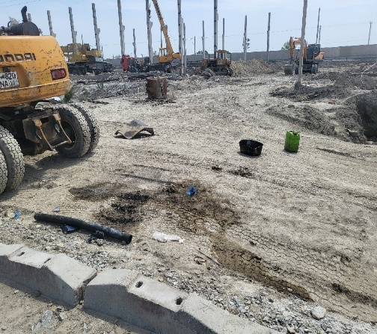 | 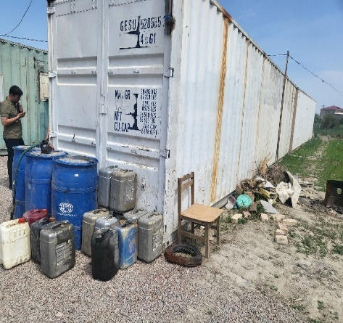 | 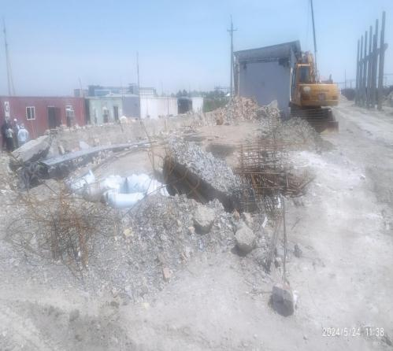
Fig.1 ТSS - Bukhara | Fig.2 ТSS - Bukhara | Fig.3. ТSS - Bukhara
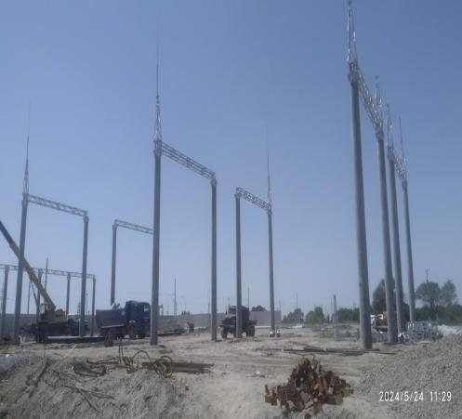 | 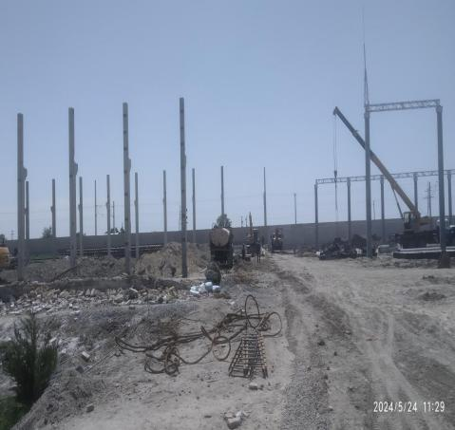 | 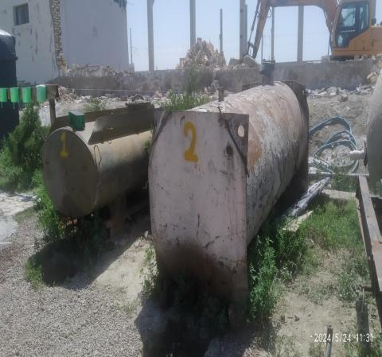
Fig.4. ТSS - Bukhara | Fig.5. ТSS - Bukhara | Fig.6. ТSS - Bukhara
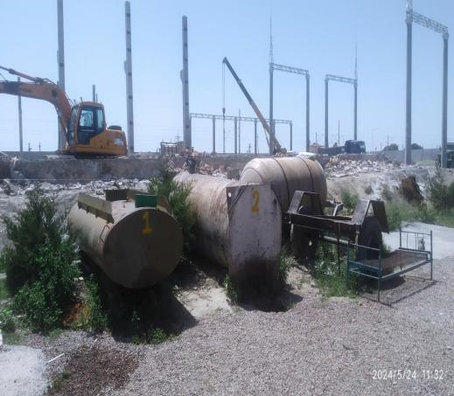 | 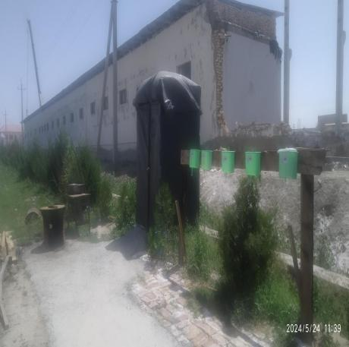 | 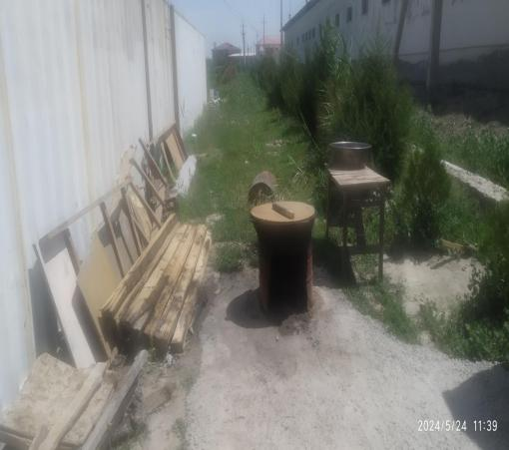
Fig.7 ТSS - Bukhara | Fig.8 ТSS - Bukhara | Fig.9 ТSS - Bukhara

- During a visual inspection of the TSS-Navbakhor construction site, the following was revealed:
- the bitumen was melted and used in an open fire on the soil cover. Soil contamination is visible around the construction site (see Fig.1, 2).
- there is no warehouse for storing hazardous waste.
- waste management is not organized. The territory was found to be littered with waste. There were no special designated areas for storing household waste on the camp territory, equipped with various containers with markings and for storing construction materials, no agreement was concluded with a specialized enterprise for the removal of solid waste and construction waste (see Fig. 3,4,5,6).
-there are no signs indicating the storage location of hazardous waste (category, type), as well as fire-fighting identification and other equipment. The bottom layer of the storage area shall be made of waterproof material and not pose a risk of leakage/scattering.
- there are no environmental management plans, health and safety instructions, registration logs with information on the training of workers on occupational safety and health, another log for recording accidents and incidents during construction work, as well as a log of suggestions and complaints from construction personnel on the site.
- the camp does not have a special medical office, but a doctor shall be appointed, and all necessary medications shall be available, including vaccines against reptile bites.
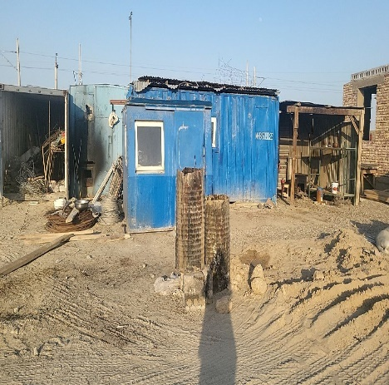 | 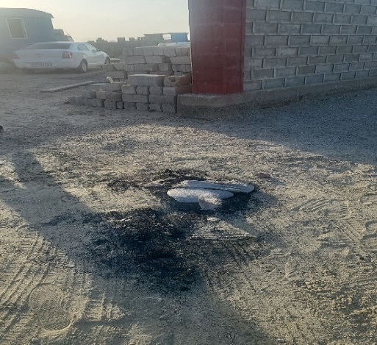 | 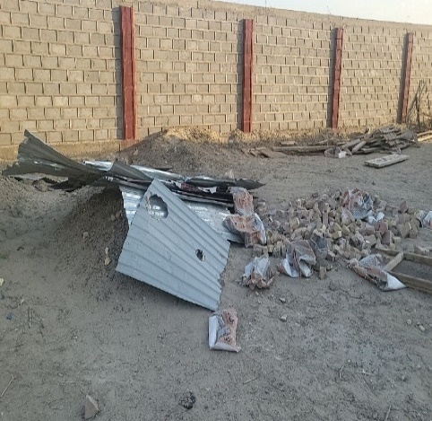
Fig. 1 ТSS - Navbakhor | Fig. 2 ТSS - Navbakhor | Fig. 3 ТSS - Navbakhor

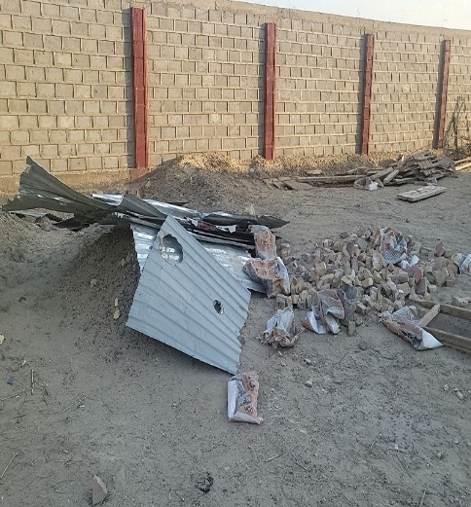 | 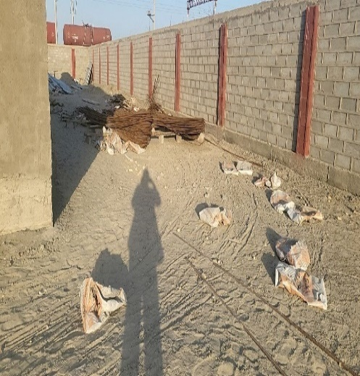 | 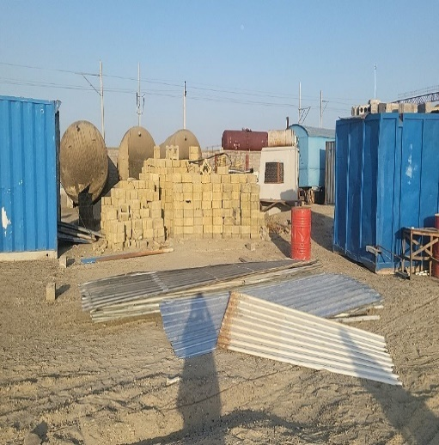
Fig. 4 ТSS - Navbakhor | Fig. 5 ТSS - Navbakhor | Fig. 6 ТSS - Navbakhor

- During a visual inspection of the construction site of TSS - Urgench, the following was revealed:
- there are no conventional and warning signs indicating the storage location of hazardous waste (category, type), as well as fire-fighting identification and other equipment. The bottom layer of the storage area shall be made of waterproof material and not pose a risk of leakage/scattering.
- there is no warehouse for fuels and lubricants. At present, fuel and lubricants containers are stored on the ground near the trailer without constructing a fire-resistant foundation (see Fig. 1).
- the bitumen was melted and used with an open fire on the soil cover (see Fig. 2).
- there were no special designated areas for storing household waste on the campgrounds, equipped with various containers with markings.
- waste management is not organized. There were no special designated areas for storing household waste on the camp territory, equipped with various containers with markings and for storing building materials, no agreement was concluded with a specialized company for the removal of solid waste and building waste.
- the camp does not have a special medical office, a doctor shall also be appointed, and all necessary medications shall be available, including vaccines against reptile bites.
- The accommodation facilities at the camp for the working personnel did not meet the requirements of the ADB and IFC. The following violations were identified at the site: in some cases, there was not enough space for workers to live, the premises did not meet sanitary standards (Fig. № 3).
The kitchen and canteen in the camp are not properly equipped and are not kept clean. There was no separate canteen for the workers. The cook was provided with personal protective equipment. Food products are stored in accordance with sanitary requirements, meat and dairy products are stored in bags in the refrigerator. (Fig. № 4, 5, 6).
- there is no fire extinguishing equipment at construction sites.
- there is no log of suggestions and complaints from construction personnel.
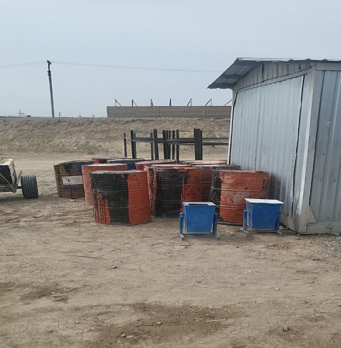 | 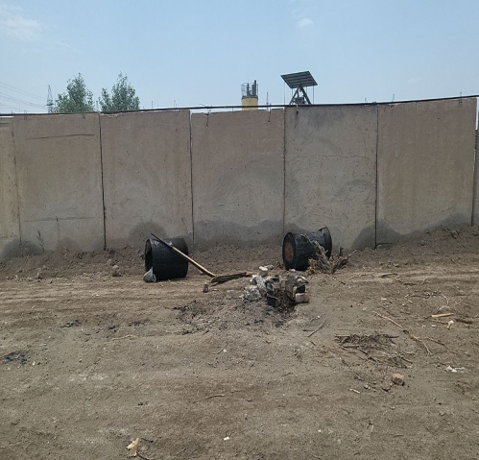 | 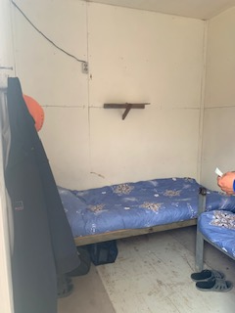
Fig.1 ТSS - Urgench | Fig.2 ТSS - Urgench | Fig.3 ТSS - Urgench

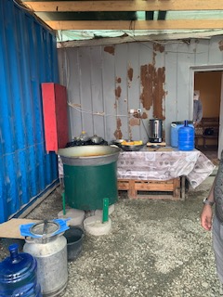 | 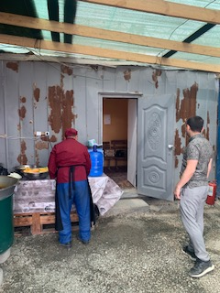 | 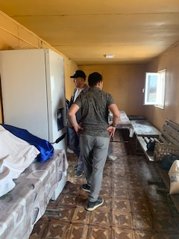
Fig.4 ТSS - Urgench | Fig.5 ТSS - Urgench | Fig.6 ТSS - Urgench

- During a visual inspection of the TSS-Turon construction site, the following was revealed:
- there is a wash basin for the working personnel on the station premises (see Fig. 1), the used water flows directly onto the soil cover. The water used in the wash basins may contain oils and soap residues, which can harm the grass and leave harmful residues on the ground.
- Environmental Management Plans, safety and health instructions, registration logs with information on the training provided to workers on occupational safety and health and for accidents and incidents during construction work, as well as a log of suggestions and complaints from construction personnel are available on site.
- bitumen was melted and used with an open fire on the soil cover (see Fig. 2).
- there is no warehouse for fuels and lubricants. At present, fuel and lubricants containers are stored on the ground near the trailer without constructing a fire-resistant foundation (see Fig. 3).
- waste management is not organized. Garbage was found behind the toilet structure. There were no special designated areas for storing household waste on the camp territory, equipped with various containers with markings and for storing construction materials, no agreement was concluded with a specialized company for the removal of solid waste and construction waste. (see Fig. 4).
- dust suppression measures are not carried out.
- there are no conventional and warning signs indicating the storage location of hazardous waste (category, type), as well as fire-fighting identification and other equipment. The bottom layer of the storage area shall be made of waterproof material and not pose a risk of leakage/scattering.
- there are no environmental management plans, health and safety instructions, registration logs with information on the training of workers on occupational safety and health, another log for recording accidents and incidents during construction work, as well as a log of suggestions and complaints from construction personnel on the site.
- the camp does not have a special medical office, a doctor shall also be appointed, and all necessary medications shall be available, including vaccines against reptile bites.
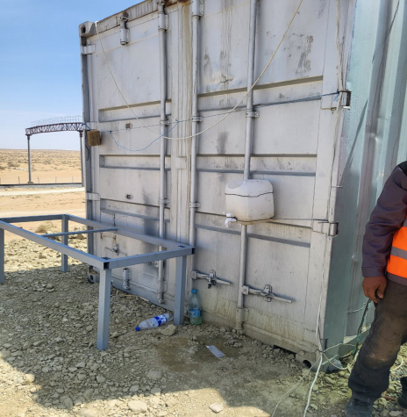 | 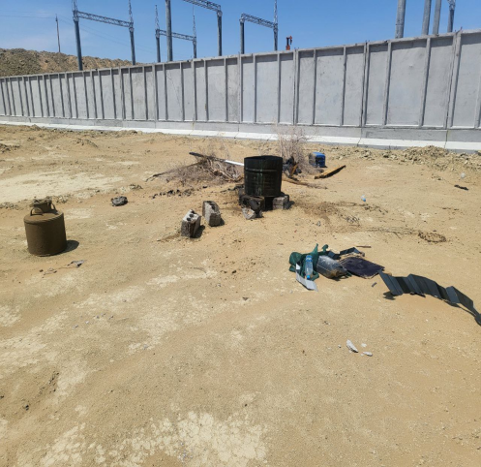 | 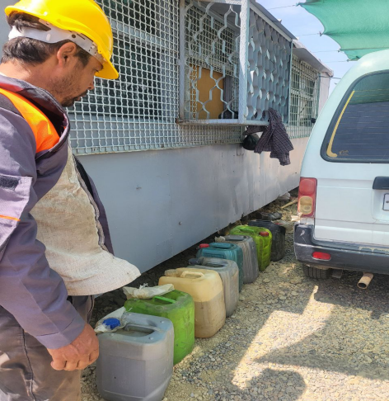
Fig.1 ТSS - Тuron | Fig.2 ТSS - Тuron | Fig.3 ТSS - Тuron
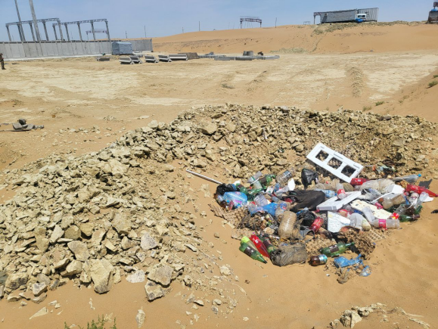
Fig.4 ТSS - Тuron

- During a visual inspection of the construction site of the TSS Jayhun (Loop Jayhun), the following was revealed:
- cooking is done on a fireplace, using firewood and dry branches of bushes as fuel (see Fig.1).
- workers are not provided with special clothing.
- there are no fire extinguishing equipment at the construction site;
- there is no fuel and lubricants warehouse. Currently, fuel and lubricants containers are stored on the ground near the container without constructing a fire-resistant foundation (see Fig. 2).
- dust suppression measures are not carried out to minimize the impact on the environment, namely during transportation and loading and unloading of inert materials; there is no covering of the vehicle body with awnings (see Fig.3).
- safety precautions are not observed, electrical appliance wires are not grounded (see Fig. 4,5,6).
- waste management is not organized. littering with waste was found outside the territory along the railway. There were no special designated areas for storing household waste on the camp territory, equipped with various containers with markings and for storing construction materials, no agreement was concluded with a specialized company for the removal of solid waste and construction waste (see Fig. 7,8).
- there are no environmental management plans, health and safety instructions, registration logs with information on the training of workers on occupational safety and health, another log for recording accidents and incidents during construction work, as well as a log of suggestions and complaints from construction personnel on the site.
- the camp does not have a special medical office, but a doctor shall be appointed, and all necessary medications shall be available, including vaccines against reptile bites.
- there are no conventional and warning signs indicating the storage location of hazardous waste (category, type), as well as fire-fighting identification and other equipment. The bottom layer of the storage area shall be made of waterproof material and not pose a risk of leakage/scattering.

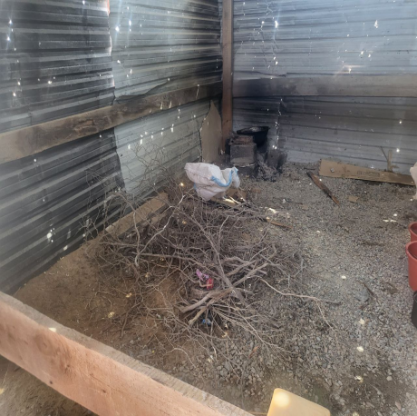 | 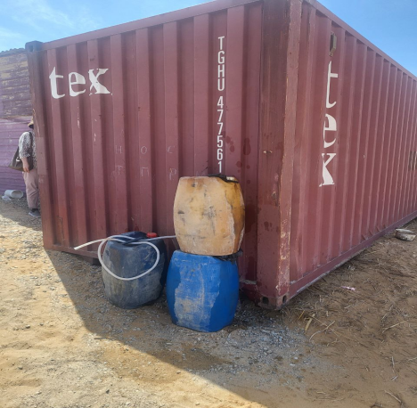 | 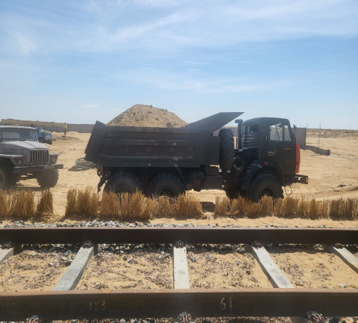
Fig.1 ТSS Jayhun | Fig.2 ТSS Jayhun | Fig.3 ТSS Jayhun
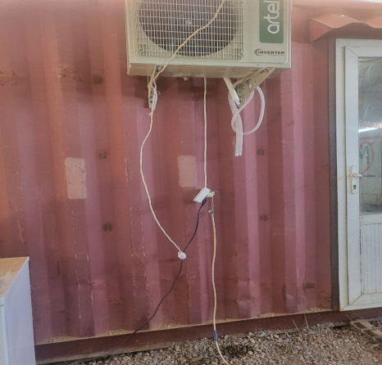 | 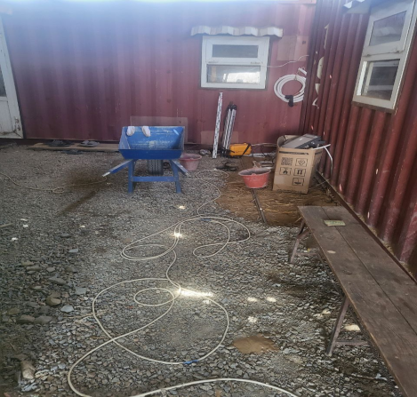 | 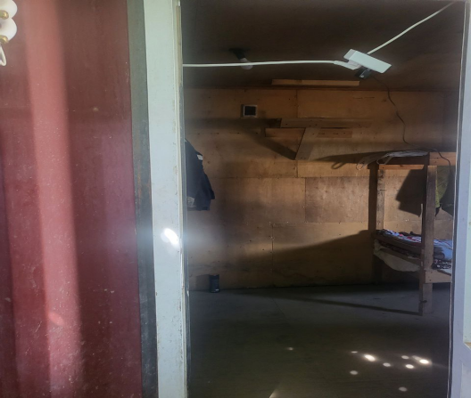
Fig.4 ТSS Jayhun | Fig.5 ТSS Jayhun | Fig.6 ТSS Jayhun
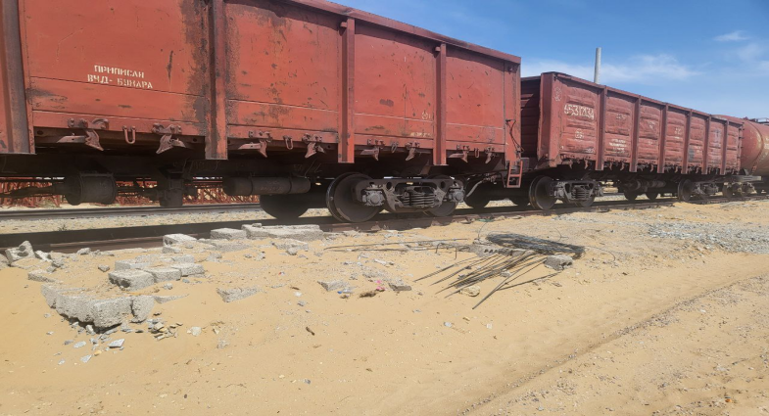 | 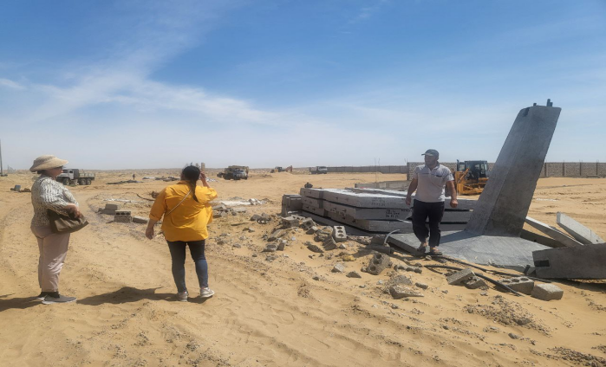
Fig.7 ТSS Jayhun | Fig.8 ТSS Jayhun

- A visual inspection along the route of the projected transmission line from the TSS Bukhara to the TSS Navbakhor showed the following:
The design and phased construction of the external power supply for the TSS Bukhara and TSS Navbakhor began in April 2024. The route passes through desert areas and areas of settlements with moderate population density. The power line for the TSS Bukhara will cross mainly agricultural land, and only in some sections will the line pass near settlements. The construction camp was not required since the workforce was accommodated in the nearest settlement. Since air quality impacts are limited to the construction phase, impacts may arise from dust and emissions from machinery and construction equipment.
During the inspection of the TSS Bukhara and TSS Navbakhor routes, areas with a sensitive zone were identified, namely, it is planned to install the design support 169 (see Fig. 1), next to fruit trees - 2 units, and support 170 - on the territory of a farm (see Fig. 2). An orchard is adjacent to the territory of the farm (see Fig. 3).
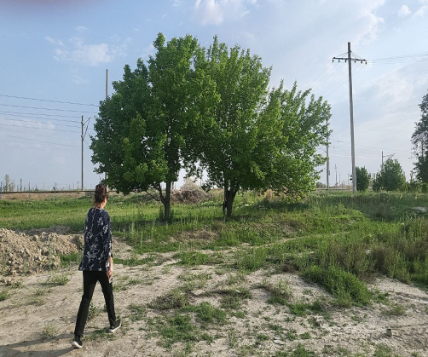 | 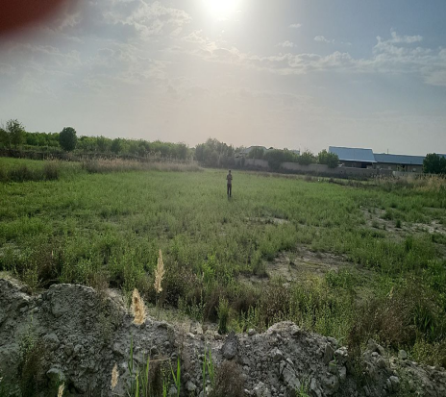 | 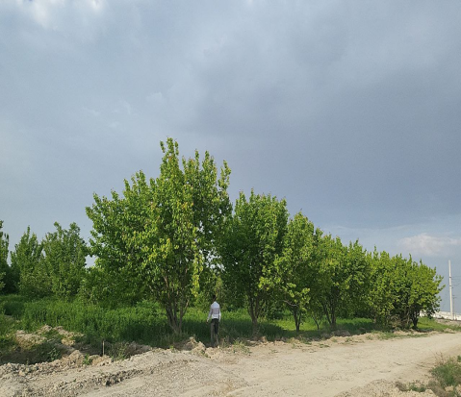
Fig.1 There are 2 fruit trees near the planned Support 169. | Fig.2 Support 170 – Farm enterprise | Fig.3 Fruit garden

The contractor, JSC ‘Tojikhydroelectromontaj’, will apply mitigating protective measures to preserve vegetation within the boundaries of the construction site, existing vegetation will be preserved where possible. Trees and areas to be preserved and protected will be identified and clearly marked. Tree cutting will be avoided where possible, instead, the possibility of replanting trees or changing design solutions will be considered. No vegetation clearing will be carried out outside the areas allocated for construction works. In case of tree cutting or disturbance of valuable pastures for the needs of the project, the same species will be replanted, or compensation will be paid, or restoration of vegetation cover will be carried out in other project areas, in accordance with the Resolution of President of Uzbekistan No. 46 dated 13.12. 2021 "On measures to accelerate landscaping work and further effective organization of tree protection in the Republic of Uzbekistan" and the Resolution of the Republic of Uzbekistan No. 255 of March 31, 2018 "On approval of certain administrative regulations for the provision of public services in the field of nature management". Protective measures will be reflected by the Contractor in the EMP for each site.
Further along the route, an irrigation canal was found, which was located at a distance of 90 m - 100 m from the installed supports - 140, 141, 142, 143 (see Fig. 4, 5, 6). This distance corresponds to the Resolution of the Republic of Uzbekistan dated 11.12.2019 No. 981 "On approval of the regulation on the procedure for establishing water protection zones and sanitary protection of water bodies on the territory of the Republic of Uzbekistan".

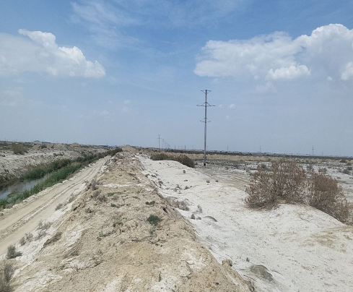 | 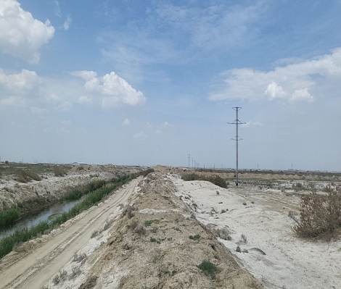 | 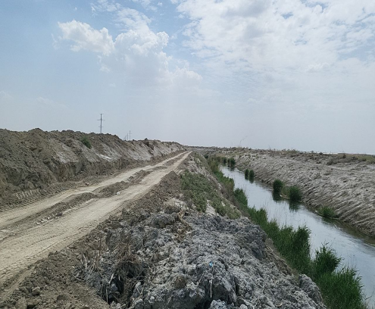
Fig. 4 Support 140, further at a distance there will be a metal support 141. Support 140 is located at a distance of 5.5 km from the TSS Bukhara 1 | Fig. 5 Near the Support 140 there is an irrigation canal at a distance of more than 90 meters | Fig.6 from supports 143, 142 a canal flow at a distance of 100 meters

An unauthorized solid waste dump was discovered along the route where supports 146-147 are located, which had formed long before the planned activity. (see Fig. 7,8).

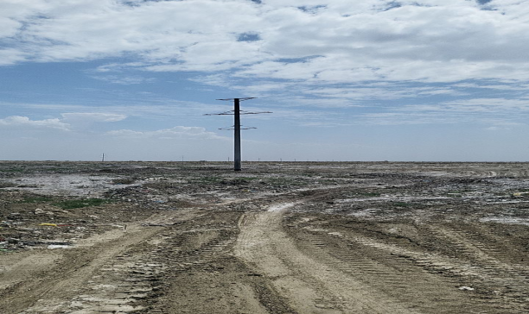 | 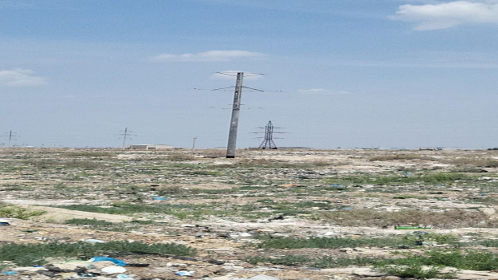
Fig. 7 Support 146 to TSS Bukhara 1 - 4.8 km | Fig.8 Support 147 will connect to TSS Bukhara 1 - 4.65 km,

Several sites that were previously used as sources of construction materials (sand) have been discovered in the vicinity of the Navbakhor railway station and the planned construction site of the TSS Navbakhor. Due to improper closure of such quarries, "wetlands" have formed as a result of groundwater wedging out, as well as heavy and prolonged rainfall. As a result, these areas have become risk zones for birds, which may attract migrating waterfowl and expose them to the risk of collision with power lines. (see Fig.9).

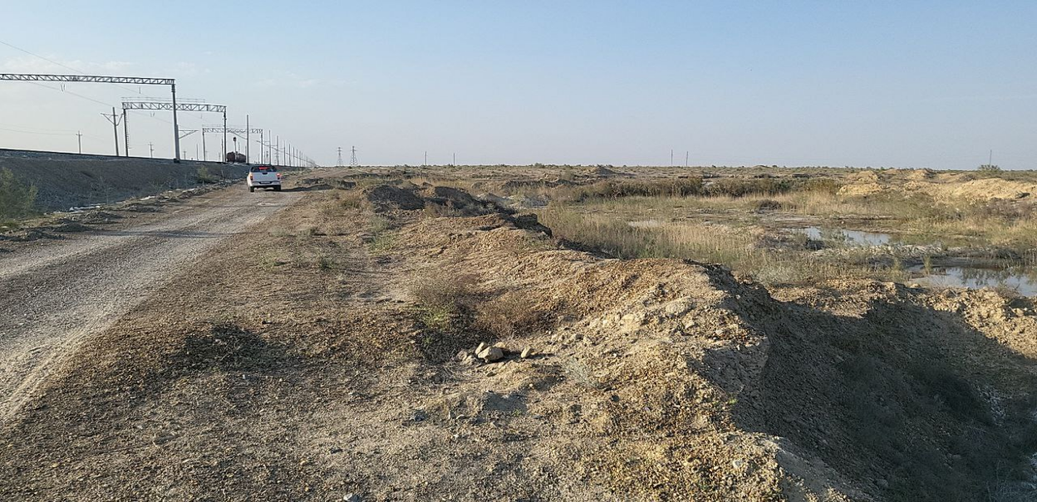
Fig 9. The area, which was previously used as a source of building materials (sand)

According to an earlier preliminary environmental assessment (IEE), 3 km northwest of the Parvoz railway station, in the ridge sands along the railway line, excavation for embankment has led to the formation of pools up to several hectares in area. During heavy rainfall, lakes may also form here, which may attract birds. (see Fig. 10)

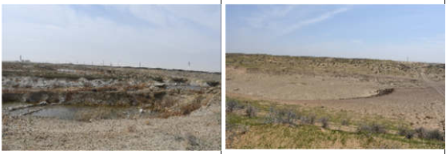 | 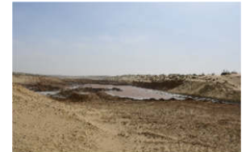
Fig. 10 Formation of reservoirs in places where soil is excavated for embankments

As a result, due to the improper closure of such quarries, these areas now become risk zones for birds.
In order to minimize the risk of bird collisions with the contact network, contractors are offered two methods:

а. Planning of areas where land was previously mined for construction, in order to avoid attracting migratory birds and other rare species of animals and their death at railway facilities;
b. Installation of markers on the contact network (500 meters) in both directions for each pond).
The route of the overhead power line bypasses all existing protected areas in the project area and therefore avoids any possible impact on their natural values ​​or their protection status.
The final mitigation measures for impacts on flora and fauna will be reflected in the ESMP for each site and submitted by the Contractor.

Issue tracking (based on non-compliance notifications)
- Based on the results of monitoring construction sites by the environmental consultant of PE DB E&C for the reporting period January-June 2024, a summary of problematic issues, corrective actions to resolve, identified problematic issues was prepared indicating the persons responsible for implementing the solutions, deadlines, and stages of implementation. This information was prepared to track problematic issues and is presented in Table No. 6.
Таble 6. Information on problematic issues and implementation of corrective actions
- Construction site of TSS Urgench
№ | Noncompliance | Corrective/Preventive Action | Responsibility according to contractual obligations | Completion Date
1 | There is no fire post on the site | Organize a fire-fighting post on the site, including providing the area where compressed gas cylinders are located with primary fire extinguishing equipment | Contractor "O’zelectroapparat-Electroshield" | Completed.  A fire-fighting post has been set up
2 | Bitumen was melted and used with open fire on the soil cover. Soil contamination was detected around the construction site | Melting and use of bitumen shall be properly organized. Isolate the soil from bitumen contamination. Burning of any materials on or near construction sites is prohibited | Contractor "O’zelectroapparat-Electroshield" | Completed.  Contaminated soil with sand isolated in a special container.  Then it will be reused in construction
3 | There is no warehouse for storing fuels and lubricants (F&L) and other hazardous chemicals | Organize a warehouse for storing tanks with fuels and lubricants on a fire-resistant foundation erected in accordance with the requirements of regulatory acts and equip the tanks with bunds and barriers. Develop instructions for preventing and eliminating spills and spills of hazardous materials | Contractor "O’zelectroapparat-Electroshield" | Completed.  A warehouse for storing fuel tanks has been organized.
4 | organize a special medical office in the camp and appoint a doctor. All necessary medications should be available, including vaccines against reptile bites | organize a special medical office in the camp and appoint a doctor. All necessary medications should be available, including vaccines against reptile bites | Contractor "O’zelectroapparat-Electroshield" | 10th November
5 | The accommodation facilities for the camp workers did not meet the requirements of the ADB and IFC. The following non-conformities were identified at the site: in some cases, there was not enough space for workers to live, and the premises did not meet sanitary standards | PS to improve sanitary and hygienic conditions in the living quarters of workers | Contractor "O’zelectroapparat-Electroshield" | Completed. Accommodation facilities for workers have been organized in accordance with sanitary standards.
6 | The kitchen and canteen in the camp are not properly equipped and are not kept clean. There was no separate canteen for the workers. The cook was provided with personal protective equipment. Food products are stored in accordance with sanitary requirements, meat and dairy products are stored in bags in the refrigerator | The kitchen and dining room in the camp shall be well-equipped and kept clean | Contractor "O’zelectroapparat-Electroshield" | Completed.  The kitchen and dining room are equipped and clean.
7 | There is no control over air quality, noise, and vibration levels | Conclude agreements with laboratories of the Centre for Specialized Analytical Control in the Field of Environmental Protection or the Republican Sanitary Epidemic Centre | Contractor "O’zelectroapparat-Electroshield" | until December 30, 2024
8 | No dust suppression measures are taken to minimize the impact on the environment | Moistening of inert materials during their transportation and loading and unloading operations, covering the body of vehicles with tarpaulins when transporting bulk and highly dusty cargo, spraying the materials being transported before loading | Contractor "O’zelectroapparat-Electroshield" | In progress.  Dust suppression measures are being carried out.
9 | Waste management is not established. There is no waste disposal site, no containers for solid waste and construction waste have been installed, no contract has been concluded for the removal of solid waste and construction waste | Establish management of household and construction waste:  - organize a separate place for storing construction waste;  - construction waste is stored on pallets (storage directly on the soil cover is prohibited);  - collection, removal, accounting of removal is registered in the log of movement of industrial waste.  - conclusion of a contract for removal with the PMT of "Toza Hudud" | Contractor "O’zelectroapparat-Electroshield" | Completed.  An iron container for waste disposal has been installed on the site.  A contract has been concluded with a specialized organization for waste removal (Appendix 5)
10 | There is no Emergency Management Plan | Develop and place on site | Contractor "O’zelectroapparat-Electroshield" | Completed.  Developed and agreed upon SSEMP
11 | There is no log of suggestions and complaints from construction personnel | It is necessary to organize a log | Contractor "O’zelectroapparat-Electroshield" | Completed.  There is a complaints and suggestions log on the site
12 | There are no signs indicating conventional or warning signs on equipment or objects located on the territory of the construction site | - Install a construction site passport;  - Install conditional and warning signs on equipment and objects located on the territory of the construction site.  Check knowledge of the purpose of these signs when instructing personnel | Contractor "O’zelectroapparat-Electroshield" | Until November 30th
- Сonstruction site of TSS Jayhun
№ | Non-compliance | Corrective/Preventive Action | Responsibility according to contractual obligations | Completion Date
1 | There is no fire post on the site | Organize a fire-fighting post on the site, including providing the area where compressed gas cylinders are located with primary fire extinguishing equipment.  Logs on Occupational Health and Safety | Contractor "O’zelectroapparat-Electroshield" | Completed.  A fire-fighting post has been set up.
2 | Failure to comply with safety precautions, lack of grounding of electrical appliance wires | In order to protect workers from electric shock in the event of a malfunction of household appliances or accidental contact with uninsulated wires, as well as to ensure the safe and correct operation of the electrical appliances themselves, it is necessary to ground the wires of electrical appliances. Develop instructions on Occupational Health and Safety and organize logs of records and instructions on Occupational Health and Safety | Contractor "O’zelectroapparat-Electroshield" | Completed  Instructions on Occupational Health and Safety have been developed;  There are logs of recording and instruction on Occupational Health and Safety
3 | The workers are not provided with special clothing | Provide all employees working at construction sites with harmful and hazardous working conditions with the necessary PPE, special footwear, and clothing in accordance with the standards of provision. In order to ensure the protection of the health of personnel, conduct regular monitoring of the use of PPE, special clothing, and special footwear, as well as workers. Also, when carrying out construction work, provide protection from dust and harmful effects, for example, by wearing respirators when working at or near dust-generating facilities | Contractor "O’zelectroapparat-Electroshield" | Completed.  Working personnel provided with special clothing
4 | Work with bitumen during construction works is carried out without observing environmental protection requirements | Burning of any materials on or near construction sites is prohibited | Contractor "O’zelectroapparat-Electroshield" | Completed.  Works with bitumen are carried out on a special concreted site at a distance of 50 m from residential premises
5 | There is no warehouse for storing fuels and lubricants (F&L) and other hazardous chemicals | Organize a warehouse for storing tanks with fuels and lubricants on a fire-resistant foundation erected in accordance with the requirements of regulatory acts, and also equip the tanks with bunds and barriers. Develop instructions for preventing and eliminating spills of hazardous materials | Contractor "O’zelectroapparat-Electroshield" | Completed.  There is a warehouse for fuels and lubricants
6 | The camp does not have a special medical room, but a doctor shall be appointed, and all necessary medications shall be available, including vaccines against reptile bites | Set up a special medical room in the camp and appoint a doctor. All necessary medications should be available, including vaccines against reptile bites | Contractor "O’zelectroapparat-Electroshield" | There is a first aid kit
7 | Food is cooked temporarily on a wood-burning stove | Speed ​​up the installation of a gas or electric stove (cauldron) | Contractor "O’zelectroapparat-Electroshield" | Until November 15th
8 | No dust suppression measures are taken to minimize the impact on the environment | Moistening of inert materials during their transportation and loading and unloading operations, for example, covering the body of vehicles with tarpaulins when transporting bulk materials | Contractor "O’zelectroapparat-Electroshield" | In progress.  Dust suppression measures are being carried out
9 | Waste management is not established. There is no waste disposal site, no containers for solid waste and construction waste have been installed, no contract has been concluded for the removal of solid waste and construction waste | Establish management of household and construction waste:  - organize a separate place for storing construction waste;  - construction waste is stored on pallets (storage directly on the soil cover is prohibited);  - collection, removal, accounting of removal is registered in the log of movement of industrial waste.  - conclusion of a contract for removal with the PMT of "Toza Hudud" | Contractor "O’zelectroapparat-Electroshield" | Completed.  An iron container for waste disposal has been installed on the site.  A contract has been concluded with a specialized organization for waste removal (Appendix 5)
10 | There is no management plan for the prevention and elimination of emergency situations | Develop and place on site | Contractor "O’zelectroapparat-Electroshield" | Completed.  Developed and agreed upon SSEMP
11 | There are no logs of suggestions and complaints from construction personnel | It is necessary to start a log | Contractor "O’zelectroapparat-Electroshield" | Completed.  A journal for complaints and suggestions has been organized.
12 | There are no signs indicating conventional and warning signs on equipment and objects located on the territory of the construction site | Install signs with conventional and warning signs on equipment and objects located on the territory of the construction site.  Check knowledge of the purpose of these signs when instructing personnel | Contractor "O’zelectroapparat-Electroshield" | Until November 30th
- Construction site of TSS Turon
№ | Non-compliance | Corrective/Preventive Action | Responsibility  according to contractual obligations | Due date
1 | There is no fire post on the site | Organize a fire-fighting post on the site, including providing the area where compressed gas cylinders are located with primary fire extinguishing equipment | Contractor "O’zelectroapparat-Electroshield" | Completed.  The post is equipped with fire extinguishing equipment
2 | Work with bitumen during construction works is carried out without observing environmental protection requirements | Isolate soil from bitumen contamination.  Burning of any materials on or near construction sites is prohibited | Contractor "O’zelectroapparat-Electroshield" | Completed.  Works with bitumen are carried out on a special concreted site at a distance of 50 m from residential premises
3 | There is no warehouse for storing fuels and lubricants (F&L) and other hazardous chemicals | Organize a warehouse for storing tanks with fuels and lubricants on a fire-resistant foundation erected in accordance with the requirements of regulatory acts, and also equip the tanks with bunds and barriers. Develop instructions for preventing and eliminating spills and spills of hazardous materials | Contractor "O’zelectroapparat-Electroshield" | Completed.  A concreted area for storing fuel and lubricants has been organized
4 | The camp does not have a special medical room, but a doctor shall be appointed, and all necessary medications shall be available, including vaccines against reptile bites | Set up a special medical room in the camp and appoint a doctor. All necessary medications should be available, including vaccines against reptile bites | Contractor "O’zelectroapparat-Electroshield" | Until November 20th
5 | No dust suppression measures are taken to minimize the impact on the environment | Moistening of inert materials during their transportation and loading and unloading operations, covering the body of vehicles with tarpaulins when transporting bulk and highly dusty cargo, spraying the materials being transported before loading | Contractor "O’zelectroapparat-Electroshield" | In progress.  Dust suppression measures are being carried out using technical water
6 | Waste management is not established. There is no waste disposal site, no containers for solid waste and construction waste have been installed, no contract has been concluded for the removal of solid waste and construction waste | Establish management of household and construction waste:  - organize a separate place for storing construction waste;  - construction waste is stored on pallets (storage directly on the soil cover is prohibited);  - collection, removal, accounting of removal is registered in the log of movement of industrial waste.  - conclusion of a contract for removal with the PMT of "Toza Hudud" | Contractor "O’zelectroapparat-Electroshield" | Completed.  An iron container for waste disposal has been installed on the site.  A contract has been concluded with a specialized organization for waste removal (Appendix 5)
7 | A wash basin has been installed for workers, where used water flows directly onto the ground | In order to prevent used water from flowing directly onto the ground, drainage containers shall be provided under the washbasins | Contractor "O’zelectroapparat-Electroshield" | Completed.  A container for collecting wastewater has been installed under the sink
8 | There is no Evacuation Plan and Action Plan for the Prevention and Elimination of Emergencies | Develop a Management Plan for the Prevention and Elimination of Emergency Situations | Contractor "O’zelectroapparat-Electroshield" | Completed.  Developed and agreed upon SSEMP
9 | The absence of environmental management plans, safety and health instructions, registration logs with information on the training of workers on occupational safety and health, and another log for recording accidents and incidents during construction work, and a log of suggestions and complaints from construction personnel | It is necessary to organize logs | Contractor "O’zelectroapparat-Electroshield" | In progress.  The SSEMP has been developed and agreed upon.  Complaint and suggestion logs have been developed.  Workers will be trained in occupational safety and health by November 30th
10 | There are no signs indicating conventional or warning signs on equipment or objects located on the territory of the construction site | - Install a construction site passport;  - Install conditional and warning signs on equipment and objects located on the territory of the construction site.  Check knowledge of the purpose of these signs when instructing personnel | Contractor "O’zelectroapparat-Electroshield" | Until November 30th
- Construction site of TSS Bukhara
№ | Non-compliance | Corrective/Preventive Action | Responsibility  according to contractual obligations | Due date
1 | Bitumen was melted and used in open fire on the soil cover. Soil contamination was detected around the construction site | Melting and use of bitumen shall be properly organized. Isolate the soil from bitumen contamination. Burning of any materials on or near construction sites is prohibited. | Contractor "O’zelectroapparat-Electroshield" | Completed.  Contaminated soil with sand isolated in a special container.  Then it will be reused in construction
2 | There is no warehouse for storing fuels and lubricants (F&L) and other hazardous chemicals | Organize a warehouse for storing tanks with fuels and lubricants on a fire-resistant foundation erected in accordance with the requirements of regulatory acts, and also equip the tanks with bunds and barriers. Develop instructions for preventing and eliminating spills of hazardous materials | Contractor "O’zelectroapparat-Electroshield" | Completed.  A warehouse for storing fuel tanks has been organized
3 | The camp does not have a special medical room, but a doctor shall be appointed, and all necessary medications shall be available, including vaccines against reptile bites | Set up a special medical office in the camp and appoint a doctor. All necessary medications should be available, including vaccines against reptile bites | Contractor "O’zelectroapparat-Electroshield" | Until November 30th
4 | Drinking water on the substation territory is stored in iron tanks directly on the ground. There is already rust on the outer walls of the tank. The roofs of the tanks are not hermetically sealed; Various impurities, including dust, can get into the water | Prevent rust from forming inside tanks. Prevent dust and other contaminants from entering drinking water | Contractor "O’zelectroapparat-Electroshield" | In progress.  The tank is installed on a concrete slab.  Until November 30.  It is planned to replace the tank
5 | Construction waste is scattered across different parts of the substation area | Prevent the collection of construction waste on the territory of the Bukhara-1 substation. | Contractor "O’zelectroapparat-Electroshield" | Completed.  Construction waste is collected and stored in a designated area. Then it is reused as needed in construction
6 | Waste management is not established. There is no waste disposal site, no containers for solid waste and construction waste have been installed, no contract has been concluded for the removal of solid waste and construction waste | Establish management of household and construction waste:  - organize a separate place for storing construction waste;  - construction waste is stored on pallets (storage directly on the soil cover is prohibited);  - collection, removal, accounting of removal is registered in the log of movement of industrial waste.  - conclusion of a contract for removal with the PMT of "Toza Hudud" | Contractor "O’zelectroapparat-Electroshield" | Completed.  An iron container for waste disposal has been installed on the site.  A contract has been concluded with a specialized organization for waste removal (Appendix 5)
7 | There is no Evacuation Plan and Action Plan for the Prevention and Elimination of Emergencies | Develop a Management Plan for the Prevention and Elimination of Emergency Situations | Contractor "O’zelectroapparat-Electroshield" | Completed.  Developed and agreed upon SSEMP
8 | There is no log of suggestions and complaints from construction personnel | It is necessary to organize a log | Contractor "O’zelectroapparat-Electroshield" | Completed.  A log of complaints and suggestions has been developed
9 | There are no signs indicating conventional or warning signs on equipment or objects located on the territory of the construction site | - Install a construction site passport;  - Install conditional and warning signs on equipment and objects located on the territory of the construction site.  Check knowledge of the purpose of these signs when instructing personnel | Contractor "O’zelectroapparat-Electroshield" | Completed.  The construction site passport has been installed.  Installation of signs on the construction site territory by November 30th
- Construction site of TSS Navbakhor
№ | Non-compliance | Corrective/Preventive Action | Responsibility  according to contractual obligations | Due date
1 | There is no fire post on the site | Organize a fire-fighting post on the site, including providing the area where compressed gas cylinders are located with primary fire extinguishing equipment | Contractor "O’zelectroapparat-Electroshield" | Completed.  The post is equipped with fire extinguishing equipment.
2 | Bitumen was melted and used in open fire on the soil cover. Soil contamination was detected around the construction site | Melting and use of bitumen shall be properly organized. Isolate the soil from bitumen contamination.  Burning of any materials on or near construction sites is prohibited. | Contractor "O’zelectroapparat-Electroshield" | Completed.  Contaminated soil with sand isolated in a special container.  It will then be reused in construction
3 | There is no warehouse for storing fuels and lubricants (F&L) and other hazardous chemicals | Organize a warehouse for storing tanks with fuels and lubricants on a fire-resistant foundation erected in accordance with the requirements of regulatory acts, and also equip the tanks with bunds and barriers. Develop instructions for preventing and eliminating spills and spills of hazardous materials | Contractor "O’zelectroapparat-Electroshield" | Completed.  A warehouse for storing fuel tanks has been organized
4 | The camp does not have a special medical room, but a doctor shall be appointed, and all necessary medications shall be available, including vaccines against reptile bites | Organize a special medical office in the camp and appoint a doctor. All necessary medications should be available, including vaccines against reptile bites | Contractor "O’zelectroapparat-Electroshield" | Until November 30th
5 | Construction waste is scattered across different parts of the substation area | Prevent the collection of construction waste on the territory of the Bukhara-1 substation | Contractor "O’zelectroapparat-Electroshield" | Completed.  Construction waste is collected and stored in a designated area. Then it is reused as needed in construction
6 | The station has wash basins for workers, and the used water flows directly onto the plants underneath the wash basins. The water used in the wash basins may contain oils and soap residues that can harm the grass and leave harmful residues on the ground | Do not allow used water to fall directly on plants under sinks. Drainage containers shall be provided under sinks | Contractor "O’zelectroapparat-Electroshield" | Completed.  A tray (container) for collecting wastewater is installed. Then it is drained into a waterproofed pit
7 | Waste management is not established. There is no waste disposal site, no containers for solid waste and construction waste have been installed, no contract has been concluded for the removal of solid waste and construction waste. | Establish management of household and construction waste:  - organize a separate place for storing construction waste;  - construction waste is stored on pallets (storage directly on the soil cover is prohibited);  - collection, removal, accounting of removal is registered in the log of movement of industrial waste.  - conclusion of a contract for removal with the PMT of "Toza Hudud". | Contractor "O’zelectroapparat-Electroshield" | Completed.  An iron container for waste disposal has been installed on the site.  A contract has been concluded with a specialized organization for waste removal (Appendix 5)
8 | There is no Evacuation Plan and Action Plan for the Prevention and Elimination of Emergencies | Develop a Management Plan for the Prevention and Elimination of Emergency Situations | Contractor "O’zelectroapparat-Electroshield" | Completed.  Developed and agreed upon SSEMP
9 | There is no log of suggestions and complaints from construction personnel | It is necessary to organize a log | Contractor "O’zelectroapparat-Electroshield" | Completed.  A journal for complaints and suggestions has been developed
10 | There are no signs indicating conventional or warning signs on equipment or objects located on the territory of the construction site | - Install a construction site passport;  - Install conditional and warning signs on equipment and objects located on the territory of the construction site.  Check knowledge of the purpose of these signs when instructing personnel | Contractor "O’zelectroapparat-Electroshield" | Until November 30th

Таble 7. Summary of issue tracking activities for the current period

Table of results | Qty
The total number of questions on the project | 52
Number of open questions | 5
Number of closed questions | 38
Close percentage | 71%
Questions opened in this Reporting Period | 53
Questions closed in this reporting period | 38

- The non-conformities mainly concerned waste management, unintentional fuel spills, safety, lack of complaint logs, etc. at each construction site. The identified non-conformities and corrective action plan will be eliminated and implemented during the next reporting period.

Тrends
- Trends in problematic issues are determined based on notifications of non-compliance with environmental protection measures. Problematic issues are conventionally divided into easy, complex, long-term (resolved, for example, with the Ministry of Ecology, Khokimiyat, basin water resources management, cadastral organizations, etc.: closed and open.)
- Analysis of trends in problematic issues points to the following features. Problematic issues, the solution of which is associated with higher authorities (the Ministry of Ecology, Khokimiyat, Cadastral organizations, basin water resources management, etc.), are long-term issues that require numerous approvals and significant time expenditures.
- Complex problematic issues are related to the adjustment of design solutions, namely, the registration of land allocation materials, in connection with which work has not begun at the TSS Khazarasp project site and obtaining permits for the use of quarries for the extraction of inert materials.
- Minor problematic issues can be resolved by the contractors themselves. For such issues, oral requests, or written notices of non-conformity (NCN) with mandatory indication of the responsible executors and deadlines are sufficient.

Unintended environmental impacts or risks
- In the Bukhara-Urgench-Khiva railway line electrification project, no unforeseen environmental impacts or risks that were not previously identified in the environmental impact assessment process were identified during the reporting period.

COMPLIANCE STATUS
- The status of compliance with environmental conditions in the Project Loan Agreement signed between the Republic of Uzbekistan and ADB on 6 August 2021 is summarized in Table 8.
Тable 8. Compliance status of the loan agreement
Schedule | Paragraph | Requirements | Compliance Status
4 | 3 | Terms of the contract  The Borrower shall ensure or instruct UTY to ensure that no contracts for performance of works involving environmental impacts are entered into until:  (a) the relevant environmental authority of the Borrower has given final approval to the IEE; And  (b) UTY has included relevant provisions of the EMP in the work contract. | Completed.  - A positive conclusion was received from the State Environmental Expertise of the Ministry of Ecology (Appendix 2) on the updated IEE.  - UTY has included the relevant provisions of the EMP in the contract for the performance of the works.
4 | 4 | Environment  The Borrower shall ensure or instruct UTY to ensure that the preparation, design, construction, implementation, operation and decommissioning of the Project and all Project facilities comply with (a) all applicable environmental, health and safety laws and regulations of the Borrower; (b) environmental safeguards – implementation of the EMP; and (c) all measures and requirements set out in the IEE (including, but not limited to, corrective action plans for Associated Facilities and Existing Facilities) and the EMP, as well as any corrective or preventive actions set out in the Safeguards Monitoring Report. | Complied.  In accordance with national legislation, the project cannot be launched unless the feasibility study is approved by all government agencies associated with the project, including the Ministry of Justice, the Ministry of Construction, the Ministry of Health, the Ministry of Employment and Labor Relations, and the Ministry of Ecology, etc. All these bodies check the compliance of the project with all relevant regulatory documents and approve the feasibility study or issue their comments / observations before issuing a Presidential Decree on the implementation of the project. All measures and requirements set out in the IEE and EMP, as well as all corrective or preventive actions, are presented in the semi-annual environmental monitoring reports.
4 | 8 | Human and financial resources to meet safeguards requirements.  The Borrower shall provide or cause UTY to provide the necessary financial and human resources for the full implementation of the EMP; Social due diligence report, including the corrective actions set out in such report. | Complied.  The PIU hired one environmental and social specialist from UTY. The Environmental Specialist is responsible for the EMP portion of all UTY projects implementing ADB-financed projects. The supervisory consultant hired by the PIU includes national and international environmental consultants responsible for compliance with environmental, health and safety requirements.
4 | 9 | Guarantees - relevant provisions in contracts for bidding. Documents and contracts for the performance of work.  The Borrower shall ensure or instruct UTY to ensure that all bidding documents and works contracts contain provisions requiring contractors to:  (a) comply with the contractor related measures set out in the IEE, EMP and Social Due Diligence Report (to the extent they relate to the impact on the population affected during construction) and any corrective or preventive actions set out in ass Monitoring Report;  (b) provide a budget for all such environmental and social measures;  (c) provide the Borrower with written notice of any unanticipated environmental, resettlement, or Indigenous people-related risks or impacts that arise during the construction, implementation, or operation of the Project or Associated Facilities or Existing Facilities that have not been accounted for in the IEE, EMP, and Social Security Report. complex check;  (a) properly record the condition of roads, agricultural land, and other infrastructure prior to the commencement of material transportation and construction; And  (b) upon completion of construction, put the paths and other local infrastructure in order at least to the pre-design condition, and carry out the reclamation of agricultural land. | Complied.  (a) The IEE and EMP are an integral part of all tender documents and work contracts and are included as appendices to contracts. Accordingly, contractors must unconditionally comply with the requirements of the IEE and EMP. All corrective or preventive actions are presented in the semi-annual environmental monitoring reports.  (b) Contractors' budgets partially include the required IEE and preventive measures. Despite this, contractors must comply with the requirements in accordance with national legislation.  (c) The Borrower will be informed of any unforeseen impacts. Since the continuation of the project is impossible without the decision of the Borrower  (d) Prior to commencement of work, the Contractor shall obtain permits from the State Railways under the Ministry of Transport with a preliminary selection of road inspectors. With regard to agricultural land and other infrastructure, governor of districts / cities makes decisions with the permission of land users or landowners.  (e) All permits are issued only subject to restoration upon completion of work.
4 | 10 | Safeguard monitoring and reporting.  The Borrower shall do the following or instruct UTY to do the following:  (a) submit semi-annual safeguard monitoring reports to ADB and disclose relevant information from such reports to affected persons promptly upon submission;  (b) if any unforeseen environmental and/or social risks and impacts arise during the construction, implementation or operation of the Project, Associated Facilities or Existing Facilities that have not been considered in the IEE, EMP and Social Comprehensive Report, immediately inform ADB of the occurrence such risks or impacts, with a detailed description of the event and a proposed corrective action plan; And  (c) report any actual or potential violation of compliance with the measures and requirements set out in the IEE; EMR; Social due diligence report, including the corrective actions set out in such report, promptly after becoming aware of the violation. | In progress.  The Loan Agreement requires the submission of Safeguard Monitoring Reports in accordance with the IEE. The PIU submits semi-annual reports, as also agreed during the ADB safeguard missions.  a) After the publication of the EMR on the ADB website, the reports are translated into Russian and then published on the website of the Executing Agency. The annual report for 2023 has been submitted.  Соmplied.  b) Complied – during this period from January to June 2024, no unexpected environmental risks and impacts were identified  c) In progress - about all actual or potential violations of compliance with the measures and requirements set out in the IEE; EMP will be reported immediately; Social due diligence report, including the corrective actions set out in such report, promptly after becoming aware of the violation.
4 | 11 | Forbidden list of investments.  The Borrower shall ensure and oblige UTY to ensure that no proceeds from the Loan are used to finance any activity included in the list of prohibited investment activities set out in Appendix 5 of the SPS. | Completed.  The proceeds of the loan are not used to finance any activity included in the list of prohibited investment activities in accordance with Appendix 5, SPS.
4 | 12 | Labor standards, labour protection and safety.  The Borrower shall ensure and oblige UTY to ensure that basic labour standards and applicable laws and regulations of the Borrower are observed during the implementation of the Project. The Borrower shall ensure that UTY's bidding documents and contracts financed by ADB under the Project include specific provisions requiring contractors to, among other things: (a) comply with applicable labour laws and the Borrower's regulations and include applicable workplace health and safety regulations; b) not use child labour; (c) not discriminate against workers in respect of employment and occupation; (d) not use forced labour; (e) allow freedom of association and effectively recognize the right to collective bargaining; and (f) disseminate or engage appropriate service providers to disseminate information about the risks of sexually transmitted diseases, including HIV/AIDS, to contractors employed by the Project and to members of local communities surrounding the Project area, in particular women. | Соmplied.  The project is implemented in accordance with basic labour standards and applicable laws and regulations. Relevant provisions are included in the tender documentation and contracts for the performance of work with contractors.
4 | 13 | The Borrower shall strictly enforce the requirements set out in paragraph 12 above and provide regular reports to ADB. | Соmplied.

- Status of implementation of the EMP before construction and during the construction and during construction is summarized in Table 9. Non-conformities identified during this reporting period will be strictly monitored by the PMC (Engineer) and PCU.

ENVIRONMENTAL MONITORING RESULTS

Overview of monitoring carried out during the current period.
- Currently, the project activities are at the design and construction stage. Thus, environmental monitoring was carried out at the following sites:

Маrch, 2024
- Kogan district - TSS Bukhara,
- Ramitan district – TSS Navbakhor,
- Karaulbazar district - SP Karakul, expansion is planned
- Peshku district - TSS Parvoz and TSS Kiyikli;

Аpril, 2024
- Kogan district - TSS Bukhara,
- Ramitan district - TSS Navbakhor,
- Karaulbazar district - SP Karakul, expansion is planned
- Peshku district - TSS Parvoz and TSS Kiyikli.

Маy, 2024
- Urgench, str. Khonka - existing substation (SS) Khorezm and projected Support No. 1 for the TSS Urgench,
- Urgench city – TSS Urgench,
- Kogan district – TSS Bukhara,
- Khazarasp district – TSS Khazarasp,
- Turtkul district – TSS Jayhun (Loop Jakasay)

June, 2024:
- Urgench, Honka street - design Support No. 1 for TSS Urgench near the existing Substation (SS) Khorezm,
- Khazarasp district - design Support, construction is planned near the existing SS Khazarasp,
- Tupraqqala district - TSS Turon

  - Air quality monitoring

- Currently, the phased construction of TSS Bukhara, TSS Parvoz, TSS Turon, TSS Jayhun, TSS Urgench, TSS-Navbakhor, as well as the projected route of the power transmission line is underway. The distance from residential premises to the TSS Bukhara is 150 m, 593 m, TSS Urgench - 283 m, and the projected TSS Khazarasp - 60 m, 70 m, which meets the established requirements of SES No. 0350-17 "Sanitary norms and protection of atmospheric air in populated areas of the Republic of Uzbekistan".
- However, during the construction of the TSS Khazarasp, there is a high risk of polluting populated areas with dust. Therefore, during construction, especially during excavation work, measures to mitigate impacts for dust suppression provided for in the EMP will be implemented. To ensure that the dust level does not exceed the norm (0.5 mg / m3), it is planned to monitor the dust level. If the dust level exceeds the standards, additional measures shall be taken.
- Most of the construction materials will be delivered by train, as there is an existing railway line nearby. Air pollution may occur if bulk materials are transported by trucks through populated areas.
- The construction of the contact network is carried out using mobile railway platforms. The contact network supports will also be transported by rail. Air pollution may occur during excavation of the pylon foundations. Since this excavation is carried out manually, the impacts from these activities will be minimal.

  - Noise

- Currently, phased construction is underway on the territories of TSS Bukhara, TSS Parvoz, TSS Turon, TSS Jayhun, TSS Urgench, TSS-Navbakhor, as well as the projected route of the power transmission line. Of the specified objects, TSS Bukhara (150-593 m), TSS Urgench (283 m), as well as the projected TSS Khazarasp (60-70 m) are at a safe distance from residential premises in accordance with SES No. 0350-17 "Sanitary Norms and Protection of Atmospheric Air in Populated Areas of the Republic of Uzbekistan" (clause 2.23.4. sanitary protection zone for high-voltage lines with a voltage of 220 kV - is set at least 20 m). In addition, the TSS sites are fenced with a fence more than 2 meters high, during construction work, heavy equipment is only allowed to operate from 7 am to 7 pm and periodically, not continuously.
- An earlier Initial Environmental Expertise (IEE) showed that noise levels at almost all construction sites would be within acceptable levels and would comply with national standards and the World Bank Group Environmental, Health, and Safety Guidelines (hereinafter referred to as the General EHS Guidelines7). However, there is one exception – the construction of the TSS Khazarasp, where additional mitigation measures may be required to address excessive noise levels.
- In case of complaints from the population, additional noise measurements will be carried out, and if they exceed the established standard, additional measures will be taken to reduce the noise level (installation of temporary sound-absorbing barriers, etc.).

Vibration
- See clause 5.3 Noise, subclause 43

Water quality monitoring
- N/D

Topsoil management and soil pollution
- The top layer of soil (about 30 cm deep) is removed and excavated separately during excavation work, and then the soil is used to fill the trenches and foundation pits. At the same time, the excess soil formed during the construction of the TSS at the same substations will be used to create a roadbed for equipment, for landscaping.

Waste generation
- The operation of construction sites for workers generates household waste. Excavation work produces waste piles and excavated soil. Other construction activities generate construction waste such as wood, metal, plastic, grass, paper, and hazardous waste. Without appropriate waste management measures, local environmental pollution may occur.

Non-hazardous waste
- The following waste will be generated during construction work: soil waste from site preparation, which will be partially used for backfilling trenches and pits, as well as site planning; waste metal materials after construction are planned to be handed over to (secondary ferrous metallurgy) or for processing at a metallurgical plant.
Storage of such waste in areas close to populated areas and untimely or improper disposal may affect air quality, dust formation and impact on neighbouring populated areas. In addition to this waste, used welding rods, packaging materials, wood will also be generated. Construction waste as well as other waste (paper, glass, plastic, etc.) should be classified into separate containers. Waste disposal sites should be carefully selected on the construction site, and waste classification rules and recycling rules should be prepared in environmental management plans.

Hazardous waste
- The most hazardous waste generated during construction includes waste fuel and lubricants. These wastes are hazardous pollutants of almost all components of the natural environment - surface and underground water, soil and vegetation, atmospheric air. They can cause significant damage to the environment during improper collection and storage. In this regard, it is necessary to comply with the conditions for their collection and storage. When installing containers with waste fuel and lubricants, the places for the accumulation of these wastes shall have a hard lid and a canopy that prevents the penetration of water and foreign objects. Tanks with waste oil and contaminated petroleum products shall be equipped with metal trays. The tray shall ensure retention of oil in case of overflow of at least 5% of the volume. Places and canopies in which used oil containers are stored shall be protected. When storing containers with waste oils, it is necessary to ensure that they are tightly sealed to avoid contamination of environmental components with waste oils (barrel caps shall be tightly tightened). Waste fuels and lubricants should be disposed of at the nearest oil depot as they accumulate. Asbestos-containing materials (ACM) and polyvinyl chloride (PVC) materials will not be used during the project.

The conditions of the construction camp for workers
- At the construction sites of TSS Bukhara, TSS Parvoz, TSS Turon, TSS Jayhun, TSS Urgench, TSS Navbakhor, air-conditioned containers have been installed for the workers to live in. Cooking is mainly done outside on an electric cauldron or in a cauldron using firewood. Food products are stored in a refrigeration chamber and in a specially designated cool place. A canteen has been organized for eating, washbasins and showers with heated water, toilets for hygiene needs in accordance with sanitary requirements have been organized on the territory of the sites. Water, gas, and electricity supplies have also been established. However, during the inspection of the territory of the project TSS Urgench, the ADB Mission and environmental supervision consultants revealed discrepancies related to the lack of space for workers to live in, the kitchen and canteen are not properly equipped, and the cook was not provided with personal protective equipment. A number of inconsistencies related to waste management and storage of fuels and lubricants, etc. were also identified. In this regard, appropriate recommendations were given. (see paragraph 61 and Appendix 4).

Storage of building materials on site
- The territory allocated for the construction of the TSS will be used as construction camps and sites for storing construction materials. No additional areas will be required.

Refuelling station N/A
- At all construction sites of the TSS, fuel and lubricants for special equipment are stored in open or closed warehouses. Equipment maintenance will be performed exclusively in special service centres and at filling stations, used oils and other liquid pollutants will be stored in specially equipped places and taken away for regeneration to the nearest oil depot.

Health and safety
- During the reporting period, there were no accidents, including incidents related to temporary disability (loss of working time), accidents and potentially dangerous incidents without consequences (errors).
Instructions are given to workers before they start work, and then they are introduced to occupational safety rules, the rights and responsibilities of workers, measures to prevent injuries and occupational diseases, as well as safe methods and techniques for performing work.

Health and safety of population
- During the reporting period, there were no incidents that could have led to problems in the area of ​​health and safety of workers and the population. There were also no road accidents at the facilities.

Covid-19 activities
- All preventive requirements are met at the facility.

Grievance Redress Mechanism
- Implementation of a complaint and suggestion mechanism to promptly respond to all types of requests and effectively manage them, i.e. keeping records of requests and taking appropriate measures to resolve them. No complaints were received from either the public or the personnel during the reporting period. Each contractor will establish a mechanism to receive, register and document complaints at construction sites. Both types of complaints from workers and surrounding communities in any form (anonymous or signed) will be considered. The contractor will report received complaints and actions taken to address them to the PIU. In this regard, appropriate recommendations have been issued.

Trainings
- ADB organized training seminars on environmental protection for the railway sector in May and July 2024 to enhance the capacity of the staff of the PIU of “O’zbekiston temir Yo’llari”, environmental supervision consultants, and environmental contractors in the preparation and implementation of environmental protection measures under the ADB-financed project.
- During the reporting period, the environmental protection consultant conducted training on environmental protection at construction sites. The results of the training are provided in Appendix 6.
Also in November and December 2024, training is planned for Contractors and PIU on Environmental Protection, Waste Management and Biodiversity in the Bukhara and Khorezm regions.

Implementation of the environmental management plan
- The status of the EMP implementation before construction and during the construction period is summarized in Table 9. Non-conformities identified during this reporting period will be strictly monitored by the contractor's ecologist, the PIU ecologist and the environmental supervision consultant, and the results will be described in the next Environmental Monitoring Report for the period July - December 2024.

Таble 9. Status of implementation of the EMP
Item | EMP requirements | Compliance achieved (yes/no) |  | Commentary on the reasons for partial or total non-compliance | Necessary actions and timelines to achieve compliance
 |  | ВХ-01-1 | ВХ-01-2
Pre-construction period
Generation of different potential environmental impacts due to design, layout changes | • The update or new IEE should be prepared in full compliance with ADB SPS (2009). | In progress | In progress | (the design description of the changes in the project is reflected in Chapter 2.4) | Complied  Due to changes in the design, the IEE for the Bukhara-Urgench-Khiva and Misken-Nukus Railway Line Electrification Project was updated. PMT of State Environmental Expertise of the Ministry of Ecology issued a positive conclusion on the implementation of the project on 20.03.2024 No. 01-02 / 01-389. (See Appendix 2). The updated IEE does not object to the implementation of the Project, provided that the envisaged mitigation measures are observed.  The above documents will be published on the ADB website.
Lack of proper environmental requirements | - Ensure that environmental provisions, along with the EMP, are included in bid documents and contracts with contractors;  - The evaluation of proposals shall take into account: the ability of bidders to comply with the requirements of the EMP, the proposal of an adequate budget that is effective for the implementation of the EMP, the presence of best practices in the field of environmental performance in other similar projects;  - Following contract award and prior to commencement of any physical work, Site Specific Environmental Management Plans (SSEMPs) will be developed by Contractors under the guidance of the PIU and approved by the PIU before being submitted to the PIU for approval. | yes | yes | Complied  Following comments received from ADB, the Contractors are finalizing the Environmental Management Plan (hereinafter referred to as EMP) for specific project sites. | Complied  Environmental provisions included in the Contractor's contract:  - contractors have environmental protection specialists on staff, whose tasks include implementing and continuously updating the EMP for specific facilities, as well as compiling (monthly, semi-annual, and annual) reports on the implementation of mitigation measures throughout the entire period of the contract.  During the third quarter of 2024, the ESMP will be finalized and submitted to ADB for approval.
Use of unauthorized quarries | - The selected contractor shall determine the location of the nearest permitted (licensed) quarries and conclude contracts for the supply of inert building materials with the relevant authorities (subject to permits/licenses from the Regional Department of Land Cadastre, the State Committee on Geology, the Ministry of Natural Resources, and the Sanitary and Epidemiological Surveillance Authority of the Ministry of Health). | yes | yes | Completed | Complied  Contractors do not use quarries.  There are contracts for the purchase of inert materials.
Unauthorized drilling of groundwater wells | - The selected contractor shall have a Permit for drilling groundwater wells for use at traction substations (State Committee on Geology) | yes | yes | There are no wells for using groundwater at any construction site. | Complied  Drinking and industrial water will be delivered to the construction sites by rail. Since all TSSs will be built in areas close to existing railway stations, they will use the same water sources. For example, the existing water supply system in a village near the TSS Bukhara and the existing wells at the Khazarasp and Urgench stations will be used for drinking purposes. However, water for industrial needs for these TSSs is delivered in tanks by rail.
Unauthorized use of water | - The selected contractor shall have permission from the relevant government agency (regional environmental department) before starting to use the wells. | yes | yes | There are no wells for using groundwater at any construction site. | Complied  Drinking and industrial water will be delivered to the construction sites by rail. Since all TSSs will be built in areas close to existing railway stations, they will use the same water sources. For example, the existing water supply system in a village near the TSS Bukhara and the existing wells at the Khazarasp and Urgench stations will be used for drinking purposes. However, water for industrial needs for these TSSs is delivered in tanks by rail.
Non-compliance of purchased equipment with national requirements for equipment and machinery | - Make sure that the purchased special equipment complies with Euro-3 standards for emissions from special equipment | yes | yes | Complied | Complied
Non-compliance of the procurement procedure with ADB Environmental and Social Safeguards Policy Statement (2009) | - Ensure that goods purchased under the project are in accordance with ADB's Prohibited Investment List set out in Appendix 5 of the Safeguard Policy Statement (2009). | yes | yes | Complied | Complied
Incorrect design of SEMP and SSEMP | Following contract award and prior to any physical works, Site Specific Environmental Management Plans (SSEMPs) will be developed by the Contractors under the guidance of the PMC and will be endorsed by the Environmental Consultant before being submitted to the PIU for approval; In addition to the SSEMPs, Contractors are required to prepare thematic SEMPs for the following activities:  Traffic Management Plan for the construction of the distribution network within the settlements.  Requirements will be met Waste Management Plan for sites where demolition of buildings and structures is planned.  Hazardous waste management plans are described in the following subsections: Construction Camp Management Plan and Occupational Health and Safety Plan (OHS Plan); | At the development stage | At the development stage | Following comments received from ADB, the Contractors are finalizing the Environmental Management Plan (hereinafter referred to as EMP) for specific project sites. | Completed  During the third quarter of 2024, the ESMP will be finalized and submitted to ADB for approval.
Inspection control | Questionnaire for site survey to identify environmental and social risks | yes | yes | Completed | Completed  A site inspection format has been developed for Contractors to optimize the environmental control process.
Construction period
Impact on air quality | Apply irrigation to construction sites of the TSS and other construction sites located near populated areas in windy weather and during the dry season;  During construction/repair of facilities and installation of signalling and communication systems, water construction sites in windy weather and during dry seasons;  Vehicles.  "Safety requirements for technical conditions" and "O'z DSt 1058: 2004 Vehicles. Technical inspection. Control method";  Cover all piles of soil, sand and gravel that will not be used within the next 24 hours to prevent dust formation;  Cover bulk materials being transported;  Vehicle speeds will be limited on construction sites and access roads.  All construction machinery and equipment will be maintained in good working order and will not be left running when not in use;  Burning of any materials on or near construction sites is prohibited. |  |  |  | Completed  Tanks delivered by rail were used to water construction sites and for technical needs.  All Contractors' vehicles and equipment undergo technical inspection twice a year;  Recommendations given to Contractors;  - all construction organizations shall provide tarpaulin covering for transported bulk non-metallic materials during transportation.  The movement of vehicles was carried out according to a schedule with a speed limit of no more than 40 km/h in populated areas.  All Contractors' vehicles and equipment undergo technical inspection twice a year.  In progress.  At present, contracts are being concluded with a specialized organization for the removal of construction waste and municipal solid waste (MSW).
Noise and vibration | Heavy equipment operation should only be carried out between 7:00 a.m. and 7:00 p.m. and should be performed intermittently rather than continuously;  In case of receiving complaints from the population, it is necessary to conduct additional noise measurements, and in case of exceeding the established standards 75, it is necessary to take additional measures to reduce the noise level (for example, install temporary sound-absorbing barriers, install special equipment on noisy equipment, etc.);  • Considering the fact that the detailed design of the TSS Khazarasp will be ready later, and the exact location of the equipment, producing noise above the standards may change, and accordingly, the noise level may decrease, it is proposed to conduct basic noise measurements before the start of construction and at the beginning of construction before the construction of residential buildings. In case of exceeding the daily norms (55 dB), it will be necessary to install an additional acoustic barrier (4 meters high). It is assumed that the installation of an acoustic barrier will be required only at the TSS Khazarasp;  Conduct noise measurements in front of residential buildings in the Urgench depot (before and during construction.) If standards are exceeded, an acoustic barrier will need to be installed.  Use of personal protective equipment (PPE) by workers engaged in construction work in conditions of increased permissible noise levels (for a situation where the equivalent sound level for 8 hours reaches 85 dB (A), peak sound levels reach 140 dB (C), or the average maximum sound level reaches 110 dB (A), workers shall use hearing protection.) | yes | yes | Complied  Not found  Planning | Complied  Working hours for heavy equipment were set from 8:00 to 16:00.  Contractors were given recommendations to organize a complaint log at the sites. No complaints from the population were found during the monitoring.  Planning  The contractor plans to conduct noise and vibration measurements. Construction work has not yet begun.  It was decided to change the location of the TSS Urgench site and locate it on the existing territory of the JSC ‘O’zbekiston Temir Yo’llari’. During the inspection of the territory, it was established that the construction site was located at a distance of 283 m from residential premises in accordance with the requirements of SES No. 0350-17.  Noise and vibration control is planned during construction.  in conditions of increased permissible noise levels, personal protective equipment (PPE) will be used by workers engaged in construction work,
Pollution of surface and ground waters | Ensure that the location of the TSS Khazarasp will not affect the local drainage system. This can be achieved by adjusting the location of the TSS or redistributing the existing drainage channel (by 30-50 m);  Construction and labour camps, including storage areas for lubricants, fuel, and other oils, will be located 100 m from water bodies;  If washing of vehicles and equipment is planned at work/construction camp sites, appropriate treatment facilities shall be provided at the camp and in designated areas.  The maintenance area shall be equipped with oil and grease interceptors to prevent oil from being washed into drainage channels outside the site.  Activities related to refuelling, oil changes or repair work will be prohibited within 100 m of surface watercourses;  Household water and solid waste will not be discharged directly into surface water courses or other water resources. Appropriate sanitary facilities with septic tanks shall be provided on site to prevent untreated wastewater from entering drainage channels, irrigation canals, rivers, and other water resources.  Material with removed topsoil shall not be stored within 100 m of water bodies or in places where natural drainage will be disrupted;  If drilling of wells is necessary for technical or drinking purposes, it is necessary to obtain the appropriate permits for drilling and water use from the relevant authorities - the Ministry of Geology and the Ministry of Ecology;  Remove the top layer of soil (about 30 cm deep) and store it separately during excavation work, and then use the soil to fill the trenches and foundation pits;  Use only authorized carriers with all necessary permits from the relevant national agencies (State Transport Commission, Khokimiyats);  If it is necessary to open a new carrier of building materials, obtain all the necessary permits and certificates.  Ensure their proper restoration after completion of design work;  Storage and handling of hazardous materials, chemicals, fuels, and oils in specially equipped places;  Ensure spill prevention and control at every construction site; | yes | yes | Construction work has not yet begun.  Fire safety, safety engineering and environmental protection requirements will be met.  Complied  All-natural drainage was included in the design work.  In progress  Completed  In progress | In progress  There is an existing drainage channel located 50 meters away from the TSS Khazarasp site, which is part of the irrigation infrastructure of these agricultural lands. Therefore, the proposed location of the TSS Khazarasp and the possible relocation of the drainage channel to a more remote location will be discussed with the Khazarasp District Water Resources Authority to ensure that changes to the drainage network do not lead to an increase in groundwater levels or adversely affect crop yields.  Construction and work camps, as well as storage areas for lubricants, fuel, and other oils, will be located inside the designated facility in specially designated areas.  Washing of vehicles is prohibited on the territory of traction substations. Vehicles are serviced at specialized points for car washing and technical maintenance.  There are no surface water bodies or other water resources near the TSS construction sites.  Domestic wastewater will be discharged into a water intake bin and solid waste will be removed in special vehicles according to the agreement.  The material with the top layer of soil removed is placed away from natural drainage.  Drinking and industrial water is delivered to construction sites by rail. Since all TSSs will be built in areas close to existing railway stations, they will use the same water sources. For example, the existing water supply system in the village near the TSS Bukhara and the existing wells at the Khazarasp and Urgench stations will be used for drinking purposes. However, water for industrial needs for these TSS is delivered in tanks by rail.  In progress  The removed topsoil is stored separately and then, after excavation work has been completed, will be used to fill the trenches and foundation pits.  In this case, excess soil formed during the construction of the TSS at the same substations will be used to create a roadbed for equipment or improvement of adapted territories;  Completed  The contractor has its own equipment with the necessary permits in accordance with national legislation.  In progress  Contractors have been assigned corrective actions to organize a warehouse for storing hazardous materials, chemicals, including fuel and oils.  Develop procedures to prevent and eliminate spills and discharges of hazardous materials.
Impact on biological resources | Effect on flora  In case of construction works in spring, check the project area for the presence of plants listed in the Red Book, redistribute, or pay compensation in accordance with the Resolution of the Cabinet of Ministers of the Republic of Uzbekistan No. 299 of October 27, 2014. "On the regulation of the use of biological resources and the implementation of licensing procedures for the use of areas of flora and fauna";  Improvement and landscaping of traction substation areas;  Do not use chemicals to remove vegetation from areas;  Informing workers and training them on the protection of local flora.  Impact on fauna  Conduct planning of areas where land was mined for construction in order to avoid attracting migratory birds and other rare species of animals and their death at railway facilities;  If necessary, install markers on the contact network wires (based on the results of basic bird monitoring);  Conduct regular training for construction workers and maintenance personnel of the railway line:  On the protection of the Central Asian tortoise, grey monitor lizard, boa constrictors, bustards and long tailed hedgehog;  On the danger of desert rodents;  On the benefits of snakes and rules of conduct when encountering them. | yes | yes | In progress  will be carried out in full compliance with the technical specifications of the project.  Not used  In progress  In progress | During the inspection of the TSS Bukhara and Navbakhor routes, areas with sensitive zones (vegetation) were identified. The Contractor will apply mitigating protective measures to preserve vegetation within the boundaries of the construction site; existing vegetation will be preserved where possible.  Reclamation and landscaping are part of the project.  Not used  All personnel on site received regular Environmental and Safety (E&S) training and basic level environmental awareness training.  In order to minimize the risk of bird collisions with the contact network on the railway, contractors of JSC ‘Tojikhydroelectromontaj’ are offered two methods:  а) Planning of areas where land was previously mined for construction, in order to avoid attracting migratory birds and other rare species of animals and their death at railway facilities;  b) Installation of markers on the contact network (500 meters) in both directions for each pond).  The final measures to mitigate the impact on flora and fauna will be reflected in the EMP for each site and presented by the contractor, JSC ‘Tojikhydroelectromontaj’.  In progress
 | To effectively implement protective actions, it will be necessary to hire a qualified national biodiversity expert who will monitor bird migration and will work with the PIU | UTY | UTY | In progress | The environmental protection consultant sent a letter to UTY regarding the hiring of a qualified ornithologist to monitor migratory birds and critically dangerous areas during the migration period (late April-May and September-October). Appendix №7
Impact on land use | All construction work will be carried out on allocated lands. | Yes | Yes | Complied | Complied
Waste generation | Non-hazardous waste  1. Separate waste into recyclable and non-recyclable waste;  2. Conclusion of agreements with relevant departments (Khokimiyat, Vodokanal, etc.) for the placement of solid and liquid waste;  3. Prior to commencement of rehabilitation works to demolish existing buildings, PIU, together with the contractor's manager, EMO and HSO will conduct observations of old buildings and structures for the presence of asbestos materials; | In the process of work | In the process of work | In progress  No asbestos-containing materials were found during dismantling work. | Contractors have been given corrective actions to improve the management of household and construction waste:  - organize a separate place for storing construction waste;  - construction waste is stored on pallets (storage directly on the soil cover is prohibited);  - collection, removal, records of removal are registered in the industrial waste movement log.  - conclusion of a contract for removal with the PMT of "Toza Hudud".  No asbestos-containing materials were found during dismantling work.
Impact on socio-economic resources | Raising public awareness of the project area through communication and early public information about project work;  Use local workers for project work where no special skills are required. | yes | yes | Completed  Local workers have been recruited to work on the project | Completed  Local workers have been recruited to work on the project
Health and safety risks | Public Health and Safety  Contractors will be required to develop traffic management plans with clear indications of vehicle routes, placement of special signs, speed limits within built-up areas (30 km/h) and a schedule of transport measures to help alleviate peak traffic periods;  Clear signs will be posted at construction sites to alert people to potential hazards such as moving machinery, excavation work, etc. and to raise awareness of safety issues.  To avoid cases of gender-based violence and sexual exploitation and abuse, each contractor shall develop and implement a Code of Conduct  Health and Safety in the Workplace  General Provisions  Contractors should develop an occupational health and safety plan (OHSP) based on the General EHS Guidelines (2007).  Contractors shall provide training to workers on the site safety and environmental management plan;  Fibre optic cable laying work  All employees performing any cable splicing or termination work shall always wear safety glasses with side shields. Any other employees or site managers entering the work area must also wear safety glasses with side shields.  Keep food and drinks away from the work area. Workers can wear disposable aprons to prevent fibre particles from getting on their clothing. Before leaving the work area, the worker should always check their clothing for fibre fragments, and if any are found, they can remove them with double-sided tape. | In the process of being finalized | In the process of being finalized | Following comments received from ADB, the Contractors finalized the Environmental Management Plan (SSEMP) for specific sites.  In progress  In progress  In progress  In progress  In progress  In progress | Completed  The SSEMP has been finalized and submitted to ADB for approval.  A construction site passport has been established. Signs of conventional and warning signs are installed on equipment and objects located on the territory of the personnel construction site. All construction sites, trenches and pits will be properly illuminated and fenced.  Tape fencing and sign installation are taken into account in design solutions and safety requirements.  Knowledge of the purpose of these signs is checked during instruction.  In progress  In progress  All personnel on site received regular Environmental and Safety (E&S) training and basic level environmental awareness training.
Creation and operation of construction camps | The ESMP for work/construction camps will describe waste collection and disposal procedures, camp facilities (e.g. storage space for construction materials and equipment, if any, laundry and toilet facilities, access roads);  choose the location of camps so as to avoid conflicts with the local population - for example, away from areas of high population density; | In the process of being finalized | In the process of being finalized | Following comments received from ADB, the Contractors are finalizing the Environmental Management Plan (hereinafter referred to as EMP) for specific project sites.  Cоmplied | During the third quarter of 2024, the ESMP will be finalized and submitted to ADB for approval.  All construction sites are at a safe distance in accordance with SES No. 0350-17 "Sanitary norms and protection of atmospheric air in populated areas of the Republic of Uzbekistan" (clause 2.23.4. sanitary protection zone for high-voltage lines with a voltage of 220 kV - is established at least 20 m)
 | Provide safe and adequate living conditions for workers such as canteens, toilets, showers, etc. | yes | yes | The requirements are being met | Work is underway to improve the workers' camps in accordance with the requirements of SES; living conditions for workers, such as canteens, toilets, showers, etc. are safe.
 | Provide all workers with personal protective equipment and require them to use it; | yes | yes | In progress | provided
 | The EWS consultant will carry out a post construction audit during the defect liability periods to ensure that the construction sites and camps have been properly cleared and restored to pre-design conditions prior to acceptance of the works and handover to the UTY regional authorities who will be responsible for the operation and maintenance of the electrified railway. | yes | yes | The requirements will be met | The requirements will be met
Impact on physical cultural resources | Excavation and other work shall be stopped immediately;  The area with potential heritage should be fenced with a barrier tape;  The designated coordinator from the local administration (khokimiyat) should be informed and invited to assess the potential heritage and take the necessary measures.  Construction work at the site of discovery may be resumed after receiving permission from the coordinator (deputy head of the relevant district). | yes | yes | Not found  Not found  Not found  Not found | If an object is detected, all work shall be suspended.  When archaeological objects are discovered, the area is cordoned off with safety tape.  Local authorities shall be notified to assess the discovered object and report it to the Cultural Heritage Agency.  After receiving permission from the coordinator.
Operational stage

FUNCTIONING OF SSEMP

Review of SSEMP
- Currently, the Contractors JSC ‘O’zelectroapparat-Electroshield’ and JSC ‘Tojikhydroelectromontaj’ have finalized the SSEMP and sent it to ADB for approval.
- The main objective of the Site-Specific Environmental Management Plan is to ensure that the various negative impacts associated with the project are adequately mitigated. At various stages of project planning and implementation, the Site-Specific Environmental Management Plan presents the following objectives:
Construction and installation stage:
-Prevention and reduction of negative environmental impacts of the project by implementing mitigation measures;
-Ensuring strict compliance and execution of the requirements of the SSEMP;
-Defining the roles and responsibilities of all parties in the implementation of the SSEMP;
-Ensuring the implementation of recommended measures aimed at improving the efficiency of environmental management.
Operation stage:
-Ensuring the protection of environmental components - air, water, soil, noise, etc.

GOOD PRACTICE AND OPPORTUNITY FOR IMPROVEMENT

Good practice
- All electrification sites of the Bukhara-Khiva-Urgench railway line have a practice of conscientious activity for timely and high-quality implementation of the project. In most sites, work has been completed on fencing the territory, lighting, and guarding the site at night, observing sanitary standards at the site, as well as careful treatment of green spaces on the territory and outside the sites. All workers observe the rules of polite and respectful relationships with the local population. This helps to avoid unwanted conflicts between workers and the local population.

Opportunity for improvement
- Although most of the professional skills are acquired by construction workers during their training at an educational institution, training in occupational safety and certain skills is conducted on-site after the worker is hired. Contractors have equipped workers with devices that ensure effective communication between team members. Clear communication with everyone not only speeds up the implementation of the project, but also helps to inform each person about various situations. Contractors provide their workers with clean drinking water, food, and kitchen utensils. Necessary trips to buy food and necessary medicines to shopping centres are organized on a conscientious basis.

SUMMARY AND RECOMMENDATIONS

Summary
- At the stage of construction.

- An analysis of construction activities for the period January to June 2024 at all electrification sites of the Bukhara Urgench-Khiva railway line showed the following:
Since April 2024, phased construction has begun on 6 top-priority facilities: TSS Bukhara, TSS Parvoz, TSS Turon, TSS Jayhun, TSS Urgench, TSS Navbakhor, as well as Overhead Lines. No work has been carried out on 3 - TSS Kiyikli Peshku District and TSS Khazarasp of Khazarasp District of Khorezm Region. Regarding the railway line electrification facilities, the Customer ‘UTY’ has decided, taking into account the changes made to the project design, to move the sites of TSS Bukhara and TSS Urgench to the existing territories of ‘UTY’, and to locate TSS Khazarasp between the stations Khazarasp-Bagat. In this regard, the revised design solutions will avoid the impact and its consequences and will not require the inclusion of protective social measures in the design solutions, including no need for significant compensation for the seizure of land.

- The contractors revised the SSEMP taking into account the comments of the ADB and, after agreement with the consultant, sent it to the ADB.

- At the same time, Contractors try to eliminate any problematic issues identified during monitoring by the construction supervision consultant. Complex problematic issues are resolved in strict accordance with current legislation in close contact with PIU and the involved organizations and local population.

- The non-conformities observed during the reporting period mainly included: insufficient implementation of safety requirements, lack of proper waste management, unintentional spills of fuel and lubricants, lack of fuel and lubricant storage areas, etc. at each construction site. The identified non-conformities and corrective action plan will be eliminated and implemented during the next reporting period. The problems identified during monitoring are presented in Table 6.

- To optimize the environmental control process, a site inspection format has been developed for Contractors (Appendix 8).

Recommendations
- At the stage of construction.

- It is recommended to monitor compliance with the environmental protection requirements of the ADB and the legislation of the Republic of Uzbekistan in accordance with the Laws "On Nature Protection", "On Environmental Control" and other applicable legislation of the Republic of Uzbekistan in the field of environment and environmental monitoring during further implementation of the project.
- Contractors are responsible for implementing mitigation measures.
- The Contractors are responsible for timely monitoring of compliance with the requirements of environmental and sanitary-epidemiological legislation of the Republic of Uzbekistan. The results of environmental activities of contractors, including monitoring activities, shall be properly documented, and reported to the PIU and the DB E&C Supervision Consultant.
- Conducting trainings to improve environmental literacy among workers.

- Monitoring the implementation of the corrective action plan to eliminate non-conformities in all areas of the TSS and OHL. The results of the corrective action plan implementation will be presented during the next reporting period.

Currency exchange of the Central Bank of Uzbekistan. https://cbu.uz/uz/архив-курсов-валют

