Social Monitoring Report
_______________________________________

Semi-Annual Report: January – June 2024
Project no: 53271-001
Loan ADB: 4170-UZB

October 2024

Uzbekistan: Central Asia Regional Economic Cooperation Corridor 2 (Bukhara-Miskin-Urgench-Khiva) Railway Electrification Project

Prepared by: International consultant of the consulting company of PE DB Engineering & Consulting GmbH (hereinafter referred to as PE DB E&C) on social issues and resettlement.

This semi-annual safeguard monitoring report is a borrower-owned document. The views expressed herein do not necessarily reflect the views of ADB's Board of Directors, management, or staff and may be preliminary in nature. In preparing any country programme or strategy, in financing any project, or by making any designation or reference to a particular territory or geographic area in this document, the Asian Development Bank does not intend to make any judgments as to the legal or other status of any territory or area.
ABBREVIATIONS

ADB | Asian Development Bank
AIIB | Asian Infrastructure Investment Bank
AD | Affected Dehkan
AF | Affected Farm Enterprise
AP | Affected Person
AH | Affected Household
BMUK | Bukhara-Misken-Urgench-Khiva
CC | Civil Code
DMS | Detailed Measurement Survey
EA | Executing Agency
ETS | Engineering and Works Supervision
FGD | Focused Group Discussion
GRM | Grievance Redress Mechanism
Ha | Hectare
IA | Implementing Agency
IP | Indigenous Peoples
Km | Kilometer
kV | Kilovolt
LAR | Land Acquisition and Resettlement
LARP | Land Acquisition and Resettlement Plan
PIU | Project Implementation Unit
SES | Socioeconomic Survey
SSMR | Semi-annual Social Monitoring Report
SPS | Safeguard Policy Statement
TL | Transmission Line
ToR | Terms of Reference
TSS | Traction Substation
UTY | JSC O’zbekiston Temir Yo’llari
XROO | Xorvilyerlayiha - Regional Office of the State Research and Design Institute on Land Management “Ozdavyerlayiha” in Khorezm province

TABLE OF CONTENTS

I. INTRODUCTION 4

1.1. Preamble 4

1.2. Methodology 4

1.3. Project background 4
II. STATUS OF THE PROJECT ACTIVITIES AND KEY FINDINGS 6

2.1. LAR documents preparation 6

2.2. TSSs under SDDR 7

2.3. Public Consultations and information disclosure 9

2.4. Grievance Redress Mechanism 10

2.5. Project Implementation and Progress of civil works 11

2.6. Gender and social aspects 13

2.7. Monitoring and Reporting 13
III. COMPLIANCE WITH SAFEGUARDS PROVISIONS IN PROJECT AGREEMENTS 14

3.1. Compliance with project administration manual 14

3.2. Compliance with the social safeguard requirements of the loan agreement 15
IV. CONCLUSIONS AND RECOMMENDATIONS 18

4.1. Conclusion 18

4.2. Recommendations 18
ANNEX 19
Annex 1. List of participants in consultations 19
Annex 2. Photos of consultation and meetings 23
Annex 3. Photo of focus group discussion, Khozarasp district (24th of January, 2024) 24
Annex 4. Photos of face-to-face meetings 25
Annex 5. Photos of areas of proposed TSSs 26
Annex 6. Protocol of the meeting for establishment of GRC 29

I. INTRODUCTION

Preamble

- This report represents the Semi-Annual Social-Safeguard Monitoring Review (SASMR) for Railway Electrification Project (Bukhara-Miskin-Urgench-Khiva) under Corridor 2 of the Central Asia Regional Economic Cooperation (CAREC) to fulfil the social safeguard requirements of the project in accordance with national laws and regulations as well as ADB SPS (2009).
- The objective of this monitoring report is to monitor the progress of project and social safeguard activities, such as the preparation of relevant LAR documents and the identification of problems, to develop further measures to address outstanding issues.
- This report is the 2nd Social Safeguard Monitoring Report for the project covering the period of January-June 2024.
- The Railway Electrification Project (Bukhara-Miskin-Urgench-Khiva) categorized as A for involuntary resettlement under the ADB Safeguard Policy Statement 2009.

Methodology
- The report follows the methodology set out in the ADB SPS 2009 and relevant laws and legislations of the Uzbekistan Republic.
- The methodology applied for this report includes review and analysis of project implementation records against applicable project standards and agreed requirements.

Project background

- The Asian Development Bank (ADB) and the Asian Infrastructure Investment Bank (AIIB) have been invited by the Government of Uzbekistan (GoU) and O'zbekiston Temir Yo'llari (UTY) to facilitate the co-financing of the railroad electrification project under Corridor 2 (Bukhara-Miskin-Urgench-Khiva) of the Central Asia Regional Economic Cooperation (CAREC).
- The main objective of the project is to electrify 465 km of the existing railroad line connecting the major urban centers of Bukhara, Miskin, Urgench and Khiva (BMUK) in western Uzbekistan.
- The project area is in the western part of Uzbekistan and comprises two provinces: Bukhara (Bukhara railroad station) and Khorezm province (Urgench and Khiva railroad stations). The total length of the electrified railroad line between Bukhara and Khiva is about 465 km and runs mainly through the provinces of Bukhara and Khorezm (Picture 1-2) as well as a small section in the Republic of Karakalpakstan.
- The project will enable the operation of high-speed trains at speeds of up to 250 km/h, which will significantly reduce travel time. The main tourist destinations of Tashkent, Samarkand, Bukhara and Khiva will be connected by high-speed trains, which will significantly increase the attractiveness of Uzbekistan as a tourist destination. The project is fully in line with the government's strategy to diversify the economy and develop the tourism sector in the Khorezm region.
- In this context and in accordance with the project documents and the letter of JSC O’zbekiston Temir Yo’llari No. N/5192-19 dated September 10, 2019, a railroad line was selected and allocated on the territory of Bukhara and Khorezm regions of the Republic of Uzbekistan
- The project components include the construction of eight (8) traction substations (TSS), an electrical room building and external 6 (six) transmission lines from the existing substations to the new TSS.
- The Project will have two Outputs:
Output 1: Development of railway infrastructure along and adjacent to the Bukhara-Miskin-Urgench–Khiva line. This includes (i) the construction of 8 traction substations, (ii) the construction of 8 line posts, (iii) the supply and installation of overhead contact line systems, (iv) the supply and installation of signaling, telecommunication and supervisory control and data acquisition (SCADA) systems, (v) the construction of an external power supply, (vi) the purchase of maintenance equipment and machinery and (vii) the procurement of special wires for the overhead contact line system. In addition, minor modernizations of the electrification infrastructure on the adjacent lines from Bukhara to Tashkent and from Samarkand to the Afghan border will be carried out. Although these modernizations are minor in terms of scope and cost, they will enable the electrified network of the UTY to continue to operate reliably and make the network fit for the expected growth in traffic volumes in the future.
Output 2: Create and promote a tourism economic corridor by (i) marketing the railway in conjunction with Uzbekistan's broader efforts to attract tourists, (ii) supporting communities along the railway corridor to develop transit-oriented development around the railway stations, (iii) supporting communities along the railway corridor through planned sustainable tourism development with a particular focus on promoting the sustainability of new tourism sites and ecotourism, (iv) introducing an e-ticketing system that facilitates ticket booking for tourists and local travelers, and (v) increasing the participation of women in economic activities related to tourism sector.
- The main project area is in the western part of Uzbekistan and includes the province of Bukhara (Bukhara railway station), the Republic of Karakalpakstan and the province of Khorezm (Urgench and Khiva railway stations). The total length of the electrified railway line between Bukhara and Khiva will be around 465 km (Picture 1 and 2).
Рicture 1. Map of the project area showing the existing railways
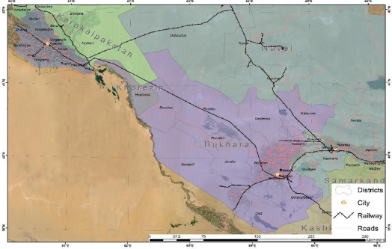

Рicture 2. Topographic map of the BMUK railway line
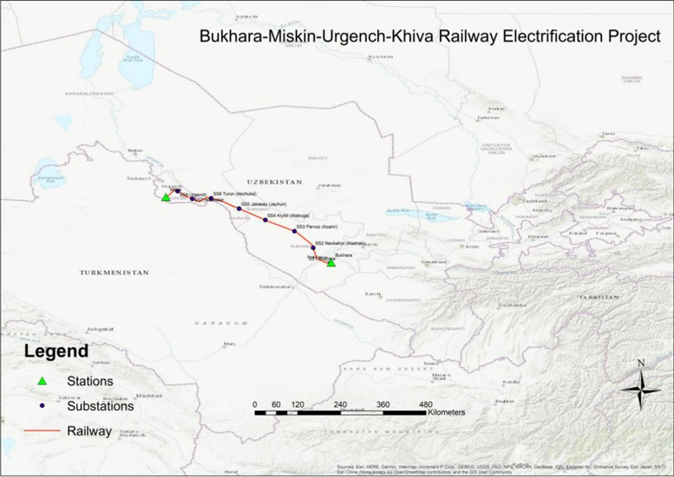

STATUS OF THE PROJECT ACTIVITIES AND KEY FINDINGS

LAR documents preparation
- The social impacts of the project were analysed and divided into components with and without land acquisition and resettlement (LAR) impacts.
- Therefore, land acquisition and resettlement aspects of the project are addressed in various social and resettlement documents such as SDDR for seven (7) TSSs without any LAR impacts and LARP for remaining one (1) sub-station.
- In addition, the impacts from the construction of the external transmission lines will be addressed in two LARP documents (LARP 1 (Bukhara region) and LARP 2 (Khorezm region)).
- The construction of TLs comprises a total of 6 transmission lines - 3 in the Bukhara region, 3 in the Khorezm region and the Republic of Karakalpakstan. Three of the lines run on 110kV and 3 (three) on 220kV, totalling 210 km of transmission lines.
- Potentially affected lands and crops were determined through field observations, topographic surveys, inventory of affected assets, Google Maps and interviews with affected persons.
- During the reporting period the ETS Consultants prepared one SDDR for 5 TSSs which have no LAR impacts (May, 2024) and LARP for Bukhara-1 TSS (February, 2024) and submitted to PIU.
- However, after the submission of the above-mentioned documents, UTY changed location of the proposed Bukhara-1 TSS to avoid land acquisition. Subsequently, it was decided to revise and update relevant social safeguards documents.
- The SDDR for seven (7) TSSs (Bukhara 1, Novbakhor, Parvoz, Kiyikli, Jayhun, Turon, Urgench) without any LAR impacts was revised and submitted to ADB in July 2024 for approval.
- The construction of 8th Khozarasp TSS will have land acquisition impact which will be addressed with separate LARP document. The detailed measurement survey was conducted, and impact identified within the reporting period. However, the valuation of identified impact and revision were carried out after the reporting period covered in this report. Details will be reported in the next semi-annual monitoring report. According to the information of valuation team (Ozdavyerlayiha - XROO) in total 2.83ha agricultural land belonging to private land user (farm enterprise) will be permanently affected.
- The table below shows LAR documentation for 8 TSSs.
Table 1. LAR documents in construction of eight (8) TSSs.
# | TSS name | Project locations,  district\tuman | Project locations,  Province | LAR Impact | Documents
 | Khozarasp | Khozarasp | Khorezm | Yes | LARP
 | Parvoz | Peshku | Bukhara | No | SDDR
 | Kiyikli | Peshku | Bukhara | No | SDDR
 | Navbakhor | Romitan | Bukhara | No | SDDR
 | Jayhun | Turtkul | Karakalpakstan | No | SDDR
 | Turon | Tuprokkala | Khorezm | No | SDDR
 | Bukhara | Kogon | Bukhara | No | SDDR
 | Urgench | Xonka | Khorezm | No | SDDR
- During the site visit for the preparation of LARP 2 (Khorezm region, TL) the Consultants was informed that the list of affected households and impacts already identified, and the valuation also completed by XROO of Ozdavyerloyihe.
- LARP-2 for construction of transmission lines in Khorezm region was prepared within the reporting period but submitted to ADB in July 2024.
- The list of affected households and impacts were identified for LARP-1 (for construction of transmission lines in Bukhara) and under valuation of Bukhara Ozdavyerloyihe.

TSSs under SDDR
- The SDD report covers the TSS Bukhara 1, Novbakhor, Jayhun, Turon and Urgench, which have no impact on land acquisition and resettlement.
- The key findings for each of these areas are listed below:
Bukhara 1 TSS
- Initially in 2020, the construction of the Bukhara-1 TSS in Bekler Makhalla in the Kogon district was planned as part of the project planning. For this purpose, 2.44 ha land plot was transferred to UTY by Decision No. 634 of the Hakim of Kogon District dated 29 June 2020. Prior to this decision, it became known that the land plot was used by the residents of Bekler village, B. Ergasov and N. Tursunova, under a 49-year lease agreement. In this context, an inventory was carried out in June 2020.
- Since the allocated land was not used by UTY for the project after the land allocation decision, the Kogon district hokimiyat re-allocated the land to another organization.
- In this context, on 23 February 2024, the railway administration decided to build the planned Bukhara TSS on the land parcel owned by Uzbekistan Railways in Kogon district. The railway administration has issued a decision No-157 on allocation of the required areas in February 2024.
- In April 2024, the new site was visited by the supervisor's consultants, the authorities were met, and it was verified that the land belongs to the Uzbekistan Railway, with cadastral document, and that the construction of the station will not affect privately owned or used lands.
Novbakhor TSS
- The area allocated for the construction of Novbakhor substation is in Romitan district of Bukhara province. The proposed TSS land plot is barren land and owned by the Government. The land plot has been allocated to JSC UTY in June 2020 with decision of Hokim of Romitan district, ref.No. 478. The area of allocated land for the construction of Novbakor TSS is three (3) hectares.
Parvoz and Kiyikli TSS
- The areas allocated for the construction of Parvoz and Kiyikli substations in Peshku district of Bukhara province. The proposed TSS land plots are pastureland and owned by the Government. The land plots have been allocated to JSC UTY with decision of Peshku Tuman Hokim is dated 12 June 2020, numbered 617. The areas of allocated lands for the construction of Parvoz and Kiyikli TSS are six (6) hectares.
- The affected pasture lands in Peshku tuman were visited and the director of department of agriculture of hokimiyyat and the previous tenants of affected lands were contacted in January 2024. It was revealed that in June 2020, the Peshku tuman hokimiyyat planned to take back these lands from the tenants with compensation. However, in September of the same year, by Decree of the President of Uzbekistan Republic all pasture lands were given to the Sericulture and Cattle Breeding Committee (O‘zbekiston Pillachilik va qorako‘lchilik qo‘mitasi). During the field assessment in January 2024, it was identified that these lands are currently reserve lands of the state, and no compensation is required for their transfer to UTY. The previous leaseholders’ contracts were amended in 2020 to reflect that change.
Jayhun TSS
- The area allocated for the construction of Jayhun substation is in Turtkul district of the Republic of Karakalpakstan is 3 hectares. The TSS land plot owned by Turtkul district hokimiyat and was transferred to UTY in December 2019 with decision of Hokim of Turtkul district of the Republic of Karakalpakstan No.5211. The allocated land for the construction of Jayhun TSS is three (3) hectares.
Turon TSS
- The area allocated for the construction of Turon substation is in Tuprokkala district of Khorezm province. The TSS site is a barren land owned by Government. It was transferred to UTY with decision of Hokim of Tuprokkala district, No.54 dated 14 May 2020. The area of the proposed land parcel is three (3) hectares.
Urgench TSS
- In February 2024, the railway administration decided to build the planned Urgench TSS on the site owned by Uzbekistan Railways since 2021 and located in Urgench district of Khorezm Province. This land was used as a parking area of railway containers. The railway administration issued a decision No-157 on allocation of the required areas on 23 February 2024. The allocated land for construction of Urgench TSS is 0,8 hectares.
Land Acquisition and Resettlement
- Due Diligence and field investigations in the first half of 2024 confirmed absence of any potential permanent or temporary livelihood impact on physical or economic displacement of any formal or informal occupants of proposed land plots for construction of Bukhara 1, Novbakhor, Jayhun, Turon and Urgench TSSs.
- No third parties are using the land of the proposed substation for residential or income earning purposes.
- All related details and decrees for allocation of lands are presented in SDDR report and will be submitted in July 2024 for approval.

Public Consultations and information disclosure
- Public consultation activities were carried out during the census and the identification of impacts for the preparation of the relevant documents. A variety of methods and tools were used to inform affected people and the local community about the details of the project, including its impacts and mitigation measures. Information was provided through public hearings, individual meetings, focus group discussions and disclosure of project documents. Details of the GRM and contact persons were also provided at the meetings.
- Information disclosure and consultations are described in two parts. The first part consists of meetings with affected households during the census, inventory of losses, and socioeconomic survey.
- During the reporting period, three (4) public consultations, two (2) focus group discussions were held.
- Representatives of the local authorities of Kogon, Romitan, Khozarasp and Urgench districts, railway administration, local women organizations, ETS international and national consultants and the local community members attended to the consultation meetings.
Table 2. Public consultation and meetings details conducted within the reporting period
# | Location | Region | Date | Participants
 | Khazarasp district | Khorezm region | 24th of January 2024 | 15
 | Urgench district | Khorezm region | 25th of January 2024 | 11
 | Kogon district | Bukhara region | 31 January 2024 | 6
 | Romitan district | Bukhara region | 24th of April 2024 | 9
- The following stakeholders were met during the site visit:
- Suvanov Uktam - Deputy head of Kogon district Hokimiyat (Executive Power) on general issues;
- Bzarov Yuldosh – Head of Bekler mahalla of Kogon district;
- Fayyoz Hamzoyev – Head of Agricultural department of Peshku tuman.
- Bernoyev Umidjan – Head of Romitan district hokimiyyat;
- Umid Soltanov – Deputy head of Romitan district Hokimiyat;
- Intizar Rahimova – Deputy head of Urgench district Hokimiyat
- Additionally, the national consultant visited and monitored of the project areas every month for preparation of monthly progress reports.
Table 3. Conducted site visits within reporting period

# | Location/districts | Region | Date
 | Urgench, Khozarasp | Khorezm Region | 22 – 26 January 2024
 | Peshku, Kogon | Bukhara Region | 31 January 2024
 | Kogon | Bukhara region | 3-4 February 2024
 | Peshku and Karakul districts | Bukhara region | 11-14 March 2024
 | Romitan, Peshku and Karakul districts | Bukhara region | 12 – 25 April 2024
 | Khozarasp, Tuprokkala | Khorezm Region | 26 April 2024
 | Khozarasp, Tuprokkala | Khorezm Region | 7-15 May 2024
 | Khozarasp, Tuprokkala | Khorezm Region | 10-14 June 2024
 | Khozarasp, Urgench | Khorezm Region | 15, 25 May 2024
 | Khozarasp, Urgench, Tuprokkala | Bukhara region | 24-28 June 2024

- During the reporting period, ADB Mission with participation of the team Leader/CEF – Shibuya Yukihiro, RETA International Consultant on Environmental Safeguard Armine Edigaryan, National Environmental Consultant TA 10110 – REG – Erkindjon Matjanov and ADB’s national social safeguards consultant Aziz Kurbanov visited the project sites.

Grievance Redress Mechanism
- At the early stages of the impact identification process, a Grievance Redress Mechanism was established by PIU. The PIU has established complaint database to record of all complaints about regular monitoring of grievances and results of services performed by the Grievance Redress Commission (GRC) for periodic review by the ADB.
- A meeting was held on 5th February 2024, with the representatives of the relevant departments of UTY such as Capital Construction Directorate, Project Implementation Unit, Bukhara Regional Railway Junction, Kungrad Regional Railway Junction and ETS Consulting Company DB for the establishment of GRC. Minutes of the meeting were taken, and the relevant members of the departments were appointed as members of the GRC to handle the complaints. (Annex 6)
Table 4: GRC members contact details
Members | Location | Occupation | Contact details
Jamshid Rasulov | Tashkent | UTY, Deputy Head of the Capital Construction Directorate | Tel: +998 99 764 88 88
Chingiz Kudabekhov | Tashkent | UTY/PIU, Deputy head of PIU | Tel: +998 71 237 99 98 (1005)
Alisher Bozorov | Bukhara | UTY, Head of the Bukhara Regional Railway Junction | Tel: +998 71 237 99 98 (1005)
Azamat Palimbetov | Kungrad | UTY, Head of the Kungrad Regional Railway Junction | Tel: +998 71 237 99 98 (1005)
Guzal Khojamyarova | Tashkent | UTY/PIU, Safeguard Specialist of the PIU | Tel: +998 90 176 51 82
Said Gulkar | Tashkent | ETS, team leader | Tel: +998 90 9060130  Email: saeid.aliakbar@db-eco.com
- The GRC should be kept operational to address timely social and/or environmental issues if any are raised during the civil works. During the implementation of the project, any complaints from the local population will be considered through the grievance redress mechanism established within the framework of the project and applied to both social and environmental protective measures. The GRC shall correspond to the GRM and consist of:
- Level 1: Railway Regional Stations offices, Construction Contractor Managers
- Level 2: Head, PIU, Safeguards officer, PIU and Representative of the relevant Hokimiyat/ mahalla or village assembly of Citizens or/and farmer’s councils, or/and women association,
- Level 3: Autorized court
Table 5: Grievance submission contact details
Level | Location | Responsible party | Contacts
Level 1 (Railway station) | Kungrad | Kungrad Railway administration | Address: 230600, Karakalpakstan Republic, Kungrad district, Uzbekistan str. 76,  Tel: (361) 312-29-43,  Email: b.axmadiev@exat.uz;rju-4@railway.u
Level 2 (UTY /GRC) | Tashkent | UTY/PIU | Address: 100060, Tashkent city, Shevchenko str.7,  Tel: +998 71 237 99 98 (1005)
- The semi-annual social monitoring, based on the review of project documents and consultation with PIU staff, confirms that there were no grievances reported during the reporting period concerning social safeguard matters.

Project Implementation and Progress of civil works
- During the reporting period, the TSSs Contractor was mobilized for the civil works for the construction of five (5) TSSs (Bukhara1, Parvoz, Jayhun, Turon, and Urgench) out of the 8 TSSs in the areas without LAR impacts which presented in SDDR.
Table 5. Civil Work Progress on construction of 5 TSSs
# | Name of TSSs | Construction progress percentage
 | Bukhara1 | 70%
 | Parvoz | 65%
 | Jayhon | 65%
 | Turon | 67%
 | Urgench | 70%

- The External Transmission Lines for energizing the Traction Sub Stations are not yet constructed at all on this 465 km, all activities were at the design stage during the reporting period.
Table 5. Schedule of LAR Implementation for 2024-2025
Project Activities | Executing agency | Implementation status | 2024 |  |  |  | 2025
Detailed design and completion/update of LARP, SDDR
Detailed design of TSS | Contractor | Completed
Conduct discussions/meetings/consultations with affected persons and other stakeholders | UTY (PIU), national and international resettlement consultants of ETS, district hokimiyat, farmer and dehkan councils and mahalla committees | Ongoing
Preparation, approval and publication of the final version of the SDDR for Bukhara, Khorezm province and Karakalpakstan Republic | UTY, DB, ADB | Completed
Preparation, approval and publication of the final version of the LARP for Khozarasp TSS | UTY, UTY, DB, ADB | Ongoing
Preparation, approval and publication of the final version of the LARP 1 for TL in Bukhara Province | UTY, UTY, DB, ADB | Ongoing
Preparation, approval and publication of the final version of the LARP 2 for TL in Khorezm Province and Karakalpakstan Republic | UTY, UTY, DB, ADB | Ongoing
LARP implementation stage
Issuing compensation, assistance | UTY (PIU),  Local hokimiyats | Not started
Handling complaints | UTY (PIU) and supervision consultant through safeguards specialists, district hokimiats | Ongoing
Monitoring and reporting | UTY (PIU) and supervision consultant through safeguard specialist | Ongoing
Construction stage
Construction at sites with no LAR impacts | Contractors | Started
Construction at sites with LAR impacts | Contractors | Not started
Completion stage
Restoration of land by the contractor along the right-of-way and other construction sites | UTY, Contractors | Not started
Restoration of access roads and entrances if they were damaged during construction work | UTY, Contractors | Not started
Consultation with local people regarding any further complaints | UTY (PIU) and supervision consultant through safeguard specialists | Not started

Gender and social aspects
- The project is categorised as Effective Gender Mainstreaming (EGM) for gender aspects. Gender design features include training female UTY staff to operate and maintain high-speed lines, training female STEM students in TVET programmes. The project also includes the development of guidelines for sustainable urban development around railway stations, which will include access and safety facilities for elderly people, women, children and people with reduced mobility. The promoter's female staff will be trained in tourism and business promotion, marketing, public health aspects such as hygiene protocols, first aid and coordination with public health facilities. The project will also develop a concept for an electronic ticketing system that provides discounts and preferential seating for the elderly, pregnant women, children and people with disabilities. The project will promote the economic empowerment of women in the communities by providing training in tourism-related professions and businesses.

- The ADB Special Technical Assistance Fund has been approved to support UTY in the preparation and implementation of key gender activities related to the project. The technical assistance will support the training of selected female STEM students in TVET programmes and female students in STEM university courses in railway operations and technology, as well as the training of women in the communities in tourism-related trades and businesses.

Monitoring and Reporting
- UTY (PIU) with support of ETS consultants systematically monitors and measures progress on social and resettlement issues of the project. The objective of monitoring is to assess the activities compliances with project related documents, agreements and national requirements. The scope of monitoring activities will be commensurate with the risks and impacts of the project.
- The implementation of the LARPs, progress of compensation payments and other resettlement activities will be monitored by UTY (PIU) and will be described in monitoring reports. The PIU will continue monitoring to provide ADB with an effective basis for assessing progress in land acquisition and resettlement and for identifying potential impacts and emerging issues.
- During the reporting period the ETS National Social safeguard consultant has prepared monthly monitoring reports for each month of between January-June 2024 and updated general quarterly monitoring reports social safeguard section and submitted accordingly.
- This semi-annual monitoring report covers January-June 2024 and will be posted on the ADB website. The next semi-annual monitoring report will be prepared for the period of July-December 2024 and will be submitted to ADB in January 2025.

COMPLIANCE WITH SAFEGUARDS PROVISIONS IN PROJECT AGREEMENTS

3.1. Compliance with project administration manual
- The Project Administration Manual (PAM) describes the main administrative and management requirements for the timely implementation of the project within budget and in accordance with the policies and procedures of the government and the Asian Development Bank (ADB). PAM is mandatory and serves as the main document describing project implementation requirements. The implementation statuses of the security requirements outlined in PAM are presented in table below.
Table 6. Compliance with PAM
Details | Compliance status | Notes
Chapter VII - Safeguards
B. Land Acquisition and Resettlement

IA will ensure that land acquisition is carried out in accordance with the requirements of the ADB SPS (2009), as well as applicable laws and regulations in Uzbekistan, which are referred to in the LARP. The IA will ensure the implementation of the LARP and monitoring to ensure that no project affected person is affected by unmanageable impacts associated with land acquisition. | In progress  (complied with) | The SDDR for seven (7) TSSs (Bukhara 1, Novbakhor, Parvoz, Kiyikli, Jayhun, Turon, Urgench) was prepared in the reporting period, but was submitted in July 2024.  The draft LARP 2 for Khorezm region TLs based on preliminary design of Contractor for construction of TL was prepared in the reporting period but was submitted in July 2024.
Qualified full-time social safeguard staff is recruited to the PIU team to implement the LARP and handle complaints related to compensation, if any. | Full compliance | Qualified full-time social safeguard specialist has been recruited to the PIU
Detailed measurement surveys (DMS), census, socio-economic surveys and adequate consultation with affected land users are carried out when the LARP is updated, and there is no downgrading of compensation entitlements from approved LARP projects. | In progress  (complied with) | DMS, census, socio-economic surveys and consultations were conducted for SDDR and  LARP for the Khozarasp TSS and LARPs (1-Bukhara region and 2-Khorezm region) for TLs during the reporting period.
The implementable LARPs must be submitted to ADB and AIIB for concurrence prior to implementation and have to be prepared as early as possible after detailed design is available. The implementable LARPs will be disclosed through ADB’s website, and the PIU will be responsible to disclose relevant information from the LARPs to the affected people. | In progress  (complied with) | Was under preparation during reporting period
No later than the date of submission by the Borrower or UTY, as the case may be, to ADB of the final LARPs based on the Project’s detailed design, engage qualified and experienced external experts or qualified non-government organizations under a selection process and terms of reference acceptable to ADB, to verify information produced through the Project monitoring process, and facilitate the carrying out of any verification activities by such external experts | Full compliance | An international social safeguard specialist hired by the ETS since 7th of January on intermittent basis to assist PIU in preparation of LAR related documents.
The notice-to-proceed for the installation phase of the plant contracts shall be done strictly after the affected households receive full payment of compensation as documented in a LARP implementation report and verified by an external monitor in a LARP compliance report to be submitted to and approved by ADB. | In progress  (complied with) | Only mobilization and design activities were done during the reporting period for installation of supports for TLs.
The final LARPs can be implemented on a sub-section basis; so that for sections not affected by the LARP, or sections completed by the LARP, notice of commencement of installation work can be sent as the compensation payment for that section is completed. The sub-sections must be defined by the final LARP, with a clear indication of the circuit, the length of each section and the mileage. The definition of sub-sections should consider not only the engineering aspect, but also the safety of the local population living near the end point of the sections, the scope of work for the contractor, and site management aspects. Sub-sections may be refined during implementation depending on progress to be clearly reflected in LARP implementation monitoring reports. Changes to subsections require ADB's prior consent before any decision is made. Changing subsections at implementation should be limited to exceptional cases only. | In progress  (complied with) | LAR documents are prepared on a sub-section phase.
ADB will also approve section-wise notice to proceed on sections which are free from LAR impacts points of view. For such cases, Social Due Diligence Reports shall be prepared for such section(s) by PIU-ET with clear indication of absence of LAR impacts and attached supporting documents. Only after the approval of SDDR(s) by ADB, notice to proceed on those sections can be given. | Partially compliance | The SDDR for 7 TSSs without LAR impacts was prepared in the reporting period but submitted to ADB in July 2024.
Semi-annual social monitoring reports (SSMRs) will be submitted throughout the project implementation period to report on the progress of LARP updating and implementation, identify unanticipated IR impacts and risks during implementation, grievance redress mechanism, and corrective actions taken. | In progress  (complied with) | The PIU submits Semi-annual Social Monitoring Reports (SSMR) for each reporting period (January-June and July-December) of the year.
All LARPs, SDDRs, LARP Implementation Reports, Compliance Reports and Social Monitoring Reports will be disclosed on its website and locally to affected communities. | In progress  (complied with) | Safeguard documents are disclosed on the website of UTY. In addition, hard copies will be provided to related hokimiyats.

3.2. Compliance with the social safeguard requirements of the loan agreement

Table 7. Compliance with loan agreement
Details | Compliance status | Notes
Schedule 4 - Project implementation
Land Acquisition and Involuntary Resettlement

UTY shall ensure that all land and all right-of-way required for the project are in accordance with the schedule agreed upon under the appropriate execution of the works contract and that all land acquisition and resettlement activities are carried out in accordance with:  (a) all applicable laws and regulations of the Borrower relating to land acquisition and involuntary resettlement; (b) safeguard measures relating to involuntary resettlement; (c) a social due diligence report, including the corrective actions set out in such report; (d) each LARP; and (e) any corrective or preventive action set out in the Safeguard Monitoring Report. | In progress  (complied with)
Without limiting the application of the Involuntary Resettlement Safeguards or any LARP, the Borrower shall ensure or cause UTY to ensure, that no physical or economic displacement takes place in connection with the Project until:  - compensation and other entitlement have been provided to affected people in accordance with the SDDR and the relevant LARP  - a comprehensive income and wealth restoration program has been established in accordance with the SDDR and the relevant LARP. | In progress  (complied with) | The mobilisation and civil works started in the areas without LAR impacts.
The Borrower shall ensure and cause UTY to ensure that, subsequent to the award of any Works contract involving involuntary resettlement impact, no notice to commence works is issued to the contractor in relation to any section or part such Works unless the applicable provisions of the applicable LARPs have been implemented, and the LARP Compliance Report prepared by an external expert or an NGO in accordance with paragraph 13(c) and describing progress with implementation of, and compliance with the provisions of the applicable LARP or LARP to such section or part of Works, including any corrective and preventive actions, has been submitted to and approved by ADB. The Borrower shall further ensure and cause UTY to ensure that all involuntary land acquisition and resettlement due diligence in relation to the Existing Facilities, including the update and satisfaction of all requirements and actions set out in the SDDR are completed before any construction work under any Works contract. | In progress  (complied with)
Indigenous peoples
The Borrower will ensure and obligate UTY to ensure that the Project does not have any impact on Indigenous Peoples as defined in the Safeguard Policy Statement. In the event that the Project does have any such impact, the Borrower shall and shall cause UTY to take all steps required to ensure that the Project complies with the applicable laws and regulations of the Borrower and the SPS. | N/A | The project was categorized as Category C for the protection of indigenous peoples. There are no Indigenous Communities within the project area or country as defined in the SPS for operational purposes. Accordingly, no planning documents of indigenous peoples will be required.
Human and financial resources to meet safeguard requirements
The Borrower shall provide or obligate UTY to provide the necessary financial and human resources for the implementation of each EMP, Social Due Diligence Report, including the corrective actions set forth in such report, and each LARP. | Full compliance | The UTY has already employed Safeguard Specialist for the implementation and monitor of Social and Environmental aspects of the project.
Guarantee Provisions in Tender Documents and Work Contracts
The Borrower shall, or cause UTY to ensure that all bidding documents and work contracts contain provisions requiring contractors to:  (a) comply with the measures relating to the contractor set out in the IEE, each EMP in the Due Diligence Report (to the extent that they relate to impacts on people injured during construction), each LARP, and any corrective or preventive actions as set out in the Safeguard Monitoring Report.  - make available a budget for all such environmental and social measures.  - provide the Borrower with written notice of any unanticipated environmental, resettlement, or impact on Indigenous Peoples risks arising from the construction, implementation, or operation of the Project or Existing Facilities were not considered in the IEE, any EMP, the SDDR, or any LARP.  - adequately record the condition of roads, agricultural land and other infrastructure prior to starting transport materials and construction.  - upon completion of construction, reinstate pathways and other local infrastructure to at least their pre project condition, and recultivate agricultural land. | In progress  (complied with) | There are clauses in the bidding documents regarding provisions and requirements regarding safeguards; LARP, IEE and EMP are appendices to BD and construction contracts.
Safeguards monitoring and reporting
The Borrower will ensure and obligate UTY to ensure:  - submit semi-annual Safeguard Monitoring Reports to ADB and disclose relevant information from such reports to affected persons promptly upon submission.  - If any unanticipated environmental and/or social risks and impacts arise during construction, implementation or operation of the Project, the Existing Facilities that were not considered in the IEE, any EMP, the SDDR or any LARPs, promptly inform ADB of the occurrence of such risks or impacts, with a detailed description of the event and a proposed corrective action plan;  - no later than, as the case may be, the date of submission to ADB by the Borrower or UTY of the final LARP based on the detailed design for this Project, engaging qualified and experienced external experts or qualified non-governmental organizations in the selection process, and based on terms of reference acceptable to ADB, for the purpose of verifying the information obtained in the course of monitoring the project, and assisting in the adoption of all verification measures by these external experts;  - report any actual or potential breach of compliance with the measures and requirements set in the IEE; each EMP; SDDR, including the corrective actions in such report and each LARP promptly after becoming aware of the breach. | In progress  (complied with) | The PIU submits semi-annual social safeguards monitoring reports and semi-annual environmental monitoring reports to ADB. All reports are published on the ADB and IA websites.
List of prohibited investments
The Borrower shall ensure and obligate UTY to ensure that no proceeds of the Loan are used to finance any activity included in the list of prohibited investments activities provided in Appendix 5 of the SPS. | Full Compliance
Labor standards, health, and safety
The Borrower will ensure and obligate UTY to ensure that during the implementation of the Project, basic labor standards and applicable laws and regulations of the Borrower are observed. The Borrower will require UTY to ensure that special provisions are included in bidding documents and contracts financed by ADB under the Project requiring contractors, among other things, to: (a) comply with applicable labor laws and regulations of the Borrower, and comply with workplace safety ; (b) did not use child labor; (c) do not discriminate against workers in terms of employment and type of employment; (d) did not use forced labor; (e) allow freedom of association and effectively recognize the right to collective bargaining; and (f) disseminate or engage appropriate service providers to disseminate information about the risks of sexually transmitted diseases, including HIV/AIDS, among the contractors involved in the Project and among members of local communities living around the Project area, especially among women. | In progress  (complied with) | All these issues and requirements are included in the Special Conditions of Construction Contracts and are an integral part of all contracts. These requirements are also regularly monitored and included in the semi-annual safeguard and environmental monitoring reports.
Gender and development
The Borrower will ensure and obligate UTY to ensure that (a) the GRAP is implemented in accordance with its terms; (b) tender documents and contracts include appropriate provisions for contractors to comply with the measures set out in the GRAP; (c) appropriate resources are allocated for the implementation of the GRAP; and (d) progress in the implementation of the GRAP, including progress towards key gender outcomes and targets, was regularly monitored and reported to ADB. | In progress  (complied with)

CONCLUSIONS AND RECOMMENDATIONS

Conclusion
- The Railway Electrification Project (Bukhara-Miskin-Urgench-Khiva) has made considerable progress in the first half of 2024. Key activities such as the preparation of Land Acquisition and Resettlement Plans (LARPs) and Social Due Diligence Report (SDDR) have been diligently carried out. Public consultations and the establishment of a GRM have ensured community involvement and addressed concerns effectively. The project has also adhered to the ADB SPS 2009 and national regulations, ensuring compliance with social safeguard requirements.

- As explained in the previous sections, the SDDR and LARP for Khozarasp TSSs and LARP 2 for TL in Khorezm region were drafted in the reporting period which planned to be submitted after the reporting period. The project has faced delay in valuation of identified impacts in Bukhara region which resulted in delay in LARP 1 (for TL in Bukhara region) preparations.

Recommendations
- Accelerate LARP Finalization: Expedite the finalization, approval, and disclosure of the SDDR for 7 TSSs, LARP for the Khozarasp TSS and LARPs for the TLs in Bukhara and Khorezm regions.

- Ensure that all LAR documents submitted to ADB for approval prior to implementation as per the revised schedule.

- Enhance Public Consultation Efforts: Continue and expand public consultation activities to ensure ongoing community engagement and address any emerging concerns promptly. Utilize diverse methods such as individual meetings, and public hearings to reach all stakeholders and affected bodies.

- Strengthen GRM: Maintain and enhance the GRM to ensure it remains accessible and responsive to the community. Regularly update the grievance database and monitor the resolution of complaints to ensure transparency and accountability.

- Ensure no construction in the areas with LAR impacts before implementation of the relevant LARPs, such as full compensation payments, meaningful consultations, and provision of other assistances as per the entitlement matrix of LARPs.

ANNEX

Annex 1. List of participants in consultations

- Khozarasp district

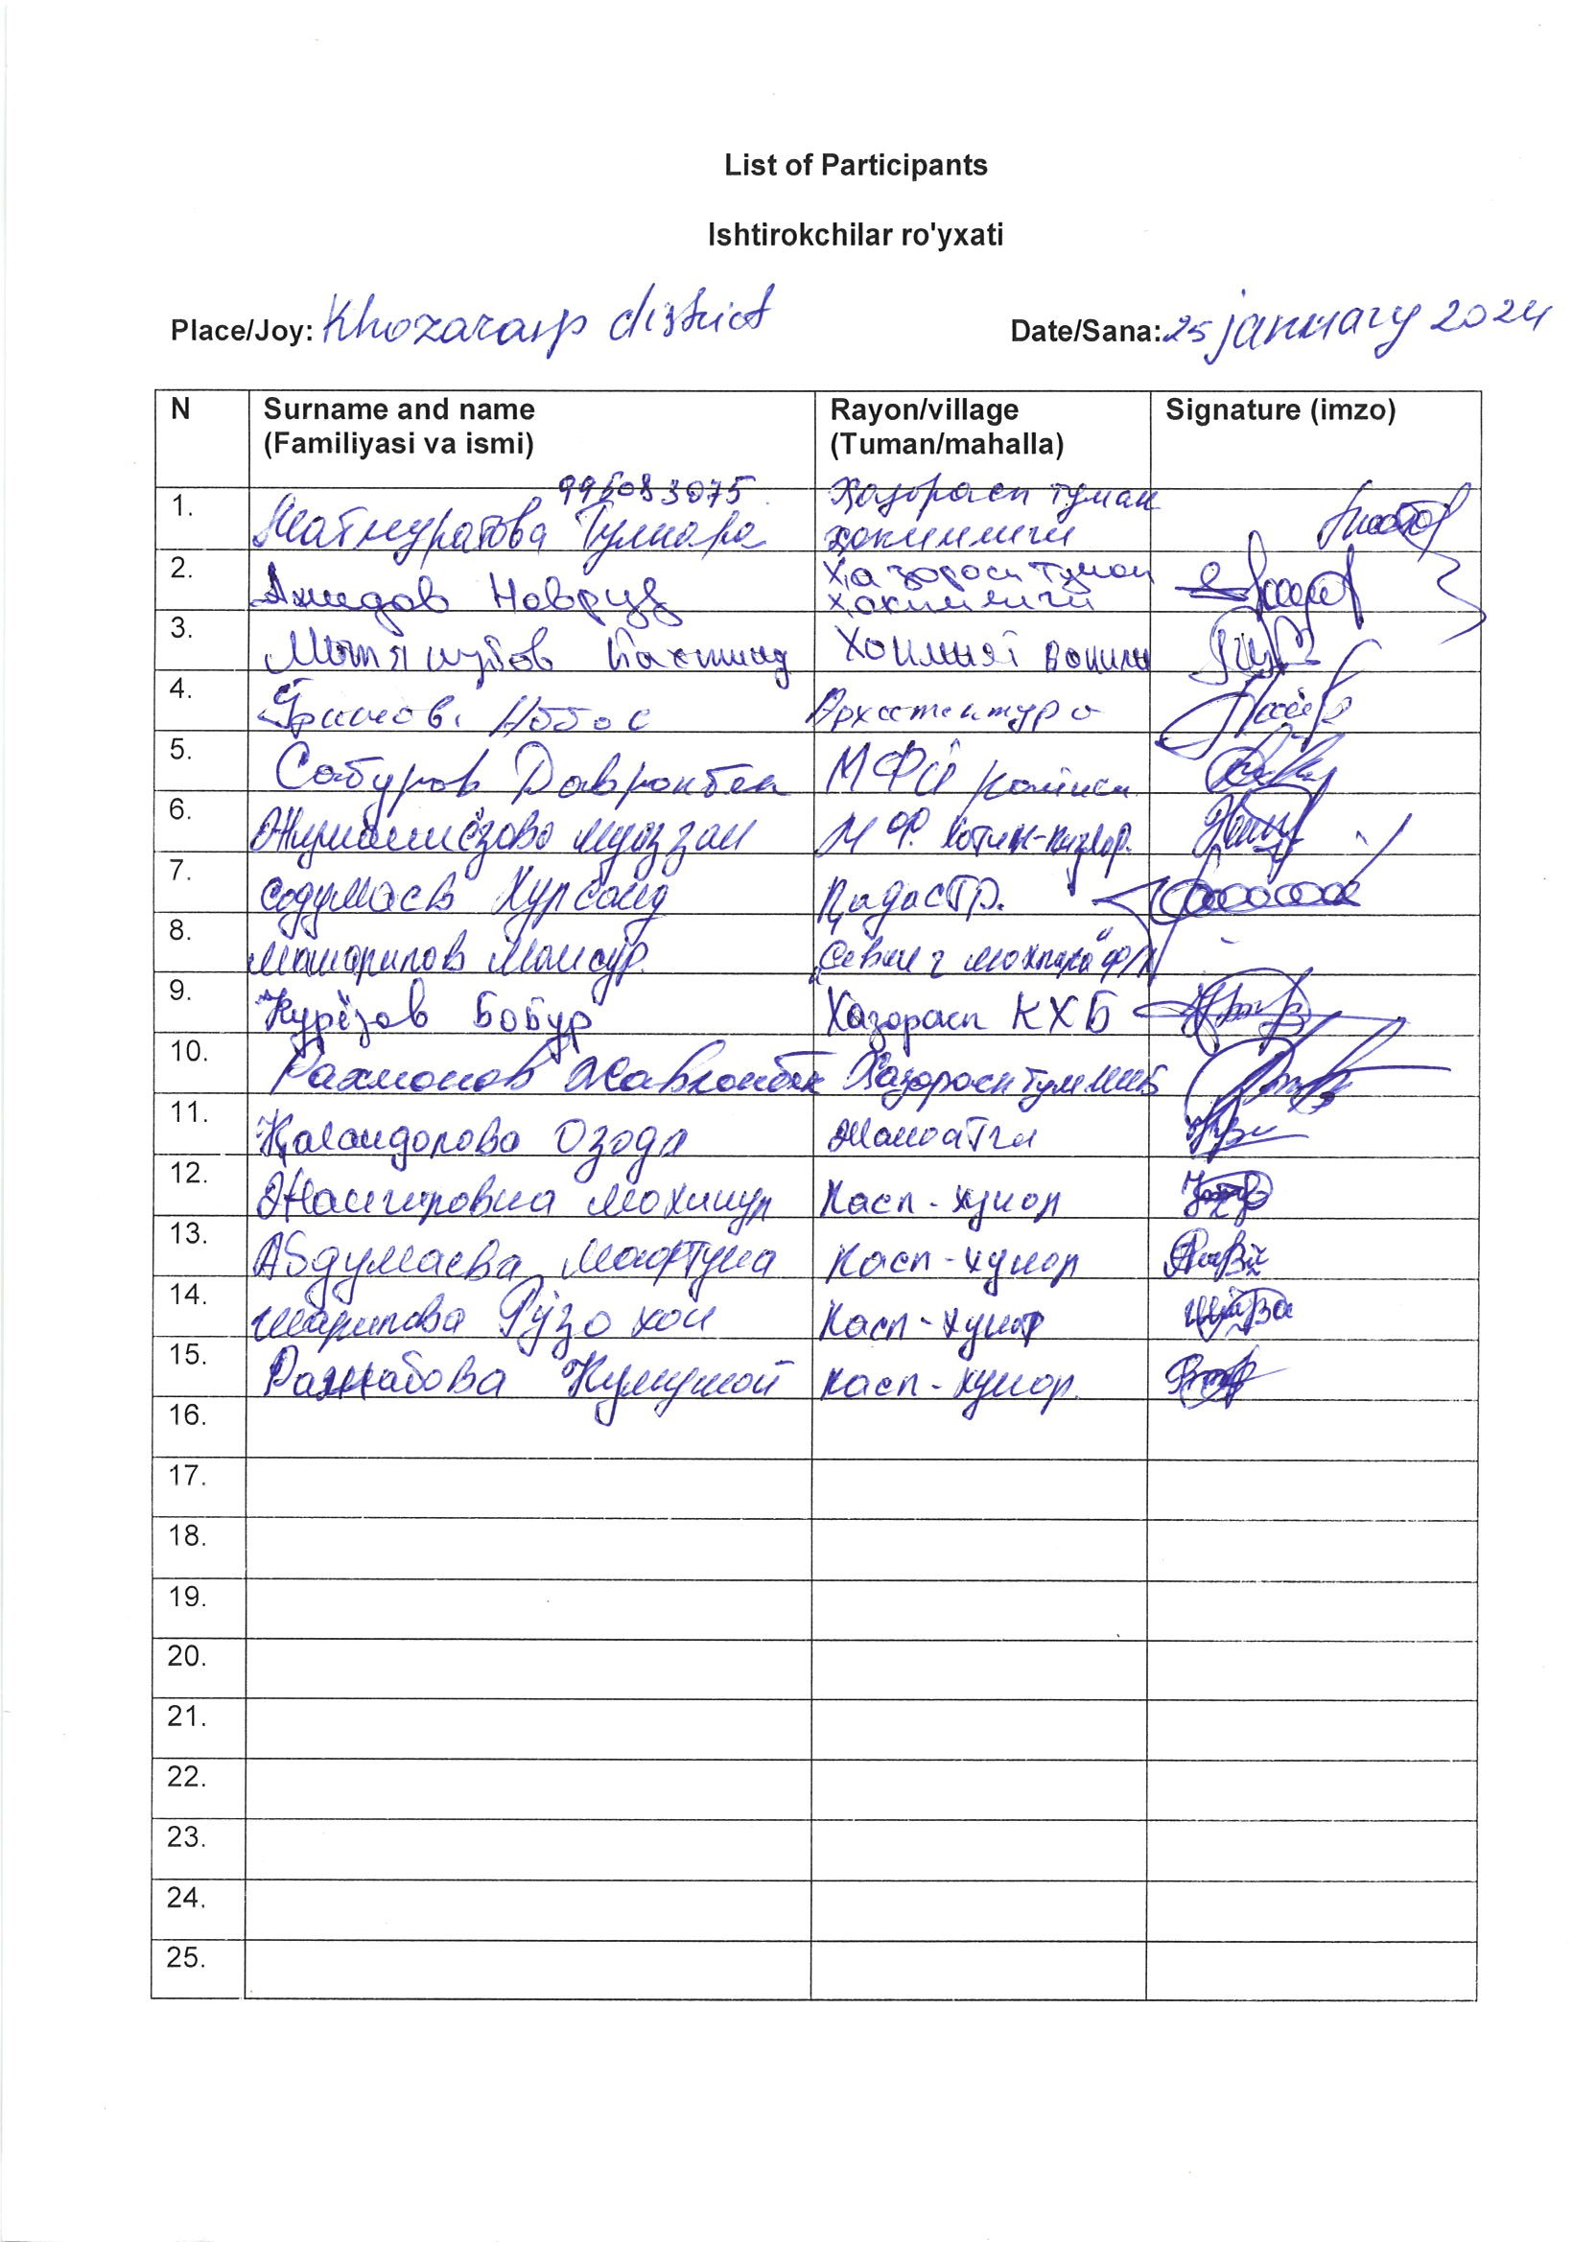
- Kogon district

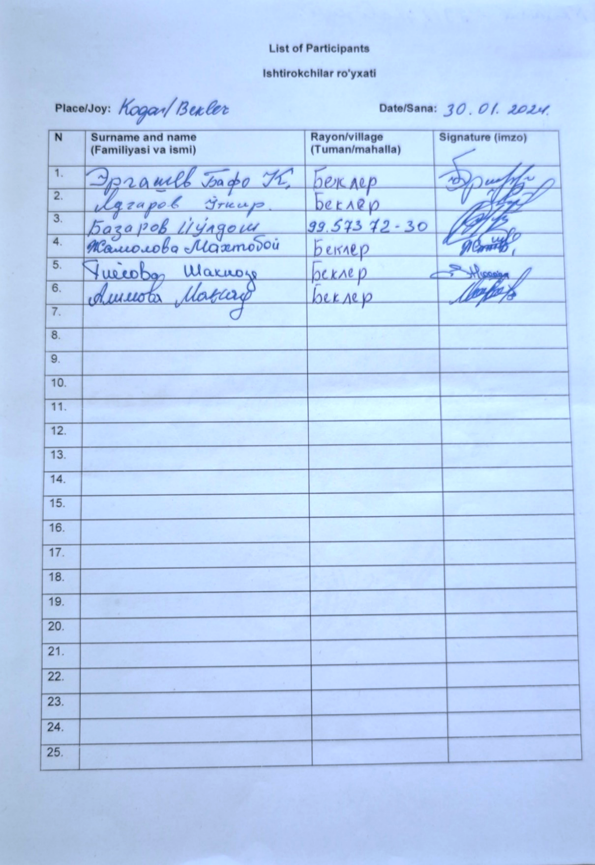

- Romitan district
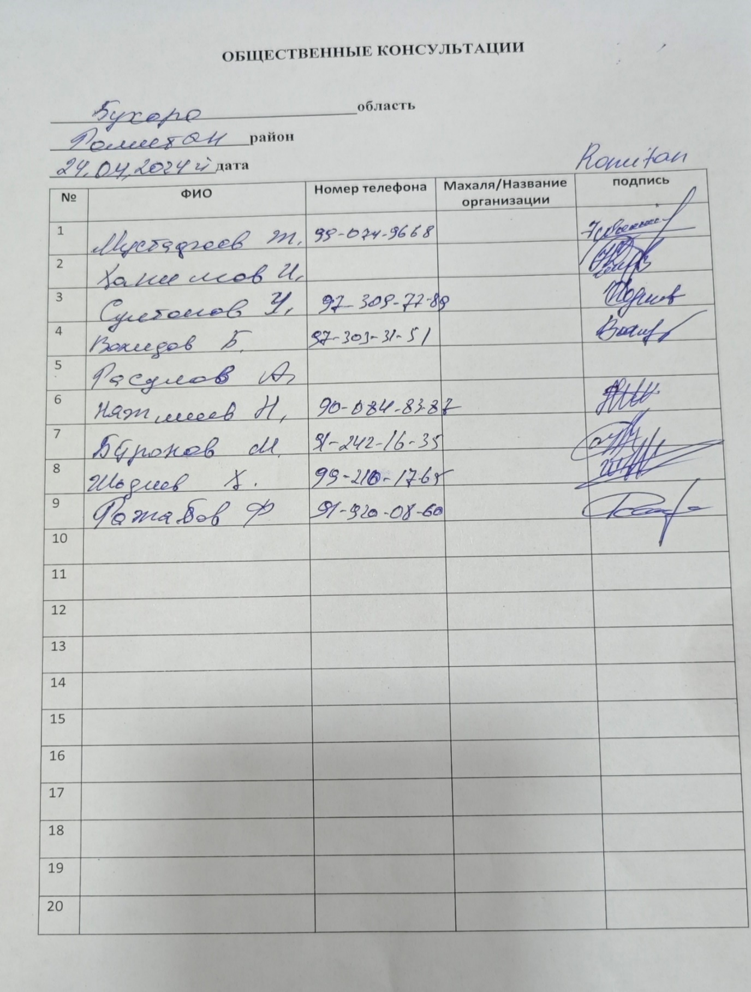

- Urgench district
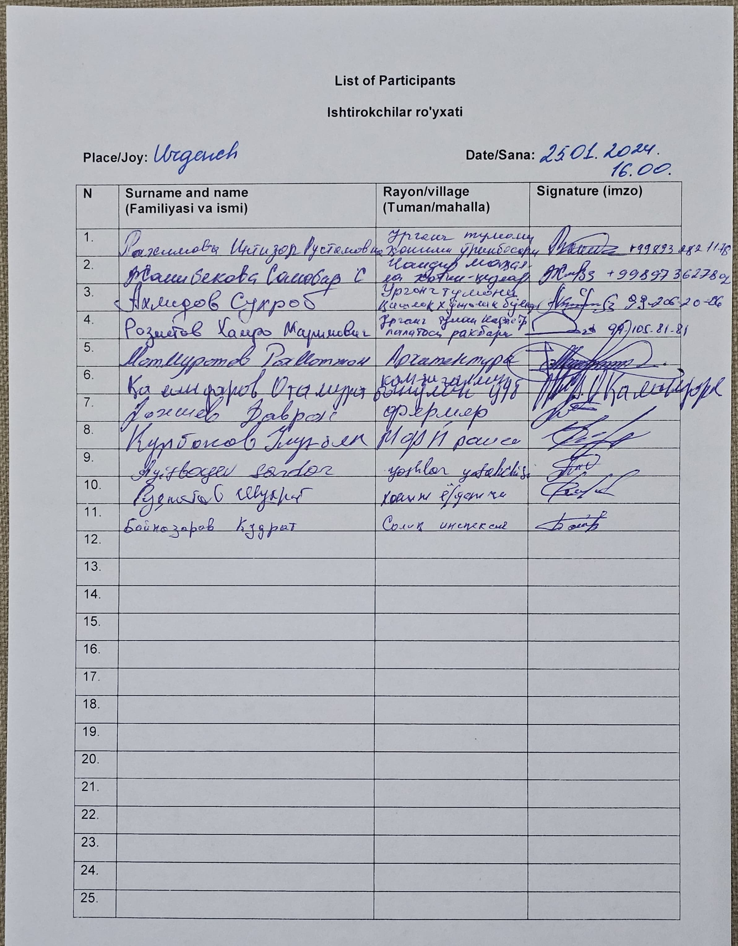

Annex 2. Photos of consultation and meetings

Kogon district (31th of January 2024)
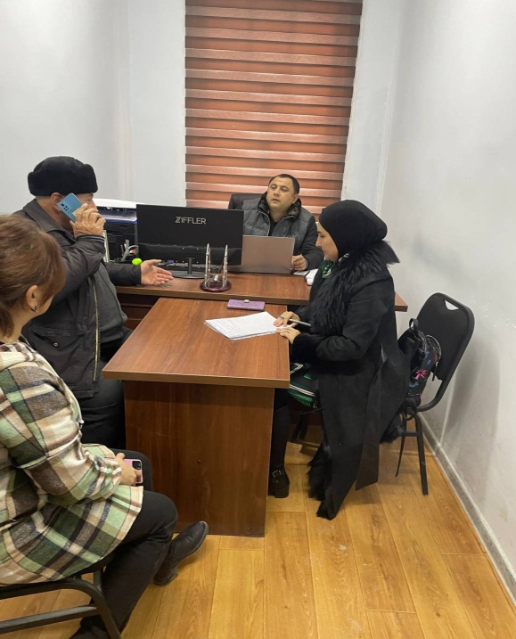 | 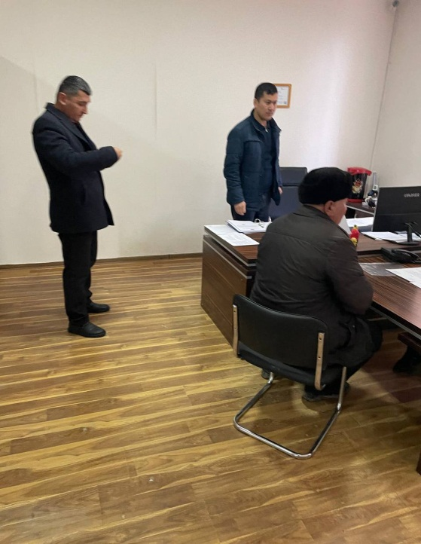
Khozarasp district (24th of January, 2024)
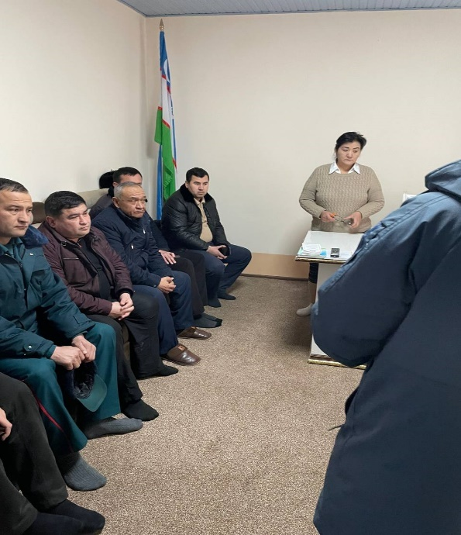 |  | 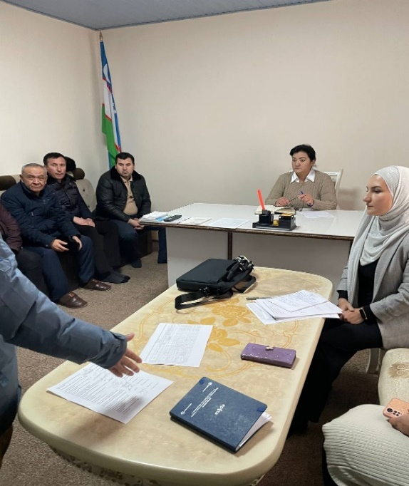
Urganch district (25th of January, 2024)
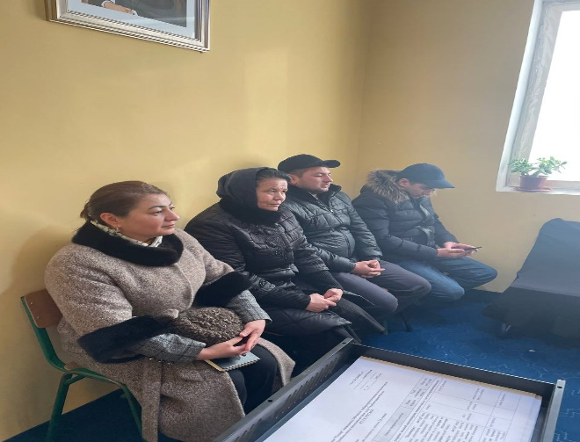 |  | 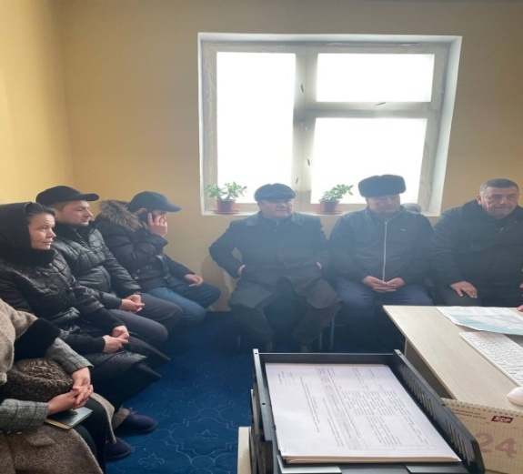
Romitan district (24th of January, 2024)
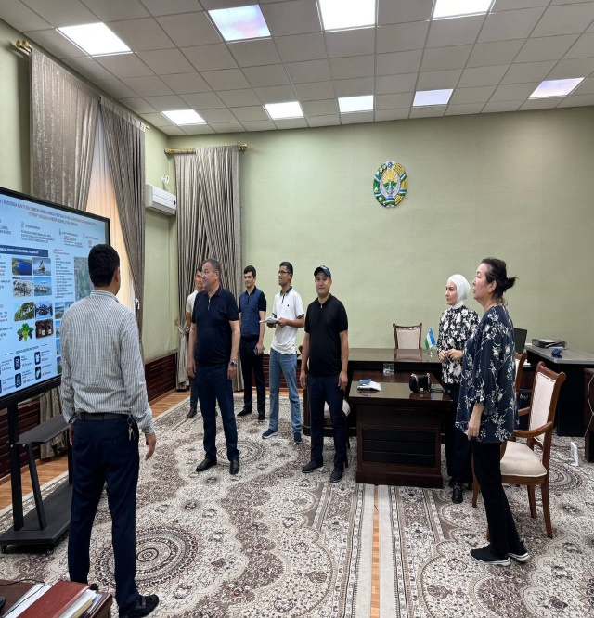

Annex 3. Photo of focus group discussion, Khozarasp district (24th of January, 2024)
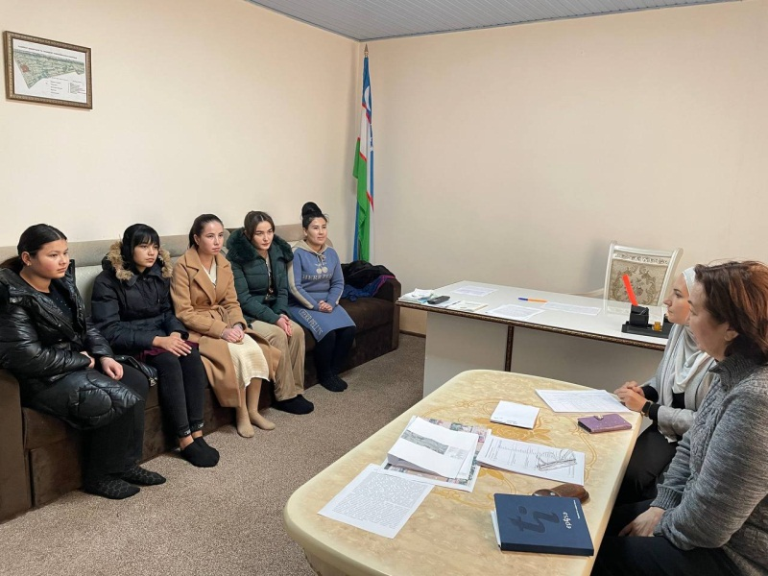

Annex 4. Photos of face-to-face meetings

Face-to-face meetings with community members and affected persons due to construction of external transmission lines

Kogon districts (20 April 2024)
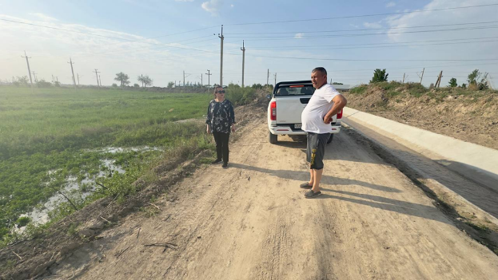 | 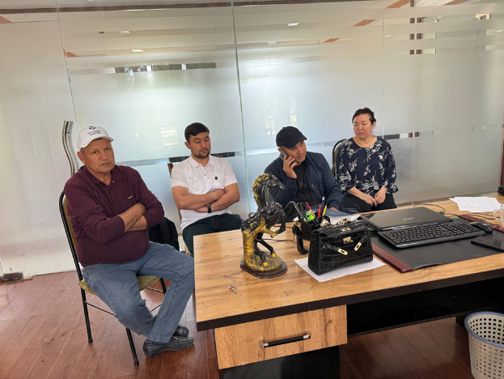
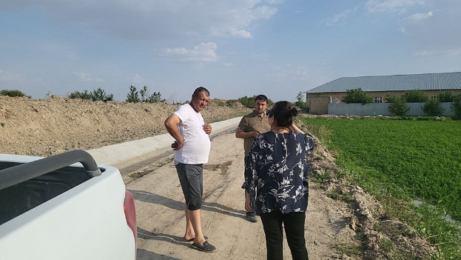 | 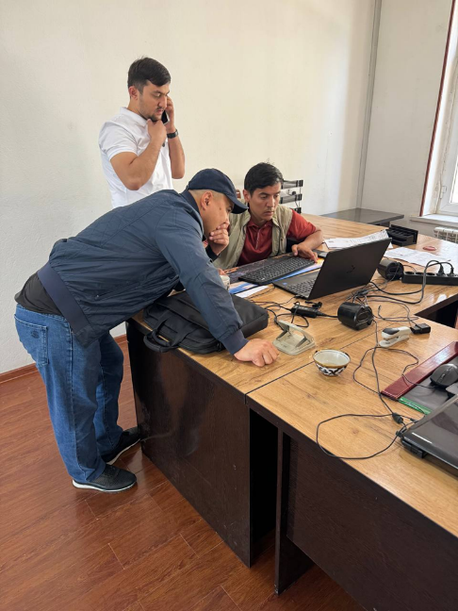

Annex 5. Photos of areas of proposed TSSs

Bukhara region

TSS Bukhara 1
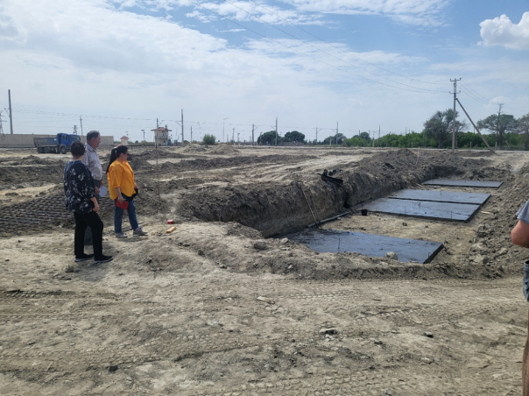

TSS Novbakhor
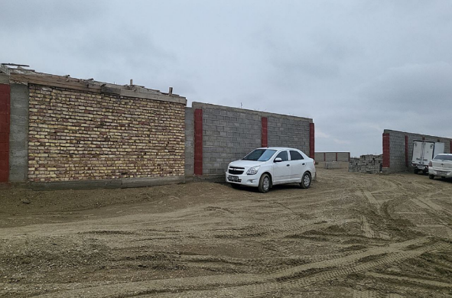

TSS Karakul
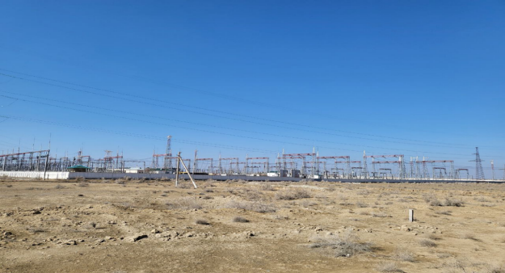

Khorezm region

TSS Urgench
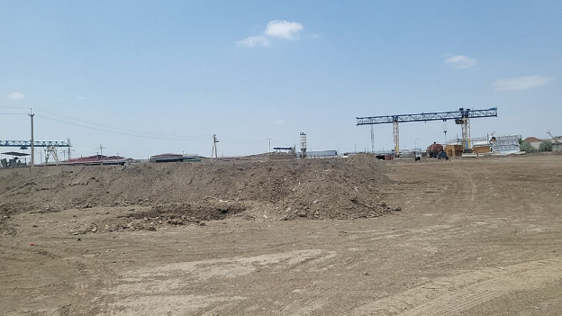

TSS Jayhun
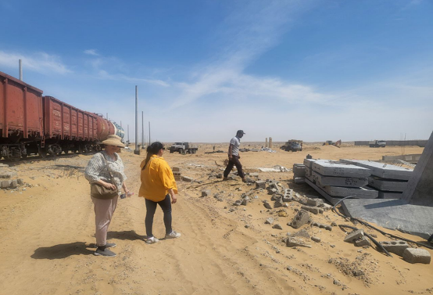

TSS Khozarasp
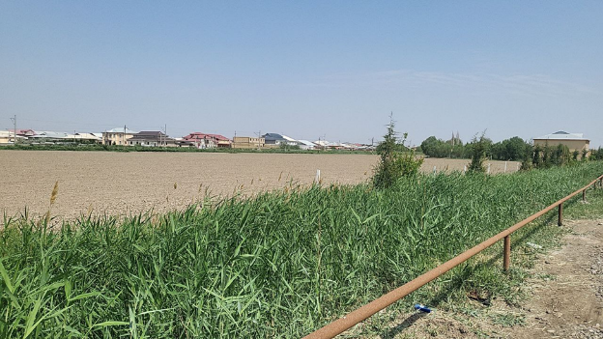

Annex 6. Protocol of the meeting for establishment of GRC

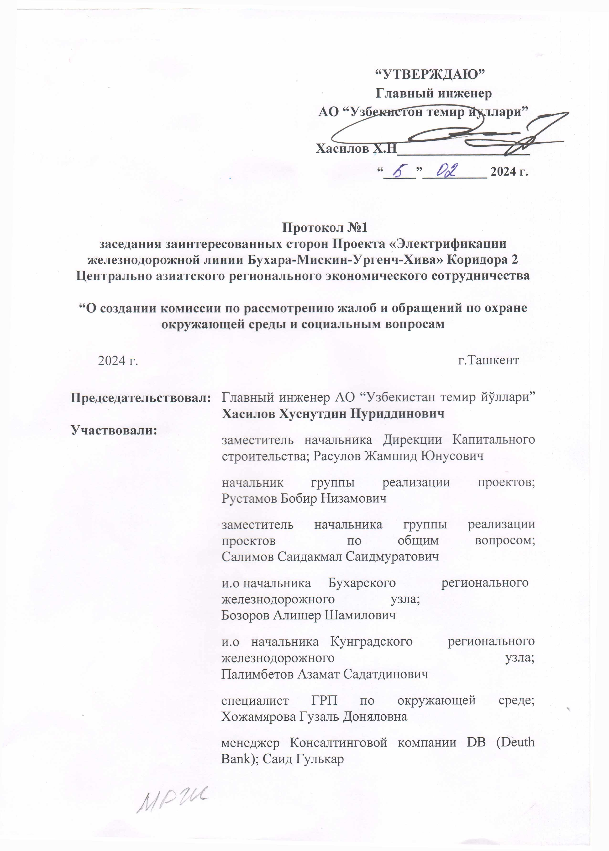

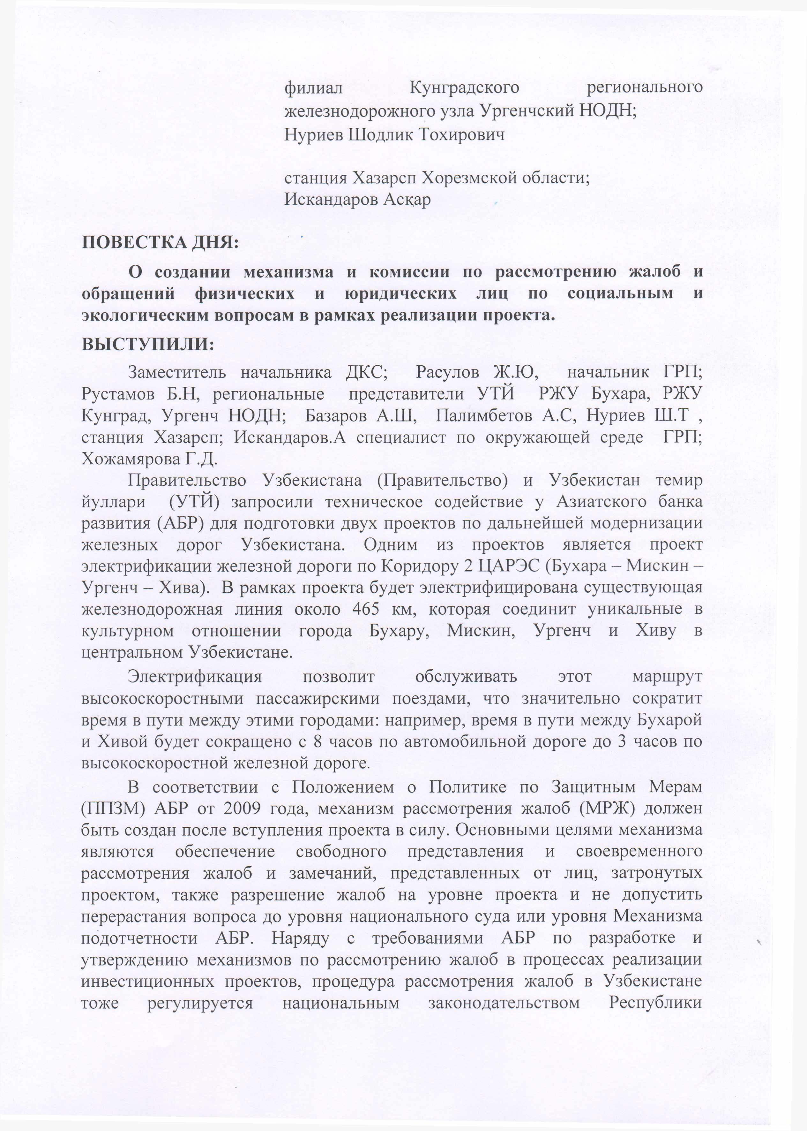

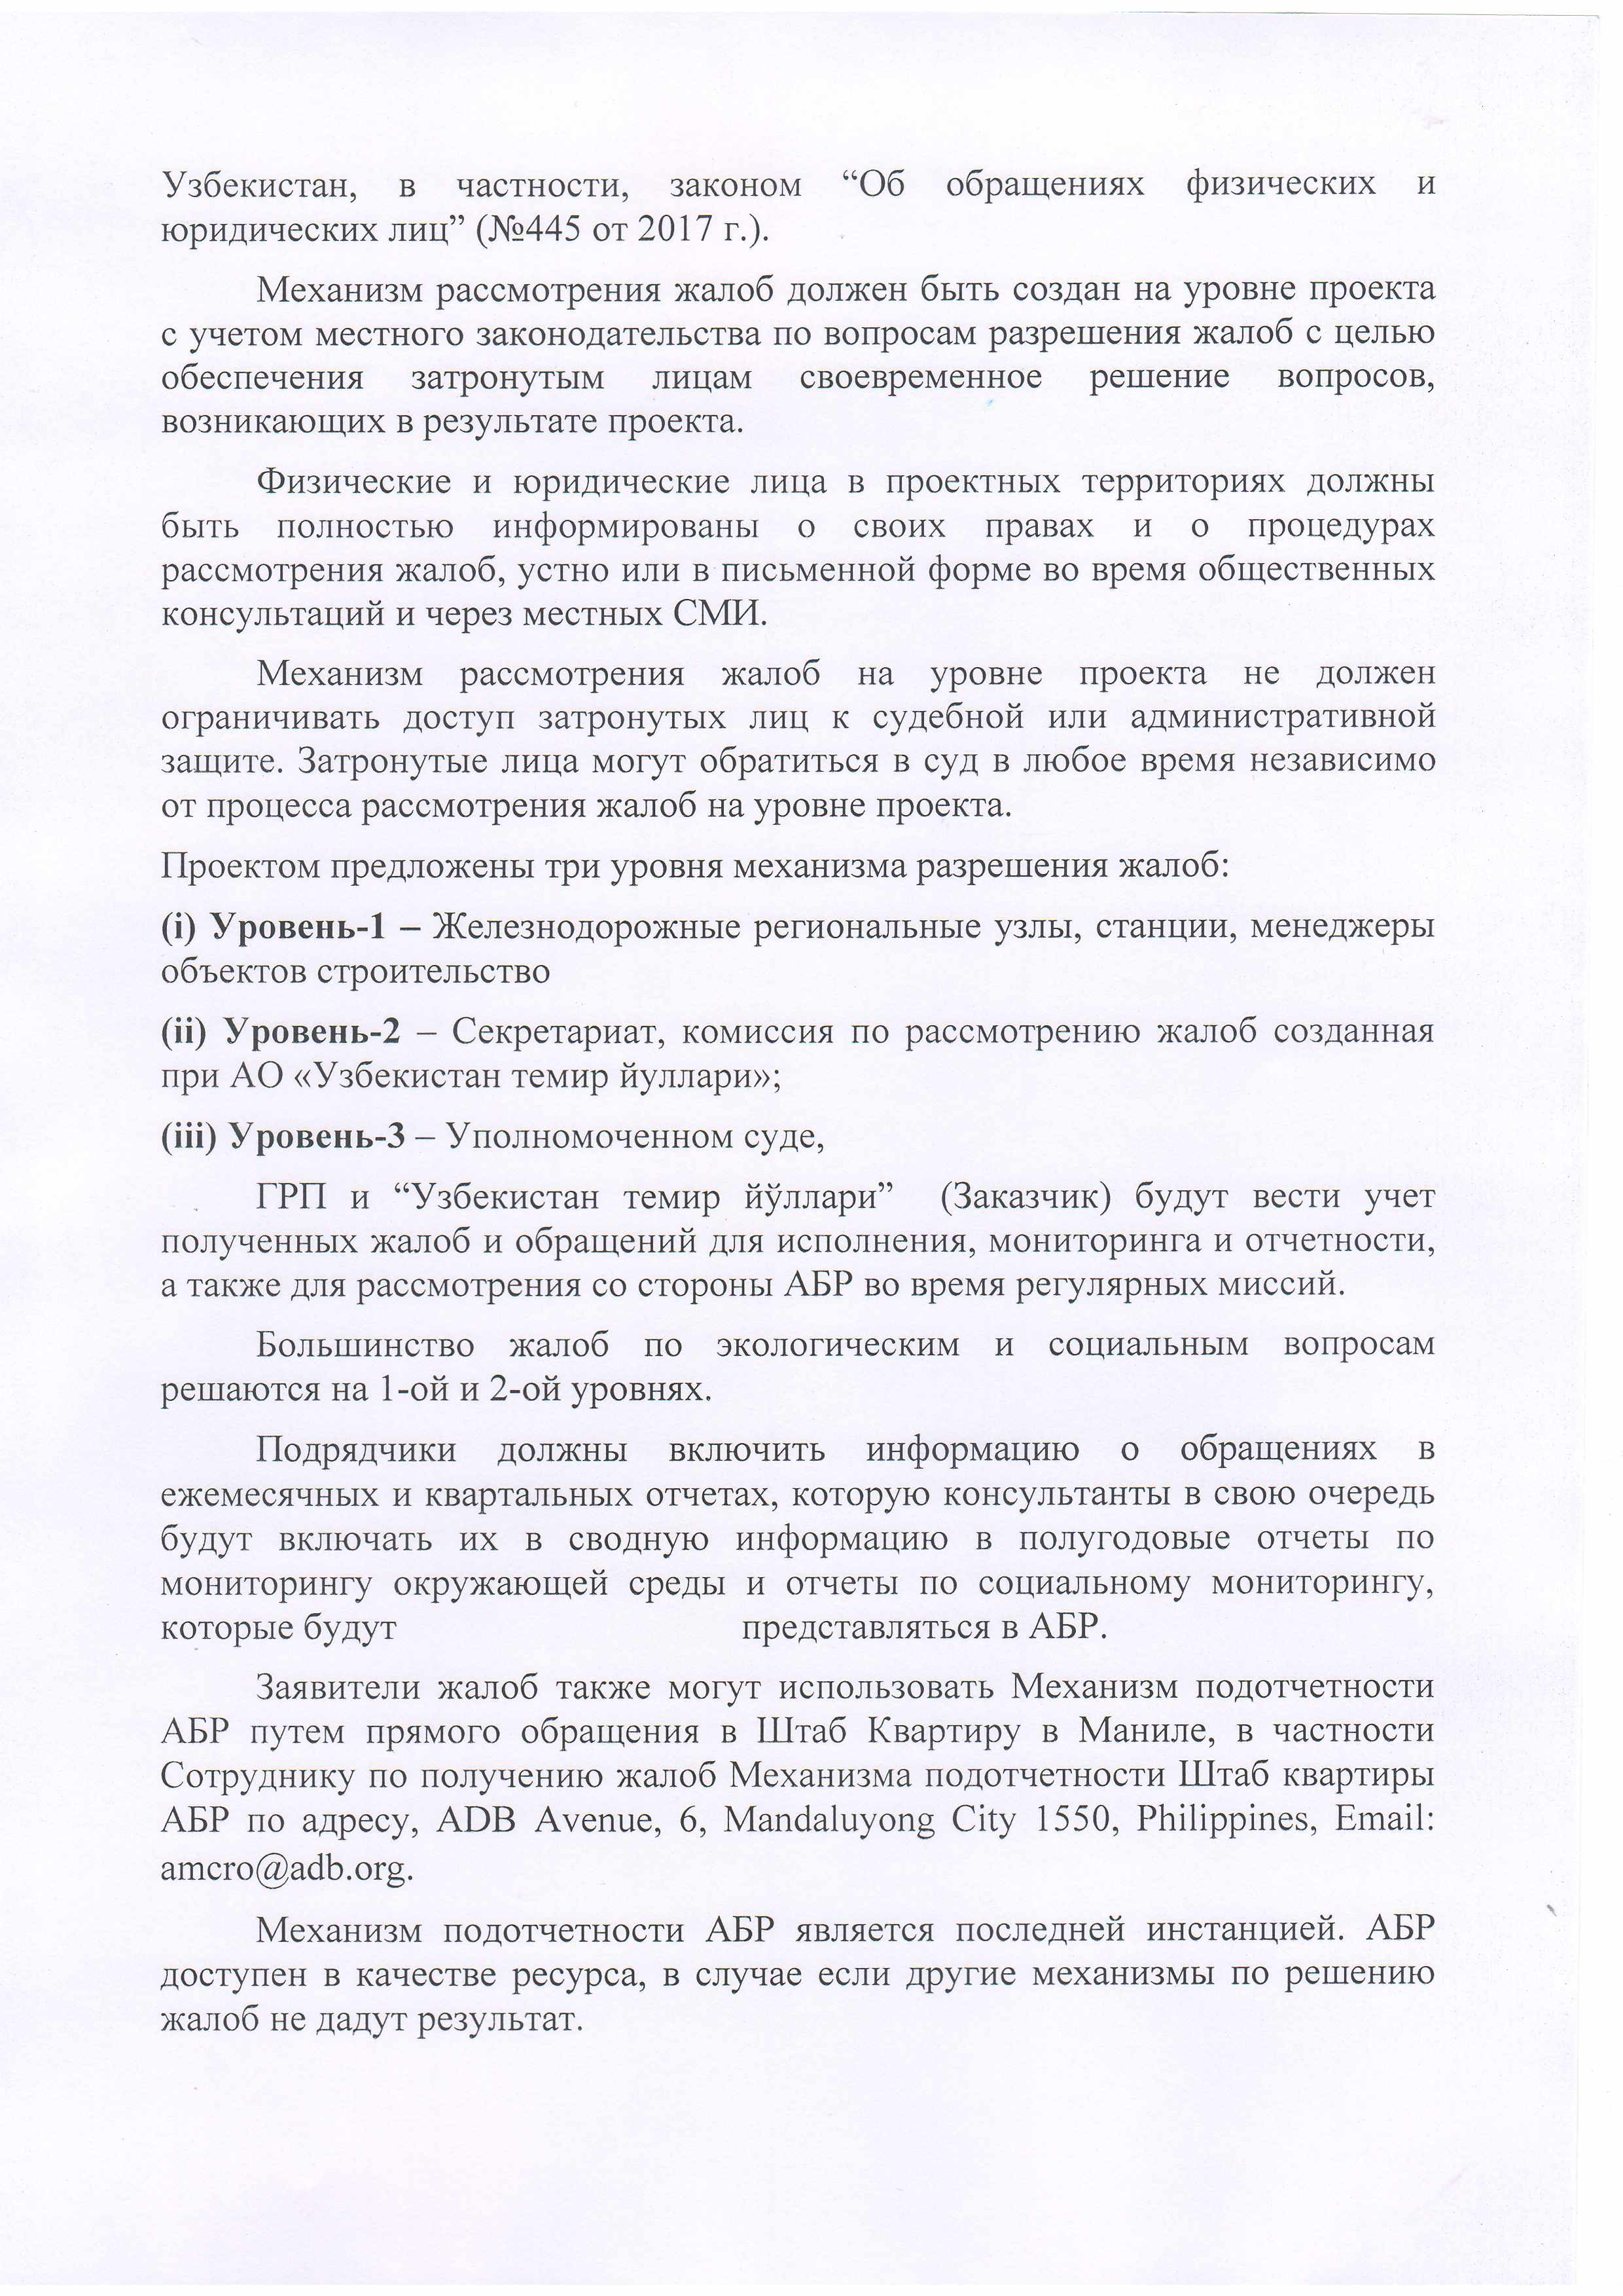

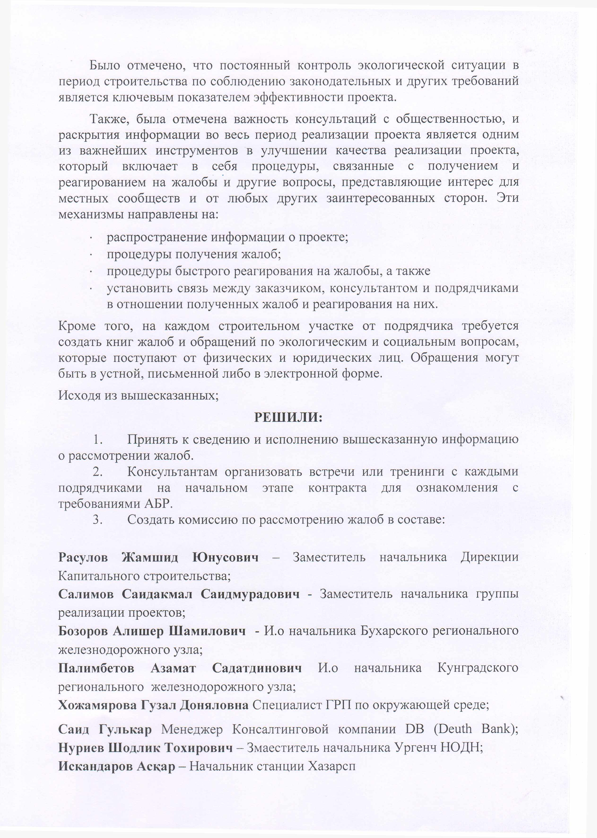



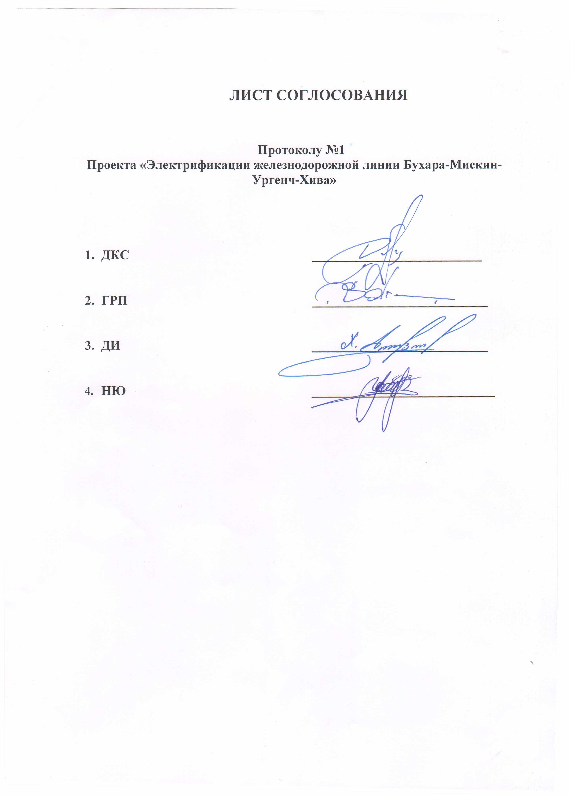

TRANSLATION
“APPROVED”
Chief Engineer of JSC ‘O’zbekiston Temir Yo’llari’ Khasilov Kh.N.
05.02.2024
Protocol №1

Meetings of stakeholders of the Bukhara-Misken-Urgench-Khiva Railway Line Electrification Project of Corridor 2 of the Central Asian Regional Economic Cooperation
On the establishment of a Grievance Redress Commission for the consideration of complaints and appeals on environmental and social issues
Tashkent, 2024

Chaired by: Chief Engineer of JSC ‘O’zbekiston Temir Yo’llari’
Khasilov Khusnutdin Nuriddinovich
Participated:
Deputy Head of the Capital Construction Directorate: Rasulov Jamshid Yunusovich
Head of Project Implementation Unit: Rustamov Bobur Nizamovich
Deputy Head of the PIU for General Issues: Salimov Saidakmal Saidmuratovich
Head of the Bukhara Regional Railway Junction: Bozorov Alisher Shamilovich
Head of the Kungrad Regional Railway Junction: Palimbetov Azamat Sadatdinovich

Environmental Specialist of the PIU: Khojamyarova Guzal Donyalovna
Manager of the Consulting Company DB: Saeid Golkar

AGENDA:

On the creation of a mechanism and commission for reviewing complaints and appeals from individuals and legal entities on social and environmental issues within the framework of the project implementation.
SPEAKERS:
Deputy Head of the CCD; Rasulov J.Y., Head of the PIU; Rustamov B.N., regional representatives of the UTY RRJ Bukhara, RRJ Kungrad; Bazarov A.Sh., Palimbetov A.S., environmental specialist of the PIU; Khojamyarova G.D.
The Government of Uzbekistan (Government) and O’zbekiston Temir Yo’llari (UTY) have requested technical assistance from the Asian Development Bank (ADB) to prepare two projects to further modernize Uzbekistan’s railways. One of the projects is the electrification of the CAREC Corridor 2 (Bukhara-Miskin-Urgench-Khiva) railway. The project will electrify an existing railway line of approximately 465 km, connecting the culturally unique cities of Bukhara, Miskin, Urgench and Khiva in central Uzbekistan.
Electrification will allow this route to be served by high-speed passenger trains, which will significantly reduce travel time between these cities; for example, travel time between Bukhara and Khiva will be reduced from 8 hours by road to 3 hours by high-speed rail.
In accordance with the ADB Safeguard Policy Statement (SPS) of 2009, a grievance redress mechanism (GRM) shall be established after the project comes into effect. The main objectives of the mechanism are to ensure free submission and timely consideration of complaints and comments submitted by project-affected persons, as well as to resolve complaints at the project level and prevent the issue from escalating to the level of a national court or the ADB Accountability Mechanism. Along with the ADB requirements for the development and approval of grievance redress mechanisms in the implementation of investment projects, the grievance redress procedure in Uzbekistan is also regulated by the national legislation of the Republic of Uzbekistan, in particular, the Law “On Appeals of Individuals and Legal Entities” (N445 of 2017).
A grievance redress mechanism should be established at the project level, taking into account local legislation on grievance resolution, to ensure that affected persons receive timely resolution of issues arising from the project.
Individuals and legal entities in project areas should be fully informed of their rights and of grievance procedures, orally or in writing during public consultations and through local media.
The project-level grievance redress mechanism should not limit the access of affected persons to judicial or administrative remedies. Affected persons may resort to court at any time, independent of the project-level grievance redress process.

The draft proposes three levels of complaint resolution mechanism:
- Level 1 — Regional stations of Railway, Construction Contractor
- Level 2 — The commission for consideration of complaints was created under JSC “O’zbekiston Temir Yo’llari”;
- Level 3 — Authorized court.
The PIU and “O’zbekiston Temir Yo’llari” (the Client) will maintain records of complaints and appeals received for implementation, monitoring and reporting, as well as for consideration by ADB during regular missions.
Most environmental and social complaints are resolved at levels 1 and 2.
Contractors will include information on complaints in monthly and quarterly reports, which consultants will in turn include in summary information in the semi-annual environmental monitoring reports and social monitoring reports to be submitted to ADB.
Complainants may also utilize ADB's Accountability Mechanism by directly contacting ADB Headquarters in Manila, specifically the Accountability Mechanism Complaint Receipt Officer, ADB Headquarters, ADB Avenue, 6, Mandaluyong City 1550, Philippines, Email: amcro@adb.org.
ADB's accountability mechanism is a last resort, and ADB is available as a resource if other grievance mechanisms fail.
It was noted that constant monitoring of the environmental situation during the construction period for compliance with legislative and other requirements is a key indicator of the project’s effectiveness.
Also, the importance of public consultation and disclosure of information throughout the project implementation period was noted as one of the most important tools in improving the quality of project implementation, which includes procedures related to receiving and responding to complaints and other issues of interest to local communities and any other interested parties. These mechanisms are aimed at:
distributing information about the project;
procedures for receiving complaints;
procedures for prompt response to complaints, and
establishing communication between the client, consultant and contractors regarding complaints received and responses to them.
In addition, at each construction site, the contractor is required to create a book of complaints and requests on environmental and social issues received from individuals and legal entities. Requests can be oral, written or electronic.
Based on the above;

DECIDED:

1. Take note and implement the above information on the consideration of complaints.
2. Consultants to arrange meetings or trainings with each contractor at the initial stage of the contract to familiarize them with ADB requirements
3. Create a complaints review committee consisting of:

Rasulov Jamshid Yunusovich - Deputy Head of the Directorate of Capital Construction;
Chingiz Kudabekhov - Deputy Head of the PIU;
Bozorov Alisher Shamilovich - Head of the Bukhara Regional Railway Junction;
Palimbetov Azamat Sadatdinovich - Head of the Kungrad Regional Railway Junction;
Khojamyarova Guzal Donyalovna - Environmental Specialist of the PIU;
Saeid Golkar - Manager of the DB Consulting Company (Deutsche Bahn);
When members of the commission transfer to another job, their composition shall include persons newly appointed (elected) to these positions or who are entrusted with the performance of the corresponding functions.
Members of the complaints review committee shall widely inform rural citizens' assemblies and the local community about the existence of a complaints book in the event of detection of violations in the area of ​​environmental protection.

Conducted the protocol Khojamyarova Guzal

After the reporting period (Jan-June 2024)

