Social Safeguard Monitoring Report

Semiannual report: January -June 2026
Project No: 48025-004
ADB Loan 4000
July 2026

Uzbekistan: Corridor 2 of the Central Asian Regional Economic Cooperation (Pap - Namangan - Andijan), Additional funding.

Prepared by:Project National Consultant of the ITALFERR consulting company on Social issues and Resettlement.

This social safeguard monitoring report is a document of the borrower. The views expressed herein do not necessarily represent those of ADB's Board of Directors, Management, or staff, and may be preliminary in nature.

TABLE OF CONTENTS

TABLE OF CONTENTS 2
ABBREVIATIONS 3
CURRENCY EQUIVALENTS 3
GLOSSARY 4
1. INTRODUCTION 7
1.1. Preamble 7
1.2. Project Background 7
2. PURPOSE OF THIS REPORT 8
3. SCOPE AND PROGRESS OF CIVIL WORKS 8
4. PROJECT IMPLEMENTATION STATUS. 11
5. SCOPE OF LAR IMPACTS 12
6. IMPLEMENTATION OF LAR ACTIVITIES 13
7. INSTITUTIONAL SET-UP 14
8. ACTIVITIES PERFORMED DURING THE REPORTING PERIOD (JANUARY-JUNE 2025) 15
9. GRIEVANCE REDRESS MECHANISM 16
10. COMPLIANCE WITH SAFEGUARDS PROVISIONS UNDER THE PROJECT 17
10.1. Compliance with Project Administration Manual 17
10.2. Compliance with Social Safeguard Covenants of Loan Agreement 18
11. CONCLUSIONS AND RECOMMENDATIONS 21
11.1. Conclusions: 21
11.2. Recommendation for the next reporting period: 21

ABBREVIATIONS
Abbreviation | Definition
ADB | Asian Development Bank
AIIB | Asian Infrastructure Investment Bank
AF | Affected Farmer
AFE | Affected Farm Enterprise
AH | Affected Household
AP | Affected Person
CAP | Corrective Action Plan
CC | Civil Code
DDM | Detailed Measurement Survey
EA | Executing Agency
EMP | Environmental Management Plan
ETS | Engineering and Technical Supervisor
FGD | Focus Group Discussion
GAZHK | Joint Stock Company “O’zbekiston Temir Yo’llari” (UTY)
GoU | Government of Uzbekistan
GRM | Grievance Redress Mechanism
IA | Implementing Agency
IEE | Initial Environmental Examination
IP | Indigenous Peoples
km | Kilometer
kV | Kilovolt
LAR | Land Acquisition and Resettlement
LARP | Land Acquisition and Resettlement Plan
PIU | Project Implementation Unit
PAM | Project Administration Manual
RRJ | Regional Railway Junction
SDDR | Social Due Diligence Report
SPS | Safeguard Policy Statement (ADB, 2009)
SSMR | Semi-annual Social Safeguard Monitoring Report
TSS | Traction Substation
TL | Transmission Line
UTY | Joint Stock Company “O’zbekiston Temir Yo’llari”

CURRENCY EQUIVALENTS
(as of July 2026)
Currency unit | – | Uzbek Soum (UZS)
$1.00 | = | 12 020 UZS

GLOSSARY
Affected Persons | Affected persons (APs) are the members of the affected households those who experience full or partial, permanent or temporary physical displacement (relocation, loss of residential land, or loss of shelter) and economic displacement (loss of land, assets, access to assets, income sources, or means of livelihoods) resulting from (i) involuntary acquisition of land, or (ii) involuntary restrictions on land use or on access to legally designated parks and protected areas. Although this definition of affected person is at variance with the usage in the SPS-2009, this is how it is understood and officially used in Uzbekistan, and it is not different from ‘displaced person’ defined in the SPS-2009.
Affected Household | A household consists of one or more people who live in the same dwelling and also share at meals or living accommodation and may consist of a single family. In the project, household is the unit for compensation and all the members in a household are considered as affected persons.
Compensation | Payment for an asset to be acquired or affected by a project at replacement cost.
Cut-off-date | The date after which people will not be considered eligible for compensation i.e., they are not included in the list of AHs as defined by the census. If the country expropriation law does not specify a cut-off date, normally, the cut-off date is the date of the detailed measurement survey which will be based on the detailed and final engineering design.
Corrective Action Plan (CAP) | A time-bound plan developed to address noncompliance or gaps identified during the social due diligence or monitoring process. It outlines corrective measures, responsibilities, and timelines to bring the project into full compliance with ADB’s Safeguard Policy Statement (2009).
Economic  Displacement | Loss of land, assets, access to assets, income sources, or means of livelihoods as a result of (i) involuntary acquisition of land, or (ii) involuntary restrictions on land use or on access to legally designated parks and protected areas.
Entitlement | The range of measures comprising cost of compensation, relocation cost, income rehabilitation assistance, transfer assistance, income substitution, and relocation which are due to /business restoration which are due to AH, depending on the type and degree nature of their losses, to restore their social and economic base. All entitlements will be given to all affected households as per the entitlement matrix.
Executing Agency (EA) | The entity responsible for overall project execution and implementation in coordination with the Asian Development Bank and relevant government bodies. For this project, the EA is Joint Stock Company “O’zbekiston Temir Yo’llari” (UTY).
Grievance Redress Mechanism (GRM) | A systematic process established to receive and resolve affected persons’ concerns and grievances related to project implementation in a timely and transparent manner. It aims to enhance accountability and build trust among stakeholders.
Inventory of  Loss | The inventory of assets gettingis getting affected by project.
Illegal/Non  recognizable | HHs that are not registered their business, agriculture, residential and orchard and those who have no recognizable rights or claims to the land that they are occupying and includes people using private or state land without permission, permit or grant i.e. those people without legal lease to land and/or structures occupied or used by them. ADB’s SPS explicitly states that such people are entitled to compensation for their non-land assets.
Hokimiyat | Local government authority that interfaces between local communities and the government at the regional and national level. It has ultimate administrative and legal authority over local populations residing within its jurisdiction.
Land  acquisition | The process whereby a person is compelled by a public agency to alienate all or part of the land s/he owns or possesses, to the ownership and possession of that agency, for public purposes, in return for fair compensation.
Land Use rights | According to Land Code (article 17) real persons (can have the land plot under the right of lifelong inheritable possession and land parcel use transferred as descent. This right is given to individual residential housing construction and collective gardening and vineyard (orchards), peasant farms. Juridical persons (enterprises, stores, and business) can possess land parcels according to the right to permanent possession, permanent use, temporary use, lease and property. In two above cases when person wants to sell the Property (land and building), he will sell the building & structure and subsequently land parcel will be sold as an attachment (right is being sold).
Leaseholder | Juridical person (farm) running agricultural production with the use of land parcels granted to him on a long-term lease. Lease term is limited to fifty years but not less than for ten years. Leaseholders cannot sell - buy, mortgage, present, exchange the land
Low Income | Low-income households are classified as households where the monthly per capita income is less than US$ 2 per capita per day).
Makhalla | It is a local level community-based organization recognized officially by the GoU that serves as the interface between state and community and is responsible for facilitating a range of social support facilities and ensuring the internal social and cultural cohesiveness of its members. Mahalla leaders are elected by their local communities.
Meaningful  Consultation | A process that (i) begins early in the project preparation stage and is carried out on an ongoing basis throughout the project cycle; (ii) provides timely disclosure of relevant and adequate information that is understandable and readily accessible to affected people; (iii) is undertaken in an atmosphere free of intimidation or coercion; (iv) is gender inclusive and responsive, and tailored to the needs of disadvantaged and vulnerable groups; and (v)enables the incorporation of all relevant views of affected people and other stakeholders into decision making, such as project design, mitigation measures, the sharing of development benefits and opportunities, and implementation issues.
Replacement  cost | Replacement cost is the principle to be complied with in compensating for lost assets. Calculation of which should include: (i) fair market value; (ii) transaction costs; (iii) interest accrued, (iv) transitional and restoration costs; and (v) other applicable payments, if any. Where market conditions are absent or in a formative stage, APs and host populations will be consulted to obtain adequate information about recent land transactions, land value by types, land titles, land use, cropping patterns and crop production, availability of land in the project area and region, and other related information. Baseline data on housing, house types, and construction materials will also be collected. Qualified and experienced experts will undertake the valuation of acquired assets. In applying this method of valuation, depreciation of structures and assets should not be taken into account.
Severely Affected  Households | Severely affected households are those who lose more than 10% of their productive assets (income generating productive land) and or physically displaced.
Significant impact | 200 people or more will experience major impacts, which are defined as; (i) being physically displaced from housing, or (ii) losing 10% or more of their productive assets (income generating).
Vulnerable Households | Low-income households, female-headed households, the elderly headed household, households having physically challenged persons.
Maslahatchi (Makhalla advisors) | Specialist in working with people and informational, religious, mental, ethical and educational advisor.

- INTRODUCTION

  - Preamble
- This report presents the Semi-Annual Social Safeguard Monitoring Report (SSMR) for the Central Asia Regional Economic Cooperation (CAREC) Corridor 2 (Pap–Namangan–Andijan) Railway Electrification Project (Additional Financing, Loan 4000-UZB) to monitor compliance with social safeguard requirements in accordance with the national legislation of the Republic of Uzbekistan and the Asian Development Bank (ADB) Safeguard Policy Statement (SPS, 2009).
- The purpose of this report is to monitor the progress of project implementation in relation to land acquisition, resettlement, and other social safeguard activities, to identify any gaps, and to propose corrective actions as needed.
- This semi-annual report covers the monitoring period from January to June 2026.
- The CAREC Corridor 2 (Pap–Namangan–Andijan) Railway Electrification Project (Additional Financing) is classified as Category B for Involuntary Resettlement and Category C for Indigenous Peoples under ADB’s SPS (2009).
Picture 1.1 Angren-Pap-Kokand-Andijan Railway.
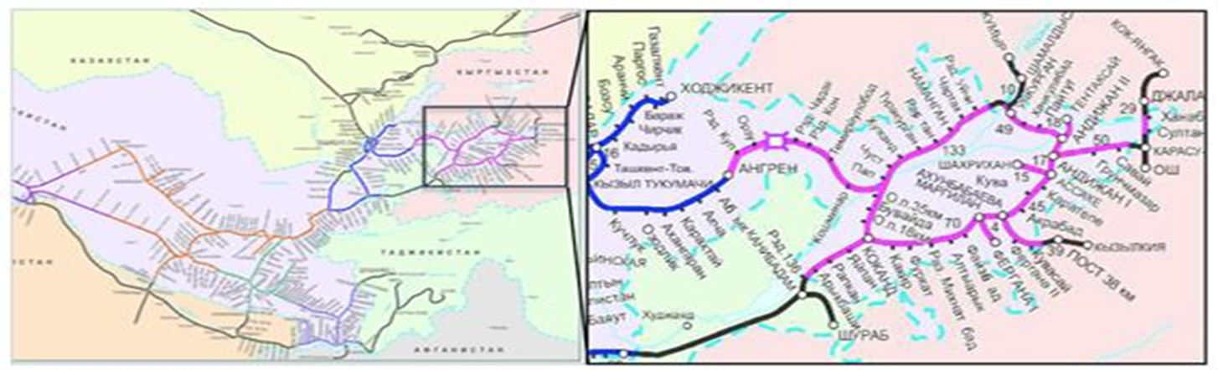
  - Project Background
- The Government of Uzbekistan (GoU), through the Joint Stock Company “O’zbekiston Temir Yo’llari” (UTY), requested the Asian Development Bank (ADB) to provide additional financing for the CAREC Corridor 2 (Pap–Namangan–Andijan) Railway Electrification Project to complete the modernization of the railway system in the Fergana Valley.
- The main objective of the Project is to electrify the remaining 145.1 km of non-electrified railway tracks connecting the major cities of the densely populated Fergana Valley with Tashkent. The project aims to improve efficiency, safety, and reliability of passenger and freight transport services, contributing to the economic development of the region and strengthening regional connectivity.
- The additional financing supplements the earlier project approved by ADB in 2017, which covered electrification, signaling, and telecommunication systems along the Pap–Namangan–Andijan railway section. The ongoing works address existing interruptions in transmission and telecommunication systems, especially between Andijan, Asaka, Margilan, Kokand, and Angren, and the limitations caused by insufficient substation capacity.
- The Project scope under additional financing includes:
- Installation of signalling and telecommunication systems on the Pap–Namangan–Andijan lines, including branch connections;
- Construction of two new traction substations (TSS) at Kokand and Asaka;
- Construction of two sectioning posts at Furkat and Andijan-1;
- Modernization of four existing traction substations at Temiryolabad, Angren, Akhangaran, and Toytepa;
- Installation of the SCADA system equipment for real-time monitoring and control.
- The Project is divided into the following lots:
Lot 1: Design, supply, installation, and commissioning of traction substations and transformers.
Lot 2: Design, supply, and installation of signaling, communication, and SCADA systems.

- PURPOSE OF THIS REPORT
- This report is the 20th Social Safeguards Monitoring Report for the CAREC Corridor 2 (Pap–Namangan–Andijan) Railway Electrification Project (Additional Financing, Loan 4000-UZB).
- It covers the period from January to June 2026 and presents the progress and current implementation status of the Project’s social safeguard activities.

- SCOPE AND PROGRESS OF CIVIL WORKS
12. Construction work within the framework of the railway electrification project “CAREC Corridor 2” (Pap – Namangan – Andijan) (additional funding, loan 4000-UZB) is divided into three main stages:
13. Lot 1. Design, supply, installation and commissioning of traction substations and transformers:
This includes the construction of two new traction substations at the Kokand and Asaka stations, two passing posts at the Furkat and Andijan‑1 stations, as well as the modernization of four existing traction substations at the Temiryolabad, Angren, Akhangaran and Toytepa stations.
As of June 2026, construction work has been completed at the traction substation sites in Kokand and Asaka. Construction work is nearing completion at the passing posts at the Furkat and Andijan‑1 stations.
All roadside posts are designed and built in accordance with the regulatory documents of the Republic of Uzbekistan, SNC 2.07.01-03* “Urban Planning” and “Planning for the Development and Construction of Urban and Rural Settlement Areas.”
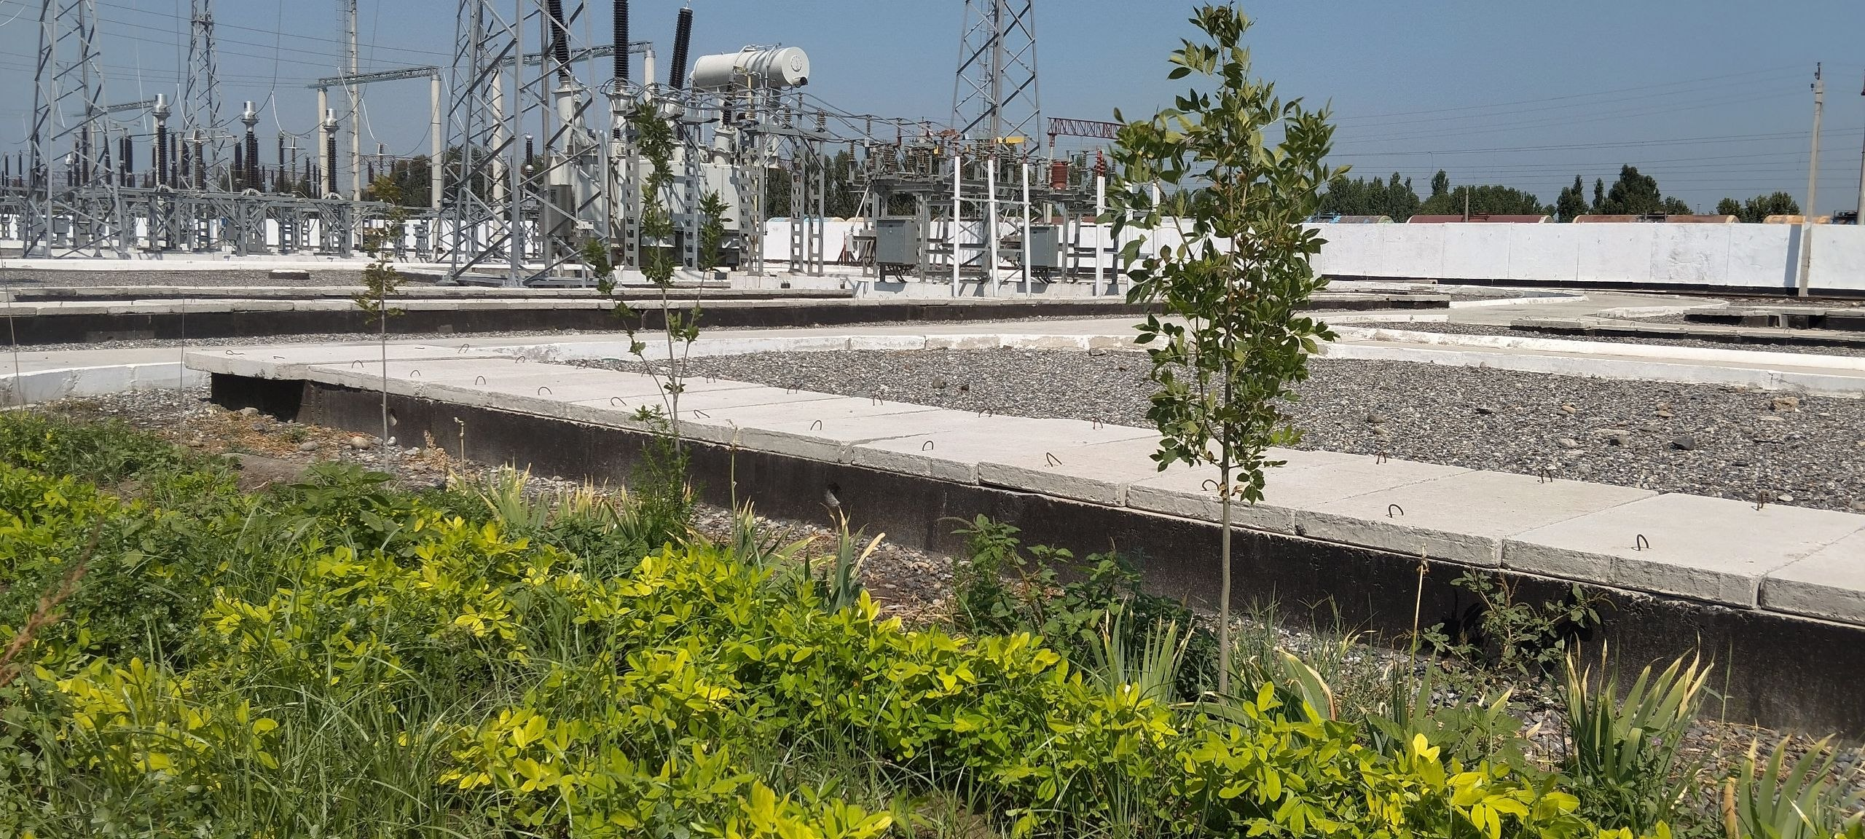 | 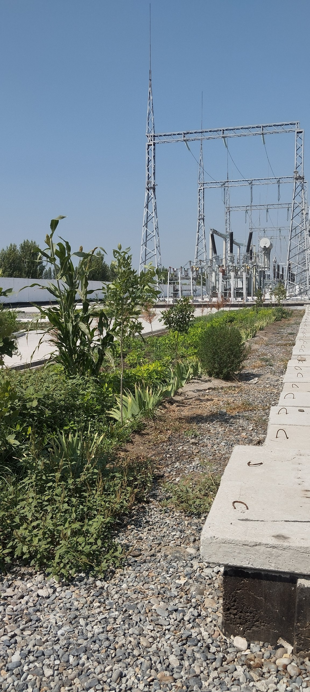
Picture. 3.1 TSS Kokand
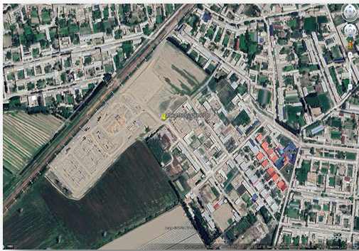 |  | 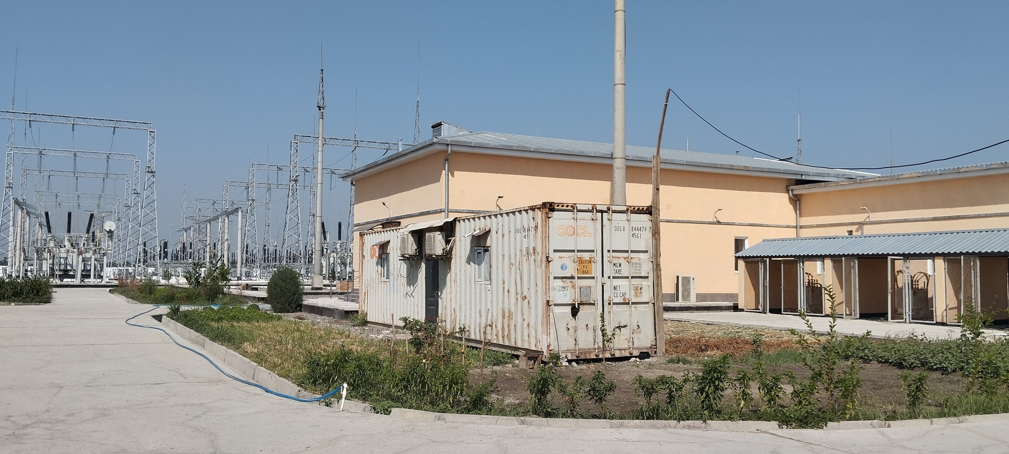
Picture. 3.2. TSS Asaka
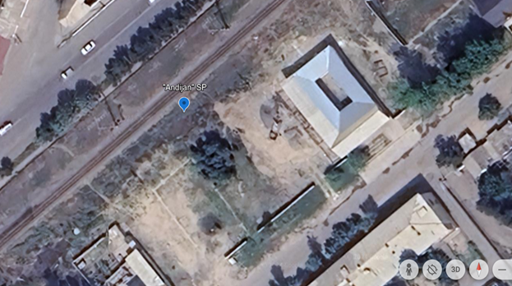 |  |  | 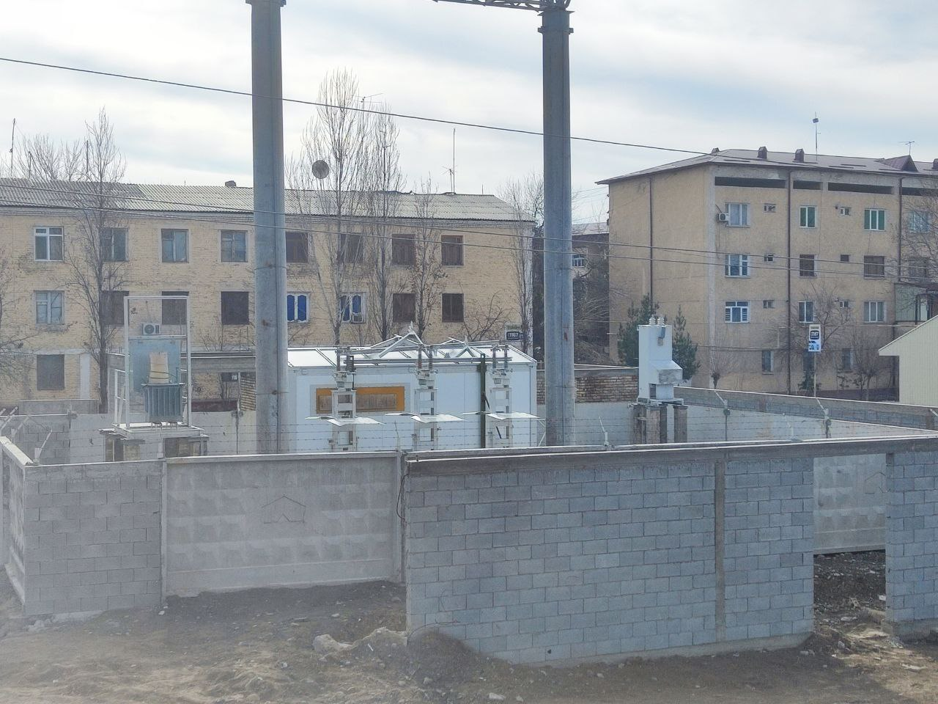
Picture 3.3. location of the Andijhan sectioning post. |  |  | Picture 3.4. the Andijhan sectioning post.

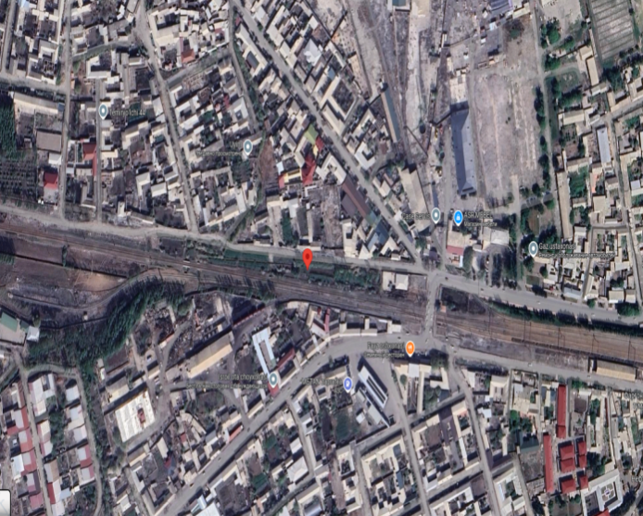 | 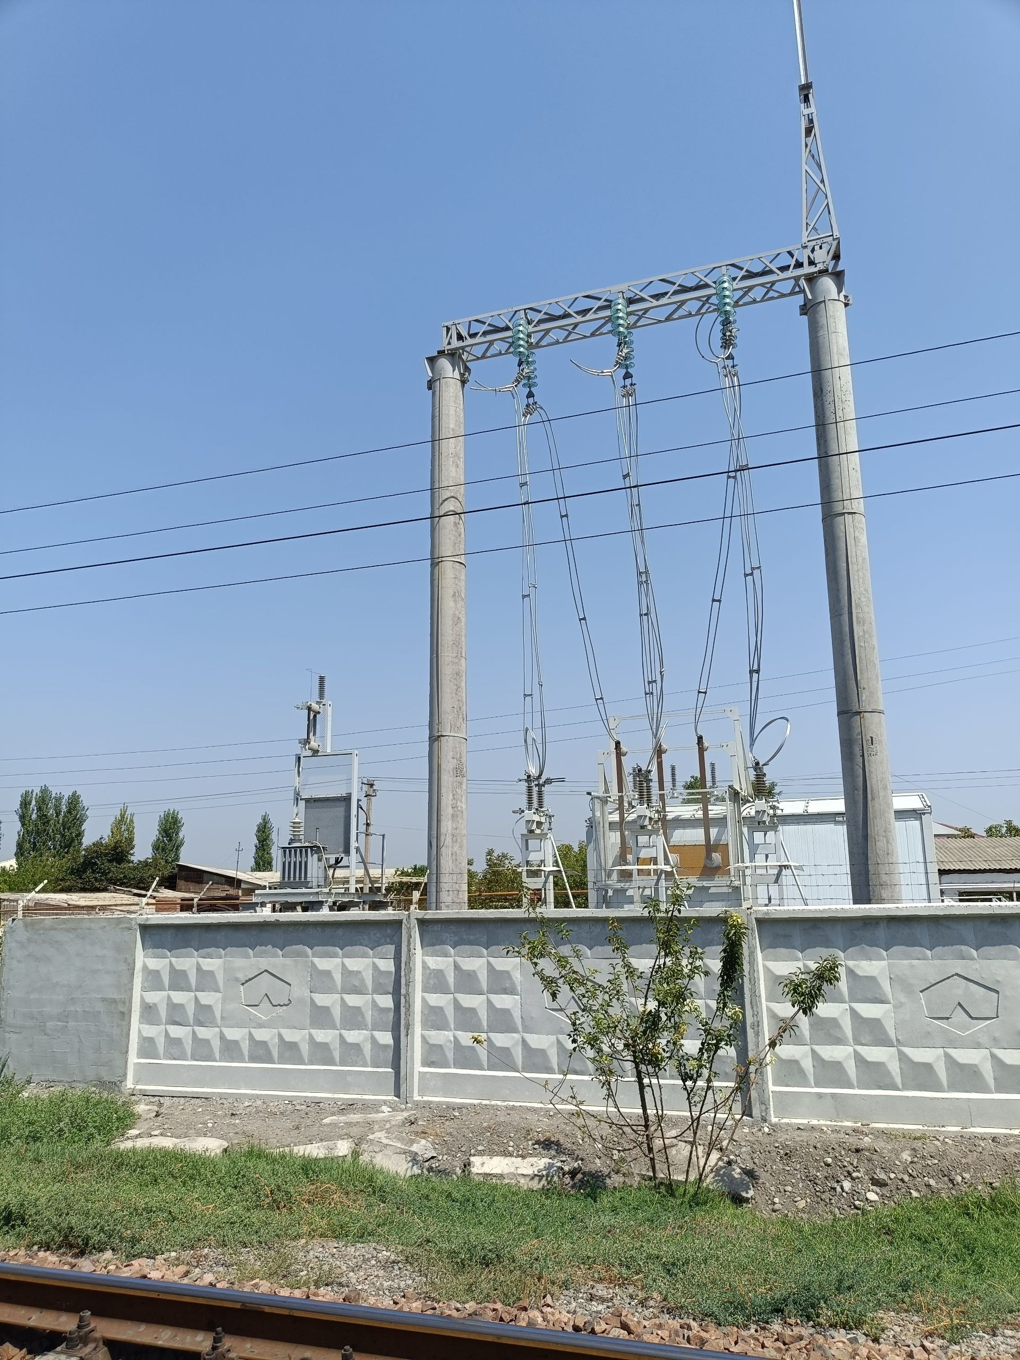
Picture 3.5. location of the Furkat sectioning post. | Picture 3.6. the Furkat sectioning post.

Lot 2: Design, supply, and installation of signaling, communication, and SCADA systems: This component covers the upgrade of signaling and communication systems across the Pap– Namangan - Andijan–section and the installation of SCADA systems at control stations. By the end of the reporting period, works were completed by approximately 85%, including cable laying and preparatory works for commissioning at Andijan and Khanabad stations.
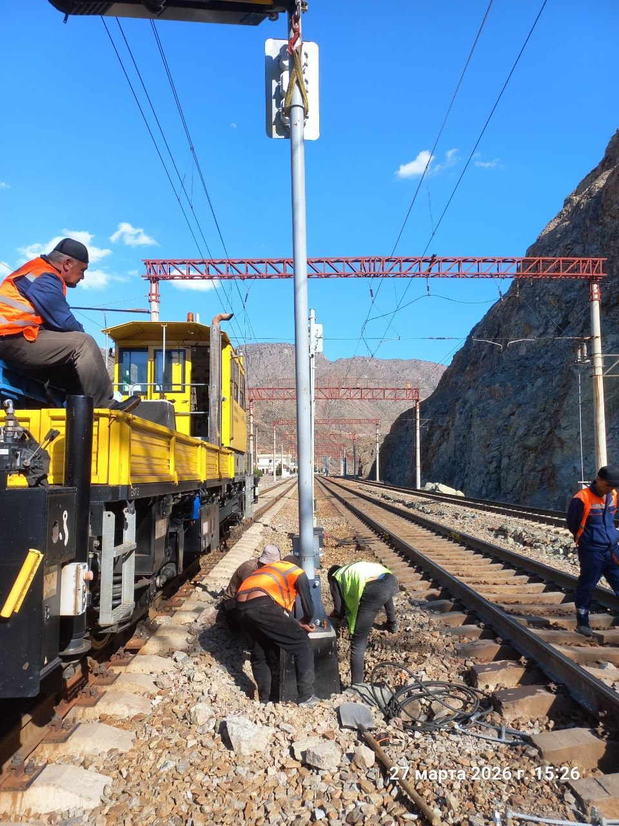 | 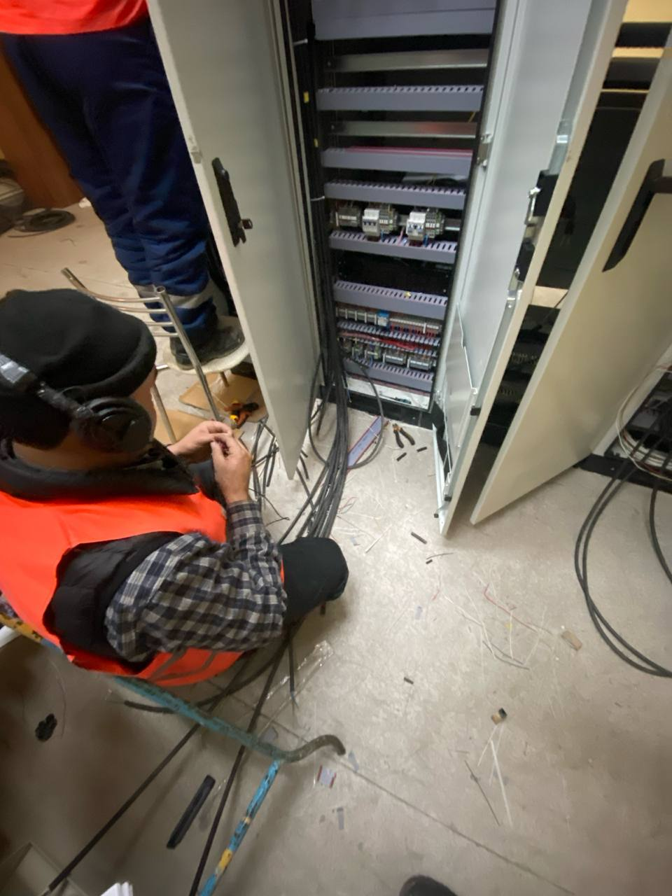
Picture. 3.7. Chodak station setting up a traffic light | Picture. 3.8. Buvayda station installing the cable
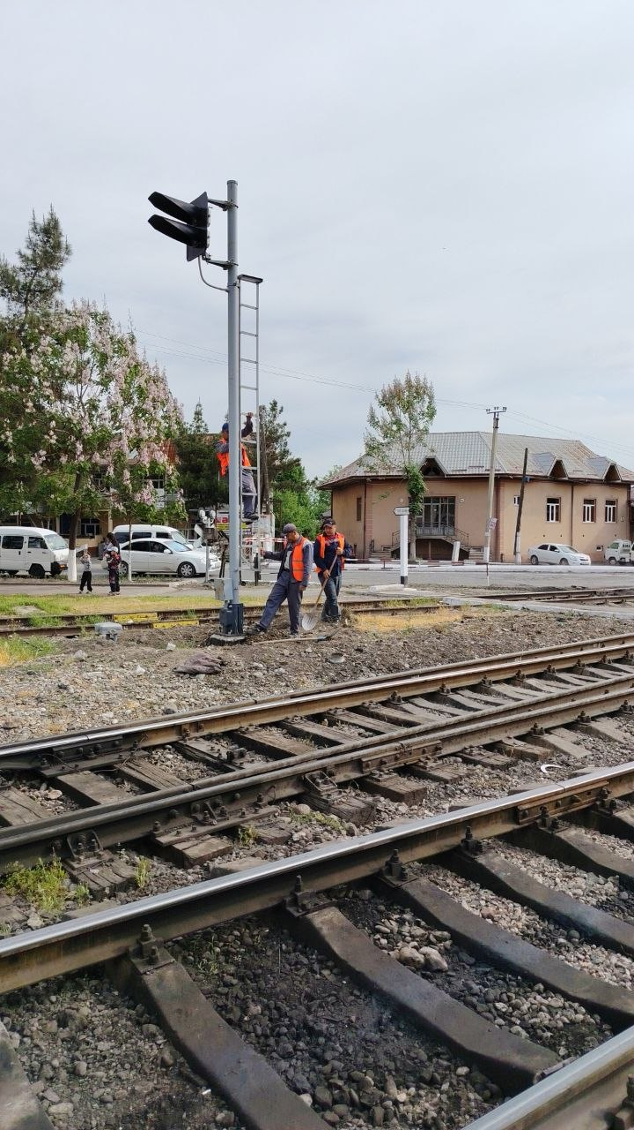 | 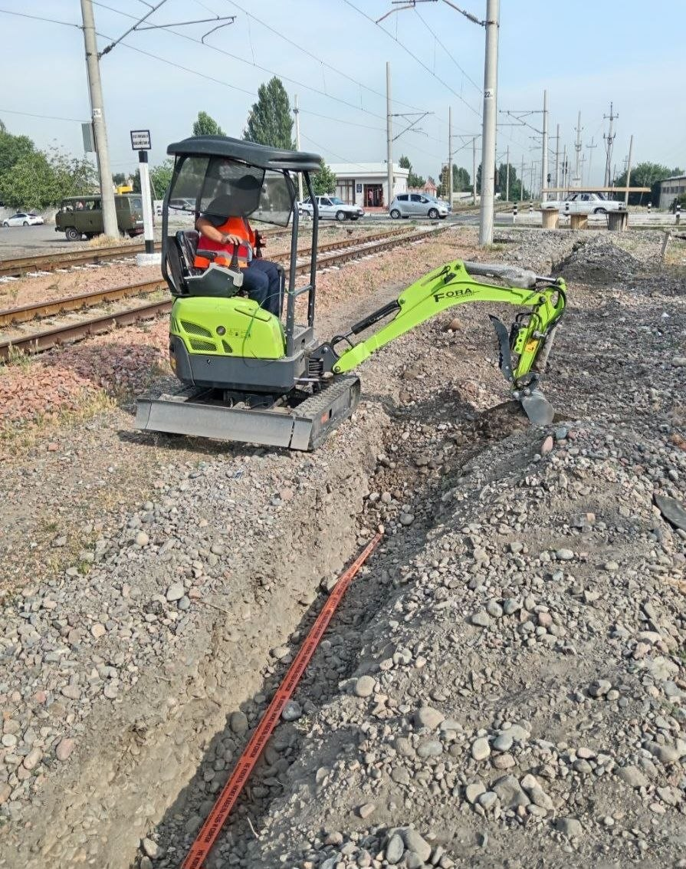
Picture 3.9 Zhalakuduk station setting up a traffic light | Picture 3.10 Trench filling with an excavator - 220m”

- PROJECT IMPLEMENTATION STATUS.

- The CAREC Corridor 2 (Pap–Namangan–Andijan) Railway Electrification Project (Additional Financing, Loan 4000-UZB) continues to be implemented in accordance with the approved schedule.
- During the reporting period (January–June 2026), civil works under the Additional Financing component were progressing actively across all three lots.
- Lot 1 – Design, supply, installation, and commissioning of traction substations and transformers:
- Construction of two new traction substations (TSS) at Kokand and Asaka stations.
- Design two of two sectioning posts at Furkat and Andijan-1 stations.
- Modernization of four existing traction substations at Temiryolabad, Angren, Akhangaran, and Toytepa stations.
- As of June 2026, construction and electrical installation work at the Kokand and Asaka traction substations had been completed, while construction and installation work continued at the Furkat and Andijan-1 sectional posts.
- Lot 2 – Design, supply, and installation of signaling, communication, and SCADA systems:
- The modernization of the signaling and communication network on the Pap–Namangan–Andijan section (additional funding) and the installation of SCADA at key control stations are approximately 85% complete. Overall, the project is nearing completion; all components are being actively implemented and are under constant technical supervision by the DI and the consultant.

SCOPE OF LAR IMPACTS

- Based on the final design and verification under the Social Due Diligence Report (August 2020) and subsequent field monitoring, no physical displacement of households will occur under the Project.
- The Project has no new permanent or temporary land acquisition impacts. All land parcels required for traction substations, sectioning posts, and power supply lines were acquired prior to ADB financing, between 2015 and 2017, by UTY and Uzbekenergo in accordance with national legislation. All other works—such as modernization of signaling and communication systems, installation of SCADA and CCTV, and upgrading of depots—are implemented within the existing UTY right-of-way (ROW) or on state-owned land.
- The completed SDDR (2020), LARP Addendum (2020), and Resettlement Plan for the 110 kV Transmission Line confirmed that no new economic displacement or loss of livelihood is anticipated. All corrective measures specified in the Corrective Action Plan (CAP) have been implemented, and the Project remains in full compliance with ADB’s Safeguard Policy Statement (2009).
Table 2. Summary of LAR Impacts by Components
№ | Component / Subproject | LAR Impacts | SDDR / LARP / CAP | Actions Taken | Notes
1 | Construction of two traction substations (Kokand and Asaka) | Yes (past) – land acquired prior to ADB financing (2015–2016) | Covered under SDDR (2020) | Land acquisition completed | There are no affected households; the construction work has been completed.
2 | Construction of two sectioning posts (Furkat and Andijan-1) | Yes (past) –the lands are the right-of-way UTY | Included in SDDR Addendum (2020) | The whole earth belongs to UTY,railway right-of-way | No affected households; construction ongoing on UTY premises
3 | Installation of signaling and telecommunication systems on the Pap–Namangan–Andijan section | No | SDDR (2020) | The whole earth belongs to UTY, railway right-of-way | No private land affected
4 | Modernization of four existing traction substations (Temiryolabad, Angren, Akhangaran, Toytepa) | No | SDDR (2020) | Modernization was carried out within the existing substations. | There is no relocation or allocation of land areas.
5 | Installation of SCADA | No | SDDR (2020) | railway right-of-way | No private land affected

Corrective Action Plan (CAP) based on ADB findings.
- The Corrective Action Plan (CAP), prepared as part of the project’s social review process, continues to be monitored by UTY and the oversight consultant. During the reporting period, a field inspection confirmed that all construction work was carried out within the existing UTY right-of-way and previously allocated lands. No new land acquisitions, forced relocation, impacts on livelihoods, or complaints related to compliance with environmental protection measures were identified. The project continues to comply with the requirements of the Asian Development Bank in the field of social and sanitary measures (ADB) (2009). During the previous reporting period, prior to the construction of the “Furkat” sectioning post, consultations were held with a local resident. An CAP was also created.
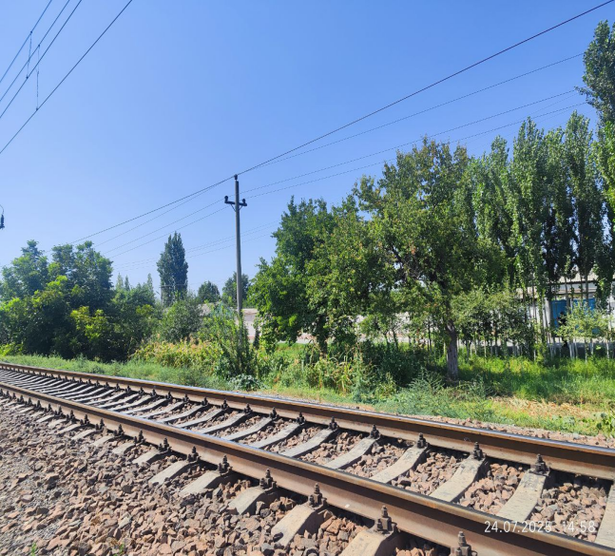 | 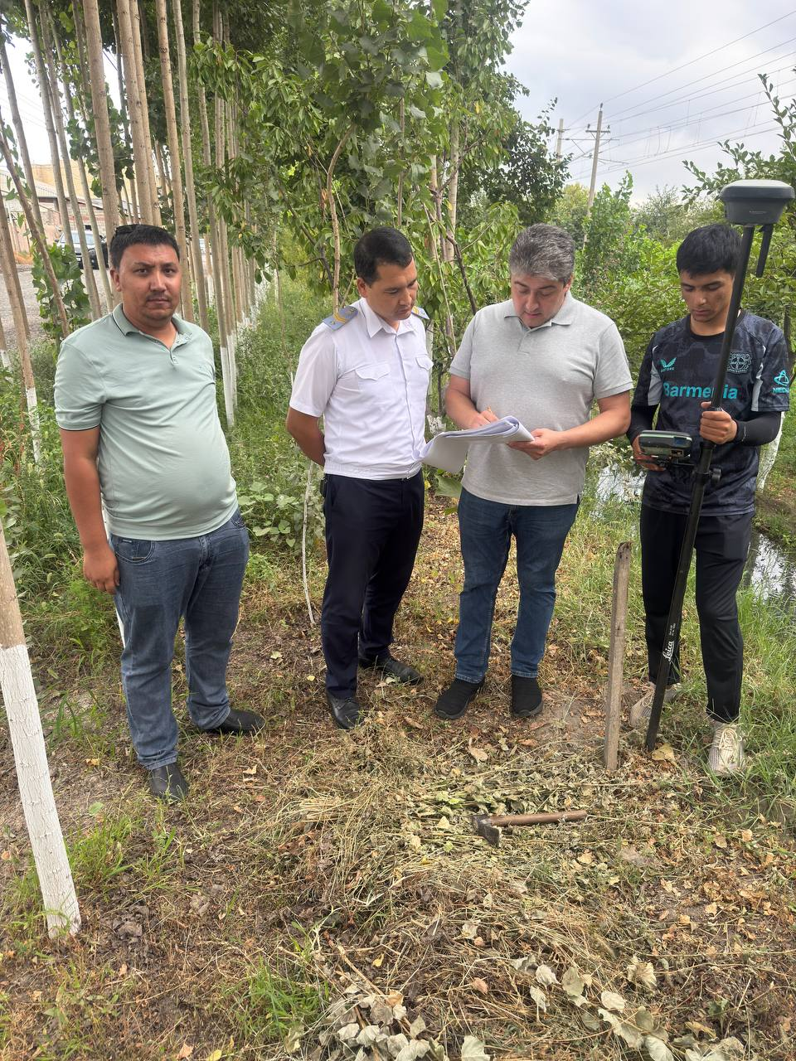
Photo 3.11 UTY right-of-way | Photo 3.12 Employees of the Kokand branch

- IMPLEMENTATION OF LAR ACTIVITIES

- All land acquisition activities related to the original project were completed before ADB financing and covered by a series of due diligence and resettlement documents disclosed by ADB.
During the current reporting period (January–June 2026), no new land acquisition or physical/economic displacement occurred.
- A summary of the disclosed safeguard documents is presented below:
Table 3. Documents’ Disclosure
№ | Document | ADB website link and date disclosed
1 | Central Asia Regional Economic Cooperation Corridor 2 (Pap–Namangan–Andijan) Railway Electrification Project – Additional Financing: Social Due Diligence Report | 48025-004-SDD  August 2020
2 | Central Asia Regional Economic Cooperation Corridor 2 (Pap–Namangan–Andijan) Railway Electrification Project: Social Due Diligence Report (Addendum) | 48025-003-SDDR  September 2020
3 | Extension due to Feeder Line Installation at Khakulabad Traction Substation – Land Acquisition and Resettlement Plan (Addendum) | 48025-003-RP-3  September 2020
4 | External Power Supply Transmission Line: 110 kV Khakulabad (40 km) – Resettlement Plan | 48025-003-RP-4  September 2020

- INSTITUTIONAL SET-UP

- The Joint Stock Company “O’zbekiston Temir Yo’llari” (UTY) serves as the Executing Agency (EA) and Implementing Agency (IA) for the CAREC Corridor 2 (Pap–Namangan–Andijan) Railway Electrification Project (Additional Financing, Loan 4000-UZB). UTY is responsible for the overall coordination, management, and implementation of the Project in accordance with the national legislation of the Republic of Uzbekistan and the Asian Development Bank (ADB) Safeguard Policy Statement (2009).
- As part of UTY 2011, a special project implementation unit (PIU) was established. The PIU managed day-to-day implementation, including procurement, supervision of construction work, monitoring compliance with social guarantees, and the operation of the grievance mechanism (GM). In 2025, the PIU merged with the investment department and continues to ensure that all social and resettlement activities are carried out in accordance with ADB requirements and national legislation.

- Two civil works Contractors are currently mobilized for the implementation of project components:
- JSC “Uzelektroapparat-Electroshield”, responsible for construction and installation of traction substations at Asaka and Kokand.
- LLPC “TOO Temirzhol Zhondeu, responsible for construction and installation of the signaling and communication system within the framework of additional financing.

- ACTIVITIES PERFORMED DURING THE REPORTING PERIOD (JANUARY-JUNE 2026)

- The following activities were conducted during the reporting period.
- Updating and verification of documents. During the reporting period, DI, together with UTY, analysed the progress in implementing the SDDR and CAP to ensure ongoing compliance with the ADB’s Statement on Guarantee Policy (2009). The verification confirmed that all construction work was carried out within the existing right-of-way (ROW), and no new cases of land expropriation or physical/economic displacement were identified.
- Internal monitoring of the CAP implementation was carried out by the DI and the oversight consultant of ITALFERR S.p.A.. The monitoring focused on verifying compliance with precautionary measures, land use boundaries, consultations with stakeholders, and the functioning of the grievance review mechanism (GRM).
- Regular field visits. During the reporting period, DI representatives and the supervision consultant conducted field inspections in the Fergana and Andijan regions. The inspections confirmed that construction of traction substations and sectioning posts is progressing in accordance with approved designs, and all works are limited to UTY-owned areas.

Table 4. Summary of Consultations
# | Location, | Districts | Date | of Membership
 | Kokand, Andijan | Pap - Kokand - Andijan | 4 March 2026 | 4
 | Kokand, Andijan | Pap - Kokand - Andijan | 17-May 2026 | 4
 | Kokand, Andijan | Pap - Kokand - Andijan | 10-June 2026 | 3

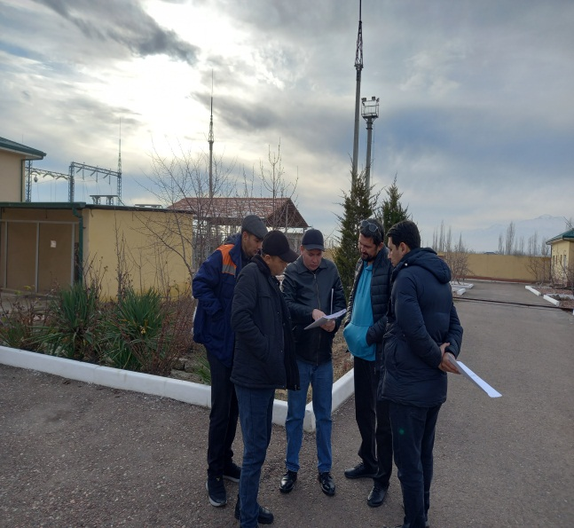 | 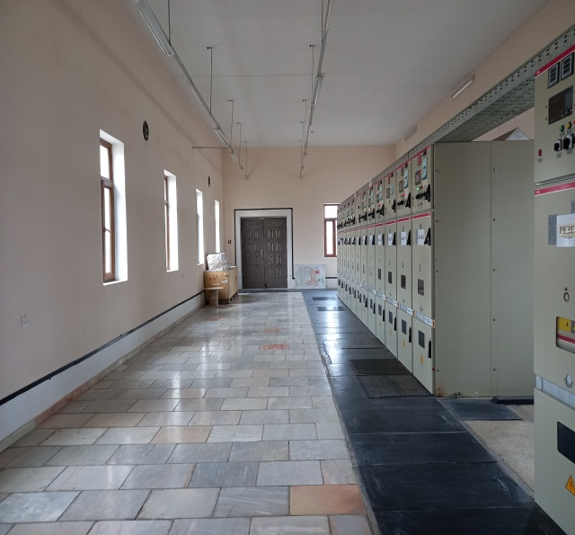
Photo 3.13 Temiryoabad TSS

Next steps. Consultations and safeguard monitoring will continue throughout the next reporting period.

- GRIEVANCE REDRESS MECHANISM

- A Grievance Redress Mechanism (GRM) has been established under the CAREC Corridor 2 (Pap–Namangan–Andijan) Railway Electrification Project to ensure that all affected persons and stakeholders have a clear and transparent process to raise concerns related to land, compensation, construction activities, or any social and environmental issues.
- The mechanism operates in accordance with the ADB Safeguard Policy Statement (2009) and national legislation. It provides a structured, three-level system for grievance handling and does not limit access to the judicial system. Aggrieved individuals may submit complaints at any level of the mechanism or directly to the Economic Court at any time.

- Structure of the Grievance Mechanism.The GRM functions at three levels:

Level 1: Local entry points (railway station offices, contractors site offices, or local hokimiyats/mahallas). Complaints are registered in site logbooks or khokimiyat journals. Contractors and PIU representatives collect and verify all complaints received at this level.

Level 2: The UTY and the Grievance Redress Committee (GRC) in Tashkent. Complaints that cannot be resolved locally are reviewed by the GRC, consisting of the Deputy Head of the Capital Construction Department, DI Safeguards Officer, and representatives of hokimiyats, mahallas, or farmers councils.

Level 3: The Economic Court, where any unresolved complaints can be addressed in accordance with national legislation.

- All grievances received from any level are recorded in a consolidated electronic Complaint Register, maintained by the DI with support from the supervision consultant ITALFERR S.p.A. and contractors.
Information from this register is included in monthly progress reports and semi-annual social safeguards monitoring reports submitted to ADB.

Table 5. Personnel Relevant to GRM
Name | Location | Organization | Contact
Kudrat Hashimov | Kokand, Tashkent | "Uzelektroapparat" | Contact number:  +998 93 380 99 60
Timur Sitikhov | Kokand, Tashkent | Specialist in healthymeasures "temirzhol zhandeu | Contact number:  +998 97 701 19 46
Chingiz Kudabekov, | Kokand, Tashkent | Department” of Uzbekiston Temir yllari JSC"deputy head | Contact number:  +998 71 2379998
Bakhter Milladjanov | Kokand RYE. | UTY, Head of Kokand Regional Railway Junction | Contact number:  +998 (373) 5431234
Guzal Khojamyarova | Tashkent | UTY/PIU, PIU Security Specialist | Contact number:  +998 998772210

- Information on GRM had been disclosed on each construction site. Contractors installed site passports (information boards) at the entrance to project facilities, placed mobile information boards at temporary sites of network construction sites.
- No grievance were received during the reporting period.

- COMPLIANCE WITH SAFEGUARDS PROVISIONS UNDER THE PROJECT
  - Compliance with Project Administration Manual

- The Project Administration Manual (PAM) describes the essential administrative and management requirements to implement the project on time, within budget, and in accordance with Government and Asian Development Bank (ADB) policies and procedures. The PAM is mandatory and serves as the main document describing implementation details. The statuses of implementing the safeguard requirements set out in PAM are provided in Table 6 below.
Table 6. Compliance to PAM
Details | Compliance Status | Remarks
Section VII - Safeguards
B. Land Acquisition and Resettlement
- The Executing Agency (EA) will ensure that land acquisition and resettlement, if required, are carried out in accordance with the ADB Safeguard Policy Statement (SPS, 2009) and the laws of the Republic of Uzbekistan. The EA will monitor that no project-affected persons suffer from unmitigated impacts. | Completed | A Social Due Diligence Report (SDDR, 2020) and a Corrective Action Plan (CAP) were prepared and disclosed on the ADB website. All civil works under the additional financing are carried out within the existing right-of-way (ROW) of UTY and previously allocated land plots for traction substations and sectioning posts. No land acquisition or economic displacement has occurred during the reporting period. CAP implementation is ongoing and monitored by the PIU and ITALFERR S.p.A.
- The additional financing project, in accordance with the ADB SPS (2009), is classified as Category “B” for Involuntary Resettlement and Category “C” for Indigenous Peoples. | Completed | There will be no additional land acquisition or resettlement under the additional financing. All project activities are implemented within UTY’s ROW boundaries; therefore, no new LARPs are required.

  - Compliance with Social Safeguard Covenants of Loan Agreement

- The status of Compliance with social Safeguard Covenants of Loan Agreement is presented in the table below.
Table 7. Compliance to social safeguard covenants
Details | Compliance Status | Remarks
Schedule 4 – Execution of Project
Land Acquisition and Involuntary Resettlement
UTY shall ensure that all land and all rights of way required for the project are completed in accordance with the schedule agreed under the relevant performance contract and that all land acquisition and resettlement activities are completed in accordance with: (a) all applicable laws and regulations of the Borrower relating to land acquisition and involuntary resettlement; (b) involuntary resettlement safeguards; (c) social safeguards; (d) any remedial or preventive measures set out in the safeguards monitoring report. | In progress | Complied with
Indigenous Peoples
UTY shall ensure that the project does not have any impact on Aboriginal peoples as defined in the Guarantee Policy Statement. In the event that the project has any such impact, UTY shall take all necessary steps to ensure that the project complies with applicable laws and regulations of the borrower and the provisions of the Guarantee Policy Statement. | is carried out | The project has been categorized as Indigenous Peoples Protection Category C. There are no Indigenous Peoples communities within the project area or the country as a whole, as defined in the SPS for operational purposes. Accordingly, no Indigenous Peoples planning documents will be required.
Human and Financial Resources to Implement Safeguard Requirements
The Borrower shall provide the necessary financial and human resources for the EMP; Social Due Diligence Report, including the remedial actions set out in such report. | In progress | Currently, the PIU employs 1 specialist in social issues, resettlement and the environment.
Provisions on guarantees in tender documents and contracts for the performance of works
All tender documents and works contracts shall be deemed to contain provisions requiring contractors to: (a) comply with the contractor-specific measures set out in the IEE, the EMP and the Social Assessment Report (in so far as they relate to impacts on affected communities during construction) and any remedial or preventive measures set out in the Safeguards Monitoring Report; (b) provide budgetary provisions for all environmental and social measures; (c) provide the Borrower with written notice of any unforeseen environmental risk, resettlement or impact on local communities arising from the construction, implementation or operation of the Project or associated facilities or existing facilities that has not been addressed in the IEE, the EMP and the Social Assessment Report; (d) adequately assess the condition of roads, farmland and other infrastructure prior to the commencement of material transportation and construction; and (e) after completion of construction, restore roads and other local infrastructure to at least the pre-design condition and reclaim farmland. | In progress | LARP, IEE and EMP are annexes to the BD and construction contracts.
Monitoring guarantees and reporting
In the following cases: (a) provide ADB with semi-annual safeguards monitoring reports and relevant information from such reports to affected persons; (b) if any unexpected environmental and/or social risks and impacts arise during the construction, implementation or operation of the project; (c) Associated facilities or existing facilities that were not addressed by the IEE, EMP, and Social Responsibility Report, promptly inform ADB of the occurrence of such risks or impacts, with a detailed description of the corrective action plan; and (d) report any actual or potential violation of the requirements set out in the IEE, EMP; Social Responsibility Report, including the corrective actions set out in such report, upon becoming aware of the violation. | In progress | PIU submits semi-annual reports on monitoring social safeguards and semi-annual reports on environmental monitoring to the ADB. All reports are published on the ADB and EA websites.
Prohibited List of Investments
The UTY shall ensure that no proceeds from the loan are used to finance any activity included in the list of prohibited investment activities contained in Appendix 5 of the SPS. | In progress | Complied with
Labor Standards, Health and Safety
UTY ensures that core labour standards and applicable borrower laws and regulations are observed during project implementation. UTY includes specific provisions in bidding documents and contracts financed by ADB under the project requiring that contractors, among other things: (a) comply with applicable borrower labour laws and regulations and incorporate applicable safety standards in the workplace; (b) employ child labour; (c) do not discriminate against workers with respect to employment and occupation; (d) do not use forced labour; (e) allows freedom of association and effectively recognizes the right to collective bargaining; and (f) disseminates, or engages appropriate service providers to disseminate, information on the risks of sexually transmitted diseases, including HIV/AIDS, to employees; contractors hired under the project, and members of local communities surrounding the project area, particularly women. | In progress | All these issues and requirements are included in the Special Conditions of Construction Contracts and are an integral part of all contracts. These requirements are also regularly monitored and included in the semi-annual reports on monitoring protective measures and environmental monitoring.
UTY shall provide ADB with regular reports on its compliance with the requirements set out in paragraph 12 above. | Being performed
Gender and Development
UTY ensures that gender equality principles are mainstreamed into the project's expansion. IMPLEMENTATION OF THE PROJECT TO IMPROVE THE SITUATION OF WOMEN. These include (a) the appointment of a gender focal point in the implementing agency for gender-related activities; (b) the collection of baseline data disaggregated by sex; (c) participation in surveys and assessments; (d) integrating a gender component into capacity building and communication strategies; (e) actively promoting and encouraging women's employment in STIs, wherever appropriate; and (f) conducting HIV/AIDS information campaigns. UTY ensures that sufficient funds are available to carry out these activities. | In progress

- CONCLUSIONS AND RECOMMENDATIONS
  - Conclusions:

- Recommendation for the next reporting period: Based on the findings of this semi-annual monitoring, implementation of the Corrective Action Plan (CAP) under the CAREC Railway Electrification Project continues in compliance with ADB’s Safeguard Policy Statement (2009) and national legislation of the Republic of Uzbekistan.
- No additional land acquisition or involuntary resettlement was required during the reporting period. All project work was carried out within the right-of-way (ROW) of existing railway infrastructure or within previously allocated UTY land.
- Field monitoring confirmed that no private or dehkan farmlands were affected, and no physical or economic displacement occurred.
- All stakeholders, including local hokimiyats, mahalla committees, and farmers located near the project sections, were properly informed about project activities and grievance procedures.
- No grievances were registered during the reporting period.
- DI continue to ensure regular internal monitoring and maintain full compliance with ADB and national safeguards requirements.

- The following recommendations for the next reporting period are as follows:
- Continue stakeholder engagement: Maintain continuous communication with local authorities, mahallas, and nearby residents to ensure awareness of ongoing and planned works.
- Maintain GRM functionality: Keep the Grievance Redress Mechanism operational at all project sites and ensure timely registration and resolution of any potential complaints.
- Ensure documentation and disclosure: Continue to document consultations and monitor results and disclose them in the semi-annual reports.
- Regular monitoring: Maintain internal monitoring on safeguard compliance, especially for CAP implementation, and submit regular updates to ADB.
- Gender and labor monitoring: Continue integrating gender equality measures, labor standards, and safety requirements into all project activities and training sessions for contractors.

