LAND ACQUISITION AND RESETTLEMENT PLAN

Stage of document completion: Draft Final
Project No: 53271-001
Date: November 2024

Uzbekistan: Central Asia Regional Economic Cooperation Corridor 2
(Bukhara-Miskin-Urgench-Khiva) Railway Electrification Project

Subproject 1: Construction of Khozarasp traction substation

Prepared by JSC Uzbekiston Temir Yullari (UTY), Republic of Uzbekistan for the Asian Development Bank.

This Resettlement Plan is a document of the borrower. The views expressed herein do not necessarily reflect the views of ADB's Board of Directors, management, or staff. These documents are publicly available in accordance with ADB's access to information policy and as agreed between ADB and JSC Uzbekiston Temir Yullari.(UTY).

In preparing any country program or strategy, financing of any project, or designation or reference to a specific territory or geographic area herein, the Asian Development Bank does not intend to make any judgment regarding the legal or other status of any territory or area.

TABLE OF CONTENTS

GLOSSARY 4
I. EXECUTIVE SUMMARY 6
II. INTRODUCTION 8
IV. SOCIO-ECONOMIC PROFILE OF AFFECTED PERSONS 12
V. PUBLIC CONSULTATION AND INFORMATION DISCLOSURE 13
VI. GRIEVANCE REDRESS MECHANISM 15
VII. POLICY AND LEGAL FRAMEWORK 19
VIII. ELIGIBILITY, ENTITLEMENT MATRIX AND RIGHT TO COMPENSATION 34
IX. RELOCATION AND RESTORATION OF INCOME SOURCE 37
X. RESETTLEMENT BUDGET 38
XI. INSTITUTIONAL SET UP 38
XII. IMPLEMENTATION SCHEDULE 42
XIII. MONITORING AND REPORTING 43
ANNEXES 46
Annex 1. The Presidential Decree on the changing category of the land from the agricultural land to non-agricultural land. 46
Annex 2. The letter of Khorezm Hokimiyat to the Ministry of Agriculture for changing category of proposed lands 50
Annex 3. The scheme and proposed location of Khozarasp TSS 55
Annex 4. Land Lease Agreement (Shartnama) of the leased land of affected person 56
Annex 5: Notarial agreement for land return 70
Annex 6. New land lease agreement 72
Annex 7. Photos of public consultation 75
Annex 8. Photo of focus group discussion 75
Annex 9. List of consultation participants in the Khozarasp district 76
Annex 10. Compensation amount calculated for the affected land 77
Annex 11. Photo of meetings with affected household 78
Annex 12. Socio-economic survey form 78
Annex 13. Grievance Redress Mechanism Brochure 80

CURRENCY EQUIVALENTS
(as of October 31, 2024)
1 USD= 12,724 UZS

ABBREVIATIONS

ADB | Asian Development Bank
AIIB | Asian Infrastructure Investment Bank
AF | Affected Farm Enterprise
AP | Affected Person
AH | Affected Household
BMUK | Bukhara-Misken-Urgench-Khiva
CC | Civil Code
DMS | Detailed Measurement Survey
EA | Executing Agency
ETS | Engineering and Works Supervision
EPS | External Power Supply
FGD | Focus Group Discussion
GRM | Grievance Redress Mechanism
Ha | Hectare
HH | Household
IA | Implementing Agency
Km | Kilometer
kV | Kilovolt
LAR | Land Acquisition and Resettlement
LARP | Land Acquisition and Resettlement Plan
LC | Land Code
MOF | Ministry of Finance
PC | Public Consultation
PIU | Project Implementation Unit
SES | Socioeconomic Survey
SS | Substation (source of external power)
SSMR | Semi-annual Social Monitoring Report
SPS | Safeguard Policy Statement
TL | Transmission Line
TSS | Traction Substation
UTY | JSC O’zbekiston Temir Yo’llari
UZS | Uzbek Som
XROO | Xorvilyerlayiha - Regional Office of the State Research and Design Institute on Land Management “Ozdavyerlayiha” in Khorezm province

GLOSSARY

Project Affected Persons | Project Affected Persons (PAPs) are members of affected households who, in whole or in part, permanently or temporarily, have been subjected to physical displacement (resettlement, loss of residential land, or loss of shelter) and deprivation of sustainable economic status (loss of land, property, access to property, sources income or livelihood) as a result of (i) forced land acquisition, or (ii) forced restriction of land use or access to legally designated parks and protected areas. Although this definition of affected persons differs from that used in the 2009 SPS, this definition describes how it is understood and officially used in Uzbekistan, and it is not different from the concept of ‘displaced persons’ as defined in the 2009 SPS.
Affected Household | A household consisting of one or more people who live in the same living space and share food or shelter and may constitute one family. In the project, the household is considered the unit for compensation, all family members are considered PAPs.
Cadastral documents | A set of materials, cadastral surveys, technical inventories and certification, quality and valuation of the object necessary for the formation, accounting and subsequent state registration of rights to real property
Cut-off-date | The date after which people will not be considered eligible for compensation, i.e., they are not included in the list of AHs as defined by the census. If the country expropriation law does not specify a cut-off date, usually, the cut-off date is the date of the detailed measurement survey which is based on the final engineering design.
Compensation | Payment for an asset that shall be disposed of or that has been damaged by a project at replacement cost.
Dehkan | small farm that operates on a household plot.
Detailed measurement survey (DMS) | With the approved detailed engineering design, this activity involves the finalization and/or validation of the results of the inventory of losses (IOL), the severity of impacts, and the list of AHs earlier done during RP preparation. The final cost of resettlement can be determined following the completion of the DMS.
Economic Displacement | Loss of land, assets, access to assets, income sources, or means of livelihoods, because of (i) involuntary acquisition of land, or (ii) involuntary restrictions on land use or access to legally designated parks and protected areas.
Entitlement | The range of measures comprising the cost of compensation, relocation cost, income rehabilitation assistance, transfer assistance, income substitution, and relocation which are due to /business restoration, which is due to AH, depending on the type and degree nature of their losses, to restore their social and economic base. All entitlements are given to all affected households as per the entitlement matrix.
Inventory of Loss | Inventory of assets that will be affected by the project.
Illegal/Non legalizable/Non recognizable households | People that have not registered their business, agriculture, residential and orchard and those who have no recognizable rights or claims to the land that they are occupying and include people using private or state land without permission, permit or grant i.e. those people without legal lease to land and/or structures occupied or used by them. ADB’s SPS explicitly states that such people are entitled to compensation for their non-land assets.
Hokimiyat | Local government authority that interfaces between local communities and the government at the regional and national level. It has ultimate administrative and legal authority over local populations residing within its jurisdiction.
Land acquisition | The process whereby a person is compelled by a public agency to alienate all or part of the land s/he owns or possesses, to the ownership and possession of that agency, for public purposes, in return for fair compensation.
Land Use Rights | According to Land Code (article 17) real persons (can have the land plot under the right of lifelong inheritable possession and land parcel use transferred as descent. This right is given to individual residential housing construction and collective gardening and vineyard (orchards), peasant farms. Legal persons (enterprises, stores, business and farm enterprises) can possess land parcels according to the right to permanent possession, permanent use, temporary use, lease and property. In the above case when person wants to sell the property (land and building), he will sell the building & structure and subsequently land parcel will be sold as an attachment (right is being sold).
Leaseholder | Legal person (including farm enterprise) running agricultural production with the use of land parcels granted to him on a long-term lease. Lease term is limited up to fifty years but not less than for ten years. Leaseholder cannot sell - buy, mortgage, bequeath 2, giving as a gift and exchange the land.
Low Income | Low-income households are classified as households where the monthly per capita income is less than US$2 per day.
Mahalla | Is a local level community-based organization recognized official by the GoU that serves as the interface between state and community and is responsible for facilitating a range of social support facilities and ensuring the internal social and cultural cohesiveness of its members. Mahalla leaders are elected by their local communities.
Relocation | The physical relocation of an AH from her/his pre-project place of residence and/or business.
Rehabilitation | Re-establishing incomes, livelihoods, living, and social systems;
Replacement cost | Replacement cost is the principle to be complied with in compensating for lost assets. Calculation of which should include: (i) fair market value; (ii) transaction costs; (iii) interest accrued, (iv)transitional and restoration costs; and (v) other applicable payments, if any. Where market conditions are absent or in a formative stage, PAPs and host populations will be consulted to obtain adequate information about recent land transactions, land value by types, land titles, land use, cropping patterns and crop production, availability of land in the project area and region, and other related information. Baseline data on housing, house types, and construction materials will also be collected. Qualified and experienced experts will undertake the valuation of acquired assets. In applying this method of valuation, depreciation of structures and assets should not be taken into account.
Resettlement | Means all social and economic impacts that are permanent or temporary and are (i) caused by the acquisition of land and other fixed assets, (ii) by change in the use of land, or (iii) restrictions imposed on land, as a result of a project.
Right to compensation | A set of measures, including the cost of compensation, assistance in income restoration, transfer and relocation, income replacement, etc., due to PAPs to restore their socio-economic status, depending on the type and extent of losses suffered by them in order to restore their social and economic basics. All rights to compensation will be presented to all affected households in accordance with the compensation matrix.
Severely Affected | Severely affected households that lose more than 10% of their total productive assets or are forced to relocate.
Significant impact | An event where 200 or more people are significantly impacted as a result of: (i) physical displacement from housing or (ii) the loss of ten percent or more of productive assets (income-producing assets).
Socioeconomic Survey (SES) | A complete and accurate survey of the project affected population. The survey focuses on income-earning activities and other socioeconomic indicators;
Stakeholders | A broad term that covers all parties affected by or interested in a project or a specific issue—in other words, all parties who have a stake in a particular issue or initiative. Primary stakeholders are those most directly affected—in resettlement situations, the population that loses property or income because of the project and host communities. Other people who have an interest in the project—such as the project authority itself, the beneficiaries of the project (e.g., urban consumers for a hydro-power project), and interested NGOs are termed secondary stakeholders;
Vulnerable | Poor households, households headed by women, the elderly, or households with members with disabilities.

EXECUTIVE SUMMARY

- The Asian Development Bank (ADB) and the Asian Infrastructure Investment Bank (AIIB) have been invited by the Government of Uzbekistan (GoU) and O'zbekiston Temir Yo'llari (UTY) to facilitate the co-financing of the railroad electrification project under Corridor 2 (Bukhara-Miskin-Urgench-Khiva) of the Central Asia Regional Economic Cooperation (CAREC).
- The main objective of the project is to electrify 465 km of the existing railroad line connecting the major urban centers of Bukhara, Miskin, Urgench and Khiva (BMUK) in western Uzbekistan.
- The project area is in the western part of Uzbekistan and comprises two provinces: Bukhara (Bukhara railroad station) and Khorezm province (Urgench and Khiva railroad stations). The total length of the electrified railroad line between Bukhara and Khiva is about 465 km and runs mainly through the provinces of Bukhara and Khorezm (Picture 1 and 2) as well as a small section in the Republic of Karakalpakstan.
- The project will enable the operation of high-speed trains at speeds of up to 250 km/h, which will significantly reduce travel time. The main tourist destinations of Tashkent, Samarkand, Bukhara and Khiva will be connected by high-speed trains, which will significantly increase the attractiveness of Uzbekistan as a tourist destination. The project is fully in line with the government's strategy to diversify the economy and develop the tourism sector in the Khorezm region.
- In this context and in accordance with the project documents and the letter of JSC O’zbekiston Temir Yo’llari No. N/5192-19 dated September 10, 2019, a railroad line was selected and allocated on the territory of Bukhara and Khorezm regions of the Republic of Uzbekistan
- The project components include the construction of eight (8) traction substations (TSS), an electrical room building and external 6 (six) transmission lines from the existing substations (SS) to the new TSS.
- The potential social impacts of the project were analysed and divided into components with and without confirmed land acquisition and resettlement (LAR) impacts.
- As members of landowner households are considered affected persons (APs), the project was categorised as Category A for involuntary resettlement under the 2009 ADB Safeguard Policy Statement.
- Currently, the land acquisition and resettlement impact due to the construction of eight (8) traction substations (TSS) are covered by two documents, namely the SDDR for seven (7) TSS without any LAR impacts and the LARP for the remaining one (1) substation.
- In addition, the project includes a total of 6 transmission lines - 3 in Bukhara region, 3 in Khorezm region and in the Republic of Karakalpakstan. Three of the lines run on 110kV and 3 (three) on 220kV, totalling 210 km of transmission lines. The impacts of the construction of the external transmission lines are addressed in two LARP documents (LARP 1 (Bukhara region) and LARP 2 (Khorezm region)).
- This LARP was prepared to identify and address the impacts of the construction of the Khozarasp TSS.
- During design phase, members of design team together with social safeguard specialists of ETS carried out site visit and explored alternatives to avoid involuntary resettlement. As a result, the major construction activities were designed on government owned lands with minimal impact on private areas.
- However, despite of all efforts, the construction of Khozarasp TSS will have some permanent land acquisition impact. A total of three (3) hectares (including state reserve lands) will be permanently affected. Of the 3 ha 2.83 ha belong to a privately leased land user (farm enterprise).
- The total affected lands are listed in the table below.
Table 1: Project Impacts
 | # |  | Type of Impact |  | Permanent impact |  | Temporary impact |  | Remarks
 |  | Number of Provinces |  | 1 |  | 0 |  | Khorezm region
 |  | Number of districts |  | 1 |  | 0 |  | Khozarasp district
 |  | Number of affected PAP (farm enterprise) |  | 1 |  | 0 |  | “Sevindjoy Maxfira” f/e
 |  | Total Affected land area (ha) |  | 3 |  | 0
 |  | State and Reserve lands (ha). |  | 0.17 |  | 0
 |  | Total affected land of farm enterprises |  | 2.83 |  | 0
 |  | Number of severely AHs |  | No
 |  | Number of vulnerable AHs |  | No
 |  | Number of affected fruit trees |  | No |  |  |  | The area is agricultural land, used for cotton cultivation

- The project also affects 0.17ha state reserve lands. The appropriate intergovernmental procedures will be followed for the land transfer to UTY.
- The project will only lead to the permanent acquisition of privately leased land by a farm, so there will be no temporary impact.
- In accordance with the principles set out in the entitlement matrix, the compensation amounts for permanent impacts have been set at UZS 42,371,404.48 (3320 USD). The total budget under this LARP is 46,608,544.928 UZS (3667 USD) including 10% contingency.
- Construction works at these sites will only commence after the full implementation of the compensation programme described in the LARP ready for implementation.
- During the consultation, the affected households were informed that the first day of the inventory conducted by the XRO of “Ozdavyerlayiha” will be the cut-off date for compensation eligibility.
- The project has established a Grievance Redress Mechanism (GRM) that allows affected people to appeal any project-related grievances, practises or activities related to compensation for land or other assets. UTY will ensure the efficiency and effectiveness of the GRM at local and national levels and ensure that complaints and grievances are dealt with promptly and effectively.
- During the site visits in January and September 2024, face-to-face meetings with affected household and public consultation with local authorities and community members were conducted.
- In consultations, all community members were informed about the project activities, the grievance redress mechanism and the timeline for the implementation of the LARP.
- In addition, stakeholders were informed that the final version of the LARP, once approved, will be published on the ADB website (in English) and on the EA website (in Uzbek) and that printed copies will be available at the local Hokimiyat offices.
- The implementation of the LARP will be closely monitored, which is the responsibility of the Executing Agency. The PIU will provide the ADB with an effective basis to assess the progress of land acquisition and resettlement and to identify potential difficulties/problems.
- The installation and construction phases (and their commencement) are conditional on ADB reviewing and approving LARP Compliance Report prepared by an external monitoring expert, which confirms that all compensation payments and resettlement assistance have been made to all affected land users in accordance with the approved LARP.

INTRODUCTION

  - Overview and background of the project
- The design, construction and installation of the project "Electrification of the Bukhara-Urgench-Khiva section" is carried out in accordance with the following resolutions of the President of the Republic of Uzbekistan:
- No. UP-72 “On Approval of the Investment Program of the Republic of Uzbekistan for 2022-2026 and the Introduction of New Approaches and Mechanisms for the Management of Investment Projects”, December 30, 2021
- No. UP-4937 “On Measures to Implement the Investment Program of the Republic of Uzbekistan for 2021-2023”, December 28, 2020
- No. UP-2376 "On Measures to Implement the Project for the Construction of the Navoi-Konimekh-Miskin Railway Line”, July 27, 2015
- No. UP-2827 "On Measures to Implement the Project for the Construction of the Bukhara-Miskin Railway Line”, March 13, 2017.
  - Project impacts, outcome, and outputs
- The project aims to electrify the existing railway line between Bukhara, Miskin, Urgench and Khiva. The project is closely linked to the government's strategy of diversifying the economy and developing the tourism sector. Electrification will allow the line to be served by high-speed trains that are already in use on other parts of the network. This will reduce the journey time between Bukhara and Khiva from the current 8 hours (by road) to 3 hours. The main tourist destinations of Tashkent, Samarkand, Bukhara and Khiva will all be connected by high-speed trains, and this will be significantly increasing the attractiveness of Uzbekistan tourism.
- The result of the project will be improved rail transport for freight and passengers, linking the capital city with the main western districts.
- The Project will have two Outputs:
Output 1: Development of railway infrastructure along and adjacent to the Bukhara-Miskin-Urgench–Khiva line. This includes (i) the construction of 8 traction substations, (ii) the construction of 8 line posts, (iii) the supply and installation of overhead contact line systems, (iv) the supply and installation of signaling, telecommunication and supervisory control and data acquisition (SCADA) systems, (v) the construction of an external power supply, (vi) the purchase of maintenance equipment and machinery and (vii) the procurement of special wires for the overhead contact line system. In addition, minor modernizations of the electrification infrastructure on the adjacent lines from Bukhara to Tashkent and from Samarkand to the Afghan border will be carried out. Although these modernizations are minor in terms of scope and cost, they will enable the electrified network of the UTY to continue to operate reliably and make the network fit for the expected growth in traffic volumes in the future.
Output 2: Create and promote a tourism economic corridor by (i) marketing the railway in conjunction with Uzbekistan's broader efforts to attract tourists, (ii) supporting communities along the railway corridor to develop transit-oriented development around the railway stations, (iii) supporting communities along the railway corridor through planned sustainable tourism development with a particular focus on promoting the sustainability of new tourism sites and ecotourism, (iv) introducing an e-ticketing system that facilitates ticket booking for tourists and local travelers, and (v) increasing the participation of women in economic activities related to tourism sector.
  - Project location
- The main project area is in the western part of Uzbekistan and includes the province of Bukhara (Bukhara railway station), the Republic of Karakalpakstan and the province of Khorezm (Urgench and Khiva railway stations). The total length of the electrified railway line between Bukhara and Khiva will be around 465 km (Picture 1-2).
Рicture 1. Map of the project area with indication existing railways | Рicture 2. Topographic map of the BMUK railway line
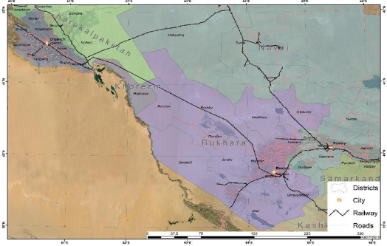 | 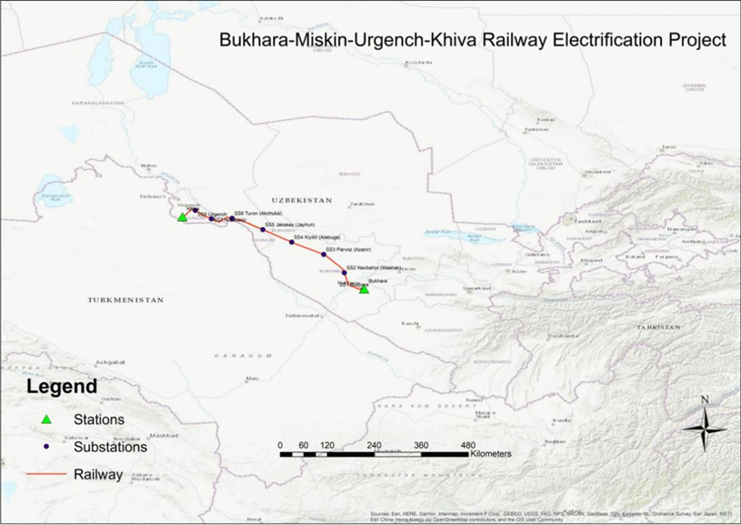

  - Socio-economic background of the project area
- Khozarasp district - is a district of Khorezm region. It has an area of 130 km² and its population is 38400 (2022). The district consists of 4 urban-type settlements (Hazorasp, Oq yop, Oyok ovvo, Nurxayot) and 11 rural communities.
  - Scope and limitations of the Land Acquisition and Resettlement Plan
- This LARP covers land acquisition with permanent impact in connection with the construction of Khozarasp TSS. The LARP sets out the requirements for compensation and resettlement assistance for the affected person (PAP).
- This LARP has been prepared in accordance with:
- ADB’s Safeguard Policy Statement (2009)
- ADB’s Involuntary Resettlement Safeguards: A Planning and Implementation Good Practice Sourcebook (2012);
- The Laws and Regulations on Land Acquisition and Resettlement (LAR) in Uzbekistan.
- The inventory was completed by XRO of “Ozdavyerlayiha” and the corresponding results were forwarded to the local Hokimiyat. Based on the result, the local hokimiyat sent a letter to the Ministry of Agriculture on 12 February 2024 to remove the affected land from the balance of agricultural land and convert it to non-agricultural land.
- The Ministry of Agriculture forwarded the relevant documents to the Cabinet of Ministers for review and approval. Subsequently, the relevant documents were submitted to the Presidential Administration for approval by decree. Finally, on 26 June 2024, the President of the Republic of Uzbekistan signed a decree on changing category of agricultural land as non-agricultural land. (See the decree and the corresponding letters in Annex 1 and 2)
- Although the local Hokimiyat applied to the Ministry of Agriculture on 12 February 2024 to change the category of agricultural land to non-agricultural land, the farmer was using his affected land with verbal permission from the Hokimiyat for cotton cultivation until June 2024. All detailed information on the current use and status of the affected land is provided in paragraphs 40-42.
- To implement the above-mentioned decree, the local Hokimiyat ordered UTY in September 2024 to pay the compensation calculated by XRO of Ozdavyerlayiha.

- IMPACT ASSESSMENT
  - General information
- The construction of the Khozarasp TSS involves the permanent land acquisition of privately leased land with land lease agreement (LLA) with Khozarasp Hokimiyat.
- The LLA N22-12-0-Q/22 was signed on 20 January 2020 for 49-year usage rights to 102.3 ha of land. Of this, 92.3 ha are intended for the cultivation of cotton. (see: Annex 4)
- During the site visit, it became clear that in June 2024, the farmer applied to the notary authorities and signed a document related to his voluntary requisition of the 9.50 hectares of land located in the area, and it is stated in the document that he does not claim any moral and financial compensation in return. During the meeting with the farmer in September, he confirmed that he signed the document for cancellation of his land lease agreement for 9.50 ha out of 102.3 ha and he doesn’t claim any compensation. (See: Annex 5) However, the project is going to compensate him for loss of 2.83ha as the land acquisition proses started before his voluntarily requisition of land.
- In this regard, a meeting was held with the relevant experts from the local authorities and the XRO of Ozdavyerlayihe to investigate and confirm the matter. Thus, in June 2024, a new LLA was prepared for the farmer in line with the current situation and the land lease agreement was amended based on the farmer's notarised rejection of 9.50 ha part of the land. In the new LLA, the land area is stated as 87.80 ha. (See: Annex 6).
- During the inventory, it was found that the area was only used for cultivation of crops and there were no structures and trees on it.
  - Impact assessment approach and methodology
- To accurately assess the impact of land acquisition, the following measures were taken:
- Identification of affected lands: Based on the land acquisition documents issued by the Hokimiyats and the Cadastre Office, a list of affected assets/land was compiled. The data was verified directly on-site during surveys and censuses.
- Cadastral maps. Extracts from the cadastral maps were checked to verify the location of the planned transmission lines route and the status of the land allocation.
- Loss Inventory/Detailed Measurement Survey (DMS) to identify the area, type of land and other assets, farms that will be affected by the land acquisition.
- Census to collect information on the socio-economic status of people affected by the project, e.g. in terms of education, livelihoods, sources of income and vulnerability.
- Consultations with all project stakeholders, government organizations (Hokimiyyats, Mahalla Committees), community members and affected household.
  - Land Acquisition Impacts
- The project will have only permanent land acquisition impact of privately used land by one farm enterprises belonging to one farmer.
- During construction, the contractor will use the existing road in the railway protection zone, which has different access to the affected land and will not have any temporary impact.
- According to the old LLA, PAP had a right to cultivate 92.3 ha of leased land in Khozarasp district. The leased area is partially located in different parts of the district.The LLA states that land plot can not be sold and sub-leased to other parties. In addition, construction of structures and plantation of trees are not allowed. Moreover, according to the LLA, the lease agreement can be canceled or revised by lessor in case if there is a need for public needs.
- In the land proposed for the project, PAP had an area of 9.50 ha, of which 2.83 ha will be permanently affected by the project. According to the LLA requirements the land area is agricultural land and is mainly used for cotton cultivation. The farmer stated that he used to cultivate the area once a year.
- During the site visit, it was confirmed that there are no structures or trees in the area. Therefore, he loss of structures and trees are not expected because of the project.
- Advanced notice was provided to AP and the project allowed him to harvest his products. He has already harvested and there will not be any crop impact.
Table 2. Permanent and temporary impact of project
No | District, region | Name of farm enterprise | Permanent impact (ha) | Temporary impact (ha) | Type of land
1 | Khozarasp district, Khorezm region | Sevindjoy Maxfira | 2.83 | 0 | Irrigated agriculture land, used for cotton cultivation
TOTAL: |  | 1 | 2.83 | 0
  - Severely Affected Households
- The severely affected households are those that will be physically displaced or will lose 10% or more of their productive assets. The assessment has revealed that the AP will not be severely affected by projects because of land acquisition. He will lose only 2.9% of his privately used land.
Table 3. Percentage of total agricultural land affected (severe impact assessment)
No | Affected Party | Total land  area (ha) | Permanently affected  area (ha) | % of impact
1. | “Sevindjoy Maxfira” f/e | 102.3 | 2.83 | 2.9
  - Impacts on Vulnerable Affected Household
- Key informant interview and socio-economic survey have identified the household is not vulnerable.
  - The Legal Status of Land Ownership / User rights
- The affected farmer utilizes the affected land parcel based on a long-term (49 years) land lease agreement with the government/Hokimiyat. (See: Annex 4)
  - Socioeconomic Impacts
- Construction of the TSSs will generate possibilities of local employment as some laborers will be required during the project implementation. The exact number of locally hired workers will be decided by the Contractor who will be responsible for the project implementation.
- Forced and child labor is strictly prohibited in ADB financed projects, as also strictly prohibited under the country laws and the project will ensure that such labor is not engaged. Overall, the implementation of the project has a positive impact on national and local socioeconomics.
  - Unanticipated Impacts
- If unanticipated impacts not defined in the entitlement matrix are found during the project implementation, the PIU will conduct an IOL, a census and a social impact assessment including valuation to update this LARP and implement it.

SOCIO-ECONOMIC PROFILE OF AFFECTED PERSONS
  - General Information
- An analysis of key field data collected through SES of project affected household’s socioeconomic characteristics, such as education, livelihoods, income sources, poverty/income levels, and housing types.
  - Affected persons and their socio-economic profile
- A socio-economic survey of affected person was carried out on the 25th of January 2024. The household was interviewed by the social safeguard consultants of ETS.
- The household consists of 7 people, 5 children under the age of 16, the head of the household and his wife. The head of the household is 42 years old and is a farmer with 6 years of work experience.
- The head of the household is of Uzbek nationality and has a vocational school education.
- The main income of the household is agriculture. Their farmland is about 102.3ha (only 92.3 ha considered for cultivation) and is used for growing cotton. The farming activity is managed by his registered enterprises called “Sevindjoy Maxfira”. The company has 15 employees, 8 of them are women.
- Apart from farming, the family also runs a business. When asked about the share of his income, he stated that 80% comes from farming while the rest (20%) comes from business. The household has an agricultural loan from the government.

PUBLIC CONSULTATION AND INFORMATION DISCLOSURE
  - General information
- Since the beginning of 2024, a series of field visits have been organized to observe and study the current land use patterns in the project area, consult and meet with stakeholders, collect relevant socio-economic information and meet with key informants.
- During the field visit in January 2024 in Khozarasp district, the consultants conducted a public consultation and a focus group discussion.
- Information disclosure and consultations described in two parts. The first part consists of meetings with affected households during the socioeconomic survey and inventory of losses. The second part consists of meetings with the local authority and other stakeholders.
  - Objectives of consultations
- The main objectives of the consultations are:
- informing people and authorities about the project progress and informing beneficiaries about the positive results of the project.
- disseminating information about the project regarding its activities and scope of work and understanding the views and perceptions of APs and local communities regarding permanent land acquisition and proper compensation.
- involving them as stakeholders in the project planning process and further implementation.
- obtaining the opinion of the local population on minimizing the negative impact because of land acquisition.
- informing people about the mechanism for filing complaints related to the implementation of the project
- stimulating public participation during the collection of information during detailed research.
- assessing the desire of the local population to be involved in the project; and listing the measures to be taken during the implementation of the project.
- discussing the general principles of national legislation and the ADB Safeguards Policy Statement 2009 and informing them of the wide range of opportunities and rights to receive compensation.
- discussion of temporary impacts in relation to land acquisition resulting from the construction of the water pipeline.
  - Information Disclosure
- During the consultations, information on the project and LAR activities, including government legislation and ADB policy requirements, the project’s grievance redress mechanism, and the entitlement matrix were disclosed.
- The public consultation was conducted on the 25th of January 2024 in Khozarsp districts Hokimiyyat office.
- There are 15 participants attended the public consultation and after meeting the focus group discussion (FGD) was held with five (5) female residence of community. The list of participants is attached as Annex 7.
Table 4. Issues raised and discussed in the disclosure meetings
No | Question/issue raised | Clarification / response
 | What is the exact location of TSS? | The exact location was shown on a map and relevant technical explanations were provided by UTY engineer.
 | What is the purpose of construction? | The project aims to electrify the existing railway in order to have faster trains. This TPS will help to receive and distribute electricity to the new transmission lines.
 | Are there some employment opportunities during construction? | Yes, the Contractor will coordinate with local authorities in order to employe local people.
 | Will the construction activities affect the other remaining area? | Construction of this TSS will only require 2.83ha land from 1 PAP, as permanent acquisition.  In addition, there will be some permanent and temporary land impacts which are being assessed for the construction of transmission lines.  PIU will monitor the construction activities to make sure that there is no other impact outside of the scope included in LARPs.
 | How many years will take construction? | The UTY engineer gave information about the duration of construction activities and he stated that it is expected no more than one year.
 | Will there be negative health impact of these TSS? | The negative health impact is not expected because of operation of TSS
 | What is the entitlement for permanent land acquisition? | The Consultants explained Entitlement matrix to all meetings participants including the PAP.
  - Consultations with the affected household
- The Consultants had a face-to-face meeting with affected household. The meeting was held on 25 January and 21 September of 2024. During the meeting, the PAP was provided with all the necessary information about the results of the inventory of his privately leased land, the impact, the right to compensation and the GRM of the project.
- A brochure on the grievance mechanism and contact information of relevant persons for complains was provided to the PAP.
  - Identification of stakeholders
- The following stakeholders met during the site visit:
- Yamqurov Bekpolat - Deputy head of Khozarasp districts Hokimiyat (Executive Power) on agriculture.
- Matmuradova Gulnara - head of woman organizations of Khozarasp district.
- Artur Tadjika – Specialist of XRO of “Ozdavyerloyiha” in Khorezm region.
  - Dissemination of information
- Information about the project will be disseminated through the publication of the resettlement planning documents.
- Public consultations should continue throughout the duration of the project.
- A detailed report will always be available to the PAPs. The LARP will be published on the ADB website (in English) and on the UTY website (in English, Uzbek) after its approval.

GRIEVANCE REDRESS MECHANISM
  - General
- A grievance mechanism is designated to allow an AP to appeal any decision on which they disagree, practice or activity arising from land or other assets compensation. The AP was fully informed of his right and of the procedures for addressing complaints whether verbally or in writing during consultation, survey, and time of compensation. Care will always be taken to prevent grievances rather than going through a redress process. This can be obtained through careful LAR design and implementation, by ensuring full participation and consultation with the APs, and by establishing extensive communication and coordination between the affected communities, UTY, and local governments in general. Complaints & grievances will be addressed through the process described below.
  - Objective
- In accordance with ADB SPS (2009), a grievance redress mechanism (GRM) is established to provide project effectiveness. The main goals of GRM are ensuring the receipt and timely redress of grievances and concerns submitted by aggrieved project affected persons, and to resolve complaints at the project level and prevent escalation to the national courts or to the ADB Accountability Mechanism. A grievance mechanism established to allow affected persons a mechanism for appealing to any disagreeable decision, practice, or activity arising from land or other assets disorientation or compensation issue. APs are fully informed of their rights and of the procedures for addressing complaints whether verbally or in writing during consultation, survey, and/or time of compensation.
- The Grievance Redress Mechanism does not impede access to the country’s judicial or administrative remedies. Affected people can apply to court at any time and independent of the project level grievance redress process.
- Along with the ADB requirements on development and approval of GRM by implementation of investment projects, grievance redress procedure in Uzbekistan is regulated by the “Law on the order of submission of appeals of physical and legal entities” (#378, 03 December 2014) of the Republic of Uzbekistan.
- According to this Law, the application or complaint shall be considered within fifteen (15) days from the date of receipt in the state authority, which is obliged to resolve the issue on its merits, as well as requiring additional study (research) and/or checking (investigation), a request for additional documents is valid for one month. The submission procedure for grievances and citizens’ applications was discussed during the public consultations in the project districts.
  - Grievance Redress Mechanism
- Aggrieved person has the right to lodge complaints and question any aspect of compensation for land acquisition and resettlement. PIU (UTY) acts as GRM Secretary to ensure that the GRM is functional and effectively addresses the environmental and social concerns of the project affected people. The proposed GRM has been developed with the PIU Manager and the Safeguards Specialist and disclosed at public consultations. PIU will ensure that complaints and grievances on all aspects of land acquisition, compensation and resettlement are addressed in a timely and satisfactory manner. All avenues were made available to aggrieved people to resolve their grievances at the project level. Under the established project level grievance redress mechanism, affected households can appeal against any decision, practice or activity related to land or other asset valuation, acquisition, and compensation.
Table 5. Grievance Redress Cycle
Level/Steps | Process
Level 1: Regional Railway Stations Administration | The aggrieved person applies to any railway station BMUK. Head of station or designated officer will oversee receiving and registration complaints.  PIU representatives on site will collect daily information on complaints received from the stations. The alternative point of contact for complaints will also be the hokimiyats as they are bound by national legislation: (i) the hokimiyats of the respective rayons (towns) are obliged to inform the owners of residential, production and other buildings, facilities and plantations in writing for signature of the decision taken at least six months prior to demolition, (ii) there is a 1st deputy of hokim in charge of industry, capital construction, communication and utilities who is usually responsible for all issues/complaints related to construction and land allocation; he works closely with the heads of the stations and in case of complaints they will inform each other.  After registering the complaints received, the PIU representatives check the nature/specificity of the complaint and forward it to the competent body for resolution. At the same time, the PIU representative informs the PIU in Tashkent about the complaint received and the further measures taken to resolve it. Depending on the nature of complaint it may go to Contractor, Land Cadaster, Mahala or district branch of Nature Protection Committee. For example, complaints related to resettlement issues may be forwarded to Land Cadaster, Hokimyiat and Mahallas. In the case of environmental issues, compliant will be forwarded to Contractor or District Nature Protection Committee. PIU representatives will be assisted by EWS Consultant and PIU’s Safeguards Specialist in GRM implementation. At this level complaints should be resolved in 2 weeks.
Level 2 -  UTY’s Secretariat in Tashkent / GRC | In case the grievance was not redressed on the first stage or applicant is not satisfied with the decision made/solution, s/he can submit the grievance directly to UTY’s secretariat in Tashkent / GRC. In accordance with established procedure, the secretariat /GRC will review the grievance in coordination with respective departments to made decision on its redress. In case the grievance is not related directly to the project, the further instance will be recommended to the applicant where s/he should apply for the decision making.  If necessary, UTY may establish complaint handling team with following members such as representatives from UTY area representative office, district hokimiyat, cadastral department and Mahalla or village assembly of Citizens or/and farmer’s councils, or/and women association.  All complaints will be resolved in 15 days, and in case additional details are required, a maximum of 30 days will be used to resolve and close the complaint with prior notification of complainant.
  - Contact details for grievance submission
- The table below describes contact information for grievance submission in accordance with Level 1 and Level 2 of the GRM.
Table 6: Grievance submission contact details
Level | Location | Responsible party | Contacts
Level 1 (Railway station) | Khozarasp | Khozarasp Railway station administration | Address: Khorezm region, Khozarasp district, Khozarasp railway station  - Tel: +998(97) 747 4185
Level 2 (UTY /GRC) | Tashkent | UTY/PIU | Address: 100060, Tashkent city, Shevchenko str.7,  Tel: +998 71 237 99 98 (1005)
  - Grievance Redress Commission
- A meeting was held on 5th February 2024, with the representatives of the relevant departments of UTY such as Capital Construction Directorate, Project Implementation Unit, Bukhara Regional Railway Junction, Kungrad Regional Railway Junction and ETS Consulting Company DB for the establishment of GRC. Minutes of the meeting were taken, and the relevant members of the departments were appointed as members of the GRC to handle grievances.
Table 7: GRC members contact details
Members | Location | Occupation | Contact details
Jamshid Rasulov | Tashkent | UTY, Deputy Head of the Capital Construction Directorate | Tel: +998 99 764 88 88
Chingiz Kudabekhov | Tashkent | UTY/PIU, Deputy head of PIU | Tel: +998 71 237 99 98 (1005)
Alisher Bozorov | Bukhara | UTY, Head of the Bukhara Regional Railway Junction | Tel: +998 71 237 99 98 (1005)
Azamat Palimbetov | Kungrad | UTY, Head of the Kungrad Regional Railway Junction | Tel: +998 71 237 99 98 (1005)
Guzal Khojamyarova | Tashkent | UTY/PIU, Safeguard Specialist of the PIU | Tel: +998 90 176 51 82
Said Gulkar | Tashkent | ETS, team leader | Tel: +998 90 9060130  Email: saeid.aliakbar@db-co.com
- The GRC should be kept operational to address timely social and/or environmental issues if any are raised during the civil works. During the implementation of the project, any grievances from the local population will be considered through the grievance redress mechanism established within the framework of the project and applied to both social and environmental safeguard measures.
- During the entire project cycle, a Grievance Redress Commission (GRC) shall be kept operational to address timely social and/or environment issues if any are raised during the civil works.
  - GRC Records and Documentation
- Most grievances on land acquisition and resettlement are redressed at Levels 1-2. All received grievances will be registered in a logbook which will be available at all levels: at the site office of Contractor, each station of railway BMUK. Further, there are also logbooks in the hokimiyats where grievances from the public are normally registered. All information received with respect to Contractor grievances and applications from aggregated person, and any measures undertaken should be submitted to the representatives of PIU on the project site for updating records and accounting of all grievances. Otherwise, all received information on grievances will be collected at the PIU. Meantime, the UTY, with the assistance of construction supervision engineers, will maintain a consolidated electronic complaint register (database). This will include a record of all complaints received from all GRM entry points and levels for regular monitoring of grievances.
- The Contractor and ETS Consultant should include the information on grievances in monthly progress reports submitted to the PIU, who in their turn will include aggregated information to the semi-annual social monitoring reports (SSMR) to be submitted to the ADB.
- The UTY PIU will maintain the complaint register (i.e. Grievance Log) to record all complaints for regular monitoring of grievances and results of services performed by the GRC for periodic review by the ADB.
  - ADB Accountability Mechanism
- In addition to the project level GRM required by ADB’s SPS, ADB also has an Accountability Mechanism (AM) Policy (May 2012). While the project level GRM is the responsibility of the EA, the Accountability Mechanism is the responsibility of ADB. The accountability mechanism provides opportunities for people (2 or more complainants) that are adversely affected by ADB- financed projects to express their grievances, seek solutions, and report alleged violations of ADB’s operational policies and procedures, including safeguards policy. ADB’s accountability mechanism comprises (i) a consultation phase led by ADB’s special project facilitator to assist people adversely affected by ADB-assisted projects in finding solutions to their concerns and (ii) providing a process through which those affected by projects can file requests for compliance review by ADB’s Compliance Review Panel.

- ADB’s accountability mechanism can be considered a last resort mechanism. The aggrieved persons are first expected to exhaust grievance handling mechanisms described in this SDDR and the ADB operations department concerned (ADB Uzbekistan Resident Mission) before lodging a complaint with ADB’s Accountability Mechanism.
- Accountability Mechanism Contact Information:
Diagram 2: Grievance Redress Mechanism
1ST LEVEL:
Railway station
The complaint issue has been resolved
Person affected by the project
LEVEL 2:
UTY/GRC Tashkent
The complaint issue has been resolved
UTY Complaints Team

POLICY AND LEGAL FRAMEWORK
  - General
- The purpose of presented policy and legal framework is to provide a legal basis for the entitlement matrix of project. The policy and legal framework of the project is based on the national laws and legislation related to land acquisition and compensation policy in Uzbekistan and the Safeguard Policy Statement 2009 (SPS) of the ADB.
- The project LARP principles were adopted based on the analysis of the applicable laws and policies as well as ADB policy requirements.
  - Laws, Regulations, and Provisions Relating to LAR in Uzbekistan
- In Uzbekistan, the expropriation of land for state and public needs is carried out in accordance with the Land Code (LC) and other legal documents. Expropriation in this context refers to the taking away private owners and leased land users for a state and public needs by the government with or without the consent of the owner subject to the laws of eminent domain, which provide for prompt and adequate compensation. Recent legal documents issued by the President and Cabinet of Ministers of Uzbekistan to provide protection of legal and human rights in land, buildings, and structures. Overall, these regulations provide a basis for the acquisition of land by the government for public needs and the compensation calculation requirements for land loss.
- The table below summarizes the legal documents detail used in preparation of entitlement matrix for this project.
Table 8. Summary of legal instruments applicable to Land acquisition and resettlement
# | Legal Instruments | Explanation
 | The Constitution | The master-source of all legal provisions.
 | The Land Code (LC) dated 30 April 1998 | Describes a condition for permanent land expropriation and temporary land acquisition
 | Civil Code (CC) dated on 29 August 1996 | Regulates general rules of property seizure, determination of property cost and rights for compensation, terms of rights termination
 | The Law of Uzbekistan on Protection of Private property and Guarantees of Ownership rights, No. ZRU-336, dated 24 September 2012 regulated the entitlement of property owner | The purpose of this Law is to regulate relations in the field of protection of private property and guarantees of property rights. It to full market value compensation in case of acquisition for the State needs.
 | The Law on Procedures of Land Acquisition for Public Needs, No. ZRU-781, 29 June 2022 | This law defines and regulates the acquisition and compensation for land plots.
 | Decree of the President No. 15 dated 18 January 2024 | This decree is about additional measures to improve the procedure for leasing agricultural land.
 | Resolution of the Cabinet of Ministers № 911 of November 16, 2019 | This Resolution defines the need for establishing team for coordination of land acquisition and resettlement and regulates institutional mechanisms.
 | The resolution of CoM “On measures to improve the procedure for granting land plots for urban development activities and other non- agricultural purposes” dated on 25 May 2011 #146 | Regulates resettlement compensations for the income loss the value of agricultural loss belonging to landowners, users, tenants in case of land acquisition.
 | The resolution of CoM “On amending and adding to some decrees of the Republic of Uzbekistan, aimed the further improvement of registration of cadastral document on a real property” No. 317 dated 21 September 2016 | This resolution is making changes and additions to some decisions of the Government of the Republic of Uzbekistan aimed at further improving the procedure for issuing cadastral documents related to real estate.
 | Presidential resolution “On measures to improve the effectiveness of training and realizing projects with participation of international financial institutions and foreign government financial organizations” dated on 16 July 2018 #3857 | Confirms that the resettlement costs are paid based on assessment documents prepared by IFI by their methodology.
 | Presidential Order F-5491(3 August 2019) | “On additional measures to provide unconditionally the property rights of citizens and business entities”
 | The resolution of CoM “On the procedure for the formation and use of funds of centralized funds for the compensation to affected individuals and legal entities for the expropriation of land for the state or public needs” dated 26 December 2018 # 1047 | It defines source of compensation payments based on the type of projects. Establishes Republican Centralized Fund (RCF) as the main body which is responsible for the compensation payments to AHs. The Supervisory Board of RCF decides on the allocation of funds for compensation.
 | Presidential Decree on Additional measures for social support of citizens and implementation of a latest public campaign on the recognition of ownership rights to illegally built residential structures dated on 20 April 2018 # PF 5421 | Residents of Uzbekistan are allowed to Legalize ownership rights to their unregistered and non-titled residential structures until 1st May 2019. The Decree defines the conditions for legalization.
 | Decree of the President of the Republic of Uzbekistan No. PF_- 6243, "On measures to ensure equality and transparency in land relations, reliable protection of land rights and their transformation into a market asset" dated 08.06.2021 | Purpose of the resolution is to introduce a transparent procedure for allocating land plots based on market principles; ensure stability in property and legal relations in the field of land use, land protection; guarantee property rights of landowners, as well as introducing property rights of landowners into free circulation as an object of civil law relations.
 | Resolution #543, Cabinet of Ministers of Republic, 27 August 2021 | This Resolution defines the procedure for allocating the land plots for permanent use for state and public needs.
 | The resolution of CoM “On the approval of the rules of protection of power transmission facility objects” dated 26.12.2018 # 1050 | This resolution defines safety zones for power transmission lines both horizontally and vertically. This resolution applies for all infrastructures and facilities in relation with power up to 500 kV.
 | KMK 2.10.08-97 – Land allocation norms for power transmission lines 0.4 – 750 kV | This set of norm regulates the land allocation for the temporary and permanent period during the construction of transmission lines.
 | Law on Valuation Activity (No. 811-I dated August 19, 1999, amended in 2017) | Valuation of assets, including real estate, business, etc., is carried out based on this law.
 | “About Privatization of Non-Agricultural Lands” No. ZRU – 728 dated 15 November 2021 | This law allows acquisition of private land for public needs only through purchasing a private land plot.
 | Presidential Decree “On measures to reliably protect the inviolability of property rights, prevent unreasonable interference in property relations, and increase the level of capitalization of private property” No. УП-198 dated August 24, 2022 (the “Decree No. УП-198”). | This Resolution outlines measures for reliable protection of immunity of the property right, non-admission of unreasonable intervention in the property relations, increase in level of capitalization of private property.

Constitution
- The Constitution of the Republic of Uzbekistan (December 8, 1992) provides that:
- Everyone shall have the right to own property (Article 36). The economy of Uzbekistan, evolving towards market relations, is based on various forms of ownership. The state shall guarantee freedom of economic activity, entrepreneurship, and labor with due regard for the priority of consumers’ rights, equality, and legal protection of all forms of ownership (Article 53).
- An owner, at his discretion, shall possess, use, and dispose of his property. The use of any property must not be harmful to the ecological environment, nor shall it infringe on the rights and legally protected interests of citizens, juridical entities, and the state (Article 54).
- The land, its minerals, waters, fauna and flora, other natural resources shall constitute the national wealth and shall be rationally used and protected by the state (Article 55)

Land Code (30 April 1998)
- The Land Code (LC) is the primary regulatory framework for land-related matters in Uzbekistan. The LC regulates allocation, transfer, and sale of land plots, defines ownership and rights on the land. It describes responsibilities of different state authorities (Cabinet of Ministers, province, district, city Hokimiyat) in land management; rights and obligations of the land possessor, user, tenant, and owner; land category types, land acquisition, and compensation, resolution of land disputes and land protection. The LC also defines the terms of rights termination on the land plot, seizure, and land acquisition of land plot for state and public needs, and conditions of confiscation of a land plot in violation of land legislation.
- According to the new version of the Code, currently, the granted lands for the construction of infrastructure, business, and residential houses shall be carried out within the three years. After that, the land will be taken back by local municipalities.
- The land can be given for temporary use as a short-term period (up to three years) or long term.
- The Code clearly states (i.e. Article 23) that the land for the construction of the power line is allocated from the agricultural or non-agricultural land of low quality. The legal entity to which the land has been allocated cannot use and take possession of the land until the title deed has been issued.
Civil Code (29 August 1996)
- The Civil Code (CC) defines the legal status of participants of public relations, the grounds, and procedure of implementation of property rights and other proprietary rights, rights of intellectual property, regulates the contractual and other obligations, as well as other property and related personal non-property relations. The CC defines general rules of property seizure, determination of property cost and rights for compensation, terms of rights termination.
- The CC provides that: a person whose right has been violated may demand full compensation for damages unless the law or the contract provides compensation for losses in a smaller size (Article 14, Clause 1). The Civil Code (Article 14, Clause 2) also specifies that losses are understood as:
- expenses that the person whose right is violated, made or must make to restore the violated right.
- the loss of or damage to property.
- the revenues that this person would have received under normal conditions of civil turnover if his right had not been violated (lost incomes).
- According to article 14, Clause 3 “If the person has violated the law, revenues received as a result of this, the person whose rights were violated, has the right to demand compensation along with other losses, lost profits in the amount not less than such profits.”

Tax Code
- The Tax Code (TC) is a regulatory framework for taxation related matters of individuals and legal entities. This law regulates compensation for vulnerable group of people in terms of applying discounts or exemption from property taxes, income tax and other taxes stipulated in this TC.
- By article 121, the use of entire land plot or expanding the territory without documents or illegally is subject for sanctions in the amount equivalent to:
- Four times of land taxes for legal entities,
- Three times of land taxes for physical bodies.
Law No 781 on procedures for the withdrawal of land plots for public needs with compensation (2022)

- The Law provides for the expropriation of private property for public needs. It sets out the conditions and procedures for lawful land withdrawal and reallocation and regulates compensation entitlements for legally registered land rights holders
Provisions on land withdrawal
- Article 4 - lists developments of public need that justify land withdrawal and reallocation. These include the construction (reconstruction) of roads and railways of republican and local importance, airports, aerodromes, air navigation facilities and aeronautical technical centres, rail transport facilities, bridges, subways, tunnels, technical facilities and lines of the energy and communication system, facilities for space activities, main pipelines, technical communication networks, irrigation and melioration systems.
- Article 14 - provides that the initiative for the implementation of the project and the withdrawal of land plots in this regard, as well as the relevant justifications, shall be considered by the Cabinet of Ministers of the Republic of Uzbekistan. Based on the results of the examination by the Cabinet of Ministers of the Republic of Uzbekistan, a decision shall be made on the implementation of the relevant project. This decision refers to the Presidential Decree. Article 14 further states that if it becomes necessary to withdraw land plots for public needs in connection with the adoption of a decision of the Cabinet of Ministers of the Republic of Uzbekistan on the implementation of the project, all obligations assigned by this Law shall be fulfilled by the hokimiyat of the region concerned.
Provisions on valuation compensation for land withdrawal
- Article 23 sets out the compensation entitlements for legitimate landowners affected by expropriation. This includes compensation (at market value) for immovable property on the affected land, compensation for life/inheritable property, compensation for perennial plantings, and conditional compensation for certain transitional costs until the affected property and livelihoods are restored.
- Article 25 states that the compensation shall be paid to the participants in the common property in proportion to their shares and adds that the compensation shall be paid within the time limits specified in the agreement, but no later than six months after the conclusion of the agreement, and if the agreement provides for compensation in the form of money, such compensation shall be paid no later than one month after the conclusion of the compensation agreement. Article 25 also provides that if an agreement is concluded with all right holders, the amount of money specified in the agreements as compensation shall be paid within three months of the date of conclusion, subject to indexation in relation to inflation officially announced by the State Statistics Committee of the Republic of Uzbekistan in the relevant months.
Law on Valuation Activity
- The Law on Valuation Activity (No. 811-I dated August 19, 1999, amended in 2017) stipulates regulations related to the implementation of valuation activities. Valuation of assets, including real estate, business, etc., is carried out based on this law and government standards, departmental regulations and other provisions of national legislation.
- The sequence of legal acts and their content characterize the state and public understanding of the theory and practice of market valuation. This is confirmed by several definitions and norms stated in the Law on Valuation Activity. For example:
- "Valuation activity is the activity of a valuation organization aimed at determining the cost of valuation”.
- “Valuation organization" - a legal entity licensed to carry out valuation activities. The valuation organization is independent in its activities. Client services (hereinafter referred to as the Client) or other interested parties do not interfere with the organization's valuation activities. Creation of a valuation organization and the implementation of valuation activities by state bodies and administrations is prohibited, unless otherwise provided by law."
- Although valuation activities are carried out by independent organizations (private companies with certified valuators), the state plays an important role in regulating valuation activities. The State Asset Management Agency is responsible for: i) development and approval of regulations, including property valuation standards; ii) licensing of valuation activities; iii) certification of expert valuators, as well as organization of their training and professional development.
- The Society of Valuators of Uzbekistan protects the rights of valuators, increases their capabilities, upon request, requests an independent expert opinion to verify the conclusions of the valuation report, etc.
Presidential decree, no. Up-15, January 18, 2024
- The decree aims to support the previous Presidential Decree "On measures to ensure equality and transparency in land relations, the reliable protection of land rights and their conversion into market assets".
- The decree provides for the introduction of electronic online auction from 1 March 2024. It serves to lease land parcels for agricultural use for thirty years; in this scenario, the starting price is set at the normative cost of the land parcel.
- The decree allows the winners of online electronic tenders to pay the cost of the land lease in equal monthly instalments over three years.
- The payment scheme may vary for certain social groups (women, young people, etc.). For example, they may make an interest-free instalment payment in equal parts within five years.
- The tenant must use the leased plot for at least three years, calculated from the date of state registration of the leasehold right.
Resolution of the Cabinet of Ministers № 911 of November 16, 2019
- On November 16, 2019, the Cabinet of Ministers approved the “Regulation on the procedure for the seizure of land and the provision of compensation to owners of real estate located on the seized land. Later, the resolution was substantially revised in accordance with other legislative acts.
- This Resolution defines the need for establishing team for coordination of land acquisition and resettlement and regulates institutional mechanisms.
- It requires that in the structure of the Council of Ministers of the Republic of Karakalpakstan, regions and Tashkent city administrations, within the limited total number of management staff, a department for coordination of land acquisition and compensation work consisting of 2 state units should be established. In necessary cases, the position of chief specialist shall be introduced by respective administrations. They are tasked to carry out the following tasks:
- to study the availability of sufficient resources (funds, land and other property) to compensate the owners of the real estate objects that will be damaged;
- preparing project documents of the future construction facility in the form of presentation materials for submission to the Supreme (Dzhokorg) Council of the Republic of Karakalpakstan or people's deputies to the regional and Tashkent City Councils;
- organizing an open discussion with the owners of real estate objects located on the acquired land;
- keeping records of the agreements concluded between the initiator of land plot confiscation and the owners of real estate objects. The agreements should include amount, type and term of compensation;
- to carry out constant monitoring of timely and complete compensations;
- to submit information to the Cabinet of Ministers of the Republic of Uzbekistan about the land acquisition, compensation, destruction of real estate objects, as well as the construction and assembly works being carried out on the acquired land plot;
- The head of the department acts as the secretary of the compensation commissions under the Supreme (Dzhokorg) Council of the Republic of Karakalpakstan, People's Deputies of the Regions and Tashkent City Councils.
Resolution of Cabinet of Ministers № 146 (25 May 2011)
- This Resolution is aimed to improve the procedure of granting land plots, protect the rights of legal entities and individuals on land, and improve the architecture of settlements and the efficient use of their land for construction by the Land Code and the Town Planning Code. This resolution has approved two Regulations: (i) Regulation on the procedure for granting land for urban development and other non-agricultural purposes, (ii) Regulation on the method of compensation for landowners, users, tenants, and proprietors (in case of residential land), as well as losses of agriculture and forestry.
- The Regulation on the method of compensation for landowners, users, tenants, and proprietors, as well as losses of agriculture and forestry, includes the following:
- Compensation for losses of landowners, users, tenants, and proprietors (hereinafter AHs);
- Compensation for losses of agriculture and forestry;
- cost of irrigation and developing the equal new land plot in return for seized irrigated agricultural land;
- Cost of fundamental improvement of grassland and pasture;
- Scheme for determination of losses of land possessors, users, tenants, and owners, as well as damages of agriculture and forestry;
- Coefficients on the location of seized land plots.
- In this LARP, the entitlements and compensation for AHs per resolution #146 have been included. According to this resolution, AH is entitled the following compensation:
- The cost of the land plot under the ownership of legal and physical entities.
- The cost of not harvested agricultural crops.
- Compensation for AHs is provided in case of:
- Permanent acquisition of land
- Redemption of land
- Temporary acquisition of land
- This resolution shall be implemented together with the Resolution of Cabinet of Ministers #317 dated 21 September 2016.

Resolution of Cabinet Ministers №317 (21 September 2016)
- The resolution “On amending and adding to some decrees of the Republic of Uzbekistan, aimed the further improvement of registration of cadastral document on real property” defines responsible design institution which calculates the agricultural and forest-related losses belonging to legal land users, tenants. This institute is “Uzdavyerloyiha” and its branches in the regions. It defines that in case of the following type of construction works, then compensation for agricultural and forest-related losses will not be compensated:
- construction of individual housing and maintenance of a residential house.
- construction of pre-school, general secondary, secondary special, professional educational and medical institutions.
- construction of water management facilities, land reclamation facilities and hydraulic structures.
- formation of protected natural areas.
- In resolution # 317, there is no indication that in case of above-mentioned purposes AHs will also not to be compensated. Based on this we consider that even though, the land is being expropriated for public needs; still, the compensation for AHs shall be paid.
- By this resolution, the Government defined the procedure of legalization cadastral document of the titled and not titled (illegal) land users. The main requirements for the legalization of non-titled land users are to provide i) explanation of circumstances of unlawful use of land, ii) certificate from local self-governed bodies on possession of the last 15 years, iii) payment of land tax for the previous five years. This resolution updates compensation mechanism of agricultural and forest-related losses. Therefore, in the calculation of compensation, this resolution shall be used together with Resolution of Cabinet of Ministers #146dated on 25 May 2011.
Resolution of Cabinet Ministers №3857 (16 July 2018)
- The resolution “On measures to improve the effectiveness of training and realizing projects with participation of international financial institutions and foreign government financial organizations” partly provides that payment of compensation for the land acquisition, demolition of houses, structures, plantings within the framework of projects with the participation of International Financial Institutions (IFIs). If it is agreed and stated in agreements, then project implementation procedure will be followed by authorized bodies following the requirements of IFIs or Foreign Governmental Finance Organizations (FGFOs). This resolution gives to Executing Agencies to implement ADB’s LAR or other principles in case of discrepancies between national legislation and ADB policies.
Presidential Order PF-5491 (3 August 2019)
- The order “On additional measures to unconditionally provide guarantees of ownership rights of citizens and business entities” has been issued after several breaching the national legislation in connection with involuntary resettlement and land expropriation for the State needs by local authorities in Uzbekistan. The main requirements of the Order are the following:
- All the Involuntary resettlement activities in connection with the expropriation for the public and the State needs must be consulted with the centralized fund that was established under the Cabinet of Ministers to compensate for the LAR activities.
- LAR Implementation can be carried out only after meaningful consultation with PAPs (residents and business entities) and valuation of compensation, and payment of the value of demolished buildings at replacement cost;
- Inappropriate/illegal issuance of the administrative documents by the respective authorities to residents and business entities will be firstly compensated by the special budget of the local respective authorities and sooner the compensation will be reimbursed by the guilty person who issued that document.
- Starting from August 5, 2019, all the LAR activities in connection with the expropriation for the public and the State needs shall be carried out in 3 stages. 1st stage includes that all the LAR documents shall be submitted to the Cabinet of Ministers (CoM), 2nd stage includes the issuance of conclusion by the responsible persons at CoM, and in 3rd stage, the prepared conclusions shall be submitted to the Prime Minister for review and issuance of final decisions.
- In general, this Order fully complies with the ADB’s SPS 2009 on Safeguard Requirements Involuntary resettlement regarding public consultation, compensation at replacement cost and provision of relocation costs. This Order clearly states that all the inappropriate documents that made property owners as illegal owners will be compensated as well. However, one discrepancy includes that property owner without any document (squatter) is not subject to compensation.
Resolution of Cabinet of Ministers № 1047 (26 December 2018)
- This full name of the resolution is called as “On the procedure for the formation and use of funds of centralized funds for the compensation to affected individuals and legal entities for the expropriation of land for the state and public needs.” This resolution appoints Republican Centralized Fund (RCF) under the Cabinet of Ministers for calculation and distribution of compensation during the involuntary resettlements to affected households and affected entities. Involuntary resettlement can be done only for the public and the state needs. RCF will be responsible for the Governmental level and internationally funded projects.
- This resolution sets the procedure of compensation payments to affected physical and legal entities. The Supervisory Board under RCF has the right to decide, and the decisions are compulsory to execute. The Board will also monitor the allocation of funds to AH during the resettlement implementation period. Local managing bodies (i.e., Hokimiyats) should start the process by inquiring to RCF on the distribution of necessary funds for LAR. The Board will review this application, and the appropriate decisions will be accepted. Regional Hokimiyats issue the Decree on the allocation of compensation based on the RCF’s decision. The Decree serves as a legal instrument to provide compensation to affected physical and legal entities.
Decree #PF-6243 of the President of the Republic of Uzbekistan of June 8, 2021: "On the measures of the equality and transparency in land relations, reliable protection of land rights and making them market assets"
- Under the given Decree, since August 1, 2021:
- The procedure for allocating the land plots by virtue of the perpetual inheritance, permanent ownership and temporary use rights has been abolished, while the same rights have been preserved for the owners for the land plots allotted in the past under the law.
- In case of transferring the ownership of the real estate legally built on a rented land plot to another person under the law, in addition to the ownership right for the given object, the new owner will also receive the right to use the land plot.
- An agricultural land plot is allocated only based on the relevant outcomes of open e-tenders. The tender is open to all persons producing agricultural products. The results of the tender are approved based on the decision of the Council of Ministers, the Council of Ministers of the Republic of Karakalpakstan and Hokimiyats of the regions and Tashkent.
- A non-agricultural land is sold through an electronic online auction based on the rights of ownership and lease.
- Based on the right of permanent use, by the decision of the Council of Ministers of the Republic of Karakalpakstan and Hokimiyats of the regions and the city of Tashkent, the land plots are given to the state organizations for the state or public needs;
- During the implementation of state projects, the land plots are handed over to the state organizations under the right of permanent use. These plots may be subsequently leased by the owner to a private partner, as well as to profit organizations and other organizations of civil society for the term period specified by the contract.
Resolution # 543 Cabinet of Ministers of Republic of 27 August 2021: “On the Approval of the Administrative Regulations for the provision of Permanent use of land for state and Public needs”
- The regulation was developed in accordance with the requirements of Decree #PF-6243 of the President of the Republic of Uzbekistan of June 8, 2021: “On the measures of the equality and transparency of land cultivation, reliable protection of land rights and making them market assets”.
- The regulation defines the procedure for allocating the land plots for permanent use for state and public needs. The land plots are allocated on the basis of the right of permanent use of state bodies, institutions, enterprises and citizens’ self-governing bodies by the decision of the Council of Ministers of the Republic of Karakalpakstan, regional Khokims and the administration of the city of Tashkent.

  - ADB Safeguard Policy Statement 2009
- The ADB Safeguard Policy Statement, 2009, applies to losses due both to physical and economic displacement caused by involuntary acquisition of land and is based on the following basic principles:
- Compensation, Assistance and Benefits for Displaced Persons (DPs)
- Compensate/assist those with formal legal rights to the land lost and those who have claims to lands that are recognized or recognizable under national laws. Compensate DPs who have neither formal legal rights nor recognized or recognizable claims to land for non-land assets.
- Compensate for affected lands, structures and other assets and put in place a comprehensive income and livelihood rehabilitation program prior to displacement.
- Give preference to land-based resettlement strategies for displaced persons whose livelihoods are land-based. Provide physically displaced persons with relocation assistance, secured tenure to relocation land, better housing at resettlement sites with comparable access to employment and production opportunities, and civic infrastructure and community services.
- Promptly compensate economically displaced persons for the loss of income or livelihood sources at full replacement cost, and provide other assistance (i.e. access to credit, training, and employment opportunities) to help them improve, or at least restore, their income-earning capacity, production levels, and standards of living to pre-displacement levels.
- Provide DPs with opportunities to share project benefits in addition to compensation and resettlement assistance.
- Social Impact Assessment
- Conduct socioeconomic survey(s) and a census, with appropriate socioeconomic baseline data to identify all persons who will be displaced by the project and to assess the project’s socioeconomic impacts on them.
- Identify individuals and groups who may be differentially or disproportionately affected by the project because of their disadvantaged or vulnerable status as part of the social impact assessment.
- Resettlement Planning
- Prepare a resettlement plan based on the social impact assessment and through meaningful consultation with DPs.
- Ensure that DPs are (i) informed about their options and entitlements pertaining to compensation, relocation, and rehabilitation; (ii) consulted on resettlement options and choices; and (iii) provided with resettlement alternatives.
- Ensure that both men and women receive adequate and appropriate compensation for their lost property and resettlement assistance, if required, as well as assistance to restore and improve their incomes and living standards.
- Analyze and summarize national laws and regulations pertaining to land acquisition, compensation payment, and relocation of DPs; and compare with ADB SPS (2009) principles and requirements. In case of gap, propose a suitable gap filling strategy in the resettlement plan in consultation with ADB.
- Consider all costs of compensation, relocation, and livelihood rehabilitation as project costs.
- Include detailed measures for income restoration and livelihood improvement of DPs. For vulnerable persons and households, provide extra assistance so that they can improve their incomes in comparison with pre-project levels.
- Finalize the resettlement plan soon after the completion of engineering design. Ensure that the final resettlement plan (i) adequately addresses all involuntary resettlement issues pertaining to the project, (ii) describes specific mitigation measures that will be taken to address the issues, and (iii) ensures the availability of sufficient resources to address the issues satisfactorily.
- Consult DPs identified after the formulation of the final resettlement plan and inform them of their entitlements and relocation options. A supplementary resettlement plan or a revised resettlement plan should be submitted to ADB for review before any contract is awarded.
- Use qualified and experienced experts to prepare the social impact assessment and the resettlement plan.

- Information Disclosure
- Submit to ADB for disclosure on ADB’s website: (i) the draft resettlement plan and/or resettlement framework endorsed by the borrower/client before project appraisal; (ii) the final resettlement plan endorsed by the borrower/client; (iii) the new resettlement plan or an updated resettlement plan, and a corrective action plan prepared during project implementation, if any; and (iv) resettlement monitoring reports.
- Provide relevant resettlement information in a timely manner, in an accessible place and in a form and language(s) understandable to affected persons and other stakeholders. For illiterate people, use other suitable communication methods.
- Consultation and Participation
- Consult meaningfully DPs, their host communities, and civil society for every project and subproject with involuntary resettlement impacts.
- Pay particular attention to the need of disadvantaged or vulnerable groups, especially those below the poverty line, the landless, the elderly, female-headed households, women and children, indigenous peoples, and those without legal rights to land.
- Grievance Redress Mechanism
- Establish a responsive, readily accessible and culturally appropriate mechanism to receive and facilitate the resolution of DPs’ concerns and grievances, paying particular attention to the impacts on vulnerable groups.
- Monitoring and Reporting
- Monitor and measure the progress of implementation of the resettlement plan. For projects/subprojects with significant LAR impacts, retain qualified and experienced external experts to verify internal resettlement monitoring information. If any significant involuntary resettlement issues are identified, prepare a corrective action plan to address such issues. Do not proceed with implementing the project until such planning documents are formulated, disclosed and approved.
- Unanticipated Impacts
- Conduct a social impact assessment, update the resettlement plan or formulate a new resettlement plan if unanticipated involuntary resettlement impacts are found during project implementation.
- Special Considerations for Indigenous Peoples
- Avoid physical relocation of indigenous peoples that will result in adverse impacts on their identity, culture, and customary livelihoods. If adverse impacts cannot be avoided, formulate a combined indigenous people resettlement plan to meet all relevant requirements specified under ADB Safeguard Requirements 3: Indigenous People.
- Negotiated Settlement
- Encourage acquisition of land and other assets through a negotiated settlement whenever possible.
- Subject to third-party validation negotiated settlements that would result in expropriation to ensure that the compensation is based on fair price (replacement cost) of land and/or other assets, and is based on meaningful consultation with DPs.
- The SPS distinguishes three categories of affected persons (AP), with variable compensation entitlements: a) Legal APs: APs with formal legal rights to land lost in its entirety or in part: b) Legalizable APs: APs without formal legal rights to land lost in its entirety or part but who have claims to such lands that are recognized or are recognizable under national law; c) Non-legal APs: APs who have neither formal legal rights nor recognized/recognizable claims to land lost in its entirety or in part.
  - Comparison of two policies
- A summary comparison between the Uzbekistan law and regulation and ADB policies, and reconciliation provisions to fill the gaps is presented in table below:
Table 9. Comparison of policies between ADB's SPS and national legislation of the Republic of Uzbekistan

Impact/Issue | ADB SAP (2009) and ADB Application Practice* | The Republic of Uzbekistan | Negotiation needs
1. Restoring livelihoods | ADB policy requires rehabilitation/improvement of livelihood standards of APs. | The concept of livelihood rehabilitation is not sanctioned by national legislation. | There is no need for policy approval. The application has already been agreed in previous ADB projects but should be formalized in relation to indirect/livelihood restoration.
2. Right to Compensation | A. APs with formal right should be compensated for lost land/other assets. | A. APs with formal right should be compensated for lost land/other assets. | A. Same in principle/application.  No approval required
 | B. APs with formalized rights are entitled to receive compensation for lost lands and assets after the EA assists them in legalizing their assets. | B. APs with legalizable title have the right to be compensated for lost land and assets after the EAs help them in legalizing their assets. | B. Same in principle/application. No reconciliation needed.
 | С. APs without property rights are compensated for lost landless assets. | C. APs with no legal title have no right to be compensated for land and non-land assets. | C. Per Resolution of CoM #3857, in case of discrepancies between International Financial Institution in terms of payment of compensation for the land acquisition then IFI policies prevail. So ADB policy can be used
3. Compensation | A. Constant loss of land. Land replacement as preferred option or cash compensation at full market rate. At least for legal/legalized APs. | A. Constant loss of land. Cash compensation at market rate for legal/legalized APs. Land for land option is not possible due to national regulations. | A. Same in principle. Reconciliation needed both for principle and application to allow the compensation of all non land losses of legalizable and non-legal APs, which shall be covenanted.
 | B. Replacement compensation of leased land. Based on replacement of lost income through monetary of gross income x remaining rental years or through a land lease replacement agreement | B. Replacement of leased land. Cash compensation for all losses including loss of profit | B. Same in principle. Application to be further improved. No reconciliation needed. To be reflected through instruction for ADB projects.
 | Loss of structures, buildings. Cash compensation for the cost of replacing the lost element of free depreciation, transaction costs, other deductions | C. Loss of structures, buildings. Cash compensation at replacement cost | C. Application approval required. Approval requires drawing up a protocol allowing compensation of structures/buildings at replacement cost. It is hoped that this can be achieved without legal reform, but only by issuing a decree on ADB projects
 | D. Loss of indirectly affected items. Any affected portions of the asset that are no longer used after the impact will be compensated. | D. Loss of indirectly affected assets. The law requires that all loss of income be compensated by legal AP | D. Agreement between principle and application is not required.
 | E. Loss of business. Reimbursement of actual costs of losses + costs of re-establishing the business. To be applied on the basis of tax on declared income during the period of suspension of business. In the absence of a tax return based on the maximum non-taxable salary. | E. Loss of business. Cash compensation at market value for all losses/costs incurred. The time of proof with the AP based on recognized documented data. | E. Same in principle, but ADB does not consider opportunity costs. Application agreement is required to define a clear methodology and distinguish between short-term and long-term losses.
 | Losses  F. Non-productive trees. Regardless of the legal occupancy status of the land, compensation is at the market rate. Application depending on the type of tree/dimension of wood or other methods that ensure the rehabilitation of APs.  (ii) fruit trees. Replacement cost compensation based on different methods: replacement cost of tree, loss of income (x type of tree x market value of 1 year of income x total loss of productive years). | F. Loss of fruit and non-fruit trees. Unproductive as well as productive trees damaged by the project must be compensated. There are different approaches used to assess non-productive and productive trees, but they are generally comparable to the tree assessment methods consistent with the SAP 2009.  Compensation for loss of trees is carried out separately from compensation for lost profits. | F. Same in principle, different in application. Approval required
 | G. Yield loss. Harvest compensation in cash at market price. | G. Yield loss. Crop losses will be compensated. There are two forms of compensation for crop losses: i) compensation for unfinished agricultural production and ii) compensation for lost income as the average income for the last three years | G. Policy agreement is not required, but application agreement is required to ensure that the crop is compensated at a point as close as possible to the profit calculation date.
 | H. Job losses. Exemption from liability for loss of income ensuring the rehabilitation of APs. Based on the application of a period of inactivity up to a maximum of 12 months of declared wages (formal workers) or minimum wage (informal workers.) Compensation is directly paid to the AP. | H. Job losses.  National legislation does not have provisions on requiring compensation for loss of jobs, in case of land acquisition fro state needs.  However, the Labour Code (updated in 2023) includes provisions on severance payments in case of termination of employee contracts,. The amount of severance compensation varies depending on the duration of work experience. (article 173). | H. Partially different in principle and application Therefore, application harmonization is required to: a) ensure the restoration of formal and informal permanent workers; b) ensuring compensation parameters that provide compensation for the actual lost income of workers, both temporary and permanent and: c) guaranteeing that APs will automatically receive their compensation. The application has already been agreed on a case-by-case basis for previous projects, but is required to be formalized through an appropriate regulation for ADB projects
4. LARP planning, evaluation and impact determination | A. Resettlement Plan (LARP). Preparation of the LARP includes:  a) impact assessment/census of APs.  b) identification of rights, income/livelihood, restoration strategies, enforcement and grievance mechanisms, institutional mechanisms.  c) results of consultations.  d) monitoring schemes.  e) budget and implementation schedule.  The following studies are required for resettlement planning: | A. Resettlement Plan. There are no requirements for the preparation of comprehensive and separate LARPs. LAR planning involves similar but less extensive/easier to assess/research than ADB policies, as described below | A. Partially different in principle and application. No approval is required since the law/rule is silent on this issue and the LARP requirements have already been applied in previous ADB projects. However, clear guidelines for ADB projects to ensure that all impacts are measured, and all APs are counted are necessary for updating purposes.
 | i. Measurement survey. Measures all affected elements. |  | i. Detailed measurement surveys that must be considered for all influences
 | ii. Census of APs. Identifies all APs and establishes legal beneficiaries based on legal status. | ii. Detection of AP. Identifies only legal APs | ii. A detailed count of the individuals who will be counted needs to be widely disseminated.
 | iii. Socio-economic survey.
 | Provides background information on the socio-economic characteristics of APs. | There are no comparative requirements. | Widespread implementation of the research is needed.
 | iv. Valuation survey
 | a)Land: If a land market exists based on a study of recent transactions; no land market based on land productivity/income; | a) Land: valued at market rate based on survey of transactions. The estimate includes transaction costs/liabilities of third parties. | a) Same in principle. Valuation of land quality (productivity/soil quality) to compensate land to equal land.
 | b) Buildings and structures. Replacement cost of materials, labor and transportation and building/structure features without discounting depreciation, salvaged materials and transaction costs; | b) Buildings and structures. Replacement cost but abandoned materials left with the developer or landowner provide full reimbursement to the owner; | b) Already agreed for previous ADB projects, but formal approval is required.
 | c) Trees/crops. Based on the methodology outlined in Section 2. | c) Trees/harvest. If compensated, it will be based on the methodology detailed in Section 3.F. and 3.G. or based on an agreed lump sum. | c) Already agreed for previous ADB projects, but formal approval is required (See 3.F. and 3.G. above). The practice of assessing each tree based on the requirements of the LARP needs to be widely disseminated.
5.Procedural Mechanisms | Disclosure of information. Documents related to resettlement must be disclosed in a timely manner in the language of the AP. | A. Disclosure of LAR information related government documents is required. | A. Same in principle but different in application.
 | B. Public consultations. Meaningful public consultations should be held with APs. APs must be informed of their rights and options, as well as the resettlement alternative | B. Public consultations. Meaningful public consultations are to be held with the APs. APs should be informed about their entitlements and options, as well as resettlement alternatives. | B. The same in principle/ application.
 | С. Grievance mechanism. A grievance mechanism must be established for each project. Information about the mechanism must be communicated to the AP | С. Grievance mechanism. Each government agency/ministry must define a process for registering (approved by the government) and addressing concerns and complaints from citizens. | C. No approval required.
 | D. Conditions for alienation of the asset. Property can be acquired only after full payment of compensation to the AP | D. Conditions for alienation of the asset. Property can be alienated only after full payment of compensation to the AP | D. The same thing in principle, but unsystematic in application. Application should be improved.
6. Assistance to vulnerable and seriously affected Aps | A. These APs must be identified, and special assistance provided to restore/upgrade their pre-project standard of living | A. Special attention is not paid to these APs in relation to the LAR.  Support for socially vulnerable segments of the population is provided on a regular basis by the government at the central and local levels and does not require additional payments in connection with the implementation of the project | Significantly different in principle/application.  Formal approval of detailed information on the application mechanism is required. To be developed in a resolution for ADB projects
  - Key principles of land acquisition and resettlement (LAR) applied to the project
- Based on the above, the basic principles of involuntary resettlement are proposed as follows:
- Land acquisition and other involuntary resettlement impacts will be avoided or minimized through all applicable alternative projects;
- Consultations will be held with AP on issues of compensation, disclosure of information on the resettlement of APs and the participation of APs in the planning and implementation of subprojects;
- Vulnerable and severely affected AP will be provided with special assistance;
- Relevant information from the LARP will be disclosed to AP in the local language;
- Payment of compensation, resettlement assistance and rehabilitation measures will be fully provided before the contractor undertakes the physical acquisition of the land and before the commencement of any construction work;
- All compensation will be paid and other resettlement rights will be granted prior to physical or economic displacement.
- Appropriate grievance redress mechanism is established to resolve grievances of APs, if any.
- People moving into the project area after the cut-off date will not be eligible for any assistance.

ELIGIBILITY, ENTITLEMENT MATRIX AND RIGHT TO COMPENSATION
  - Eligibility
- The AP, who entitled compensation for permanent land acquisition is head of farm enterprises.
  - Entitlements Matrix
- The LARP includes a detailed compensation entitlement matrix that considers the full range of project impacts and established compensation standards. The table of entitlements presented in this document may be subject to necessary modifications to reflect changes which may happen during implementation of the LARP.
Table 10. Entitlement Matrix
TYPE | SPECIFICATIONS |  |  | ENTITLED PERSONS | ENTITLEMENT
A. IMPACT ON LAND
Permanent Loss of Agriculture land/Orchard Land | All permanent land losses independent of impact severity (due to construction of substation and towers of TLs, and any other primary structures, if any) |  |  | Leaseholders/Land user having user permit (dehkan farm-holders) in terms of permanent land acquisition | Cash compensation by multiplying the area of affected land to average annual net income in the past 3 years and multiplying 4 years period.  This compensation is calculated by the agricultural department of the project district.  Unaffected portions of an affected arable plot will also be compensated, if the same becomes nonviable after impact.
Temporary loss of agricultural land | Temporary loss of agricultural land |  |  | All affected Households or farm enterprises that are temporarily losing access to land | Cash compensation at full replacement cost for income from primary (and secondary crops if any) on affected land based on 1 year of production cost (inputs) plus an allowance equivalent to 1-year average net income based on the average income over the past 3 years.  Advance notice to harvest the crops Schedule of construction to avoid crop season  Restoration of land to previous use and farmers will be allowed to continue their cultivation post the construction  Duration of construction shall not exceed more than one crop season at that stretch.  However, if the construction process lasts longer and exceeds more than two crop seasons, it will be compensated according to  the EM provisions described above.
Permanent loss of residential land/ commercial land | Permanent land loss |  |  | APs who has right on lifelong inheritable possession/ permanent possession | Cash Compensation at market replacement cost to be determined by the Independent Valuator.  Unaffected portions of an affected arable plot will also be compensated, if it becomes nonviable after impact.
Permanent loss of unregistered agricultural land | Permanent land loss |  |  | Unregistered lessee who initiated paying unpaid land taxes and become a leaseholder. | All entitlements for agricultural land losses as stated above for lease holders, however, they will be entitled for compensation for non-land assets regardless of tax payments and registration.  Assistance in acquiring required legal documents for registration at no cost for APs.
Permanent loss of unregistered residential  /commercial land | Permanent land loss |  |  | Non titled or non- legalizable affected household | Non-legalizable affected households will be entitled for compensation for non-land assets only.
B. IMPACT ON STRUCTURES
Structure impacts | Full or partial loss of structures |  |  | All APs irrespective of legal title and irrespective of nature of impact whether permanent land acquisition or temporary acquisition | Compensation at full replacement cost for affected structure/fixed assets free of depreciation and transaction cost.  Members of households of land users must have right to salvage materials with no deduction from the compensation.  In case of partial impacts on structures (structure wall, fences etc.), cash compensation at replacement rates to restore the remaining structure. If the parts not affected by the Project become unusable, a compensation fee will be set for them as well.  Costs of re-supply of existing water, electricity, gas and telephone networks shall be included in the compensation  payment.
 | Non-residential structure without right of usage |  |  | Nonresidential structure owners without the right of usage | Compensation at inventory cost for affected structure/fixed assets free of depreciation and transaction cost.  Members of household of land users must  have right to salvage materials with no deduction from the compensation.
 | Loss of place to rent |  |  | Tenants | New lease by landlord or 3 months cash equivalent of existing lease to allow for a new lease to be found and signed.  Compensation for lost rent paid in advance. The time is to be established by the independent valuer.  Tenant without formal notarized lease to show proof or evidence in order to claim  compensation
C. IMPACT ON CROPS AND TREES
Agriculture  land, orchard, within residential complex | Loss of standing crops |  |  | All APs | Advance notice to harvest the crops.  Schedule of construction to avoid crop season.  If it is impossible to avoid the harvest then unfinished harvest type of compensation swill be calculated as: cash compensation at replacement cost for primary (and secondary crops if any) on affected land based on 1 year production cost (inputs).
 | Loss of productive (fruit) trees |  |  | All APs | Cash compensation based on replacement cost calculated using the average income for past 3 years multiplied by the affected area and multiplied by the number of years to regrow a new tree up to the same productive age plus cost of saplings.  Plus, cash compensation based on the market value of the wood as determined by an evaluation company.  Felled fruit trees will be kept by APs with no  deduction from the compensation.
 | Loss of non- productive (timber) trees |  |  | All APs | Cash compensation for timber trees will be compensated based on market value of dry wood volume based on evaluation company report.  Felled trees will be kept by APs with no  deduction from the compensation.
D. IMPACT ON INCOME AND LIVELIHOOD
Employment from affected agricultural land | Loss of employment from affected agricultural land |  |  | Agricultural workers losing their contract | Compensation corresponding to their salary (in monetary terms or in kind) for the remaining part of the agricultural year/or contractual period whichever is higher in monetary value  In case of informal agricultural workers those work without any agreement will be  paid an allowance equivalent to 3 months of minimum wage.
Business and displaced workers | Loss of business and employment (permanent or temporary interruption of business and employment) |  |  | Affected household losing business and involved workers | Cash compensation for the loss of business/income to be calculated based on the average net income multiplied by the duration of interruption.  In case of permanent interruption, average net income will be multiplied by 6 months as provided by tax department of each project district. This period includes time for receiving new land plot, designing new construction and erection of premises and structures of an equivalent nature and size.  All affected business holders will be exempted from all mandatory tax for a period of relocation up to 6 months. In cases wherein exemption is not possible, the tax will be paid by the khokimyats of Surkhandarya region and districts at the expense of the relevant centralized fund and other sources not prohibited by law.  Workers from the affected businesses will be paid for lost wages for the duration of business interruption up to 6 months.  In case of informal workers working without any agreement will be paid an allowance  equivalent to 3 months of minimum wage.
 |  |  |  | Affected household losing non-titled (unregistered) business and involved workers | Affected household losing non-titled business will be paid a rehabilitation allowance equivalent to 3 months of minimum wage.  Workers from the affected non-titled businesses will be paid an allowance  equivalent to 3 months of minimum wage.
Livelihood/ employment due to physical relocation | Loss of livelihood/employment due to physical relocation |  |  | Affected household losing livelihood/ employment due to physical displacement | Affected household losing livelihood/ employment due to physical displacement will get a rehabilitation allowance equivalent to 3 months of average monthly income in case of provision of relevant grounds of such loss.
E. VULNERABLE AND SEVERELY AFFECTED HOUSEHOLDS
Vulnerable Affected Households | All Impacts |  |  | Women headed household, Low Income household, household headed by elderly with no support and household headed by physically disabled people | Rehabilitation allowance equivalent to 3 months of minimum wage.  Priority for employment in project-related jobs, training opportunities, self- employment, and wage employment assistance.
Severely Affected AHs/APs | Loss of 10% or more of income generating land productive assets |  |  | Leaseholders with lease agreement/ Dehkan plot holder and other land users regardless of title or use rights  on the affected land | Severe impact allowance equal to the net income from annual crop production (inclusive of winter and summer crop in addition to standing crop compensation) will be paid in addition to the compensation for land loss.
 | AHs subject physical resettlement (loss  of shelter |  |  | All physically displaced households | Household losing structures/buildings who need to physically relocate will each be provided with a severe impacts allowance (equal to 3 months of minimum salary).
 | Permanent business stoppage (impact to income generating asset, I.e main structure used for  commercial activities) |  |  | All affected businesses regardless of registration of affected business | Business owner losing structures/buildings used for business income generation purposes will be provided with a severe impacts allowance (equal to 3 months of minimum salary).
F. IMPACT ON COMMUNITY STRUCTURES AND ASSETS
Community structures and assets |  | Loss or damage to public infrastructure and utility | Community owned Assets |  |  | Rehabilitation/replacement of affected structures/utilities (i.e. roads, pavements, pipelines) to pre-Project level.
G. TEMPORARY IMPACTS DURING CONSTRUCTION
Temporary impact on private or public Land, assets and/or Income |  | Due to construction | All affected households and assets |  |  | UTY will ensure that any kind of temporary impact on private and public assets during project implementation for civil work purposes will be compensated by contractor based on replacement value for structures, rentals for land use, replacement value for crop and tree loss as stated above in the entitlement matrix.
H. ANY UNANTICIPATED IMPACTS
Any unanticipated impacts identified during Project implementation will be compensated in full at replacement cost and the entitlement matrix shall be revised if required in case major unanticipated
impacts occur during detailed and final design.

RELOCATION AND RESTORATION OF INCOME SOURCE
- Land acquisition under the project does not lead to any physical displacement. Therefore, there is no need for any relocation efforts within the subproject. Permanently affected land is 100% agricultural land.

RESETTLEMENT BUDGET

  - Compensation for permanent land acquisition
- Compensation amounts for permanent acquisition of land had been evaluated by XRO of Ozdavyerlayiha. The compensation amounts for permanent impacts were determined in accordance with the principles of national regulation No. 146 and this evaluation are shown in entitlement matrix of this LARP.
- The compensation amount considered missed profit and existing improvements on the land (such as irrigation improvement, soil quality increase).
- The amount of the total compensation permanent impacts is 42,371,404.48 UZS (3229 USD).
  - Total cost of land acquisition and resettlement
- The amount of the total compensation is 42,371,404.48 UZS (3229 USD).
- Ten percentage (10%) contingency is added on the land acquisition and resettlement budget. The total budget under this LARP is 46,608,544.928 UZS (3667 USD) including 10% contingency.
Table 11: Land acquisition and resettlement budget details
 | Description | Total, UZS | Total, USD
A. | Compensation for permanent acquisition of land | 42,371,404.48 | 3,229
B. | Contingencies (10% from total amount) | 4,237,140.448
Grand Total |  | 46,608,544.928 | 3,667

INSTITUTIONAL SET UP
  - General information
- JSC “O'zbekiston Temir Yo'llari” (UTY) will be the executing agency (EA) responsible for the implementation of the project. UTY has a Rolling Stock Electrification and Renewal Project Implementation Team (PIU-ET), which will be responsible for overall land acquisition and resettlement (LAR) activities. The PIU-ET has a dedicated safeguards specialist who specializes in safeguards related activities and will be responsible for ensuring compliance and execution of all types of work related to land acquisition and involuntary resettlement in accordance with the laws and policies of Uzbekistan and ADB RPPM (Regulations on the Policy on Protective Measures). The Engineering Supervision Consultant (ESC) will provide support to the PIU-ET in monitoring and reporting on compliance with protective measures.
- JSC O'zbekiston Temir Yo'llari (UTY) will be the executing agency (EA) responsible for the implementation of the project. UTY has a Rolling Stock Electrification and Renewal Project Implementation Team (PIU-ET), which will be responsible for overall land acquisition and resettlement (LAR) measures. The PIU-ET has a designated safeguards specialist who also specializes in social safeguards and will be responsible for ensuring that all activities related to land acquisition and involuntary resettlement are respected and carried out in accordance with the laws and policies of Uzbekistan and ADB's SPS. The Safeguard Specialist at PIU will ensure that the final LARP is completed before the start of construction work. Also, several other government bodies will be responsible for activities under the LAR, such as (i) regional/district administrations (hokimiyats) and (ii) The Cadastre Agency at the district level UTY (PIU) will ensure systematic coordination with local authorities and other partners regarding the implementation and monitoring of the LARP.
  - Executing agency
- UTY, as an agency, established the PIU with the necessary personnel, including a Safeguard specialist. UTY is also responsible to support the implementation of the LARP and will assist in coordinating activities with relevant sectoral government departments and ADB through the Directorate for Capital Construction and PIU. UTY and PIU will ensure compliance with requirements for full payment of compensation to APs before the start of construction work, in close coordination with the relevant authorities.
  - Safeguard Specialist of PIU
- The PIU Safeguards Specialist will monitor the implementation of the LARP with compliance of ADB and national legislation and will provide technical assistance to the PIU. This specialist will coordinate with the relevant government agencies on social issues, prepare social monitoring reports for submission to ADB, and draft all revisions/amendments to the LARP and the corrective action plan in case of unforeseen social consequences of involuntary resettlement in because of changes in structure, location, etc. The Safeguard Specialist should have up-to-date knowledge of the various Government of Uzbekistan and ADB social safeguard policies of relevance in the case of land acquisition and resettlement. Specific tasks and responsibilities of the PIU Safeguard specialist will include the following:
- Responsibility for overall planning, coordination and implementation of social safeguards, including land acquisition and resettlement.
- Overall coordination on all social issues in the PIU and ensuring that project components comply with national legislation and ADB SPS requirements.
- Ensure that all comments of ADB are addressed in the final documents.
- Publication of the final LARP and dissemination of information about the LARP to affected people through appropriate consultations.
- Coordination with several government organizations such as local administration (Hokimiyat), Cadastre Agency, “Ozdavyerloyiha” at the regional and district levels for identification of affected of households, impacts, valuation of affected assets and obtaining compensation packages.
- Coordination with the local authorities to facilitate the transfer of funds for the payment of compensation APs in accordance with the LARP.
- Coordination with the contractor to ensure that land is brought to pre-construction condition in the event of temporary land loss.
- Assist UTY in preparing in advance the necessary budgetary measures for updating and implementing the LARP.
- Responsible for solving and addressing grievances trough the project lifecycle.
- Monitoring of LARP implementation, including related reporting to ADB.
- Obtaining permission from ADB to continue construction work, for which APs should receive compensation and assistance, after submitting a report on compliance with the LARP (by section, if necessary).
- Submission of semi-annual monitoring reports to ADB.
- Under the guidance and in close collaboration with the PIU, conducting daily monitoring of the LARP implementation for each project component in accordance with defined monitoring indicators and subsequent preparation of reports on compliance with the LARP implementation requirements.
- Assist the PIU in monitoring project sites and related social safeguard issues and provide corrective measures/actions if necessary.
  - Consultant for engineering and technical supervision (ETS)
- PIU engaged an international consulting company as an engineering supervision (ETS) consultant to assist UTY in the management and implementation of the project, as well as in ensuring compliance with the project implementation plan, loan agreement and project agreement(s), including supervision of implementation and monitoring compliance with social and environmental safeguards, as well as social/gender development aspects.
- To carry out the scope of services provided by the ETS consultant, international and national resettlement specialists (IRSs and NRSs) are involved, who are provide general assistance to PIU in the management and implementation of the project, as well as in ensuring compliance of protective measures with the project implementation plan, Loan Agreement and the Project Agreement(s) from a social protection and resettlement perspective, particularly in the implementation and monitoring of LARP implementation, including the preparation of LARP compliance reports and other required project progress reports. During the execution of the task, SMEs and NSPs must work in close cooperation with each other, as well as with the PIU specialist on protective measures, in particular, their responsibilities include:
- Assistance to the PIU in the implementation of the LARP, namely, on the payment of compensation and other practical activities for affected people in accordance with the final measures for the payment of compensation and income restoration specified in the LARP, before the start of construction;
- under the guidance and in close cooperation with the PIU, conducting daily monitoring of the LARP implementation for each project component in accordance with defined monitoring indicators and subsequent preparation of LARP implementation reports in accordance with the requirements.
- Under the guidance of and in close collaboration with the PIU, updating the LARP (and/or preparing corrective action plans (CAPs) in accordance with ADB requirements) for each project component in case of changes in the project structure.
- Assist the PIU in monitoring the implementation of the Social Safeguard Assessment Report for project sites and related social safeguard issues and provide recommendations for corrective measures/actions for the implementation of the PIU as required.
- Under the guidance of and in close collaboration with the PIU, prepare semi-annual social monitoring reports indicating progress and any social safeguard/resettlement issues for each project component, including associated facilities.

Other relevant government sectoral departments.
Regional and district branches of the Cadastre Agency
- The key areas of the Agency are the sphere of geodetic and cartographic activities, the sphere of maintaining the state cadastre, the sphere of state registration of rights to real estate, ensuring state land, cadastral and geodetic supervision.
- There are 7 subordinate organizations, such as the Chamber of State Cadastres, the Republican Center for Aerial Geodesy, the State Cartographic and Geodetic Fund; Cartography Factory, State Unitary Enterprise "Geoinnovation Center", State Unitary Enterprise "Center for the Implementation and Development of Computerization and Geoinformation Technologies", Tashkent College of Geodesy and Cartography. Moreover, there are regional departments of the Agency in each region.
- The Cadastre Agency provides mainly 11 types of public services, namely:
- State registration of rights to real estate;
- Preparation of a cadastral passport for real estate;
- State registration of lease agreements for buildings and structures;
- State registration of easement agreements;
- State registration of mortgages and mortgage agreements;
- Provision of information on the presence (absence) of housing in ownership;
- Provision of information on the area of ​​housing;
- Assignment, change and termination of the existence of addresses of real estate objects;
- Licensing of geodetic and cartographic activities;
- Acceptance into operation of completed construction (reconstruction) of buildings and structures.
- Provision of information on a real estate object;

District Administration (Hokimiyat, local authorities)
- The district administration (Hokimiyat) will actively participate in the consideration and implementation of the LARP and will form a Land Acquisition Commission and District Valuation Commissions.
- Implementation of the LARP will require close coordination with local communities and farmers' associations. This coordination will help UTY in the following aspects:
- Disclosure of information related to the LARP;
- Verification of timely payment of compensation to affected household specified in the LARP;
- Obtaining information about AP complaints at an early stage;
- Obtain information about any unexpected impacts, if any, on affected households.
Independent appraisal companies
- An independent appraisal company will evaluate the assets affected by the project after it is involved in the work of PIU and receives a detailed technical specification.
Table 12. Roles and responsibilities of institutions
Activity | Responsible organization
A. Completion/Update of Detailed Design and LARP
Conducting discussions/meetings/consultations with APs and other stakeholders | UTY (PIU), local and international specialists in protective measures as part of the ETS consultant team, district hokimiyats, farmer and dekhkan councils and mahalla leadership
Publication of information on the final grant of rights and restoration packages | UTY (PIU), local hokimiyats
Approval of the final LARP | UTY, ADB
B. LARP implementation stage
Payment of compensation and assistance | District hokimiyats, UTY (PIU)
Issuance of monetary compensation to APs who have lost land use rights to small parts of land plots | UTY (PIU)
Obtaining land ownership | UTY with the assistance of the district hokimiyat
Implementation of proposed recovery measures | UTY (PIU)
Handling complaints | UTY (PIU) represented by a social safeguard specialist, district hokimiyats
Monitoring and reporting | UTY (PIU) represented by a specialist in protective measures as part of a team of ETS consultants
C. Completion stage
Restoration by the contractor of land plots along the right-of-way and other construction sites | The UTY/ETS consultant will ensure that the contractor complies with the specified standards.
Restoration of access roads and driveways if they were damaged during construction | The UTY/ETS consultant will ensure that the contractor complies with the specified standards.
Consultation with local communities regarding additional complaints | UTY (PIU), ETS consultant

IMPLEMENTATION SCHEDULE
  - General Information
- The time for implementation of the LARP will be scheduled in accordance with the overall project implementation schedule. All land acquisition and resettlement activities were planned to ensure payment of land acquisition compensation and commencement of construction work. Public consultation, monitoring and grievance redress mechanism will be carried out periodically throughout the life of the project. Construction can begin only after compensation payments have been completed and resettlement has been completed.
  - LARP Implementation Stage
- The updated LARP implementation schedule for this sub-project is presented in below table.
Table 13. Implementation schedule for 2024-2025

Project Activities | Executing agency | Implementation status | 2024 |  |  |  | 2025
Detailed design and completion/update of LARP, SDDR
Detailed design of TSS | Contractor | Completed
Conduct discussions/meetings/consultations with affected persons and other stakeholders | UTY (PIU), national and international resettlement consultants of ETS, district hokimiyat, farmer and dehkan councils and mahalla committees | Ongoing
Preparation, approval and publication of the final version of the LARP for Khozarasp TSS | UTY, UTY, DB, ADB | Ongoing
LARP implementation stage
Issuing compensation, assistance | UTY (PIU),  Local hokimiyats | Not started
Handling complaints | UTY (PIU) and supervision consultant through safeguards specialists, district hokimiats | Ongoing
Monitoring and reporting | UTY (PIU) and supervision consultant through safeguard specialist | Ongoing
Construction stage
Construction at sites with no LAR impacts | Contractors | Started
Construction at sites with LAR impacts | Contractors | Not started
Completion stage
Restoration of land by the contractor along the right-of-way and other construction sites | UTY, Contractors | Not started
Restoration of access roads and entrances if they were damaged during construction work | UTY, Contractors | Not started
Consultation with local people regarding any further complaints | UTY (PIU) and supervision consultant through safeguard specialists | Not started

MONITORING AND REPORTING
  - Overview and Goals
- Monitoring is the responsibility of UTY. UTY will systematically monitor and measure progress in the implementation of the LARP with the support of social and resettlement specialists from the ETS consultant team. The objective of monitoring is to assess the progress of LARP implementation in terms of process, objectives, issues, remedial and corrective actions, etc. so that the physical activity and implementation of the project proceeds uninterrupted. The scope of monitoring activities will be commensurate with the risks and impacts of the project. The implementation of the LARP, progress of compensation payments and other resettlement activities will be monitored by UTY (PIU). UTY will prepare monitoring reports to ensure that the implementation of the LARP continues to achieve the desired results. The PIU will provide ADB with an effective basis for assessing progress in land acquisition and resettlement and for identifying potential impacts and emerging issues.
  - Internal Monitoring
- The monitoring will involve (i) administrative monitoring to ensure that implementation is on schedule and problems are dealt with on a timely basis and (ii) overall monitoring to assess the status of affected persons in terms of compensation and assistance.
- UTY is required to implement safeguard measures as provided in the LARP. UTY through its PIU will:
- monitor the progress of LARP implementation,
- verify the compliance with safeguard requirements and their progress toward intended outcomes,
- record and disclose monitoring reports and identify necessary corrective and preventive actions,
- submit LARP implementation compliance reports, and semi-annual social monitoring reports (SSMR) as a requirement of ADB SPS.
- Monitoring will include daily planning, implementation, troubleshooting, and feedback, individual affected person file maintenance, community relationships, dates for consultations, number of appeals placed and progress reports. UTY through its PIU will be responsible for managing and maintaining affected person databases, documenting the results of the affected person census.
- With the assistance of the ETS consultant, UTY, through its PIU, will prepare monitoring reports on the progress of LARP implementation and the final report to be submitted to ADB for review and consideration. The monitoring report will include (i) results achieved to date, (ii) evidence of compensation and land allocation, (iii) problems encountered, complaints received and resolved, consultations held during the reporting period, if any, and (iv) suggestions for further corrective actions.
- Internal monitoring will continue throughout the project period to identify unforeseen impacts during construction, complaints and their resolution, the implementation of corrective measures and the restoration of temporarily utilised land. Semi-annual Social Monitoring Reports (SSMRs) will be prepared and regularly submitted to ADB for review and disclosure. The SSMRs are submitted in July (for the period January-June) and January (for the period July-December) of each year until the completion of the project. The final SSMR summarizes the overall LAR experience in the project, including lessons learned and recommendations for future projects.
  - Internal monitoring indicators
- The LARP implementation Monitoring policy and objectives in the implementation process will be carried out through the creation of indicators. The main indicators that should be monitored will include the content of activities and rights to compensation payments. The LARP contains indicators for achieving the goals of the resettlement program. Indicators for achieving the proposed objectives during LARP implementation are of two types: (i) process indicators (indicating project activities, costs, staff mobilization, etc.) and (ii) outcome indicators (indicating results in terms of the number of people affected who will be affected and to whom assistance will be provided. Indicative indicators for monitoring are presented in the table below.
Table 14. Monitoring indicators
Type | Indicators
Process indicators | - Establishment of a PIU with adequate staff (Safeguard Specialist )  - Number of consultations and activities held with various stakeholders  - Grievance procedures  - Project staffing at project level  - Inventory of losses (based on final design)  - Household census (based on final design)  - Allocation of funds for the acquisition of land plots  - Disclosure and consultation activities  - Grievance Redress procedure and its functioning  - Cost of compensation that APs will receive  - Submission of monitoring reports
Project results indicators | - Number of households who received compensation and assistance  - Number of vulnerable households that received compensation and assistance  - Number of severely affected housholds who received compensation and assistance  - Number of households compensated for loss of income  - Amount of compensation paid
  - External Monitoring
- ADB policy requires external monitoring for the projects with significant involuntary resettlement impacts (Category A projects). After the approval of the final/implementation-ready LARP, an external resettlement monitoring expert agreed with ADB will be engaged to undertake external monitoring for the project. The external monitoring expert will verify the LARP implementation completion report prepared by the PIU (with support of ETC) and prepare a LARP Compliance Report. ADB will review the LARP Compliance Report is a condition for issuing no-objection for commencing civil works in the components/sections of the project with LAR impacts. The main goal of external monitoring is to assess the compliance of action taken in relation to the approved LARP, determine the completeness of all the required actions, assess the relevance, efficiency, effectiveness and impact of the LARP implementation process and to suggest any corrective measures, if necessary.
- External resettlement monitoring will also be continued throughout the project implementation period to assess the adequacy of actions taken on emerging impacts and issues during project implementation. The External Monitoring Consultant (EMC) will monitor and verify LARP, LARP1 and LARP2 implementation to determine if the resettlement goals have been achieved, livelihood and living standards have been restored and to provide recommendation for improvement, if needed. Within 6 months before project closing, the external monitor will make an overall assessment/evaluation of the LAR experience in the project independently from the overall assessment made by the PIU and its supervision consultants.
  - Reporting
- Monitoring reports will reflect the progress of implementation of LARP activities, and a report on completion of LARP will be provided to UTY JSC through the PIU and to ADB for review on a semi-annual basis. Prepared LARP compliance report, submission and verification are a condition of handing over the project sites to contractors.
- Monitoring reports will be posted on the ADB website.

ANNEXES

Annex 1. The Presidential Decree on the changing category of the land from the agricultural land to non-agricultural land.

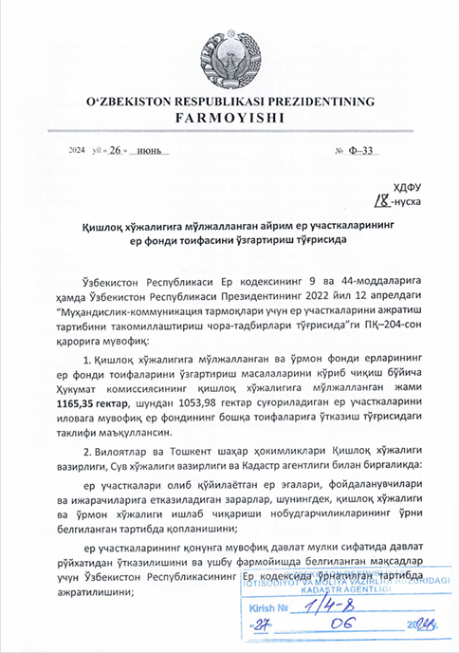

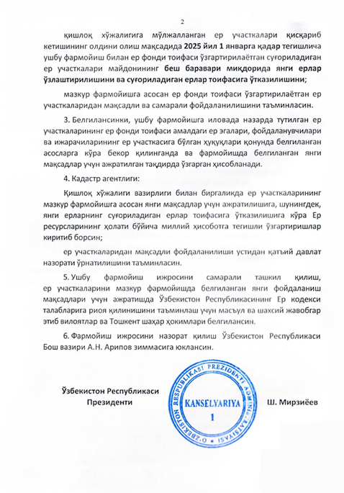

TRANSLATE:

The Presidential Decree on changing the category of certain land plots intended for agriculture
2024 «_26_» June №F-33

In accordance with Articles 9 and 44 of the Land Code of the Republic of Uzbekistan, and the Decree of the President of the Republic of Uzbekistan No. PK-204 dated April 12, 2022, 'On measures to improve the procedure for allocating land plots for engineering and communication networks:
- The proposal of the Government Commission on reviewing issues of changing the category of agricultural and forest fund lands is approved to transfer a total of 1,165.35 hectares of land intended for agriculture, of which 1,053.98 hectares, to other categories of the land fund, in accordance with the attached appendix.
- Together with the regional and Tashkent city administrations, the Ministry of Agriculture, the Ministry of Water Resources, and the Cadaster Agency shall ensure the compensation for damages caused to landowners, users, and tenants due to the seizure of land plots, as well as the losses in agricultural and forestry production, in accordance with the established procedure;
That the land plots are registered as state property in accordance with the law, and land from the land fund of the Republic of Uzbekistan is allocated for the purposes specified in this decree.
In order to prevent the reduction of land, plots intended for agriculture, by January 1, 2025, new lands, amounting to five times the area of the irrigated land plots whose category is being changed under this decree, shall be developed and transferred to the category of irrigated lands;
Ensure the targeted and efficient use of the land plots whose category is being changed in accordance with this decree.
- It should be specified that the change in the land fund category for the land plots listed in the appendix to this decree is considered effective if the existing rights of landowners, users, and tenants to these plots are terminated in accordance with the law, and the plots are allocated for the new purposes specified in the decree.
- Cadaster Agency:
Together with the Ministry of Agriculture, ensure the allocation of land plots for new purposes as specified in this decree, as well as the transfer of new lands to the category of irrigated lands, and make the necessary amendments to the national land resources report accordingly.
Ensure strict state control over the targeted use of the land plots.
- To ensure the effective implementation of this decree and compliance with the requirements of the Land Code of the Republic of Uzbekistan in allocating land plots for the new purposes specified in this decree, the regional and Tashkent city governors are appointed as responsible and personally accountable.
- The oversight of the implementation of this decree shall be assigned to the Prime Minister of the Republic of Uzbekistan, A.N. Aripov.

President of the Republic of Uzbekistan, Sh. Mirziyoyev

Attecment of Presidential Decree
List of irrigated land plots transferred from the category of agricultural land to non agricultural land category

Name of the place | The name of the land user until the land fund category is changed | Contour number |  | Total land area, ha |  | From this: |  |  |  | Soil quality score |  | Land fund category proposed for change |  |  | Proposed use purpose | Basis
 |  |  |  |  |  | Irrigated lands, ha |  | Other lands, ha
Khorezm Region
Khazarasp district
Dostlik massif |  |  | 9937к |  | 0,08 |  | 0,08 |  |  |  | 49,7 |  | Lands intended for industry, transportation, communications, defense, and other purposes | With the aim of constructing an electrical substation for the Bukhara-Urgench-Khiva railway |  |  | Based on the Decree No. PK-5 of the President of the Republic of Uzbekistan dated January 16, 2023
 |  |  | 9940к |  | 0,38 |  | 0,37 |  | 0,01 |  | 49,7
 |  |  | 9941к |  | 0,63 |  | 0,61 |  | 0,02 |  | 49,7
 |  |  | 9947к |  | 0,07 |  | 0,07 |  |  |  | 49,7
 | Land reserves of the district administration |  | 2106к |  | 0,03 |  |  |  | 0,03
 | ‘SEVINCHOY MAXPIRA’ f/e |  | 2047к |  | 2,83 |  | 2,83 |  |  |  | 54
 | Land reserves of the district administration |  | 1744к |  | 0,14 |  |  |  | 0,14

Annex 2. The letter of Khorezm Hokimiyat to the Ministry of Agriculture for changing category of proposed lands
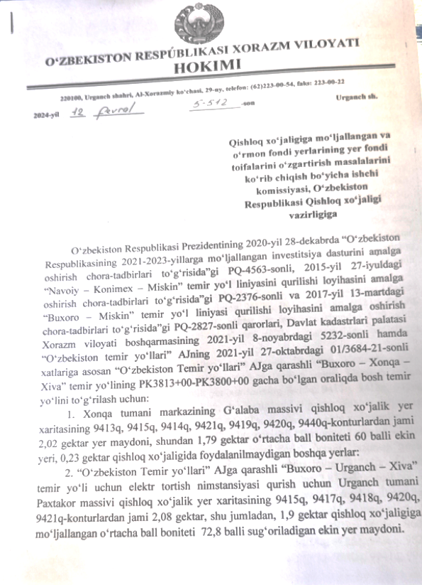

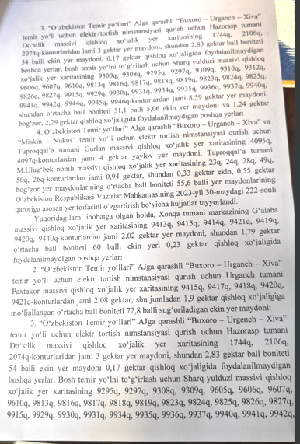
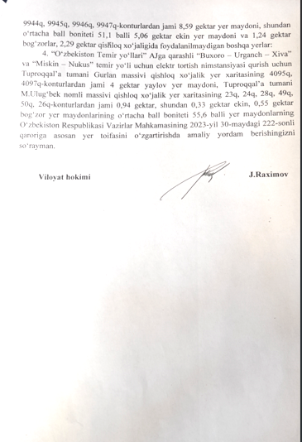

TRANSLATION

HOKIMIYAT OF KHORAZM REGION OF THE REPUBLIC OF UZBEKISTAN
29, Al-Khorazmiy street, Urganch city, 220100, phone (62) 223-00-54, fax: 223-00-22
The working commission for consideration
of the issues of changing the land fund categories of the lands intended for agriculture and the forest fund,
to the Ministry of Agriculture of the Republic of Uzbekistan
Based on decree of the President of the Republic of Uzbekistan dated December 28, 2020 “On measures to implement the investment program of the Republic of Uzbekistan for 2021-2023” No. PQ-4563, dated July 27, 2015, PQ-2376 “On measures to implement the project for the construction of the Navoi - Konimekh – Miskin railway line" and PQ-2827 dated March 13, 2017 "On measures to implement the project for the construction of the Bukhara - Miskin railway line", according to letters No. 5232 dated November 8, 2021 of the Khorezm Regional Department of the State Cadastral Chamber and No. 01/3684-21 dated July 27, 2021 from JSC “O’zbekiston temir yo’llari”, to correct the main railway track on the “Bukhara - Khanka – Khiva” railway line, owned by JSC “O’zbekiston temir yo’llari” in the range from PK3813+00 to PK3800+00:
- A total of 2.02 hectares of land from contours 9413q, 9415q, 9414q, 9421q, 9419q, 9420q, 9440q the agricultural land map of the Galaba massif of the centre of the Khanka district, of which 1.79 hectares have an average score of 60 points of irrigated land, 0.23 hectares other non-agricultural lands:
- A total of 2.08 hectares of land from contours 9415q, 9417q, 9418q, 9420q, 9421q of the agricultural land map of the Pakhtakor massif of the Urganch district for the construction of an electric traction substation for the "Bukhara-Urganch-Khiva" railway line belonging to JSC “O’zbekiston temir yo’llari”, including 1.9 hectares of agriculture cropland with an average score of 72.8 points for irrigation.
- For the construction of a traction substation for the Bukhara - Urgench - Khiva railway line, owned by JSC “O’zbekiston temir yo’llari”, from 3 hectares of land area from the contour 1744q, 2106q, 2074q of the agricultural land map of the Dostlik massif, Khazorasp district, 2.83 ha - these are 54-point agricultural lands, 0.17 hectares of other lands not used in agriculture, 9300 square meters of agricultural land map of the Sharq Yulduzi massif to correct the main railway, 9308q, 9295q, 9309q, 9310q, 9312q, 9606q, 9607q, 9610q, 9813q, 9816q, 9817q, 9818q, 9819q, 9823q, 9824q, 9825q 826q, 9827q, 9915q, , 9930q, 9931q, 9934q, 9935q, 9936q, 99 37q, 9940q, 9941q, 9942q, 9944q, 9945q, 9946q-contours, a total of 8.59 hectares of land, of which 5.06 are arable lands with an average score of 51.1 points and 1.24 hectares of gardens, 2.29 hectares of other non-agricultural land:
- Based on the decision of the Cabinet of Ministers of the Republic of Uzbekistan No. 222 dated May 30, 2023, documents on changing the land category were prepared for a total of 4 hectares of pasture land from contours 4095q, 4097q of the agricultural land map of the Gurlan massif of Tuproqkala district and a total of 0.94 hectares from contours 23q, 24q, 28q, 49q, 50q, 26q of the agricultural land map of the M.Ulug'bek massif of Tuproqkala district, of which 0.33 hectares are crops, for the construction of an electric traction substation for the "Bukhara-Urganch-Khiva" and "Miskin-Nukus" railways belonging to JSC “O’zbekiston temir yo’llari”.
Taking into account the above, a total of 2.02 hectares of land from contours 9413q, 9415q, 9414q, 9421q, 9419q, 9420q, 9440q the agricultural land map of the Galaba massif of the centre of the Khanka district, of which 1.79 hectares have an average score of 60 points of irrigated land, 0.23 hectares other non-agricultural lands:
2. A total of 2.08 hectares, including 1.9 hectares of agricultural irrigated land with an average score of 72.8 points from contours 9415q, 9417q, 9418q, 9420q, 9421q of the agricultural land map of Pakhtakor massif, Urganch district, for the construction of a traction substation for the "Bukhara-Urganch-Khiva" railway belonging to JSC "Uzbekistan Railways":
3. A total of 3 hectares of the land from contours 1744q, 2106q, 2074q of agricultural map of the Dostlik massif of Hazorasp district for the construction of an electric traction substation for the Bukhara-Urgench-Khiva railway belonging to JSC "Uzbekistan Railways", of which 2.83 hectares of score 54 points of cultivated land, 0.17 hectares of other non-agricultural land, for the correction of the main railway line of the agricultural land map of Sharq Yulduzi Massif from contours 9295q, 9297q, 9308q, 9605q, 9606q, 9607q, 9610q, 98l3q, 9816q, 98l7q, 98l9q, 9823q, 9824q, 9825q, 9826q, 9827q 915q, 9929q, 9930q, 9931q, 9934q, 9935q, 9936q, 9937q , 9940q, 9941q, 9942q, 9944q, 9945q, 9946q, 9947q - a total of 8.59 hectares of land area, of which the average score is 51.1 points, 5.06 hectares of cultivated land and 1.24 hectares of gardens, 2.29 hectares of other non-agricultural land:
Asking you for the assistance to change the category of land based on the decision of the Cabinet of Ministers of the Republic of Uzbekistan dated May 30, 2023 No. 222 of land plots from contours 4095q, 4097q of the agricultural land map of the Gurlan massif of the Tuprokkala district and a total of 4 hectares of pasture land from the contours of the M. Ulugbek massif, the area of agricultural land, a total of 0.94 hectares from the contours 23q, 24q, 28q, 49q, 50q, 26q maps of the Tuprokkala district, including garden land, with an average score of 0.33 hectares of crops, 0.55 hectares of credit 55.6 points for the construction a traction substation for the ‘Miskin-Nukus’ and ‘Bukhara-Urganch-Khiva’ railway lines, owned by JSC “O’zbekiston temir yo’llari”.
Hokim of the region J. Raximov

Annex 3. The scheme and proposed location of Khozarasp TSS

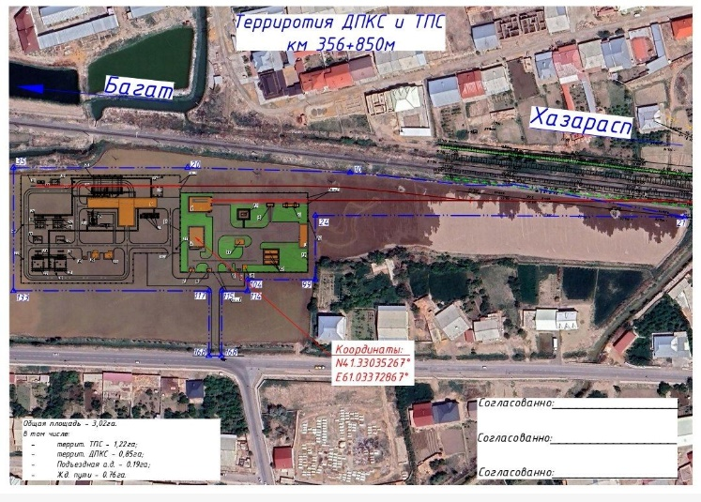

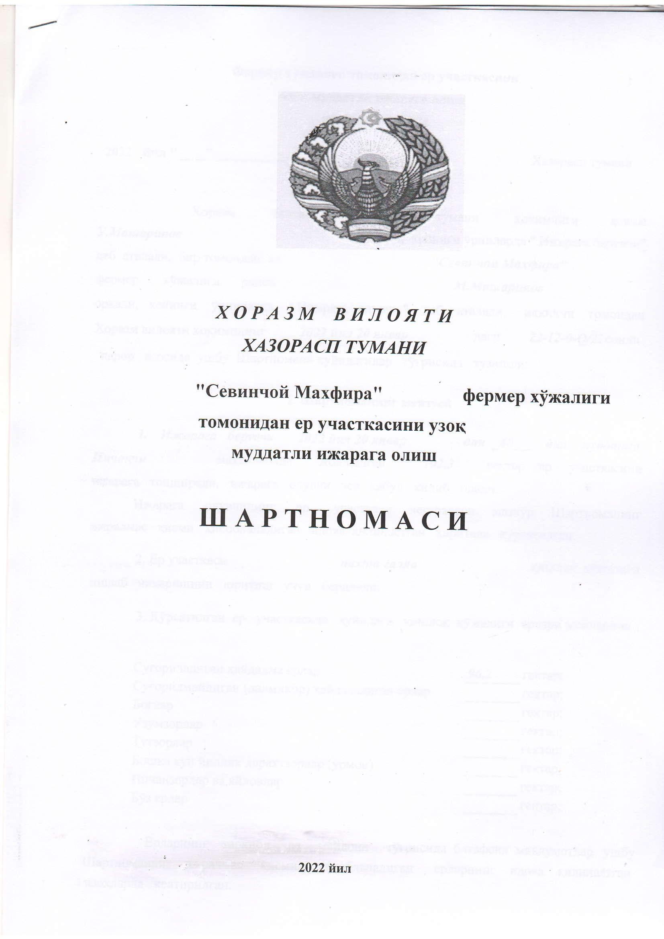
Annex 4. Land Lease Agreement (Shartnama) of the leased land of affected person
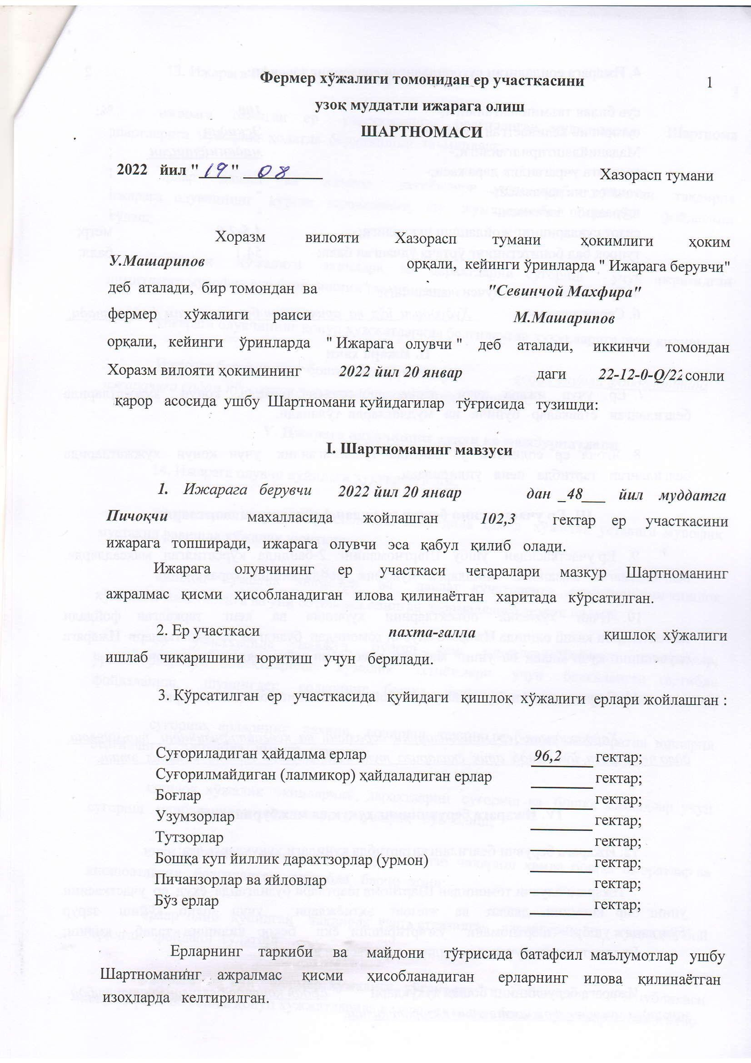
ez

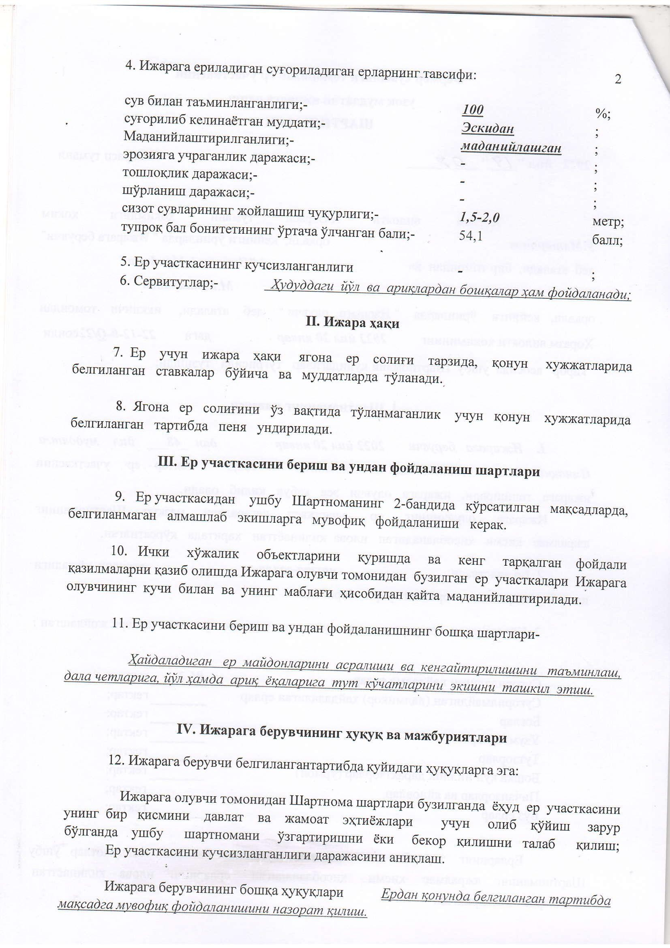

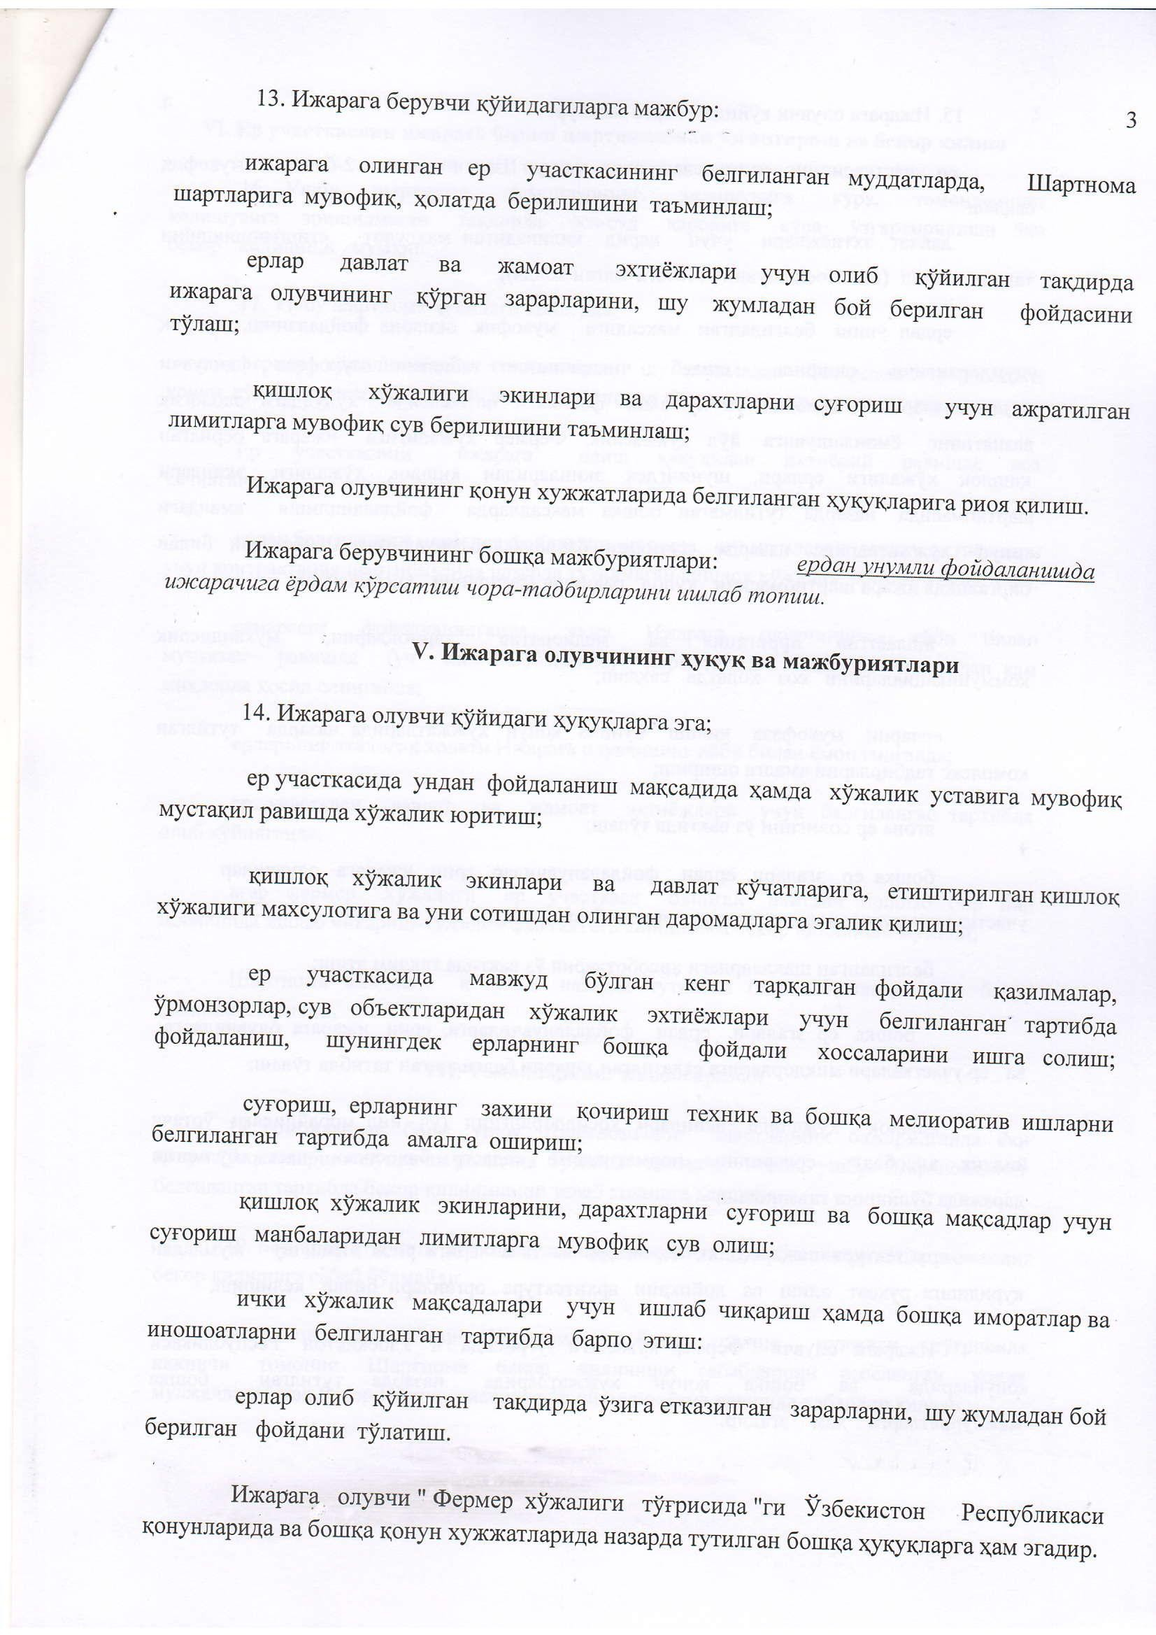
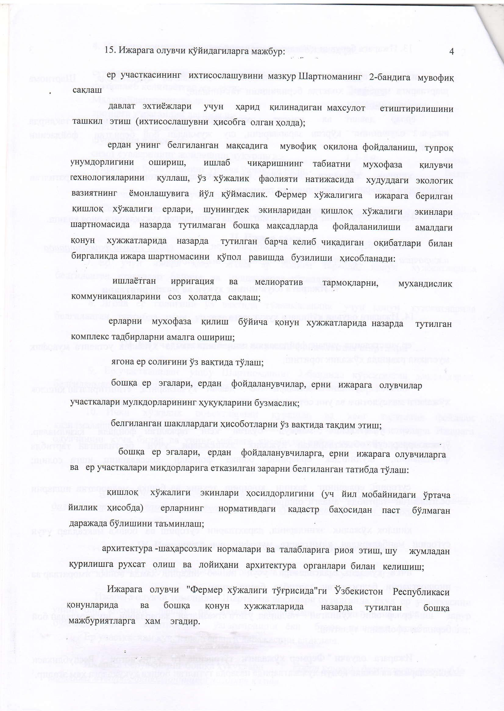

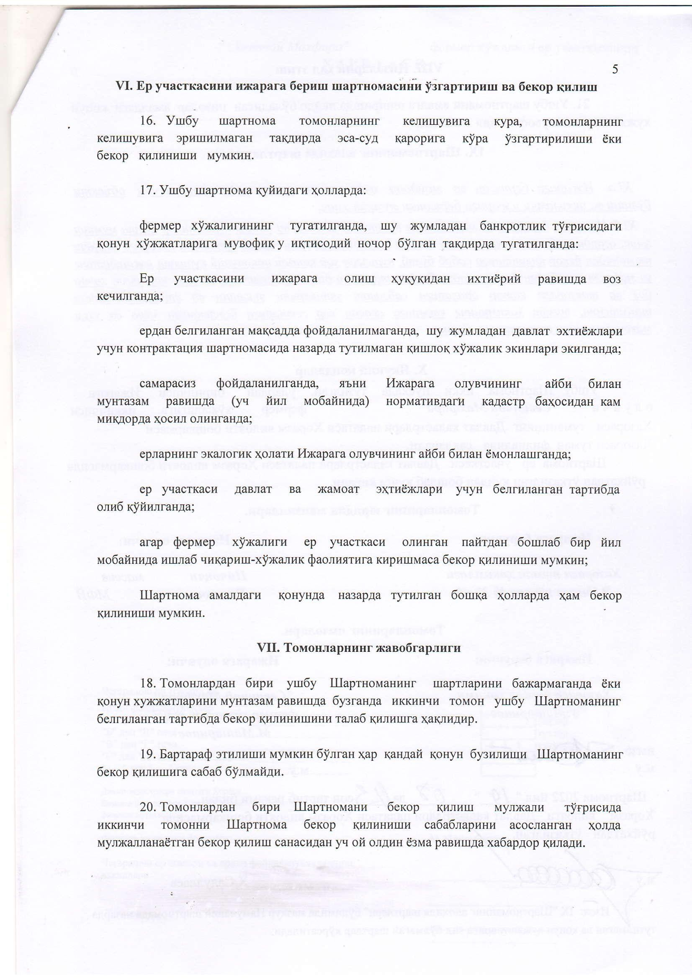

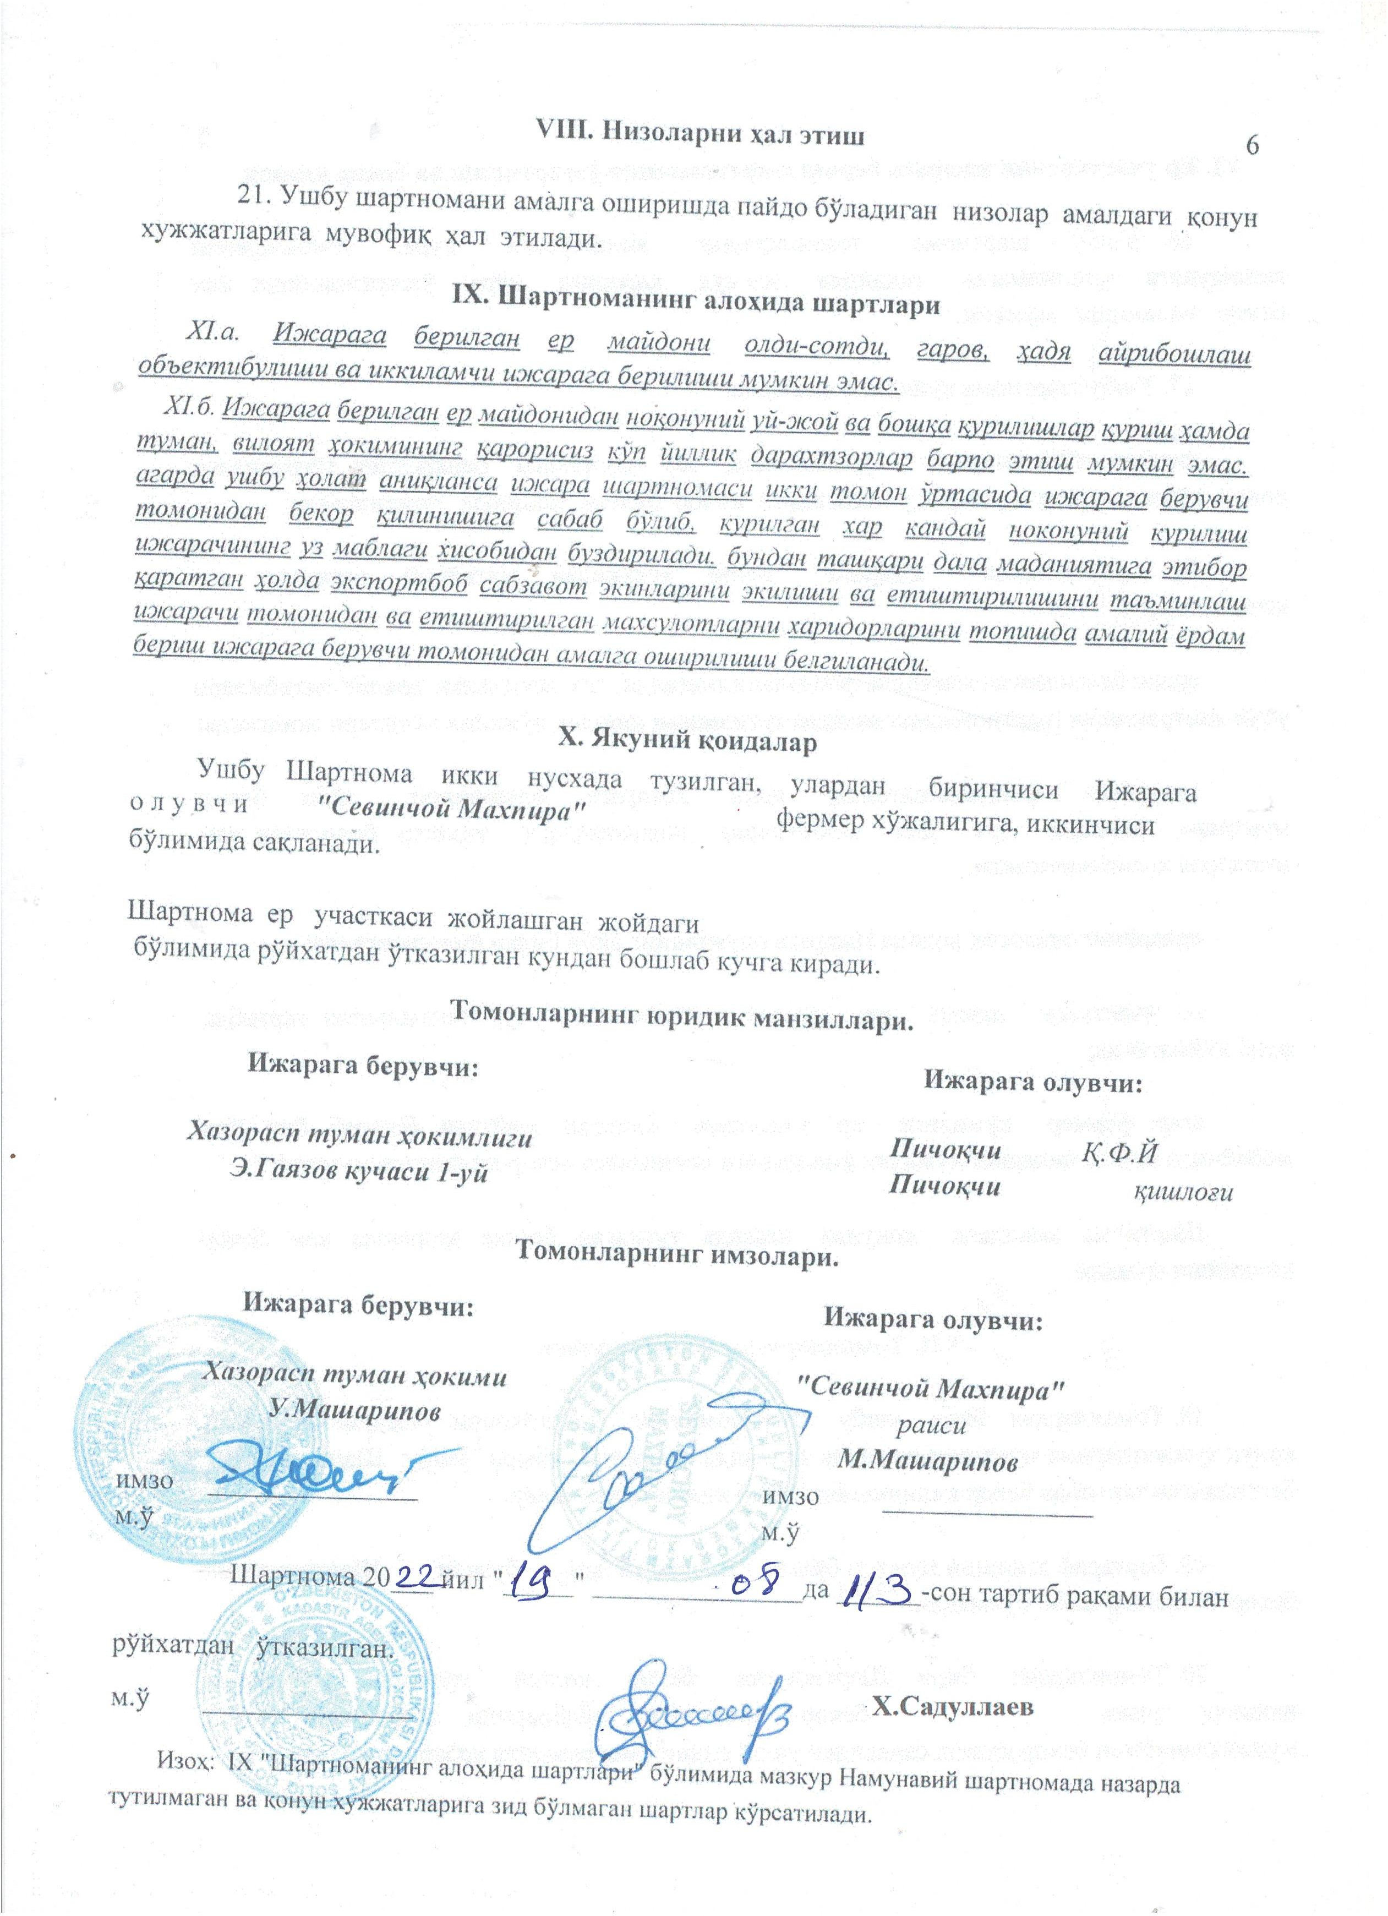

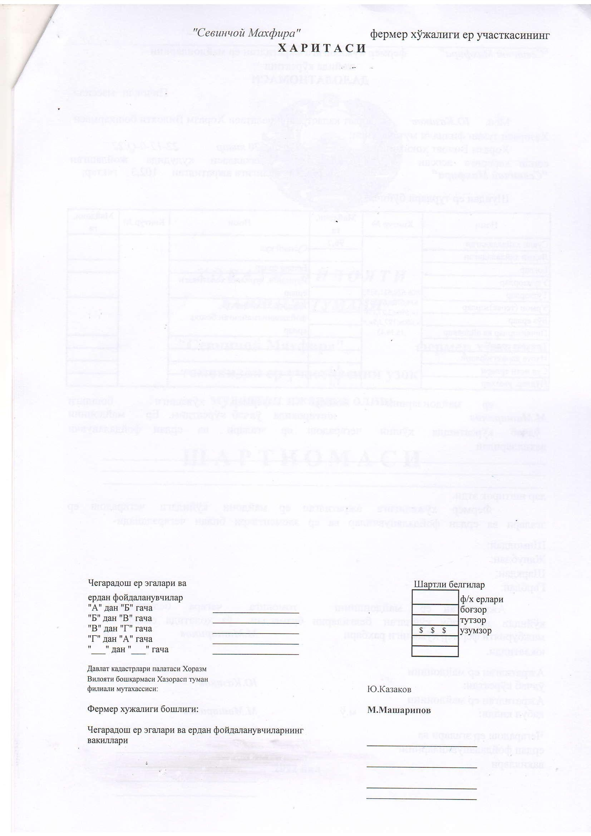

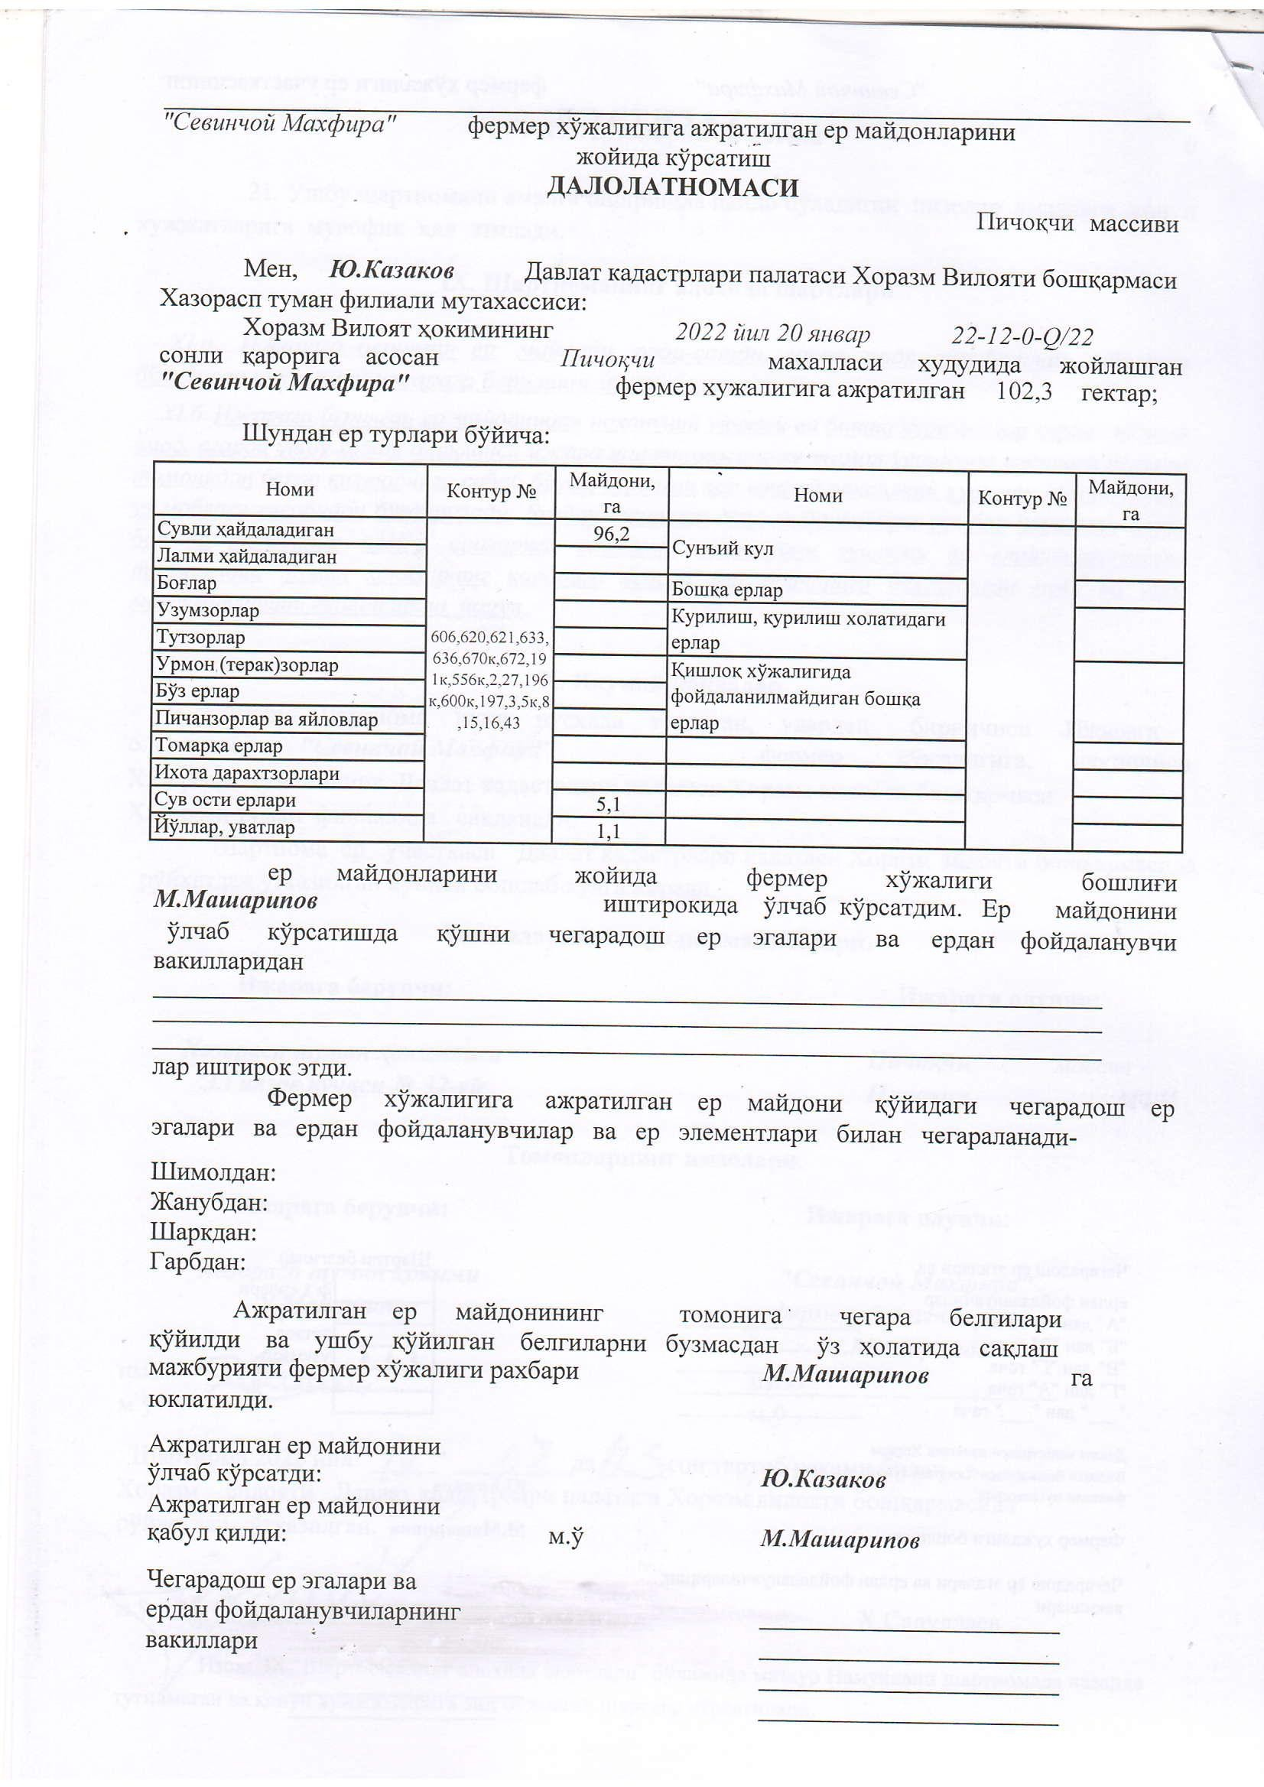

TRANSLATION
KHORAZM REGION, KHAZORASP DISTRICT
Long-term lease of a plot of land by "Sevinchoy Makhfira" farm

AGREEMENT for long-term lease of land plot by the farm

Khozarasp, 2022

Khorezm Region, Khazorasp District Administration, through the Hokim U. Masharipov, hereinafter referred to as "Lessor," on one side, and "Sevinchoy Makhfira" farm, through its head M. Masharipov, hereinafter referred to as "Lessee," on the other side, based on the decision No. 22-12-0-Q/Z of the Hokim of Khorezm Region dated January 20, 2022, have entered into the following agreement regarding the following:
- Subject of the Agreement
- The Lessor leases out a 102.3-hectare plot of land located in Pichokchi neighborhood for a term of 48 years starting from January 20, 2022, and the Lessee accepts and receives it.
  - The boundaries of the land plot leased by the Lessee are shown on the map attached to this Agreement, which is considered an integral part of the Agreement.
- The land plot is provided for conducting cotton and grain agricultural production.
- The following agricultural lands are located on the specified land plot:
Irrigated arable lands. 96,2 hectares.
Non-irrigated (rain-fed) arable lands hectares.
Gardens hectares.
Vineyard’s hectares.
Mulberry groves hectares;
Other perennial orchards (forests) hectares;
Meadows and pastures hectares.
Abandoned lands hectares.

Detailed information about the composition and area of the lands is provided in the descriptions attached to this Agreement, which are considered an integral part of the Agreement.
- Description of the irrigated lands being leased: their water supply status.
water supply status; - | 100
duration of its irrigation; - | Previously cultivated.
level of cultivation; -
degree of erosion; -
degree of stoniness; -
degree of salinity; -
depth of the saline water table; - | 1,5-2,0 metre;
average measured score of soil fertility; - | 54,1 score;
- Degree of land degradation
- Easements: The land is also accessible for the use of roads and other infrastructure.

- Lease term
- The lease payment for the land is made as a single land tax type, according to the rates and terms specified in the legal documents.
- Penalties will be imposed for late payment of the single land tax, in accordance with the procedures specified in the legal documents.

- Conditions for Providing and Using the Land Plot

- The land plot shall be used in accordance with the purposes specified in Clause 2 of this Agreement, and it should not be used for any other purposes or activities that are not specified in the Agreement.
- In the case of constructing internal facilities and extracting widely distributed useful minerals, any damage caused to the land plot by the Lessee will be repaired and reclaimed at the Lessee's expense.
- Other conditions for granting and using a plot of land-
Ensuring the preservation and expansion of arable land areas and organizing the planting of protective vegetation along field edges, roads, and canal banks.
- Rights and Obligations of the Lessor:

- The lessor has the following rights in accordance with the established procedure:

If the Lessee violates the terms of the Agreement or if it becomes necessary to withdraw the land plot or part of it for state or public needs, the following actions may be required:
Modification or Termination: Request to modify or terminate the Agreement.
Determine the degree of land degradation.
Rights of the Lessor: The right to monitor and ensure that the land is used in accordance with the purposes specified in the law and the Agreement.

- The Lessor's obligations include:

Ensure that the leased land plot is provided in the agreed condition and within the specified time frames, in accordance with the terms of the Agreement.
If the land is taken for state or public needs, the Lessee will be compensated for any losses incurred, including the loss of expected profits.
Ensure that water is provided in accordance with the allocated limits for irrigating agricultural crops and trees.
Ensure compliance with the rights established for the Lessee under the legal regulations.

Other Obligations of the Lessor: Develop and implement measures to assist the Lessee in making effective use of the land.

- The rights and obligations of the tenant.
- The tenant has the following rights:

to independently manage the land plot for the purpose of its use and in accordance with the business charter;
to own agricultural crops, state seedlings, the agricultural products grown, and the income obtained from their sale;
to use widespread natural resources such as minerals, forests, and water bodies on the land plot for business needs in accordance with the established procedures, as well as to utilize other beneficial properties of the land;
to carry out irrigation, drainage, and other technical and reclamation works on the land in accordance with established procedures;
to draw water from irrigation sources for agricultural crops, trees, and other purposes in accordance with the established water usage limits.
to construct production and other buildings and structures for internal business purposes in accordance with the established procedures.
in the event of land expropriation, to claim compensation for damages, including lost profits.
The tenant is also entitled to other rights provided for in the laws of the Republic of Uzbekistan, including the "Law on Farmer Enterprises" and other legal documents.

- The tenant is obliged to:

To maintain the specialization of the land plot in accordance with Clause 2 of this Agreement and to organize the production of products to be purchased for state needs (considering the specialization).
To use the land rationally in accordance with its designated purpose, to improve soil fertility, to apply nature-protecting technologies in production, and to avoid worsening the environmental situation in the area because of its economic activities.
The use of agricultural land, provided on lease for farming purposes, for other purposes not specified in the agricultural lease agreement will be considered a breach of the lease agreement, along with all the consequences stipulated in the current legal documents.
To maintain the operational condition of the existing irrigation and reclamation networks, as well as engineering communications.
To implement the comprehensive measures prescribed by legal documents for land protection; to pay land taxes on time; to respect the rights of other landowners, land users, and leaseholders; and to submit reports in the prescribed forms on time.
To compensate for any damage caused to other landowners, land users, leaseholders, and land plot areas in accordance with established procedures.
To ensure that the productivity of agricultural crops (based on the average annual yield over three years) does not fall below the normative cadastral value of the land.
To adhere to architectural and urban planning norms and requirements, including obtaining construction permits and coordinating the project with architectural authorities.
The tenant is also subject to other obligations provided for in the laws of the Republic of Uzbekistan, including those outlined in the "Law on Farmer Enterprises" and other legal documents.

- Amendment and Termination of the Land Lease Agreement
- This agreement may be amended or terminated based on the parties' mutual consent, or, if no agreement is reached, by a court decision.

- This agreement is valid under the following conditions:

In the event of the termination of the farmer enterprise, including in accordance with bankruptcy laws and economic insolvency regulations:
If the right to lease the land plot is voluntarily relinquished:
If the land is not used for its designated purpose, including when agricultural crops are planted that are not specified in the state needs contract:
If the land is used inefficiently, meaning that the tenant regularly (over a period of three years) yields less than the normative cadastral value:
If the ecological condition of the land deteriorates due to the tenant's fault:
If the land plot is expropriated for state and public needs in accordance with the established procedure:
If the farming enterprise does not commence production or business activities within one year from the time the land plot is acquired, the lease may be terminated.
The agreement may also be terminated under other conditions provided for in the current legislation.
- Liability of the Parties
- If either party fails to fulfill the terms of this Agreement or regularly breaches legal regulations, the other party has the right to request the termination of this Agreement in the manner specified.
- Any legal violations that can be remedied shall not be grounds for the termination of the Agreement.
- If one party intends to terminate the Agreement, they must notify the other party in writing of their intention to terminate, along with the reasons for termination, at least three months before the intended termination date.
- Resolution of Disputes
- Disputes arising in the implementation of this Agreement shall be resolved in accordance with the applicable legal regulations.
- Specific Terms of the Agreement

- The leased land plot cannot be subject to sale, collateral, donation, exchange, or secondary leasing.
- The construction of unauthorized buildings or other structures on the leased land, as well as the establishment of perennial orchards without the decision of the district or regional governor, is prohibited. If such activities are detected, the lease agreement may be terminated by the lessor, and any unauthorized constructions will be dismantled at the lessee's expense. Additionally, the lessor is responsible for providing practical assistance in finding buyers for exported vegetables and ensuring attention to field cultivation practices.
- Final Provisions
- This Agreement is executed in two copies: one for the lessee, "Sevinchoy Mahpira" farmer enterprise, and the other to be kept on file.
- The Agreement shall become effective from the day it is registered with the relevant authorities in the area where the land plot is located.
Legal Addresses of the Parties:
Lessee Legal Adress: Pichoqchi village, Pichoqchi street
Lessor’s Legal Address: Khokimiyat of Khazorasp district, E. Gayazov Street, 1.
Signatures of the Parties
The Agreement was registered on August 19, 2022, under registration number 113.
Section IX "Specific Terms of the Agreement" includes conditions that are not covered in this Sample Agreement but are stipulated in legal regulations and are not in conflict with them.

Y. Kazakov
Head of the Farmer Enterprise: M. Masharipov

Representatives of Adjacent Landowners and Land Users
On-Site Indication of Land Plots Allocated to "Sevinchoy Mahpira" Farmer Enterprise

CERTIFICATE
Pichoqchi massif
I, Y. Kazakov, Specialist at the State Cadastre Chamber of Khorezm Region Management, Khazarasp District Branch based on the decision No. 22-12-0-(2/22) of the Khorezm Region Governor dated January 20, 2022, 102.3 hectares of land have been allocated to the "Sevinchoy Mahpira" Farmer Enterprise located in the Pichokchi neighborhood.

Of the allocated land, by land type:

Name | Contour № | Area, hа | Name | Contour № | Area, hа
Irrigated Haymaking Lands | 606, 620, 621, 633, 636, 670k, 672, 191k, 556k, 2, 27, 196k, 600k, 197, 3, 5k, 8, 15, 16, 43 | 96,2 | Artificial Irrigation
Lands Designated for Haymaking |  |  | Other lands
Gardens |  |  | Construction and Construction-Related Lands
Grape Vineyards |  |  | Other Lands Not Used for Agriculture
Orchards
Forestry (Tree) Areas
Reclaimed Lands
Hayfields and Pastures
Undeveloped Lands
Boundary Orchards
Subsurface Lands |  | 5,1
Roads and Paths |  | 1,1
The land plots were measured on-site with the participation of the head of the farmer's enterprise, M. Masharipov. The measurement of the land plots was conducted with the participation of neighboring landowners and land users' representatives, including
The land allocated to the farmer's enterprise is bordered by the following neighboring landowners, land users, and land elements:
North:
South:
East:
West:
The boundary markers of the allocated land area have been set, and the responsibility for maintaining these markers in their current state, without altering them, has been assigned to M. Masharipov, the head of the farmer's enterprise.
The allocated land area was measured by: Y.Kazakov
The allocated land area was accepted by: M. Masharipov
Representatives of Neighboring Landowners and Land Users

Annex 5: Notarial agreement for land return
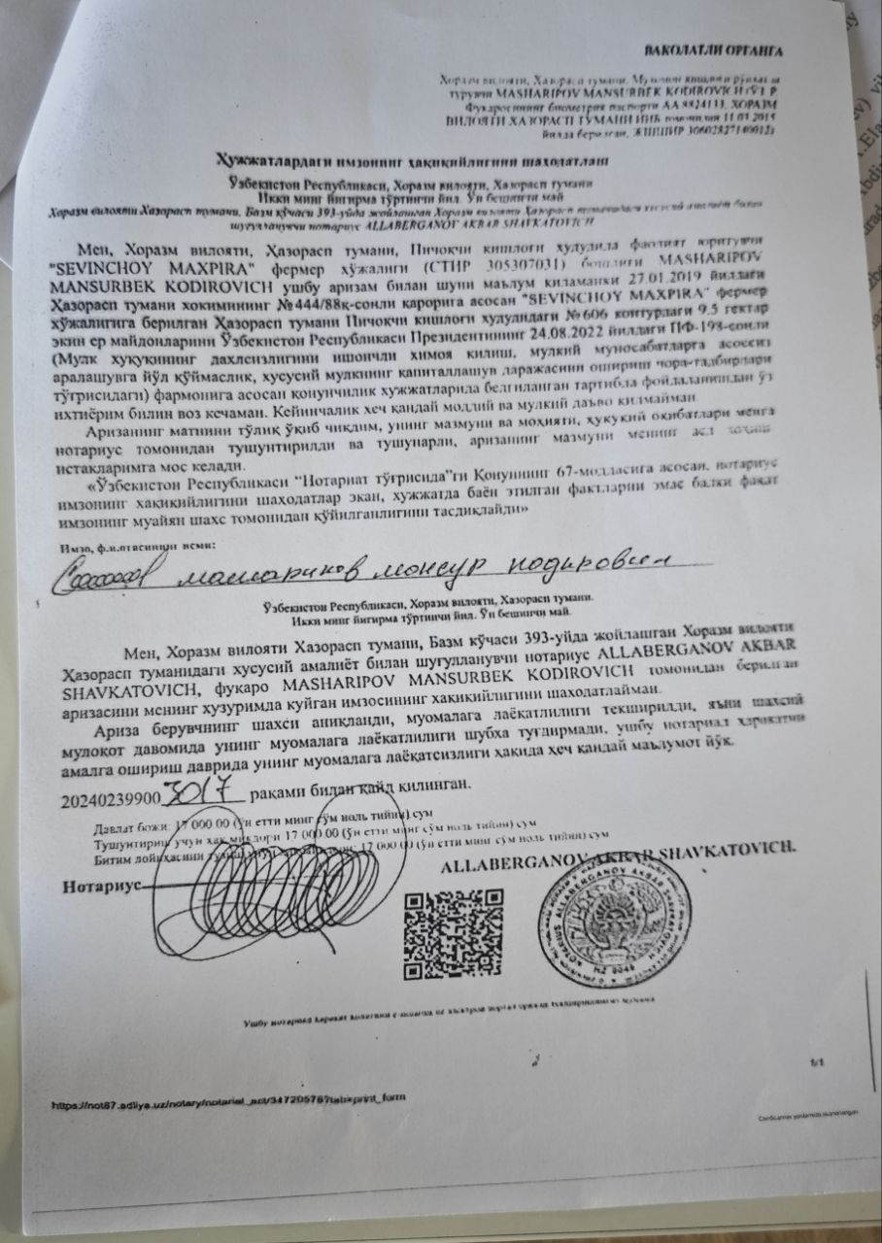

TRANSLATION

To the authorized body
Khorezm Region, Khazorasp District

Certification of the authenticity of the signature on the documents
Republic of Uzbekistan, Khorezm Region, Khazorasp District
May 15, 2024

Private notary AKBAR SHAVKATOVICH ALLABERGANOV, located in Khorezm Region, Khazorasp District, 393 Bazm Street, Khazorasp District, Khorezm Region.

I, MASHARIPOV MANSURBEK KODIROVICH, head of the 'SEVINCHOY MAXPIRA' farming enterprise (TIN 305307031), operating in the Pichokchi village area, Khazorasp district, Khorezm region, hereby declare that, based on the decision of the Khazorasp district governor dated 27.01.2019, №444/88k, 9.5 hectares of arable land in contour №606 of the Pichokchi village area, allocated to the 'SEVINCHOY MAXPIRA' farming enterprise, I voluntarily relinquish the use of this land in accordance with Presidential Decree №PF-198 of the Republic of Uzbekistan dated 24.08.2022 (regarding measures to ensure reliable protection of property rights, prevent undue interference in property relations, and increase the capitalization level of private property). I will not make any material, or financial claims in the future.
I have read the full text of the application, and its content, essence, and legal consequences have been explained to me by the notary and are clear. The content of the application corresponds to my genuine wishes and desires.
In accordance with Article 67 of the Law of the Republic of Uzbekistan 'On Notaries,' the notary certifies that the signature was made by a specific individual.

Signature, full name Masharipov Mansur Nodirovich
Republic of Uzbekistan, Khorezm Region, Khazorasp District.
May 15, 2024

I, AKBAR SHAVKATOVICH ALLABERGANOV, a private notary practicing at 393 Bazm Street, Khazorasp District, Khorezm Region, certify the authenticity of the signature of the citizen MASHARIPOV MANSURBEK KODIROVICH on the application submitted in my presence.

The identity of the applicant has been verified, and their legal capacity has been checked. During the personal communication, there were no doubts about their legal capacity, and at the time of performing this notarial action, there is no information indicating their lack of legal capacity.

202402399003017 recorded in figures.

State fee: 17,000.00 (seventeen thousand som and zero tiyin)
Amount for clarification: 17,000.00 (seventeen thousand som and zero tiyin)

Notary ________________________

ALLABERGANOV AKBAR SHAVKATOVICH

Annex 6. New land lease agreement
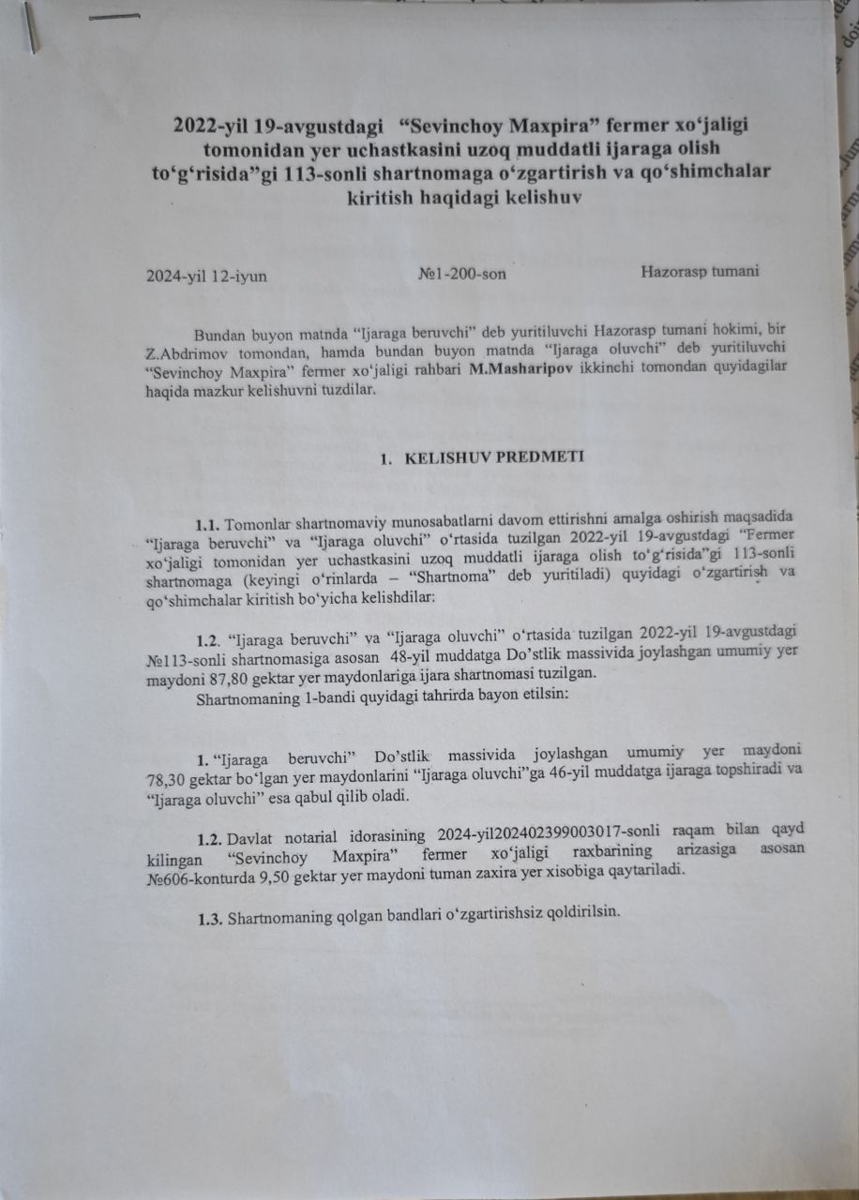
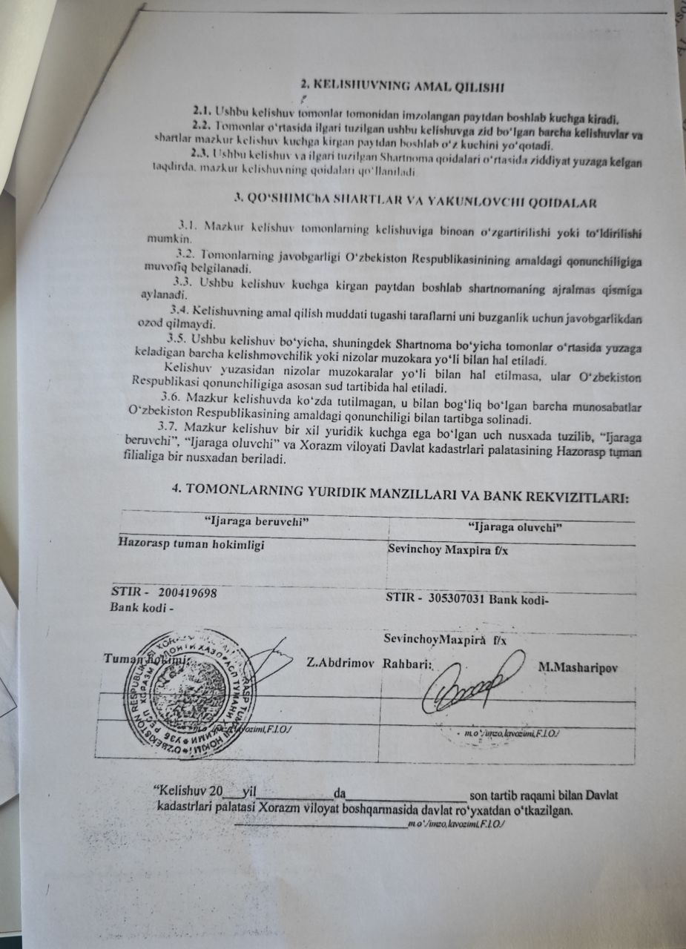
TRANSLATION
Agreement on amendments and additions to the contract No. 113 regarding the long-term lease of the land plot by the 'Sevinchoy Maxpira' farming enterprise dated August 19, 2022.

June 12, 2024, №1-200-number Khozarasp district

From now on, the term 'lessor' will refer to the Khazorasp district governor, Z. Abdrimov, and the term 'lessee' will refer to M. Masharipov, the head of the 'Sevinchoy Maxpira' farming enterprise. The following agreement has been made between the two parties.

- SUBJECT OF AGREEMENT

  - To continue the contractual relations, the 'lessor' and the 'lessee' have agreed to make the following amendments and additions to the contract dated August 19, 2022 (hereinafter referred to as the 'Contract').
  - According to the contract No. 113 dated August 19, 2022, between the 'lessor' and the 'lessee,' a lease agreement has been made for a total land area of 87.80 hectares located in the Dostlik massif for a period of 48 years.
  - The 'lessor' shall lease to the 'lessee' a total land area of 78.30 hectares located in the Dostik massif for a period of 46 years, and the 'lessee' accepts it.
  - Based on the application of the head of the 'Sevinchoy Maxpira' farming enterprise, registered under number 2024-202402399003017 by the State Notarial Office, a land plot of 9.50 hectares in contour No. 606 will be returned to the district's reserve land account.
  - The remaining clauses of the contract shall remain unchanged.
- VALIDITY OF THE AGREEMENT

  - This agreement shall come into effect from the time it is signed by the parties.
  - All agreements and conditions that contradict this agreement previously concluded between the parties shall become invalid from the moment this agreement comes into effect.
  - In the event of a conflict between the provisions of this agreement and the previously concluded Contract, the provisions of this agreement shall prevail.
- ADDITIONAL TERMS AND FINAL PROVISIONS

  - This agreement may be amended or supplemented by mutual consent of the parties.
  - The liability of the parties shall be determined in accordance with the current legislation of the Republic of Uzbekistan.
  - From the time this agreement comes into effect, it shall become an integral part of the contract.
  - The expiration of the term of the agreement shall not exempt the parties from liability for its breach.
  - All disagreements or disputes arising between the parties regarding this agreement and the Contract shall be resolved through negotiations.
  - If disputes regarding the agreement are not resolved through negotiations, they shall be settled in court according to the legislation of the Republic of Uzbekistan.
  - All matters not provided for in this agreement and related to it shall be regulated by the current legislation of the Republic of Uzbekistan.
  - This agreement is made in three copies, each having equal legal force, and one copy shall be provided to the 'lessor' and one copy to the branch of the State Cadastre Committee of Khorezm Region in Hazorasp District.
- LEGAL ADDRESSES AND BANK DETAILS OF THE PARTIES:
Lessor | Lessee
Khazorasp District Khokimiyat | Sevinchoy Maxpira f/e
STIR - 200419698 | STIR – 305307031 Code of Bank -
District hokimi: Z. Abdrimov | Director: M. Masharipov
(signature, position, full name) | (signature, position, full name)

“The agreement was registered with the State Cadastre Committee of the Khorezm Region under the registration number _________ on the ________ of 20___.

Annex 7. Photos of public consultation
Khozarasp district Hokimiyyat building, 24th of January 2024

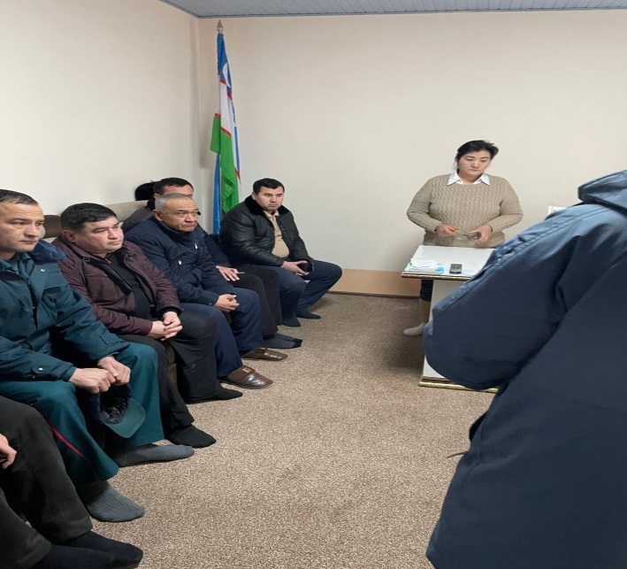 | 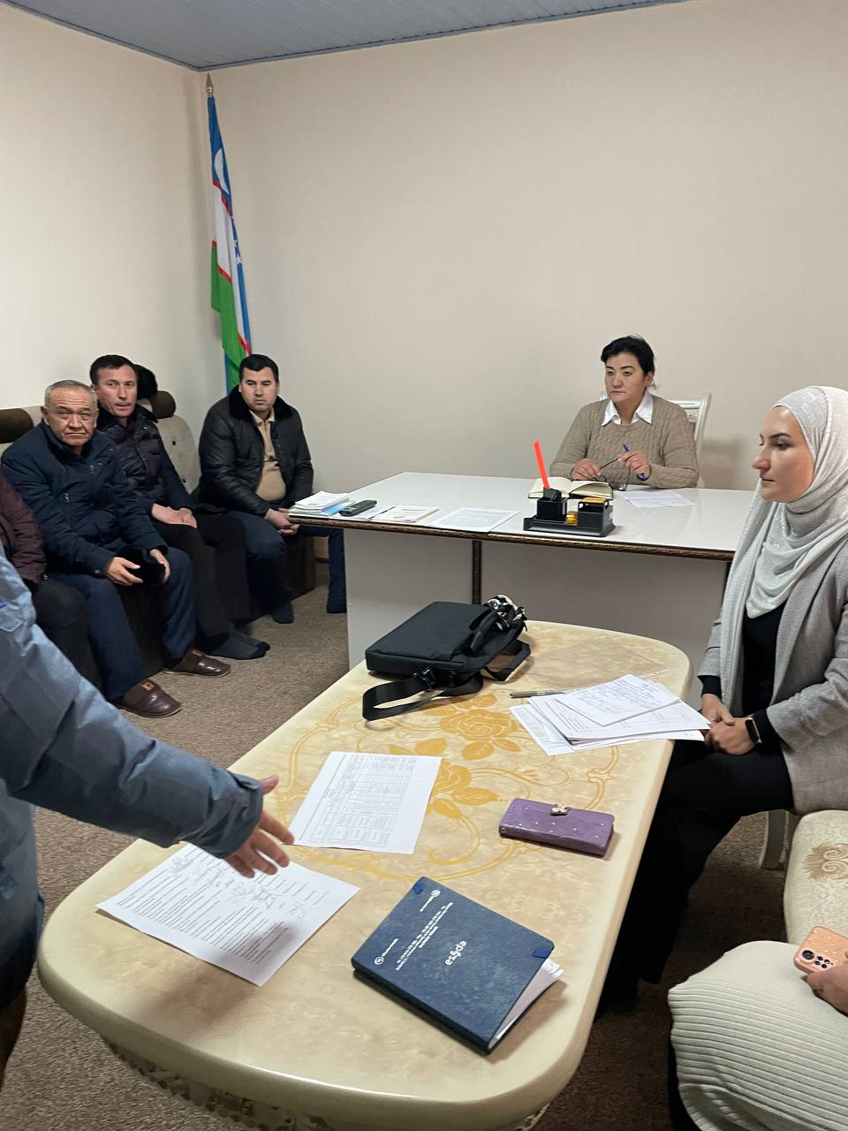

Annex 8. Photo of focus group discussion
Khozarasp district Hokimiyyat building, 24th of January 2024
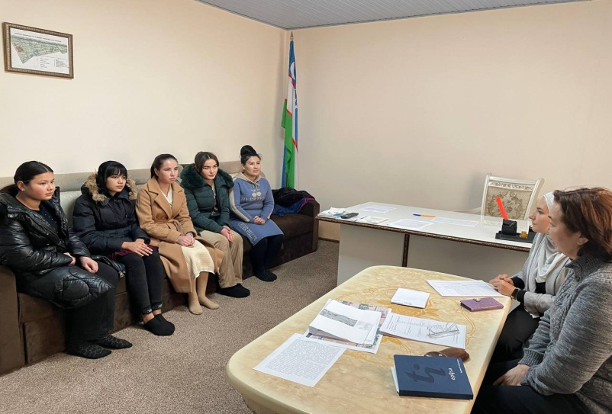

Annex 9. List of consultation participants in the Khozarasp district
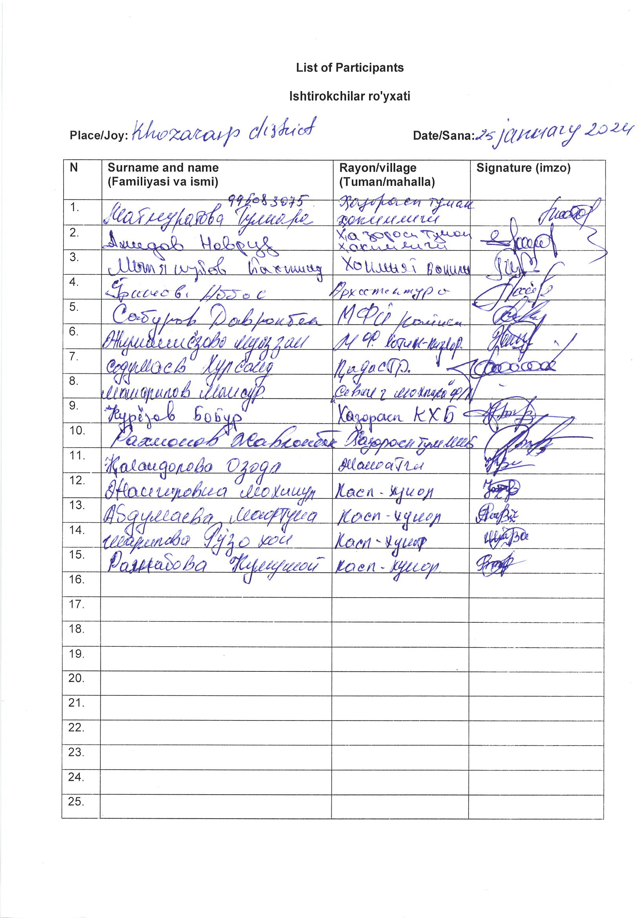

Annex 10. Compensation amount calculated for the affected land
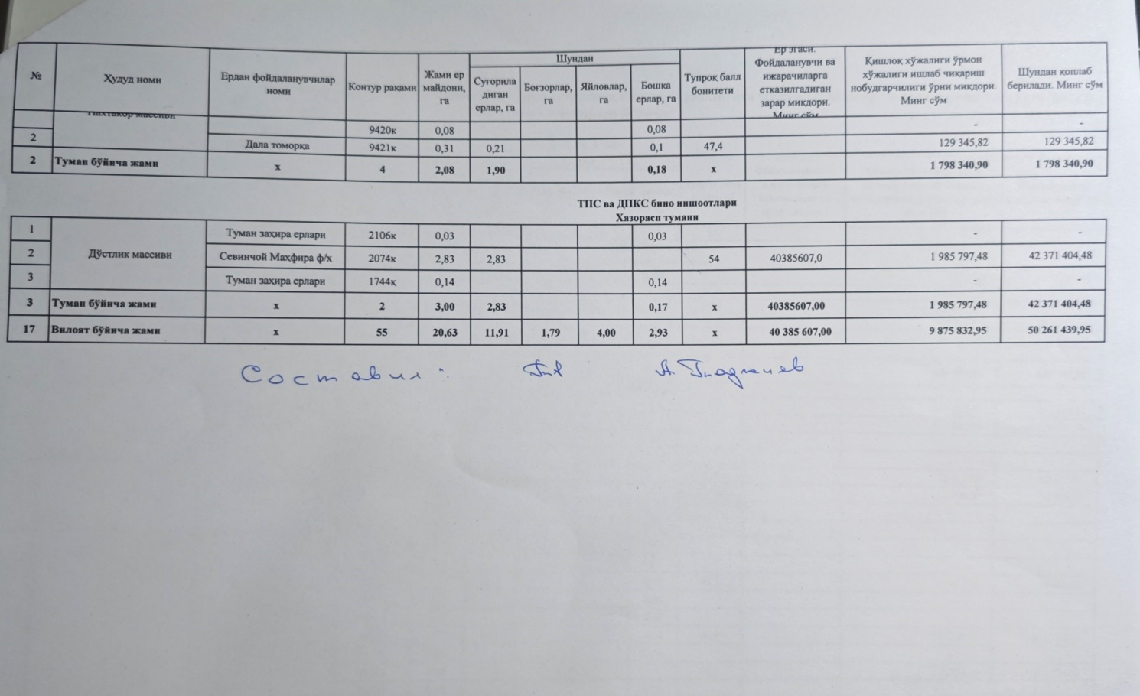

TRANSLATION

№ | Region name | Names of land users | Contour Number | Total land area | From this |  |  |  | Soil quality score | Landowner. The amount of damage to be compensated to users and tenants. One thousand soms. | Amount of damage caused by agricultural and forestry production. Sums. | From this covered. S0ms
 |  |  |  |  | Irrigated land, ha | Gardens, ha | Pastures, ha | Other lands, ha
 | Paxtakor massif |  | 9420к | 0,08 |  |  |  | 0,08 |  |  | - | -
2 |  | Field garden | 9421к | 0,31 | 0,21 |  |  | 0,1 | 47,4 |  | 129 345,82 | 129 345,82
2 | Total by the district | х | 4 | 2,08 | 1,90 |  |  | 0,18 | х |  | 1 798 340,90 | 1 798 340,90
TSS and CNMD building structures, Khozarasp district.
1 | Dostlik massif | District reserve lands | 2106к | 0,03 |  |  |  | 0,03 |  |  | - | -
2 |  | Sevinchoy Mahfira f/e | 2074к | 2,83 | 2,83 |  |  |  | 54 | 40385607,0 | 1 985 797,48 | 42 371 404,48
3 |  | District reserve lands | 1744к | 0,14 |  |  |  | 0,14 |  |  | - | -

Annex 11. Photo of meetings with affected household
Khozarasp Hokimiyyat building, 25th of January 2024 | Khozarasp district, 21 September 2024
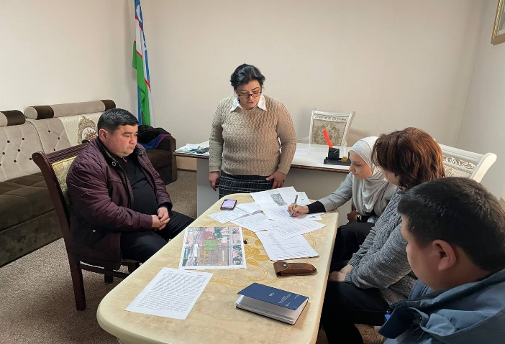 | 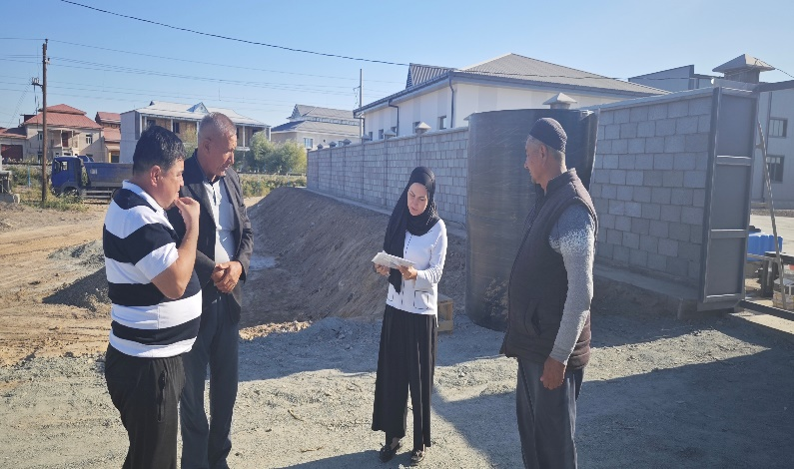

Annex 12. Socio-economic survey form
A-1 | Name Head of Household (HH):
A-2 | Age of HH head | 0-16  16-25  25-35  35-45  45-55  55-65  65-75  75+
A-3 | Sex of HH head | 1- Male  2- Female
A-4 | Ethnic Background | 1. Uzbek  2. Tajik  3. Kazakh  4. Karakalpak  5. Jewish  6. Russian  7. Ukrainian  8. Others (Specify)
A-5 | Number of household’s members
A-7 | Marital Status of HH head | 1. Married  2. Unmarried  3. Widow  4. Widower  5. Others
A-8 | Education of HH head | 1. Illiterate  2. Primary  3. Secondary  4. Higher Secondary  5. College  6. University  7. Kinder garden
A-9 | Occupation of HH head | 1. Agriculture  2. Business  3. Government Jobs  4. Private Jobs  5. Daily Wage  6. Retired  7. Student  8. Self-employed  9. Housekeeping  10. Under employment age  11. Unemployed  12. Disabled  13. Others (Specify)
 | Type of Skills /handicraft/ master ship | 1. Skilled  2. Un Skilled
A-10 | Is it a woman headed household | 1. Yes  2. No
A-11 | Is it a Below Poverty Line Household? | 1. Yes  2. No
A-12 | Is it a household headed by and/or with member physically/mentally handicap/disabled person? | 1. Yes  2. No (if “Yes”), specify How many and Type of disability
A-13 | Is it a household headed by Elderly Person? | 1. Yes  2. No
A-14 | Main Occupation of the Head of the Household: | 1. Agriculture  2. Business  3. Government Jobs  4. Private Jobs  5. Daily Wage  6. Pension  7. Others (Specify)
A-15 | Total Annual Income of the Household/Family (Som)
A-16 | Total Annual Income of the Household/Family (Som)
A-17 | The annual HH income in percentage; | 1. Agriculture________%;  2. Business_______%;  3. Government Jobs_______%; 4. Private Jobs_______%;  5. Daily Wage_______%;  6. Pension_______%;  7.Any social allowance by Government  8. Others (Specify)_______
A-18 | Total Annual Expenditure of the Household (Som)
A-19 | If the Household has any loans: | - Yes  - No
A-20 | If yes, from whom? | - Government  - private bank  - other
A-21 | If yes, what is the monthly amount to be paid for the loan (Som)?
A-22 | If the Household is leasing equipment for agricultural purposes: | - Yes  - No
A-23 | Compensation Options for Structure loss | - Structure for Structure  - Cash for Structure

Annex 13. Grievance Redress Mechanism Brochure
БРОШЮРА

Крупные и сложные проекты, такие как, Проект электрификации железной линии (Бухара-Ургенч-Мискин-Хива), проходящей по коридору в рамках 2 Центральноазиатского регионального экономического сотрудничества, могут иногда создавать проблемы для живущих на территории проекта или прилегающей к нему территории. Мы хотим знать о любых проблемах (также называемых «жалобами»), которые могут быть вызваны нашей деятельностью/деловой практикой с тем, чтобы сделать всё возможное для их своевременного разрешения.

В этой брошюре говорится о том, как Вы можете подать жалобу. В ней также описываются шаги, которые будут приняты нами для решения Вашей проблемы.

КАКУЮ ЖАЛОБУ Я МОГУ ПОДАТЬ?

Вы можете подать жалобу Исполнителю проекта АО РЖУ, если считаете, что деловая практика компании или развитие Проекта оказывает отрицательное воздействие на населенный пункт (махаллю), окружающую среду или качество Вашей жизни. Примеры этого могут включать:

- Угроза здоровью и безопасности или окружающей среде;

- Несоответствие стандартам или правовым обязательствам;

- Негативные воздействия на Ваш населенный пункт;

- Финансовые злоупотребления или нарушение этики или мошенничество;

- Криминальная деятельность;

- Неправомерные поступки или неэтичное поведение;

- Преследования любого характера;

- Попытки скрыть что-либо из этого.

Мы будем рассматривать все получаемые нами жалобы. В некоторых случаях мы можем прийти к выводу, что Ваша жалоба не связана с нашей деятельностью или, что мы работаем в рамках национальных и международных стандартов (например, стандартов шумового воздействия). В таких случаях это будет объяснено Вам письменно. Во всех остальных случаях мы будем расследовать факты несоответствия наших работ намеченным стандартам и в случае, если они будут подтверждены, нами будут определены меры, которые могут быть предприняты во избежания повторения таких инцидентов.

КАК СООБЩИТЬ О ЖАЛОБЕ?

Существует три способа подачи жалобы:

Отправить заполненный Бланк Жалобы (приложенный в конце этой брошюры) на адрес, указанный внизу Бланка.

Связаться с координатором по рассмотрению жалоб. Список контактов приведен в конце данной брошюры.

ЧТО ПРОИЗОЙДЕТ ПОСЛЕ ТОГО, КАК Я ПОДАМ ЖАЛОБУ?

В некоторых случаях, например, когда Вы обратились к одному из наших специалистов: координатору по рассмотрению жалоб, координатору по управлению проектом и Специалиста группы по вопросам защиты окружающей среды и социальным вопросам, и он смог немедленно предпринять необходимые действия, Вашу жалобу возможно будет урегулировать сразу. Если это невозможно, то работа над Вашей жалобой будет проходить по следующим пяти этапам:
Этап 1: Получение жалобы По получении заполненного бланка жалобы или извещения о Вашей проблеме, мы назначим лицо, ответственное за рассмотрение Вашей жалобы.
Этап 2: Подтверждение - Мы отправим Вам письмо, подтверждающее факт получения жалобы в течение 14 дней. В этом письме будет указана фамилия контактного лица, регистрационный номер и объяснение предлагаемых нами действий.
Этап 3: Расследование Мы будем работать над выяснением причин Вашей жалобы. В это время нам может понадобится связаться с Вами.
Этап 4: Разрешение После того, как жалоба будет расследована, мы сообщим Вам о результатах расследования и о предлагаемых нами мерах по разрешению жалобы, в случае если принятие таковых будет сочтено необходимым. Если Вы сочтете, что жалоба разрешена удовлетворительно, мы предложим Вам подписать Заявление об Удовлетворении. Если жалоба останется на разрешенной, она будет пересмотрена, и мы обсудим с Вами дальнейшие действия по ее разрешению.
Этап 5: Последующие действия Если Вы не будете возражать, то специалист может связаться с Вами позднее, чтобы убедиться, что деятельность проекта не вызывает дальнейших проблем.
КОНФИДЕНЦИАЛЬНОСТЬ И АНОНИМНОСТЬ
Вы можете захотеть выразить озабоченность с соблюдением конфиденциальности. Если Вы попросите не разглашать информацию удостоверяющую Вашу личность, она не будет разглашена без Вашего согласия. Ответственность за хранение поданных на рассмотрение документов и обвинений будет возложена на команду, отвечающую за расследование Вашей жалобы. Однако, могут возникнуть ситуации, когда вопрос будет невозможно разрешить без раскрытия Вашей личности. (в случаях, когда могут понадобиться Ваши показания суде). Группа по расследованию Вашей жалобы обсудит с Вами дальнейшие действия.
Вы также можете выразить озабоченность анонимно. Тем не менее, помните, что, если Вы не сообщаете кто Вы, это может усложнить изучение вопроса, защиту Вашей позиции или предоставление Вам обратной связи. Поэтому, хотя мы и рассматриваем анонимные жалобы, они не поощряются. Если Вы настаиваете на том, чтобы выразить озабоченность анонимно, Вам необходимо предоставить достаточные факты и данные, для того чтобы вопрос мог быть расследован без Вашей помощи.
Как можно связаться со специалистами проекта?
Искандаров Аскар Tel: +998(97) 747 4185,
Нуриев Шодлик Tel: +998(91) 997 07 7
Guzal Kojamyarova: Tel: +998 90 176 51 82,
Email: guzal7123@gmail.com

Бланк жалобы проекта электрификации железной линии (Бухара-Ургенч-Мискин-Хива)
Регистрационный номер №
Полное имя
Контактная информация  Укажите предпочитаемый способ контакта (почта, телефон, электронная почта) | Адрес_  Телефон  Электронная почта__________________
Укажите язык общения  (Отметьте, на каком языке Вы хотите, чтоб с Вами связались) | Узбекский  Русский  Английский
Номер Вашего паспорта
Описание происшествия или жалобы: | Что произошло?  Где произошло?  С кем произошло?  Что имеется в итоге?
Дата происшествия, жалобы
Имело место один раз (дата _______________)
Имело место более одного раза (сколько раз?)
Постоянно (проблема испытывается в настоящее время)
Какие действия, по Вашему мнению, необходимо предпринять для разрешения проблемы?

Подпись: _____________ Дата: ___________________

TRANSLATION:
BROCHURE

Large and complex projects, such as the Central Asia Regional Economic Cooperation Corridor 2 Railway Electrification Project (Bukhara-Urgench-Miskin-Khiva), can sometimes create problems for people living in or near the project area. We want to know about any problems (also known as “complaints”) that may be caused by our activities/business practices so that we can do our utmost to resolve them in a timely manner.
This brochure tells you how you can make a complaint. It also describes the steps we will take to resolve your problem.

You can file a complaint with the Project Contractor JSC RRJ if you believe that the company's business practices or the development of the Project have a negative impact on the locality (mahalla), the environment or your quality of life. Examples of this may include:
- Threats to health, safety or the environment;
- Failure to comply with standards or legal obligations;
- Negative impacts on your community;
- Financial or ethical misconduct or fraud;
- Criminal activity;
- Misconduct or unethical behaviour;
- Harassment of any kind;
- Attempts to conceal any of these.

We will investigate all complaints we receive. In some cases, we may conclude that your complaint is not related to our activities or that we operate within national and international standards (e.g. noise standards). In such cases, this will be explained to you in writing. In all other cases, we will investigate the facts of non-compliance of our work with the intended standards and, if they are confirmed, we will determine the measures that can be taken to avoid recurrence of such incidents.

HOW TO REPORT A COMPLAINT?

There are three ways to lodge a complaint:

Send the completed Complaint Form (attached at the end of this booklet) to the address at the bottom of the Form.

Contact the Complaints Coordinator. A list of contacts is provided at the end of this brochure.

WHAT HAPPENS AFTER I FILEMENT A COMPLAINT?

In some cases, for example where you have approached one of our specialists: Complaints Coordinator, Project Management Coordinator and Environmental and Social Team Specialist, and they have been able to take the necessary action immediately, your complaint may be resolved straight away. If this is not possible, your complaint will be dealt with in the following five stages:
Step 1: Receive Complaint. Once we have received your completed complaint form or notification of your concern, we will assign someone to deal with your complaint.
Step 2: Acknowledgment. We will send you a letter acknowledging receipt of your complaint within 14 days.
This letter will include the name of the contact person, reference number and an explanation of the action we propose to take.
Step 3: Investigation. We will work to find out why you have complained. We may need to contact you during this time.
Step 4: Resolution. Once the complaint has been investigated, we will notify you of the outcome of the investigation and of any proposed action we think is necessary to resolve the complaint.
If you feel the complaint has been resolved satisfactorily, we will ask you to sign a Satisfaction Statement.
If the complaint remains resolved, it will be reviewed, and we will discuss with you how to resolve it.
Step 5: Follow-up. If you agree, the specialist may contact you at a later date to ensure that the project's activities are not causing further problems.
PRIVACY AND ANONYMITY
You may wish to raise a concern in a confidential manner. If you ask for your identity to be kept confidential, it will not be released without your consent. The team investigating your complaint will be responsible for maintaining the records and allegations lodged. However, there may be situations where the matter cannot be resolved without disclosing your identity (in cases where your evidence may be required in court). The team investigating your complaint will discuss the next steps with you.
You may also raise a concern anonymously. However, please remember that not disclosing your identity may make it more difficult for us to investigate the matter, defend your position or provide you with feedback. Therefore, although we consider anonymous complaints, they are not encouraged. If you insist on raising a concern anonymously, you shall provide sufficient facts and information so that the matter can be investigated without your assistance.
How can I contact the project specialists?

Iskandarov Askar Tel: +998(97) 747 4185,
Nuriev Shodlik Tel: +998(91) 997 07 7
Guzal Kojamyarova: Tel: +998 90 176 51 82,
Email: guzal7123@gmail.com
Grievance form for the Railway Electrification Project (Bukhara-Urgench-Miskin-Khiva)
Registration number №
Full name
Contact information  Please indicate your preferred method of contact (mail, phone, email) | Address_  Phone  Email__________________
Specify the language of communication  (Check the language in which you want to be contacted) | Uzbek  Russian  English
Your passport number
Description of the incident or complaint: | What happened?  Where did it happen?  Who did it happen to?  What is the result?
Date of incident, complaint
Occurred once (date _______________)
Occurred more than once (how many times?)
Ongoing (problem is currently being experienced)
What actions do you think need to be taken to resolve the problem?

Sign: _____________ Date: ___________________

